ARIA
  - Automated Residential Intelligence Assistant

Introduction
This project has for objective to centralise every connected device in a home. Aria will make life easier and make daily tasks faster.

Structure
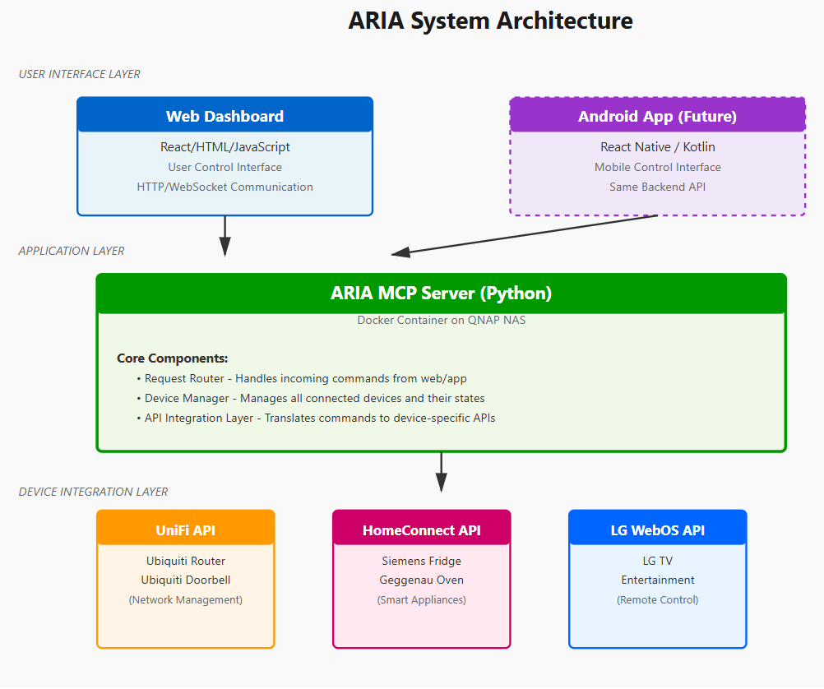
This is how ARIA will be structured. The User interface will be a Web Dashboard, maybe in the future I will developpe an application. The application will be running on a NAS in a container. And to conclude with this diagram ARIA will get all the information she needs in the API corresponding to the device.

Devices
ARIA MCP Server running in a container on NAS
Oven API (Home Connect)
Fridge API (Home Connect
TV API (LG)
Unifi Dorrbell API (Unifi)

Sécurity requirements
See below the security requirements for this project.
SECURITY_REQUIREMENTS.md

What i can do :
- Use TV (switch on put channels
- Use the Oven
- Fridge (only check status)
- Doorbell activities
- Network (TBD)

Security issues:
- Problem with the heating adding a maximum heat or maybe a switch off button after 2- 3 hours
- Blocking outside connexion to the AI (hacking or spying problem)
- Network giving access to network connexion to the ai could be an entry point for people outside.

