*femtoino.*

*Ver.0.10.1.*

*Developed by:*

*Dmitry Shpakov*

*Lidija Sokolova*

*2022-2023*

*Riga - Daugavpils, Latvia*

|  |  |  |  |
| --- | --- | --- | --- |
| *Pos.* | *Description* | *Note* | *p.* |
| *1.* | *Document conventions.* | *In progress.* | *4* |
| *1.1.* | *Abbreviations used.* | *In progress.* | *5* |
| *1.2.* | *Text formatting.* | *Done.* |  |
| *1.3.* | *Appearance of pages.* | *Done.* |  |
| *1.4.* | *Versioning.* | *Done.* |  |
|  |  |  |  |
| *2.* | *General description.* | *In progress.* |  |
| *2.1.* | *Hardware.* | *Done.* |  |
| *2.2.* | *Software.* | *Not started.* |  |
|  |  |  |  |
| *3.* | *Hardware.* | *In progress.* |  |
| *3.1.* | *Technical specification.* | *In progress.* |  |
| *3.2.* | *Schematics.* | *Not started.* |  |
| *3.3.* | *BOM.* | *Not started.* |  |
| *3.4.* | *PCB.* | *Not started.* |  |
| *3.5.* | *Assembly* | *Not started.* |  |
|  |  |  |  |
| *4.* | *Software.* | *Not started.* |  |
|  |  |  |  |
|  |  |  |  |
|  |  |  |  |
|  |  |  |  |
|  |  |  |  |
|  |  |  |  |
|  |  |  |  |
|  |  |  |  |
|  |  |  |  |
|  |  |  |  |
|  |  |  |  |
|  |  |  |  |
|  |  |  |  |
|  |  |  |  |
|  |  |  |  |
|  |  |  |  |
|  |  |  |  |
|  |  |  |  |
|  |  |  |  |
|  |  |  |  |
|  |  |  |  |
|  |  |  |  |
|  |  |  |  |
|  |  |  |  |

|  |  |  |  |  |  |  |
| --- | --- | --- | --- | --- | --- | --- |
|  |  |  |  |  | Table of contents. | Page |
|  |  |  |  |  | 2 |
| Chg. | Page | Doc № | Signature | Date |

|  |  |  |  |
| --- | --- | --- | --- |
| *Pos.* | *Description* | *Note* | *p.* |
|  |  |  |  |
|  |  |  |  |
|  |  |  |  |
|  |  |  |  |
|  |  |  |  |
|  |  |  |  |
|  |  |  |  |
|  |  |  |  |
|  |  |  |  |
|  |  |  |  |
|  |  |  |  |
|  |  |  |  |
|  |  |  |  |
|  |  |  |  |
|  |  |  |  |
|  |  |  |  |
|  |  |  |  |
|  |  |  |  |
|  |  |  |  |
|  |  |  |  |
|  |  |  |  |
|  |  |  |  |
|  |  |  |  |
|  |  |  |  |
|  |  |  |  |
|  |  |  |  |
|  |  |  |  |
|  |  |  |  |
|  |  |  |  |
|  |  |  |  |
|  |  |  |  |
|  |  |  |  |
|  |  |  |  |
|  |  |  |  |
|  |  |  |  |
|  |  |  |  |
|  |  |  |  |
|  |  |  |  |
|  |  |  |  |
|  |  |  |  |
|  |  |  |  |
|  |  |  |  |

|  |  |  |  |  |  |  |
| --- | --- | --- | --- | --- | --- | --- |
|  |  |  |  |  | Table of contents. | Page |
|  |  |  |  |  | 3 |
| Chg. | Page | Doc № | Signature | Date |

*1. Document conventions.*

|  |  |  |  |  |  |  |
| --- | --- | --- | --- | --- | --- | --- |
|  |  |  |  |  | 1. Document conventions. | Page |
|  |  |  |  |  | 4 |
| Chg. | Page | Doc № | Signature | Date |

***1.1. Abbreviations.***

|  |  |  |  |  |  |  |
| --- | --- | --- | --- | --- | --- | --- |
|  |  |  |  |  | 1.1. Abbreviations. | Page |
|  |  |  |  |  |  |
| Chg. | Page | Doc № | Signature | Date |

*PCB – printed circuit board*

*TBD – to be discussed*

*ADC – analog to digital converter*

*DAC – digital to analog converter*

*RGB – red, green, blue*

*LED – light emission diode*

*USB – universal serial bus*

*GPIO – general purpose input output*

*GHz – giga hertz*

*IMU – inertial measuring unit*

*CNC – computer numerical control*

***1.2. Text formatting.***

|  |  |  |  |  |  |  |
| --- | --- | --- | --- | --- | --- | --- |
|  |  |  |  |  | 1.2. Text formatting. | Page |
|  |  |  |  |  |  |
| Chg. | Page | Doc № | Signature | Date |

*The font name used – ISOCPEUR.*

*The font size – 14.*

*The font format – italic.*

*The font color – black.*

*Try not to use different text colors. If possible stick to only black color of text. Exception may be images, there may be different colors, but if possible use black text color everywhere. And yeah, if source code is added then there is no limitation on source code highlighting.*

*To highlight some part of text use* ***bold*** *text or underlined text.*

***1.3. Appearance of pages.***

|  |  |  |  |  |  |  |
| --- | --- | --- | --- | --- | --- | --- |
|  |  |  |  |  | 1.3. Appearance of pages. | Page |
|  |  |  |  |  |  |
| Chg. | Page | Doc № | Signature | Date |

*All pages follow the following format.*

*Cover page:*

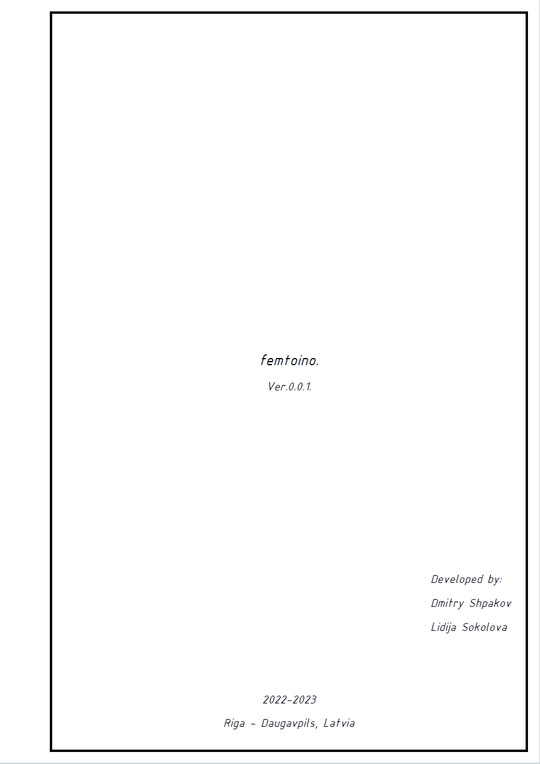

*Nothing special just usual cover page. Version numbering should be changed according to section* ***1.4.*** *of this document****.***

*The end date at bottom should be changed according to last modification date.*

***1.3. Appearance of pages.***

|  |  |  |  |  |  |  |
| --- | --- | --- | --- | --- | --- | --- |
|  |  |  |  |  | 1.3. Appearance of pages. | Page |
|  |  |  |  |  |  |
| Chg. | Page | Doc № | Signature | Date |

*Table of contents page:*

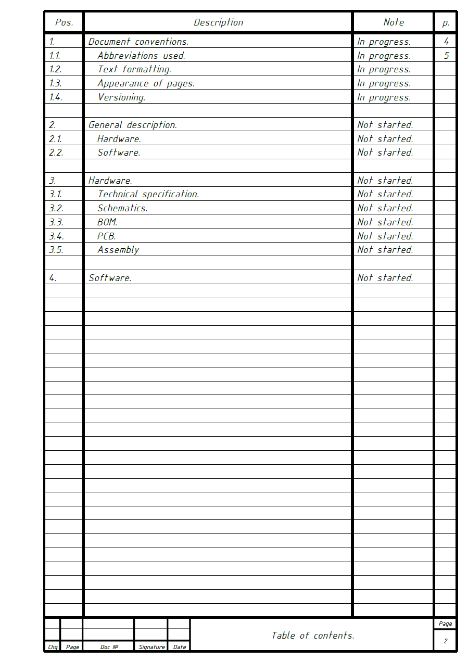

*Sections and sub-sections have status in `Note` column.*

*Possible statuses: `Not started`, `In progress`, `Done`.*

*Every sub-section is indented by two `spaces` relative to its parent section.*

***1.3. Appearance of pages.***

|  |  |  |  |  |  |  |
| --- | --- | --- | --- | --- | --- | --- |
|  |  |  |  |  | 1.3. Appearance of pages. | Page |
|  |  |  |  |  |  |
| Chg. | Page | Doc № | Signature | Date |

*Section main page:*

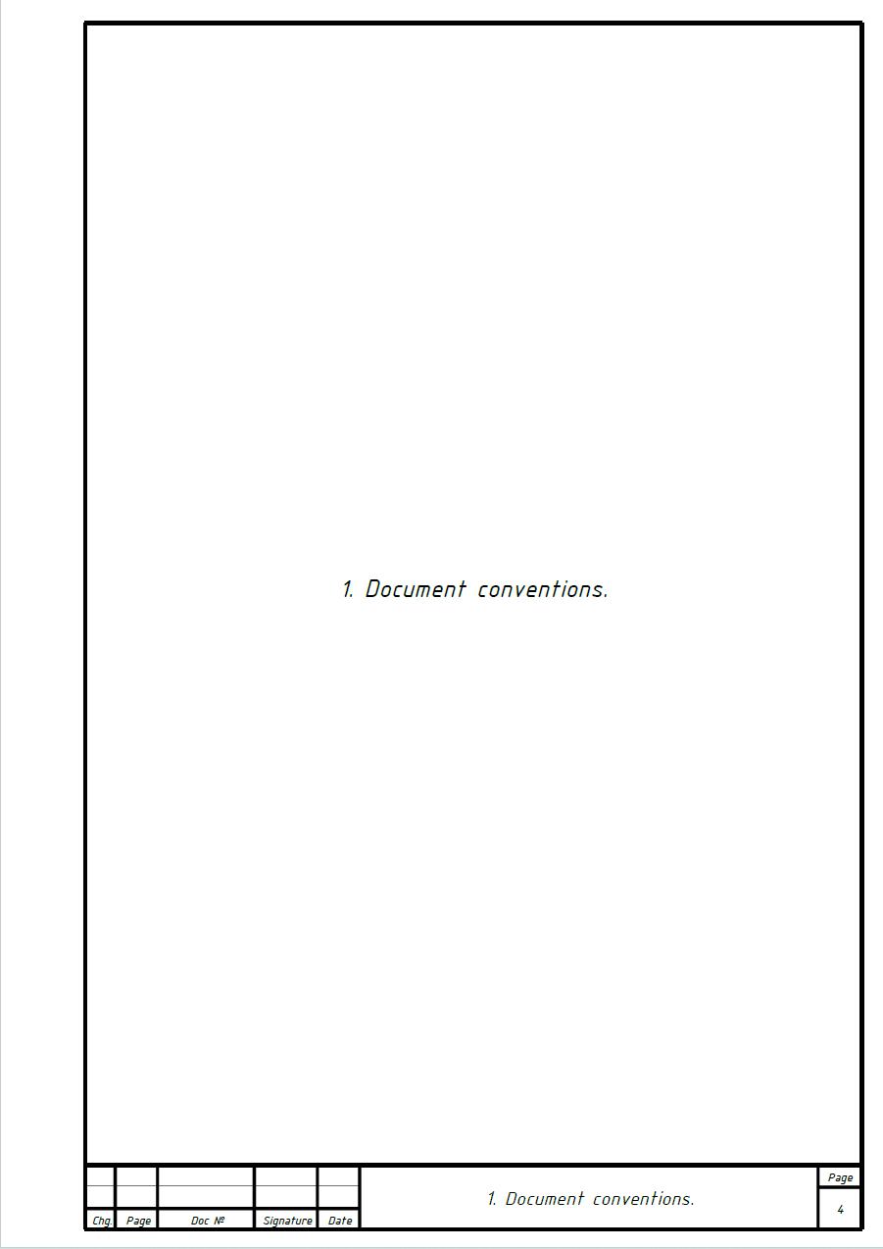

*Simple as it is.*

***1.3. Appearance of pages.***

|  |  |  |  |  |  |  |
| --- | --- | --- | --- | --- | --- | --- |
|  |  |  |  |  | 1.3. Appearance of pages. | Page |
|  |  |  |  |  |  |
| Chg. | Page | Doc № | Signature | Date |

*Section/subsection content page:*

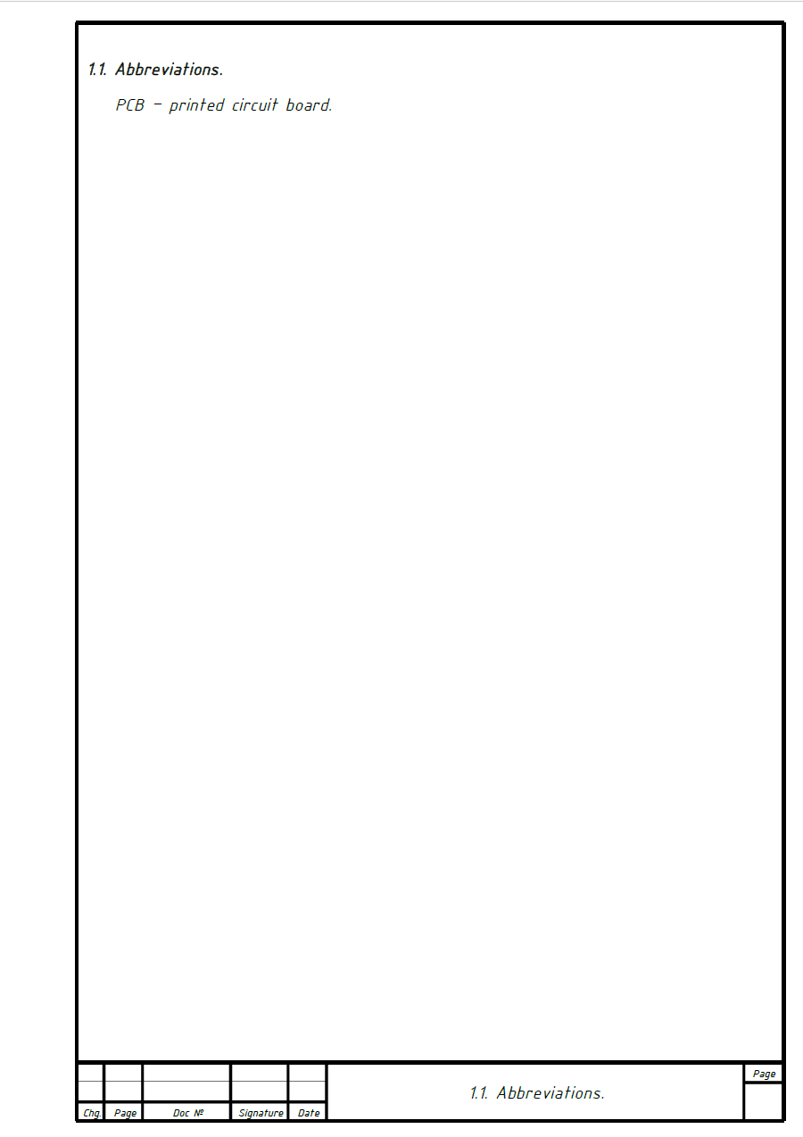

*Simple as it is.*

*Note. All those page templates may be obtained by simply copy and paste from already existing pages and then modifying them.*

***1.4. Versioning.***

|  |  |  |  |  |  |  |
| --- | --- | --- | --- | --- | --- | --- |
|  |  |  |  |  | 1.4. Versioning. | Page |
|  |  |  |  |  |  |
| Chg. | Page | Doc № | Signature | Date |

*The document versioning scheme is the following:*

*Ver.major.minor.patch.*

*For example:*

*Ver. 4.2.1.*

*major – is incremented only if completely different document version is released or document changes its state from `beta` version to `first release` state. For example, from Ver.0.2.14 to Ver.1.0.0 or something similar.*

*minor – is incremented when new chapter is added or similar. Minor version number may be reset when major version number is incremented*

*patch – is incremented when chapter is edited, some cosmetics are made or similar. Patch number may be reset when minor or major version number is incremented.*

*Note. Try to increment versions constantly. For example, if section is added, increment the minor version and only then start to add the next section.*

*Note. This document version does not represent the version of hardware or software. Hardware and software have their own private version schemes and numbers.*

*2. General description.*

|  |  |  |  |  |  |  |
| --- | --- | --- | --- | --- | --- | --- |
|  |  |  |  |  | 2. General description. | Page |
|  |  |  |  |  |  |
| Chg. | Page | Doc № | Signature | Date |

***2.1. Hardware.***

|  |  |  |  |  |  |  |
| --- | --- | --- | --- | --- | --- | --- |
|  |  |  |  |  | 2.1. Hardware. | Page |
|  |  |  |  |  |  |
| Chg. | Page | Doc № | Signature | Date |

*The `femtoino` is Arduino like device, but in a small form factor with the following features:*

* *USB Type-C power connector with data communication over it*
* *GPIO expansion pins including analog pins for ADC and DAC*
* *External Li-ion battery connector, for autonomous operation*
* *Some on-board sensors if enough space is available (TBD), for example the temperature, barometric pressure, humidity, IMU, light sensors, etc.*
* *2.4GHz wireless interface for connectivity*
* *One or more onboard RGB LEDs*
* *CR2032 battery holder*
* *One or more micro buttons*
* *Micro SD card slot if possible*
* *Possibly some CNC milled case may be developed for this device in future, so consider to make usable GPIO expansion pins and wireless antenna connector*

***2.2. Software.***

|  |  |  |  |  |  |  |
| --- | --- | --- | --- | --- | --- | --- |
|  |  |  |  |  | 2.2. Software. | Page |
|  |  |  |  |  |  |
| Chg. | Page | Doc № | Signature | Date |

*3. Hardware.*

|  |  |  |  |  |  |  |
| --- | --- | --- | --- | --- | --- | --- |
|  |  |  |  |  | 3. Hardware. | Page |
|  |  |  |  |  |  |
| Chg. | Page | Doc № | Signature | Date |

***3.1. Technical specification.***

|  |  |  |  |  |  |  |
| --- | --- | --- | --- | --- | --- | --- |
|  |  |  |  |  | 3.1. Technical specification. | Page |
|  |  |  |  |  |  |
| Chg. | Page | Doc № | Signature | Date |