VGGT Seminar Report · Supplementary Material
Peleg Shpitzer · University of Haifa · July 2026

S1. Reproducibility Record
Item | Exact value
Repository commit | a288dd0f14786c93483e45524328726ab7b1b4ce
Checkpoint SHA-256 | d15bf50a8615c8225ed48b51ea5cac673d82442ec0309036df555a053253afe0
Protocol | eth3d-overlap-aware-nested-v1
Source commits | delivery: 5ef68d3 · courtyard/cross-scene: ccb5487
Execution boundary | Saved outputs only; no model/checkpoint/CUDA execution

S2. Exact Frozen Frames
Scene | Set | Indices | Filenames
delivery_area | S2 | [0, 6] | DSC_0675.JPG, DSC_0681.JPG
delivery_area | S4 | [0, 3, 6, 9] | DSC_0675.JPG, DSC_0678.JPG, DSC_0681.JPG, DSC_0684.JPG
delivery_area | S6 | [0, 3, 4, 5, 6, 9] | DSC_0675.JPG, DSC_0678.JPG, DSC_0679.JPG, DSC_0680.JPG, DSC_0681.JPG, DSC_0684.JPG
delivery_area | S8 | [0, 1, 2, 3, 4, 5, 6, 9] | DSC_0675.JPG, DSC_0676.JPG, DSC_0677.JPG, DSC_0678.JPG, DSC_0679.JPG, DSC_0680.JPG, DSC_0681.JPG, DSC_0684.JPG
delivery_area | S10 | [0, 1, 2, 3, 4, 5, 6, 7, 8, 9] | DSC_0675.JPG, DSC_0676.JPG, DSC_0677.JPG, DSC_0678.JPG, DSC_0679.JPG, DSC_0680.JPG, DSC_0681.JPG, DSC_0682.JPG, DSC_0683.JPG, DSC_0684.JPG
courtyard | S2 | [0, 9] | DSC_0286.JPG, DSC_0295.JPG
courtyard | S4 | [0, 4, 6, 9] | DSC_0286.JPG, DSC_0290.JPG, DSC_0292.JPG, DSC_0295.JPG
courtyard | S6 | [0, 2, 3, 4, 6, 9] | DSC_0286.JPG, DSC_0288.JPG, DSC_0289.JPG, DSC_0290.JPG, DSC_0292.JPG, DSC_0295.JPG
courtyard | S8 | [0, 2, 3, 4, 5, 6, 7, 9] | DSC_0286.JPG, DSC_0288.JPG, DSC_0289.JPG, DSC_0290.JPG, DSC_0291.JPG, DSC_0292.JPG, DSC_0293.JPG, DSC_0295.JPG
courtyard | S10 | [0, 1, 2, 3, 4, 5, 6, 7, 8, 9] | DSC_0286.JPG, DSC_0287.JPG, DSC_0288.JPG, DSC_0289.JPG, DSC_0290.JPG, DSC_0291.JPG, DSC_0292.JPG, DSC_0293.JPG, DSC_0294.JPG, DSC_0295.JPG

S3. Complete Runtime and Memory Results
Scene | Set | Views | Inference s | Total s | Allocated GiB | Reserved GiB
delivery_area | S2 | 2 | 0.906 | 3.208 | 5.261 | 5.883
delivery_area | S4 | 4 | 0.971 | 7.808 | 5.631 | 7.023
delivery_area | S6 | 6 | 0.853 | 10.712 | 6.084 | 8.074
delivery_area | S8 | 8 | 0.897 | 13.900 | 6.535 | 9.166
delivery_area | S10 | 10 | 1.142 | 17.386 | 6.599 | 9.230
courtyard | S2 | 2 | 0.876 | 4.510 | 5.261 | 5.883
courtyard | S4 | 4 | 0.713 | 7.614 | 5.631 | 7.023
courtyard | S6 | 6 | 0.727 | 10.858 | 6.084 | 8.074
courtyard | S8 | 8 | 0.974 | 14.496 | 6.535 | 9.166
courtyard | S10 | 10 | 1.055 | 18.645 | 6.599 | 9.230

S4. Complete Confidence and Geometry Results
Scene | Set | Depth mean | Depth median | Point mean | Point median | Retained | Path | Max sep.
delivery_area | S2 | 1.916 | 1.519 | 2.443 | 2.389 | 181300 | 0.534 | 0.534
delivery_area | S4 | 3.609 | 3.949 | 3.711 | 3.390 | 362600 | 0.741 | 0.741
delivery_area | S6 | 4.196 | 4.528 | 4.242 | 3.892 | 543900 | 0.770 | 0.770
delivery_area | S8 | 3.964 | 4.097 | 3.996 | 3.583 | 725200 | 0.831 | 0.831
delivery_area | S10 | 5.017 | 5.552 | 4.477 | 3.796 | 906499 | 0.748 | 0.747
courtyard | S2 | 2.319 | 2.516 | 3.034 | 2.931 | 181300 | 0.800 | 0.800
courtyard | S4 | 5.162 | 5.410 | 4.908 | 4.874 | 362600 | 0.894 | 0.893
courtyard | S6 | 6.535 | 6.832 | 5.591 | 5.488 | 543900 | 0.942 | 0.941
courtyard | S8 | 8.374 | 8.739 | 6.298 | 6.158 | 725199 | 0.927 | 0.926
courtyard | S10 | 8.012 | 8.372 | 6.151 | 6.019 | 906499 | 0.919 | 0.917

S5. Point-Cloud Rendering Parameters
Source: saved confidence-filtered ASCII PLY files. Deterministic sampling retained every fixed-stride vertex to approximately 45,000 points, followed by median centering and 97th-percentile radial normalization. Renders use a dark RGB(12,18,28) background, saved RGB point colors, two-pixel splats, perspective projection, a -12° elevation, and 80 evenly spaced azimuths. Animations are 960×640 at 10 fps for 8 seconds. Coordinates remain arbitrary and unaligned; normalization is visual, not geometric filtering intended to improve results.
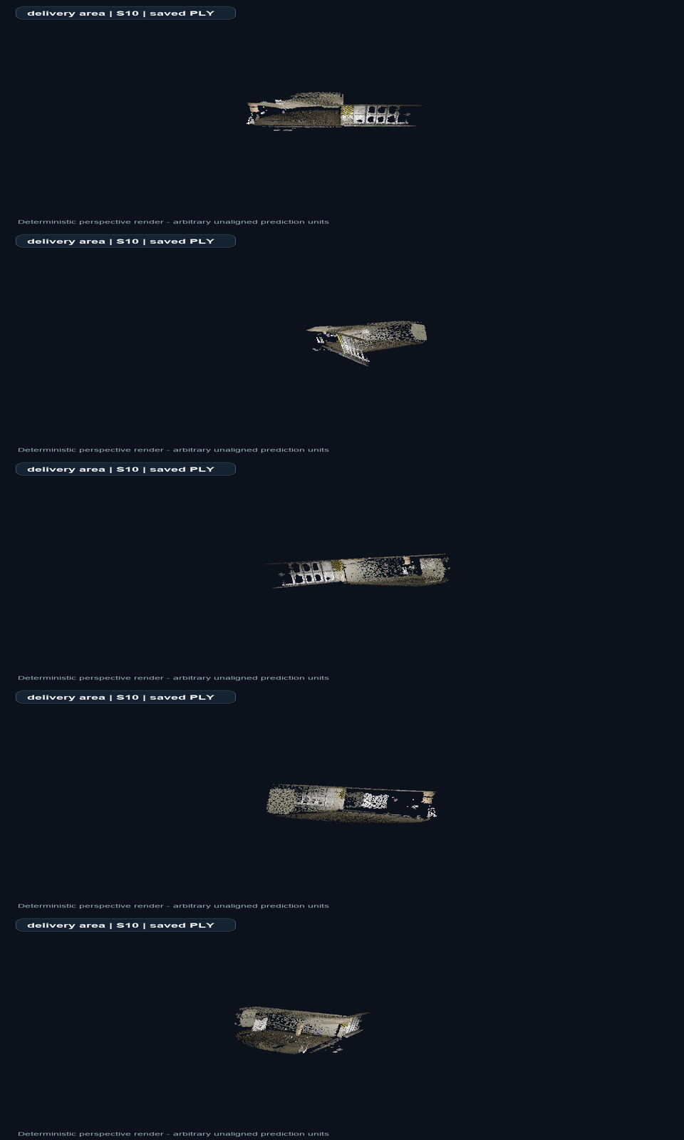
Figure S1. delivery_area S10 rotation keyframes.
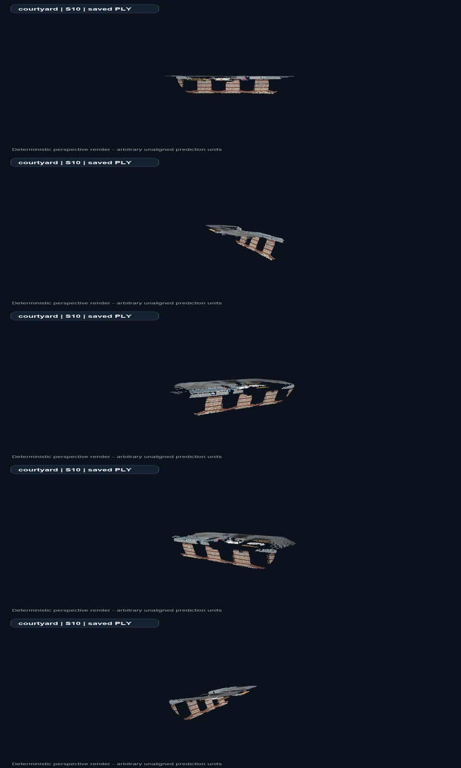
Figure S2. courtyard S10 rotation keyframes.

S6. Artifact and Build Record
Canonical inputs are report/data/view_count_results.csv and the source manifests/summary files recorded in report/data/report_provenance.json. V2 is regenerated with scripts/build_v2_animations.py and scripts/build_phase10_report_v2.py, then exported through Microsoft Word to selectable-text PDFs. The build imports neither VGGT nor Torch and does not load a checkpoint.
Digital animation files: report/v2/animations/delivery_area_s10_rotation.gif/.mp4 and courtyard_s10_rotation.gif/.mp4. Main visual assets are under report/v2/figures and report/v2/diagrams.

