REPRODUCING VGGT
A Controlled Study of View-Count Scaling
with Overlap-Aware ETH3D Inputs
Reproduction, experimental methodology, and qualitative multi-view analysis
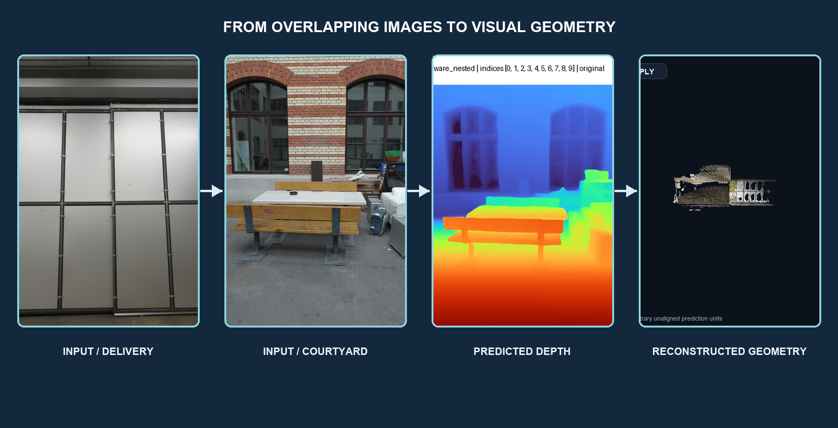
Peleg Shpitzer · Course / Instructor · University of Haifa · July 2026

Abstract
Visual Geometry Grounded Transformer (VGGT) predicts cameras, depth, point maps, confidence, and tracks from one or more images in a single feed-forward model. We reproduced the maintained official implementation and public VGGT-1B checkpoint locally, then designed a controlled study of how operational behavior changes with 2, 4, 6, 8, and 10 overlapping views. Two calibrated ETH3D scenes, delivery_area and courtyard, were sampled with a deterministic overlap-aware protocol combining pose and feature evidence. Across ten configurations, all required outputs remained finite. Allocated memory rose from about 5.26 to 6.60 GiB, synchronized inference stayed near one second, and complete processing time grew with the amount of per-view postprocessing. Model confidence generally increased but was not monotonic, while visible gains appeared to diminish around eight to ten views. Dominant scene structure remained qualitatively coherent. Because predictions were not aligned to ETH3D coordinates, this report makes no quantitative reconstruction-accuracy claim. The results support reliable local operation and a defensible view-count methodology, while identifying aligned evaluation as the main next scientific step.
INTERPRETATION BOUNDARY
VGGT confidence is a model output, not calibrated reconstruction accuracy. Camera and point-cloud coordinates remain in arbitrary, unaligned prediction units.
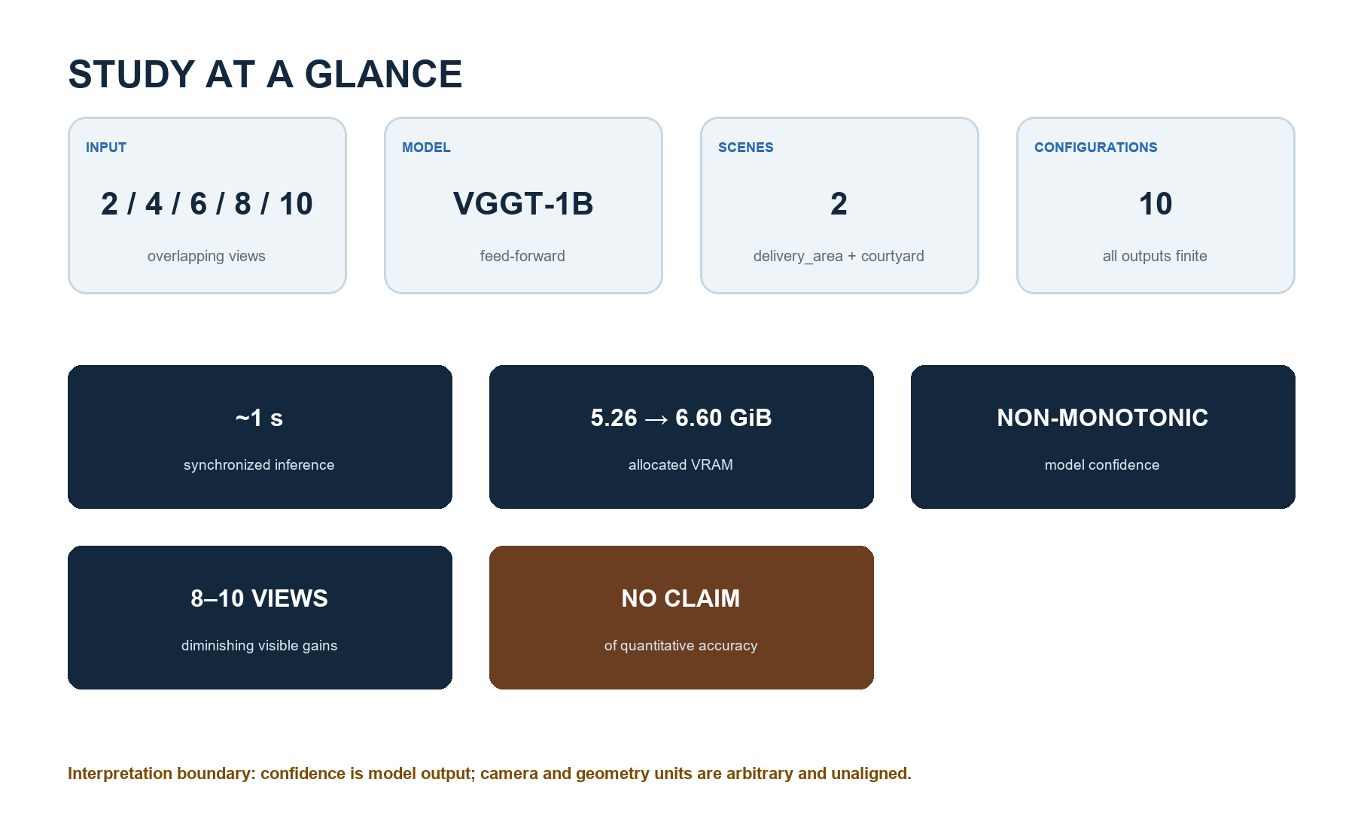
Figure 1. Study at a Glance. Ten saved configurations; no new model execution.

1. Introduction
VGGT asks whether a shared transformer can replace much of a conventional multi-stage geometry pipeline with direct prediction [1]. This project tests that proposition at the level appropriate for a seminar reproduction: operational correctness, a controlled input study, resource measurements, and bounded qualitative analysis. The research question is how runtime, memory, confidence, predicted camera structure, and visible completeness change as overlapping input views increase from two to ten.
RESEARCH QUESTION
How do runtime, memory, model confidence, predicted camera structure, and visible geometric completeness change as overlapping views increase from two to ten?
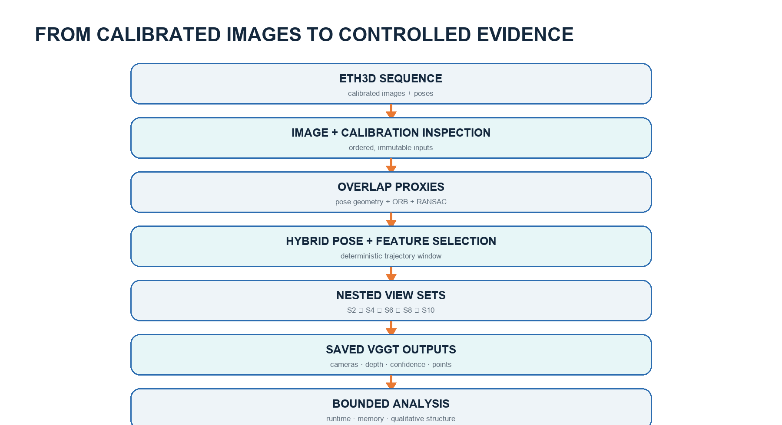
Figure 2. Project pipeline. Saved outputs support operational and qualitative analysis; no aligned accuracy evaluation was performed.

2. VGGT in Brief
Multi-view RGB images are tokenized by a DINOv2 encoder [5]. An aggregator alternates frame-local attention with global cross-view attention, after which dedicated heads predict cameras, depth, point maps, confidence, and tracks. Predictions use the first camera as a reference. The conceptual diagram in this report is original and based on the architecture description in VGGT [1], not a reproduction of its figure.
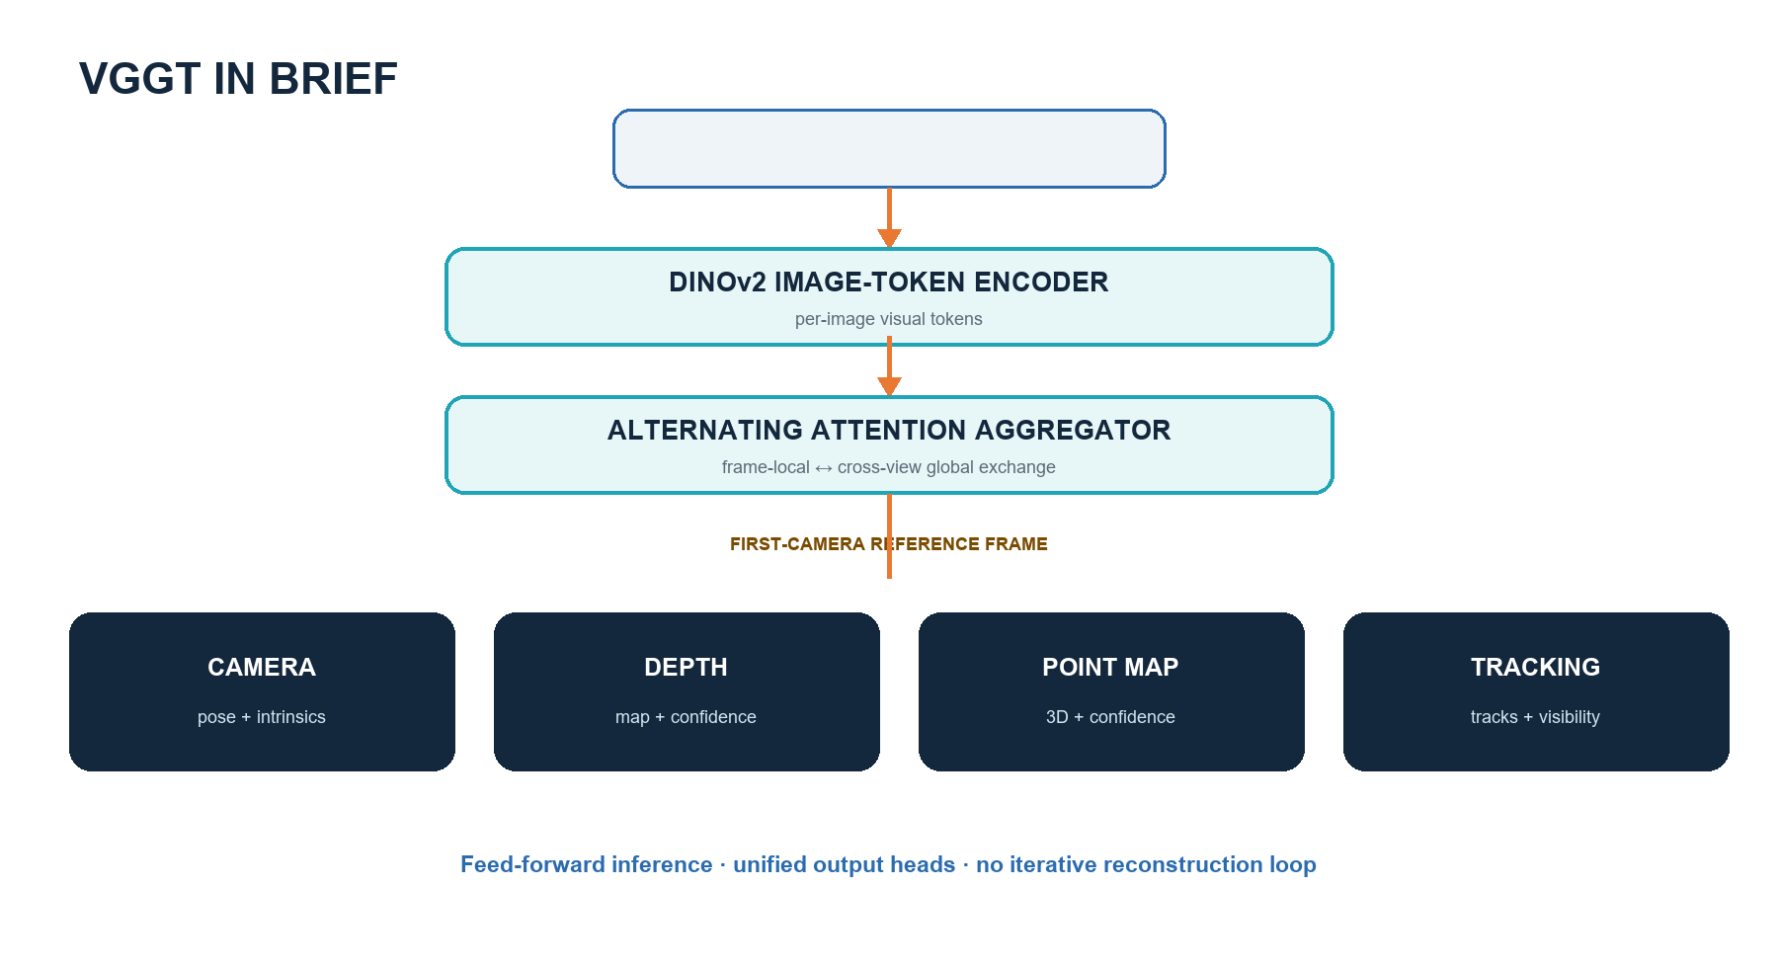
Figure 3. Simplified conceptual diagram created for this report based on VGGT [1].

3. Reproduction Setup
The maintained official repository was pinned at `a288dd0f14786c93483e45524328726ab7b1b4ce`; the public checkpoint hash was `d15bf50a8615c8225ed48b51ea5cac673d82442ec0309036df555a053253afe0`. Inference used Python 3.11.15, PyTorch 2.13.0+cu130, CUDA 13.0, an RTX 5080, BF16 autocast, and disabled Flash SDPA. The official example and all documented output heads were validated. This establishes operational reproduction, not independent reproduction of every benchmark result reported by the authors.
Component | Verified setting
Implementation | Official maintained VGGT; commit a288dd0f…
Checkpoint | VGGT-1B; SHA-256 d15bf50a…afe0
Compute | RTX 5080 · CUDA 13.0 · BF16 autocast
Runtime | Python 3.11.15 · PyTorch 2.13.0+cu130
Attention | Flash SDPA disabled
Boundary | Operational reproduction; not paper-wide metric replication
Table 1. Compact environment and reproduction summary. Full hashes appear in the supplement.

4. Experimental Methodology
ETH3D provides calibrated high-resolution imagery and laser scans [2]. We selected delivery_area and courtyard as complementary indoor and outdoor cases. Laser geometry was deliberately not used for scoring because coordinate conventions and similarity alignment must be validated first. The independent variable was view count; model, checkpoint, preprocessing, precision, hardware, ordering, postprocessing, and the strict `confidence > median` visualization rule were controlled. There was one run per condition, so timings are descriptive and have no error bars.
CONTROLLED VARIABLES
Checkpoint · preprocessing · precision · hardware · order · postprocessing · confidence filter · visualization method
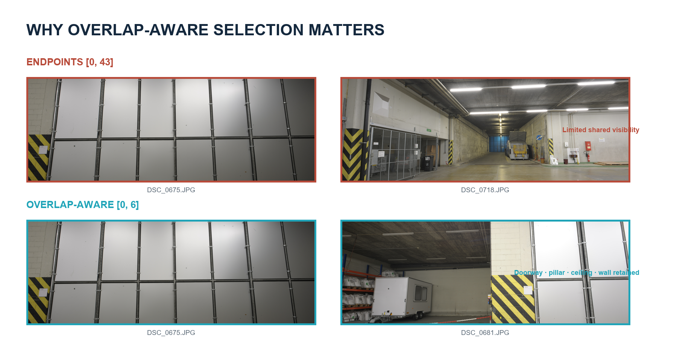
Figure 4. Endpoint separation increased sequence coverage but reduced common visibility. The overlap-aware pair retained substantially more shared scene content.

5. Overlap-Aware Frame Selection
Uniform endpoints `[0,43]` increased sequence coverage but shared little visible structure. The selected hybrid method combined camera-center distance, viewing-direction and relative-rotation angles, ORB correspondence counts [3], and fundamental-matrix RANSAC inliers [4]. It froze nested subsets satisfying `S2 ⊂ S4 ⊂ S6 ⊂ S8 ⊂ S10`. Nesting reduces frame-selection confounding because every larger condition retains all evidence from the smaller condition.
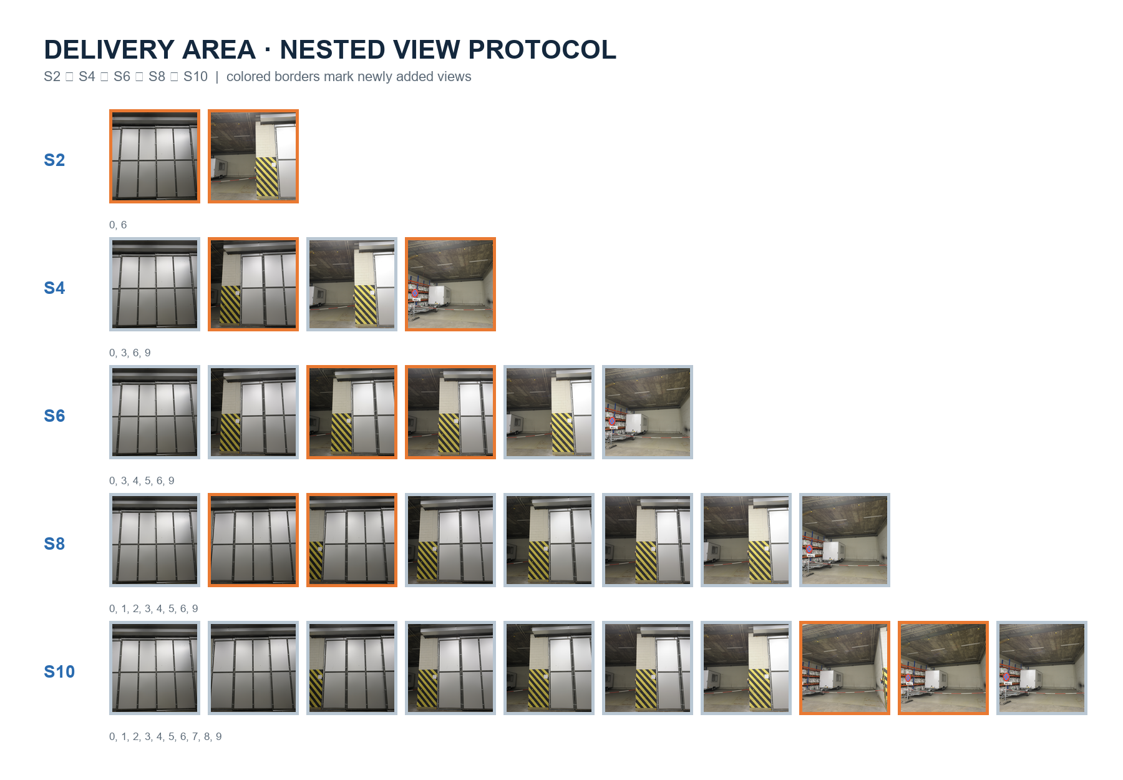
Figure 5. Frozen nested delivery_area subsets. Orange borders identify views introduced at each step.

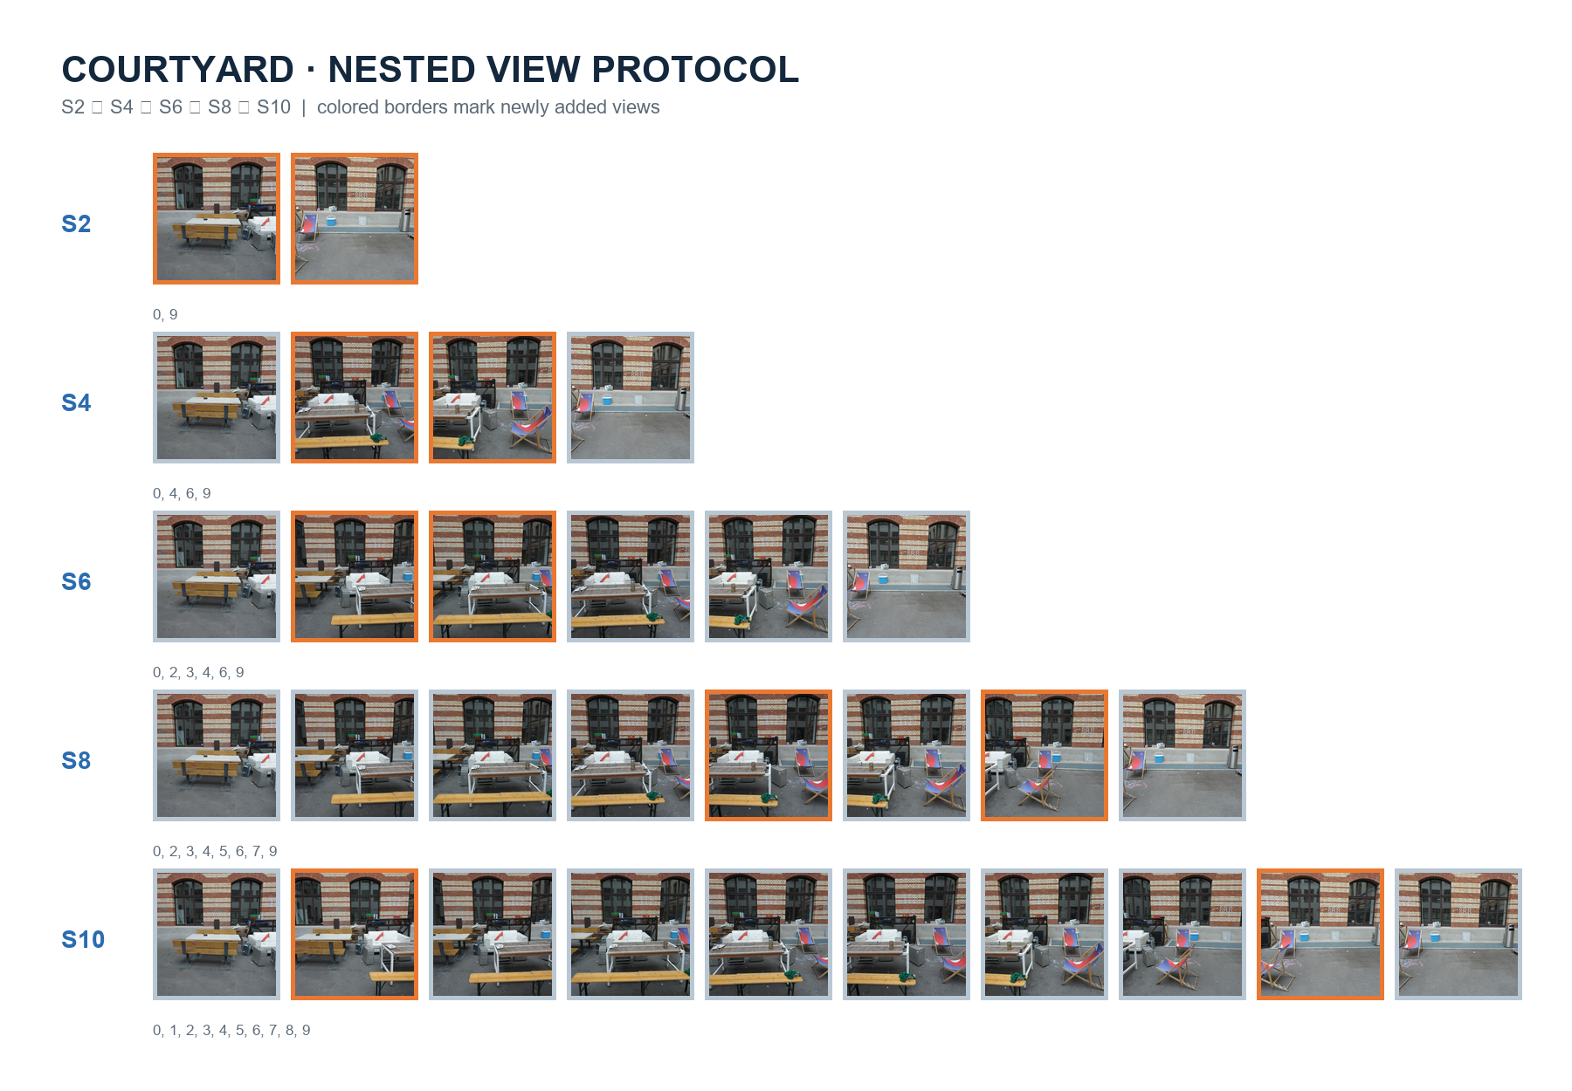
Figure 6. Frozen nested courtyard subsets. Every larger set retains all earlier views.
WHY NESTING MATTERS
The principal designed change is view count. Deterministic containment reduces frame-selection confounding and makes the comparison reproducible.

6. Experimental Results
RESULTS DASHBOARD
5 view counts · 2 scenes · 10 configurations · all output tensors finite · 5.26 → 6.60 GiB allocated VRAM · approximately one-second inference · visible saturation around 8–10 views
All ten configurations produced finite outputs. Allocated VRAM rose from 5.261 GiB at S2 to 6.599 GiB at S10 in both scenes; reserved memory approached 9.23 GiB. Synchronized inference remained between 0.713 and 1.142 seconds, whereas total processing reached 17.386 seconds for delivery_area and 18.645 seconds for courtyard at S10. The divergence is explained by CPU transfer, decoding, validation, visualization, and serialization scaling with dense per-view outputs.
Confidence increased overall but not monotonically. Delivery depth confidence dipped at S8 before recovering at S10; courtyard peaked at S8 and softened at S10. Courtyard confidence was higher at matched counts, but confidence is model output - not calibrated accuracy - and cannot establish that one scene was easier or reconstructed more accurately. Predicted camera-path extent also changed non-monotonically in arbitrary unaligned units.
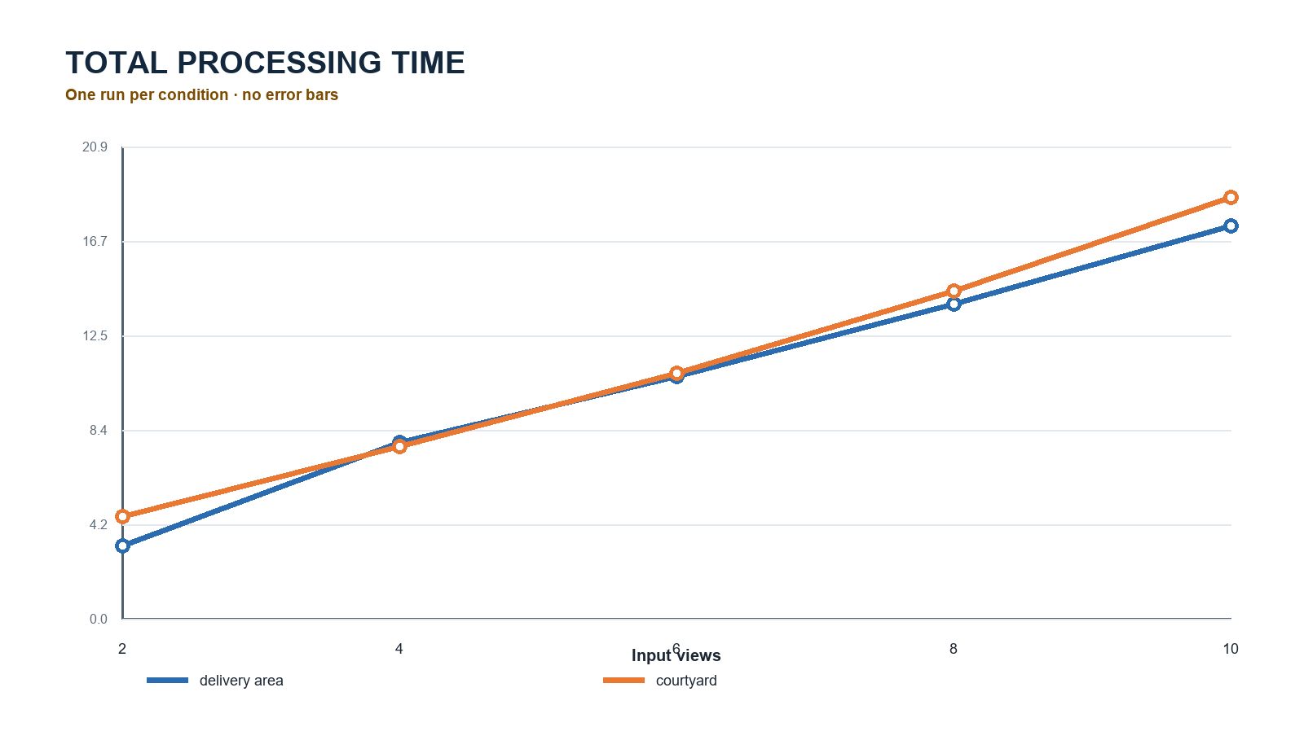
Figure 7. Total processing time by view count. One run per condition; no error bars. Source: report/data/view_count_results.csv.

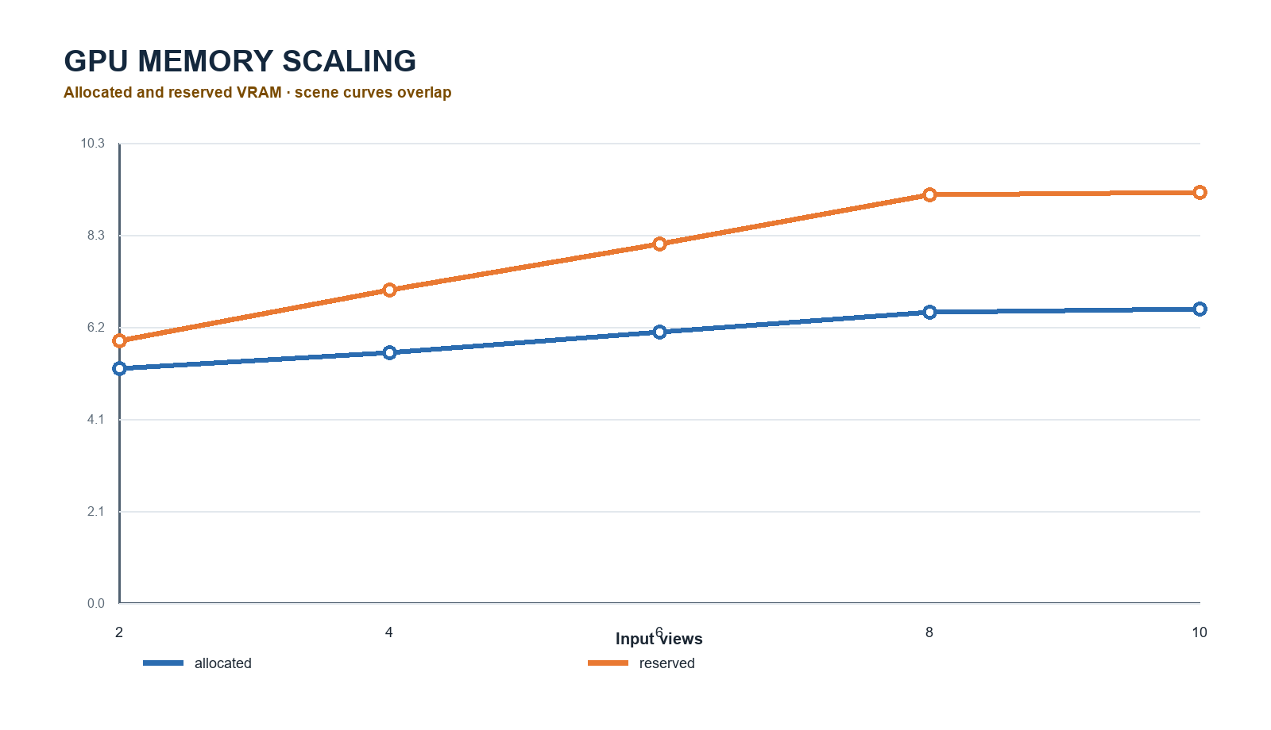
Figure 8. Allocated and reserved VRAM. Scene curves overlap because tensor dimensions and code paths match.
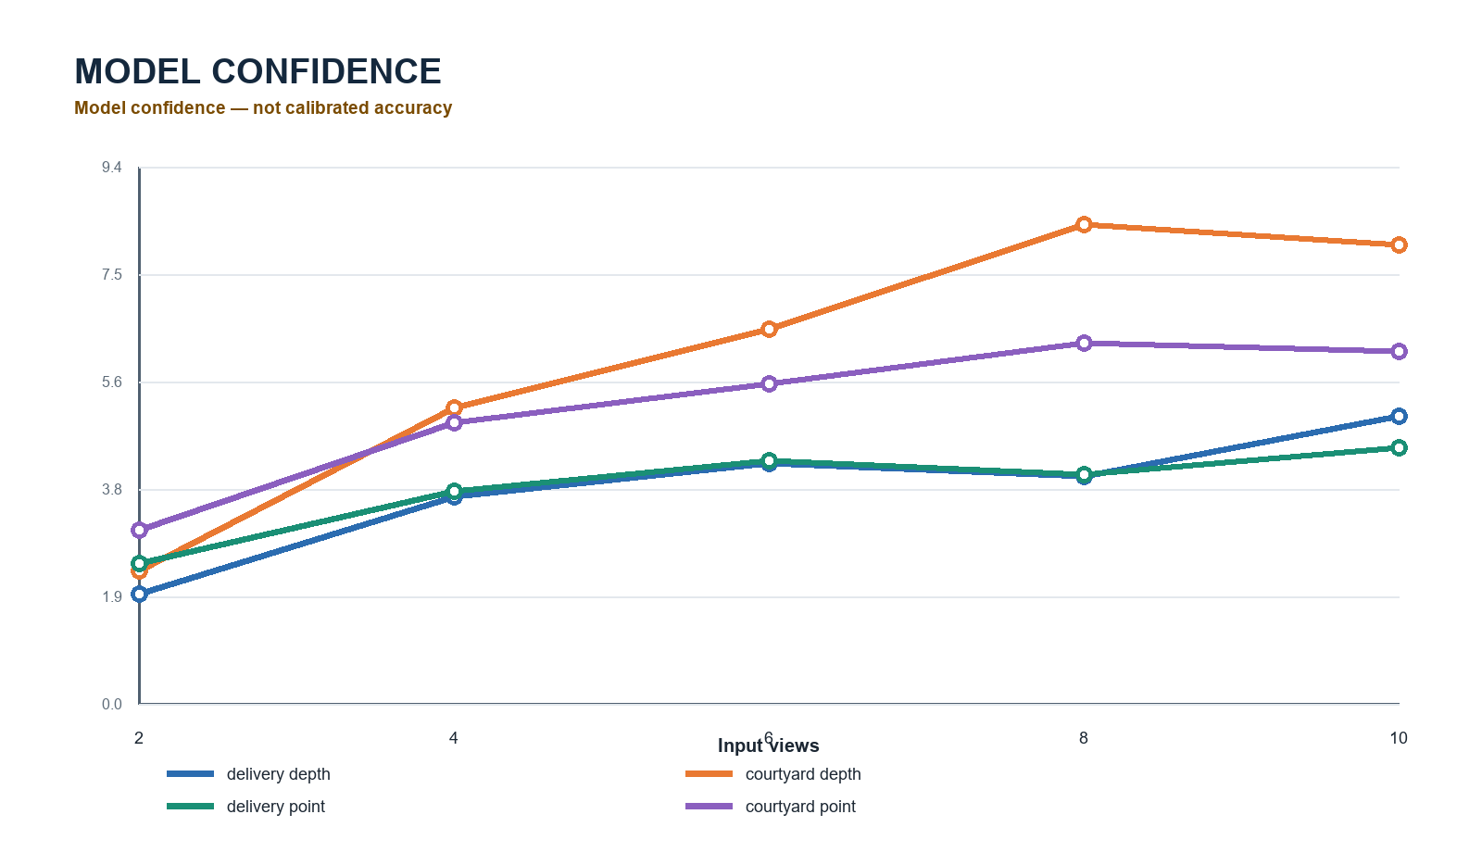
Figure 9. Mean depth and point confidence. Model confidence - not calibrated accuracy.

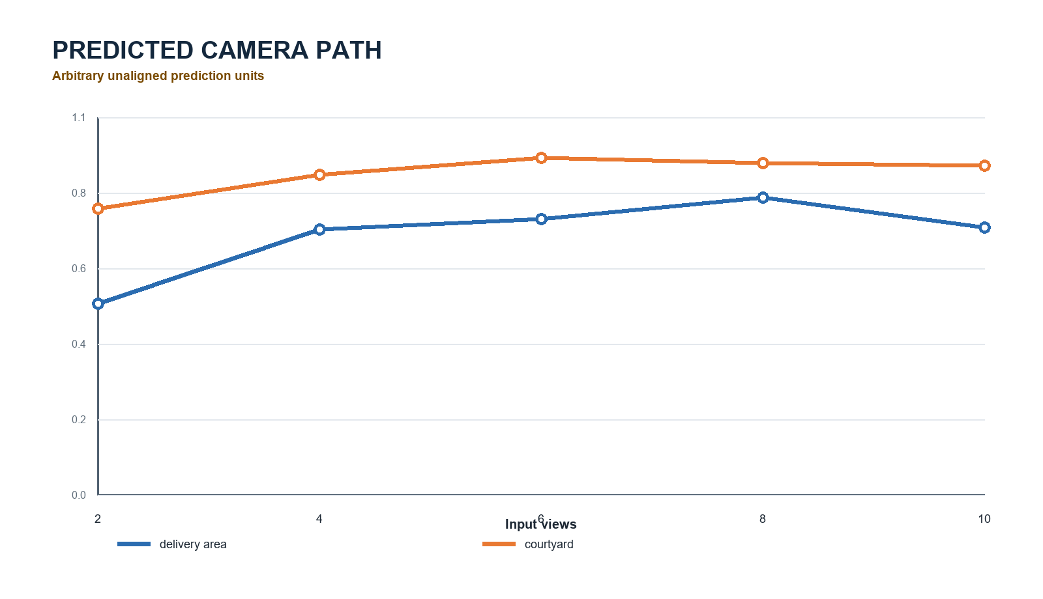
Figure 10. Predicted camera-path behavior in arbitrary unaligned prediction units.
Scene | S2 total | S10 total | S2 alloc. | S10 alloc. | Confidence pattern
delivery_area | 3.208 s | 17.386 s | 5.261 GiB | 6.599 GiB | overall rise; S8 dip
courtyard | 4.510 s | 18.645 s | 5.261 GiB | 6.599 GiB | rise to S8; slight S10 dip
Table 2. Main quantitative summary. Complete values are in the supplement.

7. Qualitative Results
Shared-first-view depth retained the large door plane and ceiling structure in delivery_area and the facade, windows, foreground furniture, and ground in courtyard. Confidence concentrated around recognizable edges and structures, while point-cloud previews preserved dominant surfaces across counts. Visible differences became smaller near S8-S10. These are structured visual observations, not metric completeness or accuracy measurements.
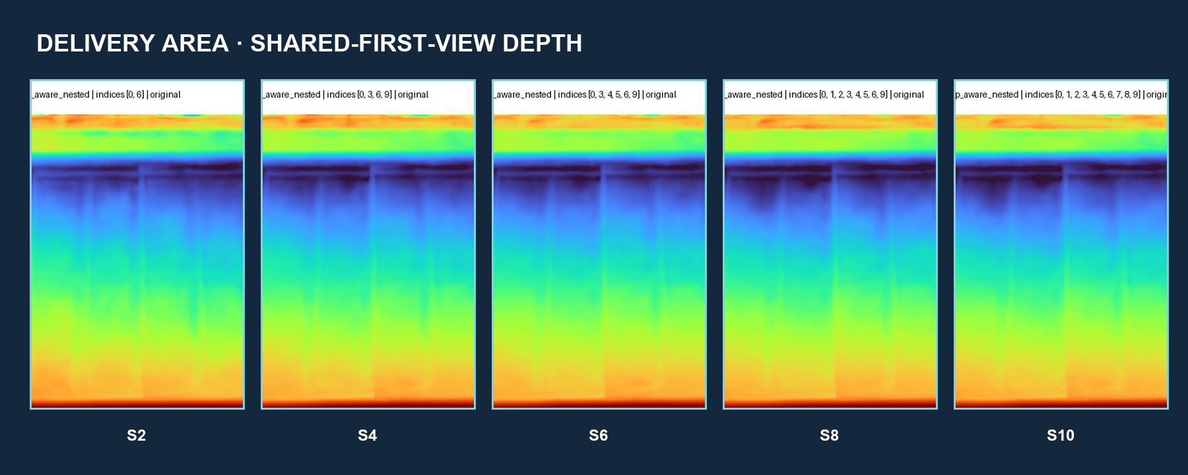
Figure 11. delivery_area shared-first-view depth across S2-S10. Colors are independently mapped prediction values, not metric depth.

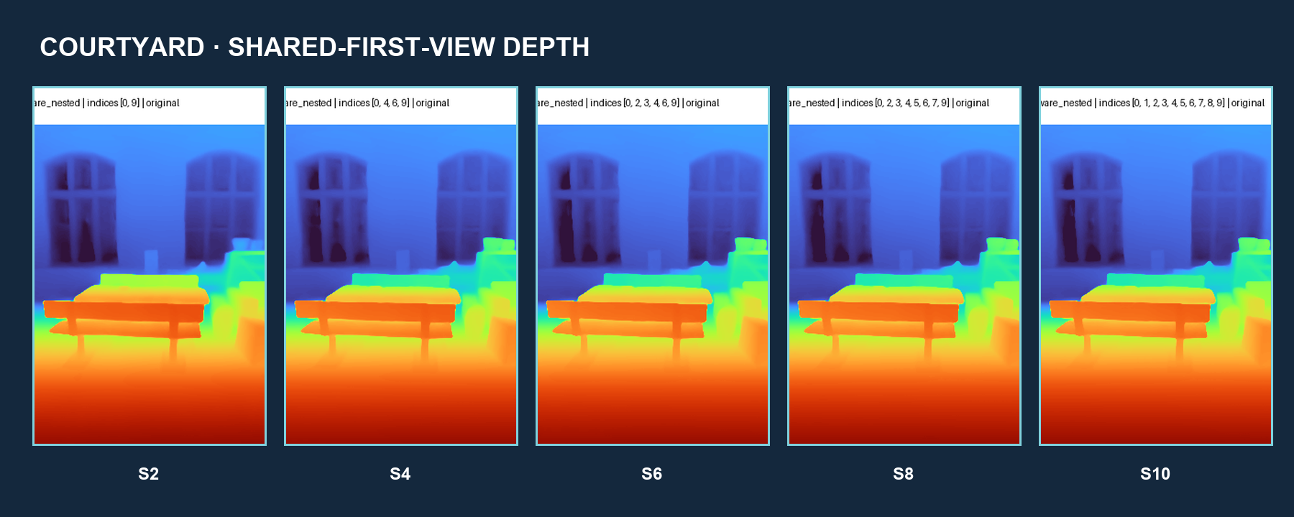
Figure 12. courtyard shared-first-view depth across S2-S10.
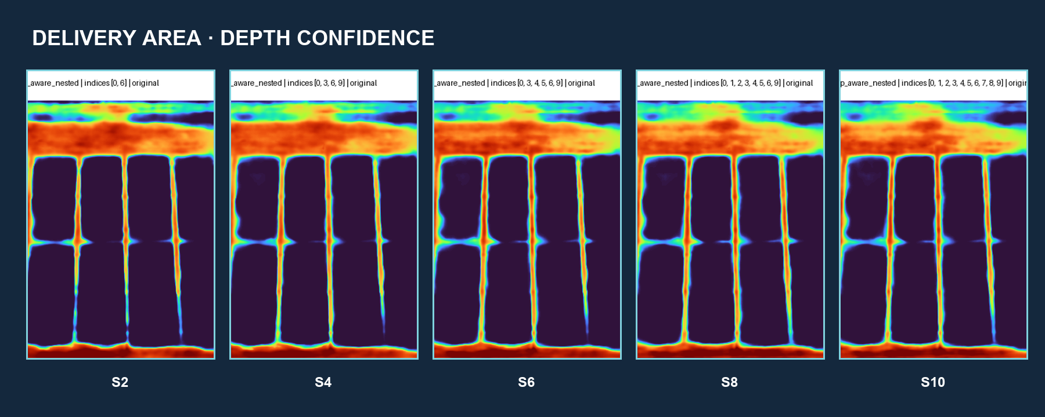
Figure 13. delivery_area depth confidence. Model confidence is not calibrated against ETH3D error.

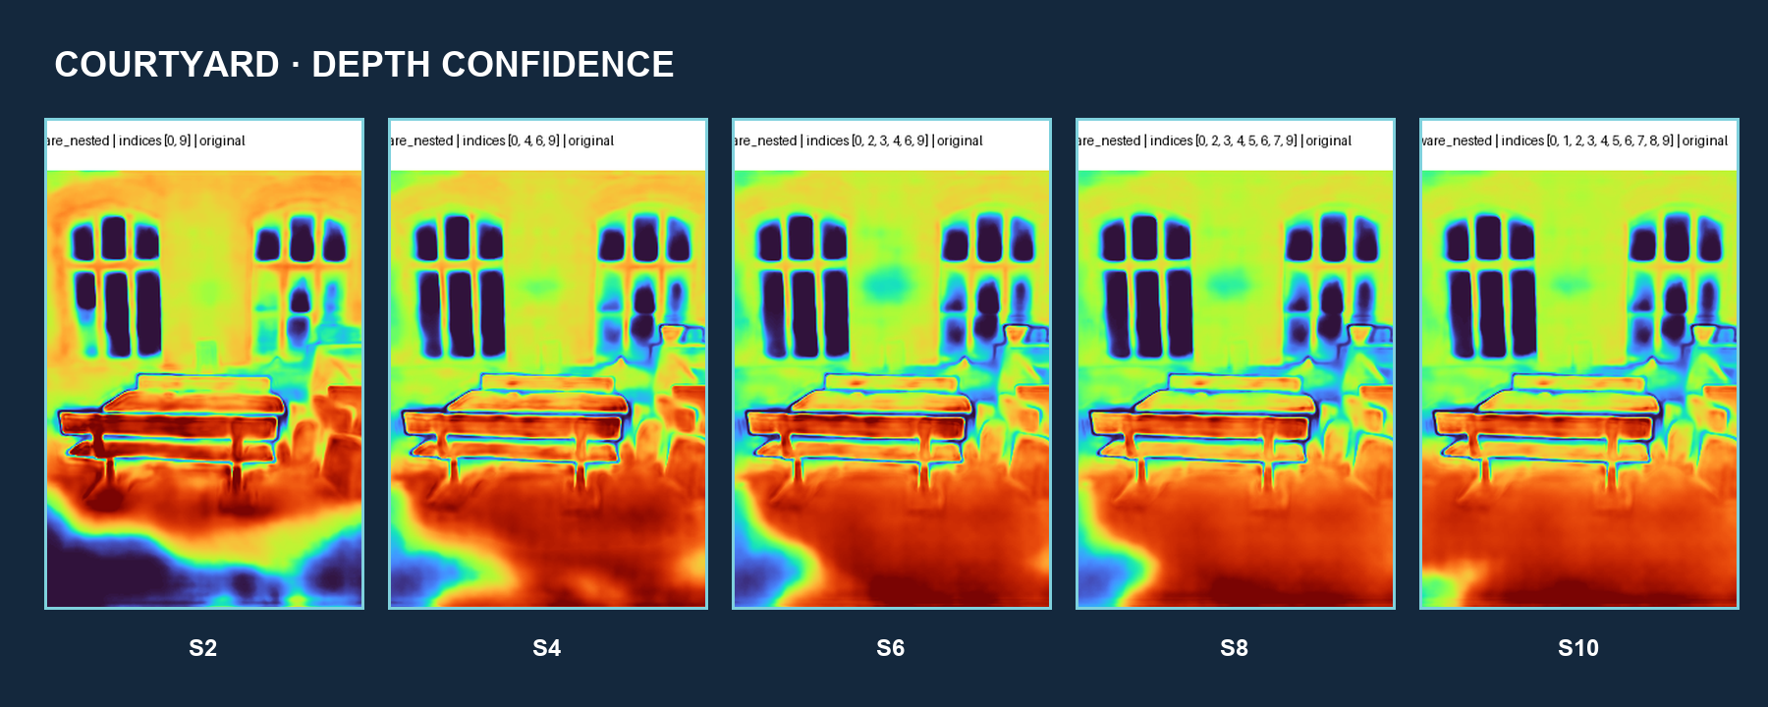
Figure 14. courtyard depth confidence.
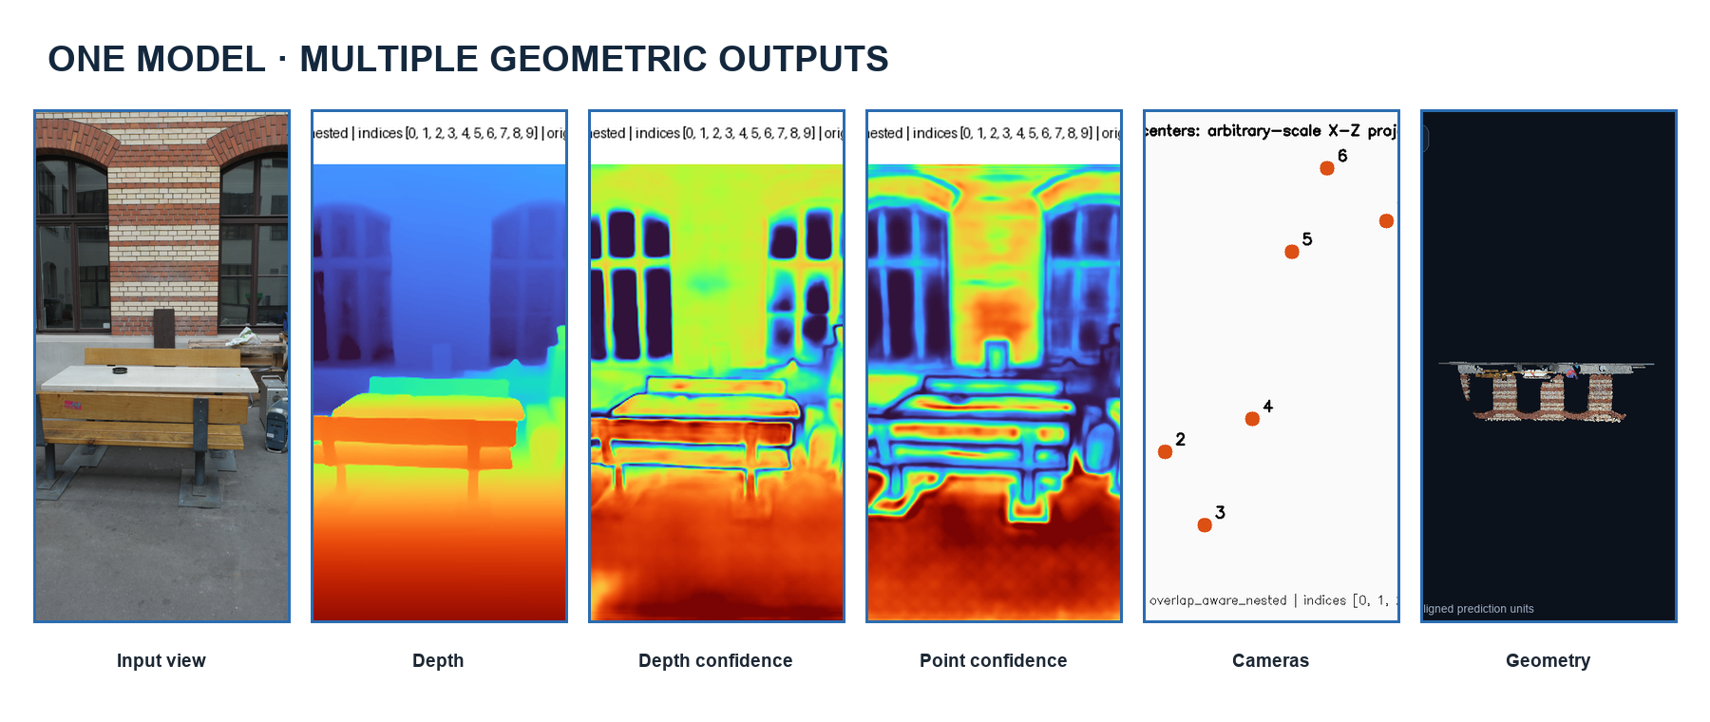
Figure 15. Article-like qualitative panel: representative inputs and diverse VGGT outputs.

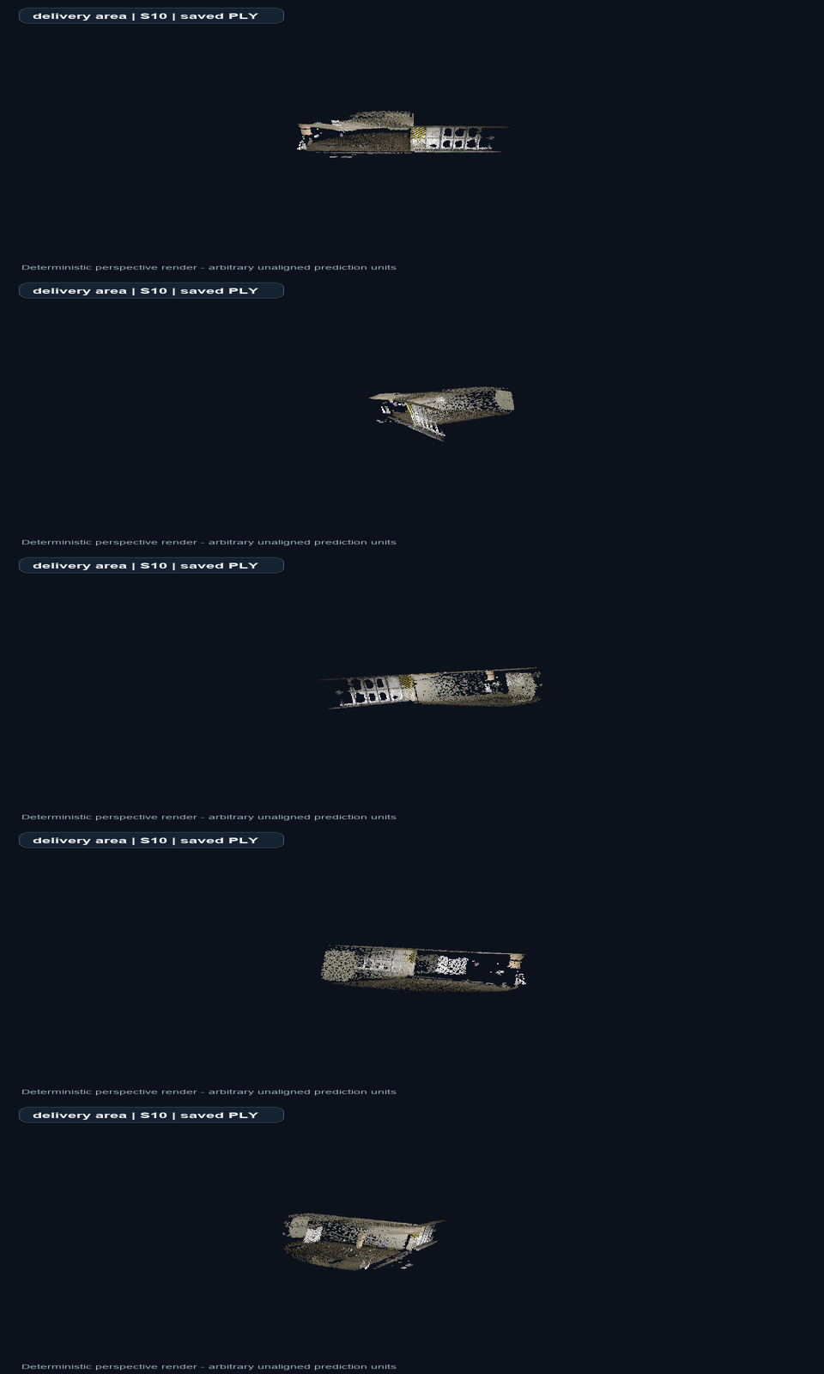
Figure 16. delivery_area S10 deterministic rotation keyframes from the saved PLY. Full GIF/MP4 supplied digitally.
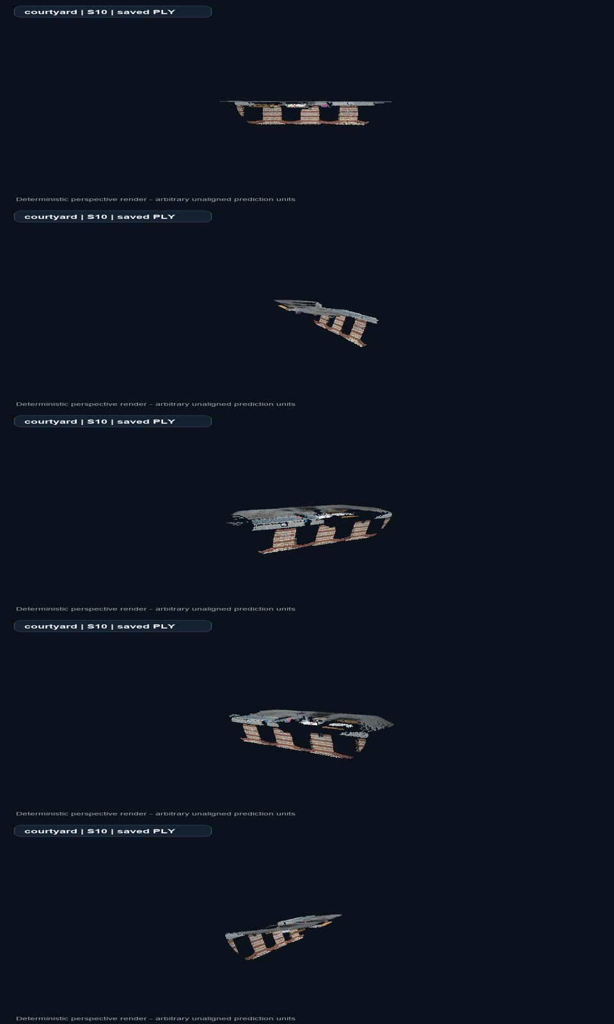
Figure 17. courtyard S10 deterministic rotation keyframes. Normalization and viewing parameters are documented in the supplement.

8. Strengths and Failure Modes
Observed strengths include reliable operation of all heads, coherent dominant structure, moderate allocated-memory growth, improved common visibility from overlap-aware inputs, and generally higher confidence with more views. Difficult behavior includes non-monotonic confidence, changing camera extent, diminishing high-view gains, and sensitivity of qualitative comparisons to auto-fit framing. No catastrophic failure was observed, and none is manufactured here.
Supported strength | Observed difficult behavior
All output heads operated reliably | Confidence was non-monotonic
Dominant structure remained coherent | Camera extent changed with added views
Allocated-memory growth was moderate | High-view visible gains diminished
Overlap-aware selection retained shared content | Auto-fit complicates size comparison
Confidence generally rose with views | Confidence is not accuracy; scale is arbitrary
Table 3. Evidence-backed strengths and difficult behavior; no failure example was manufactured.

9. Discussion
Near-constant inference and growing total time describe different system boundaries: the model forward is efficient for this range, while artifact production grows with views. Moderate memory growth may reflect parameter reuse, chunked decoding, and allocator behavior; this is a hypothesis rather than an isolated causal measurement. Confidence changes may reflect redundant, useful, or inconsistent added evidence. The two-scene pattern suggests practical robustness, but not broad generalization.

10. Limitations
The study covers two scenes and one local trajectory window per scene, with one timing run per condition. It includes no alignment, pose/depth/scan error, alternative model, order sensitivity, degradation study, robustness matrix, or fine-tuning. Confidence is not accuracy. Geometry has arbitrary scale, and independently auto-fitted previews can exaggerate apparent size differences. These boundaries prevent claims of benchmark accuracy, statistical significance, or superiority.
IMPORTANT LIMITATION
Two scenes, one local window per scene, and one timing run per condition do not support broad generalization or statistical claims.
Limitation | Implication
No alignment or metric errors | No quantitative reconstruction-accuracy claim
One run per condition | No variance, error bars, or significance tests
Arbitrary scale | No physical cross-scene camera comparison
Independent auto-fit | Visual size differences may be framing effects
Table 4. Highest-impact limitations. Full limitation inventory is in the supplement.

11. Future Work
The priority is validated similarity alignment to ETH3D, followed by pose and depth or point-to-scan evaluation. Further work should add scenes, repeated timing trials, input-order tests, degradations, alternative selection strategies, and a reconstruction baseline. Fine-tuning should be considered only after aligned evaluation identifies a repeated domain-specific failure and suitable labels and resources exist.

12. Conclusion
VGGT was successfully reproduced and operated reliably on consumer hardware. Overlap-aware nested sampling enabled a controlled two-scene 2/4/6/8/10-view study. Additional views generally increased confidence and visible completeness, but gains were non-monotonic and appeared to diminish at high counts. No additional inference is required for this report redesign; aligned quantitative evaluation is the appropriate next scientific phase.
DECISION
No additional inference is required for the report redesign. The next scientific phase is validated similarity alignment and quantitative ETH3D evaluation.

References
[1] J. Wang et al., “VGGT: Visual Geometry Grounded Transformer,” CVPR, 2025.
[2] T. Schöps et al., “A Multi-View Stereo Benchmark with High-Resolution Images and Multi-Camera Videos,” CVPR, 2017.
[3] E. Rublee et al., “ORB: An Efficient Alternative to SIFT or SURF,” ICCV, 2011.
[4] M. A. Fischler and R. C. Bolles, “Random Sample Consensus,” Communications of the ACM, 1981.
[5] M. Oquab et al., “DINOv2: Learning Robust Visual Features without Supervision,” Transactions on Machine Learning Research, 2024.
Detailed provenance, filenames, complete numeric tables, rendering parameters, artifact locations, and animation keyframes are provided in the supplementary PDF.

Closing visual. The study connects overlapping RGB inputs to depth and saved reconstructed geometry without claiming aligned accuracy.

