
Echo-Location
WP1 – Project Proposal


Yelyzaveta kareieva
S00267553
Contents
1. Project Description 2
a) What is the idea behind the application? 2
b) What are the main features? 2
c) Why is this application useful or interesting? 2
2. User Interface Design 2
a) Navigation bar 2
b) Sidebar 3
c) Map area 3
3. API 4
a) Primary API - Last.fm 4
Endpoint used 4
Postman testing 4
Shape of the data 4
Search functionality 5
b) Supporting API - BigDataCloud Reverse Geocoding 5
c) What will be saved to MongoDB? 5

1. Project Description

Echo-Location is an interactive music discovery web application built with Angular that allows users to explore global musical trends through a live map.

a) What is the idea behind the application?

Most streaming platforms recommend music based on past behavior, creating an "echo chamber." Echo-Location breaks this by letting users travel the world through sound. By interacting with a world map, users can instantly discover what is trending in any specific country.

b) What are the main features?
- Country search bar - users can type a country name to retrieve tracks without clicking the map.
- Track sidebar - displays the top 10 most-listened tracks for the selected country, including track name, artist name, listener count, and a direct link to the Last.fm page.
- Exploration history - each country visited is saved to a MongoDB database via an Express server, creating a persistent record of the user's musical journey.

c) Why is this application useful or interesting?

The application turns data retrieval into an immersive experience. It is visually intuitive and provides a personal "musical timeline," making it rewarding for users to return and see how cultural tastes evolve over time.

2. User Interface Design
The user interface for Echo-Location takes strong visual inspiration from Google Maps - a full-screen interactive map occupies the right-hand portion of the screen, while a sidebar on the left provides search functionality, track listings, and statistics. This layout is immediately familiar to most users and minimises the learning curve for interacting with the application.

a) Navigation bar
A fixed navigation bar runs along the top of the page. It displays the application name (Echo-Location) on the left and a brief tagline on the right. The navbar uses a dark background to contrast with the map area below.

b) Sidebar
The sidebar sits on the left side of the screen and contains the following elements:
- A search input field at the top, allowing users to type any country name. On submission, the map flies to that country and the Last.fm API is queried using the country name as a parameter.
- Two tabs - 'Top Tracks' and 'Stats' - allowing users to switch between the current track listing and their exploration history.
- The Top Tracks tab displays a numbered list of up to 10 tracks. Each item shows the track name, artist, and a link icon that opens the Last.fm page for that track.
- The Stats tab displays recently explored countries (pulled from MongoDB) along with the number one track recorded on the previous visit, enabling a before-and-after comparison.

c) Map area
The map area takes up the remainder of the screen. It is rendered using Leaflet.js and displays a world map with country borders. When a user clicks a country, the selected country is highlighted on the map, and a small tooltip confirms the country name.
A wireframe of the proposed interface is included below.
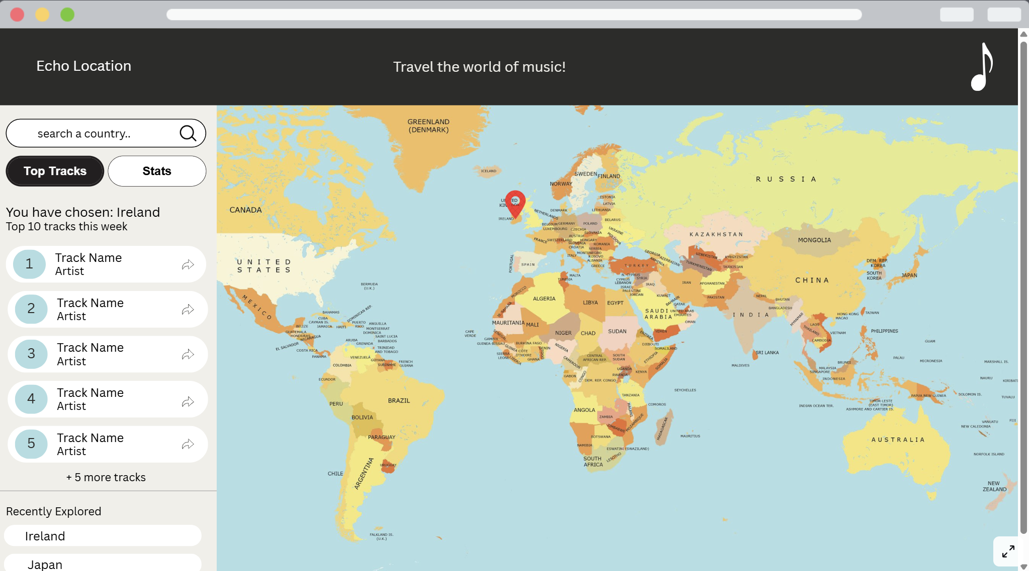

Was made using Canva, you can access the full-screen view of the wireframe on the following link

3. API
When user clicks on a map, the following sequence occurs: Leaflet returns the coordinates of the click, these are passed to the BigDataCloud reverse geocoding API to resolve the country name, and the country name is then passed to the Last.fm API to retrieve the top tracks.

a) Primary API - Last.fm
The primary data source for Echo-Location is the Last.fm API, a free music metadata service. The specific endpoint used is geo.getTopTracks, which returns the most-listened-to tracks in a given country over the past week. The endpoint requires no user authentication - only a free API key obtained from the Last.fm developer portal.

Endpoint used
GET https://ws.audioscrobbler.com/2.0/?method=geo.gettoptracks&country={country}&api_key={key}&format=json&limit=10

Postman testing
The endpoint was tested in Postman using Spain as a test country. The request returned a 200 OK status with a JSON response. The query parameters used were method (geo.gettoptracks), country (spain), api_key, and format (json). The response confirmed that the API returns real-time data with no additional authentication required beyond the API key.

Shape of the data
The response is structured as a JSON object with a top-level tracks key, containing a track array. Each object in the array includes the following fields:
- name - the title of the track (e.g. "Stateside + Zara Larsson")
- duration - track length in seconds (e.g. "176")
- listeners - number of listeners in the country for the past week (e.g. "5184")
- url - a direct link to the track page on Last.fm
- mbid - MusicBrainz identifier for the track
- artist.name - the name of the artist (e.g. "PinkPantheress")
- artist.url - link to the artist's Last.fm page
- image - an array of image objects at different sizes (small, medium, large, extralarge), each containing a #text field with the image URL
The application will display track name, artist name, and listener count in the sidebar for each result. The url field will be used to provide a direct link to Last.fm for users who wish to listen to or explore a track further. The image field will be used if track artwork is displayed.

Search functionality
The Last.fm geo.getTopTracks endpoint accepts a country name as a required parameter. This means search by country is supported natively - the Angular application passes the user's typed input directly as the country parameter in the API request. No additional search API is required. The search bar in the sidebar is therefore a direct interface to this parameter.

b) Supporting API - BigDataCloud Reverse Geocoding
When a user clicks on the map, Leaflet returns latitude and longitude coordinates. These coordinates cannot be passed directly to the Last.fm API, which requires a country name. To bridge this gap, the BigDataCloud Reverse Geocoding API is used. This free, no-authentication API accepts latitude and longitude values and returns a countryName field, which is then passed to the Last.fm API call.
GET https://api.bigdatacloud.net/data/reverse-geocode-client?latitude={lat}&longitude={lng}&localityLanguage=en

c) What will be saved to MongoDB?
Each time a user explores a country - either by clicking the map or using the search bar - a document is saved to a MongoDB collection via an Express server. Each document will store the following:
- country - the name of the country explored (e.g. "Spain")
- trackName - the number one track at the time of the visit (e.g. "Stateside + Zara Larsson")
- artist - the artist of the number one track (e.g. "PinkPantheress")
- listeners - the listener count for the top track
- exploredAt - a timestamp recording when the country was explored
This data powers the statistics panel in the sidebar. When a user returns to a previously explored country, the application retrieves the saved document from MongoDB and displays what the number one track was on the previous visit, alongside the current number one track. This allows the user to see at a glance how that country's music tastes have changed over time.
The Express server will expose the following REST endpoints to support this functionality: a POST route to save a new exploration record, a GET route to retrieve all previously explored countries, and a DELETE route to remove a record if required. This structure mirrors the Express and MongoDB setup used in the Week 9 and Week 10 labs.

