1)INTRODUCING BREADBOARD

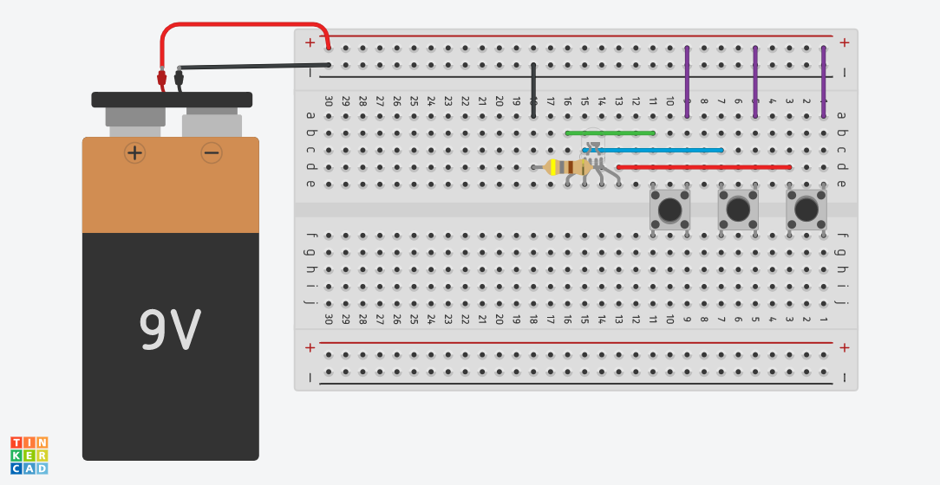

2)OHM’S LAW

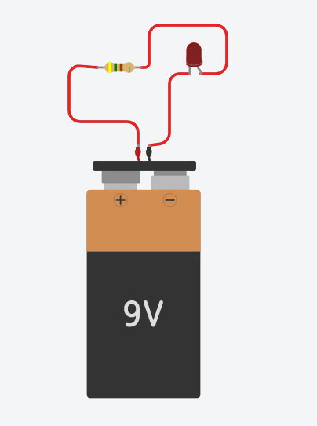

3) Ardunio - Blink a LED with Digital Output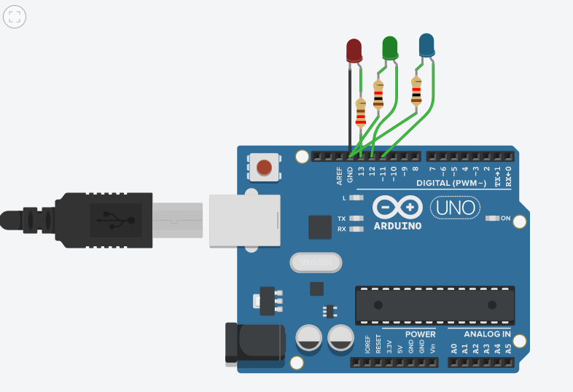

Code-

void setup()

{

pinMode(LED_BUILTIN, OUTPUT);

pinMode(LED_BUILTIN, OUTPUT);

pinMode(LED_BUILTIN, OUTPUT);

}

void loop()

{

// turn the LED on (HIGH is the voltage level)

digitalWrite(LED_BUILTIN, HIGH);

delay(100); // Wait for 1000 millisecond(s)

// turn the LED off by making the voltage LOW

digitalWrite(LED_BUILTIN, LOW);

delay(100);

digitalWrite(LED_BUILTIN, HIGH);

delay(100);

digitalWrite(LED_BUILTIN, LOW);

delay(100);

digitalWrite(LED_BUILTIN, HIGH);

delay(100);

digitalWrite(LED_BUILTIN, LOW);

delay(100);

}

4)  Digital Input and Analog Output

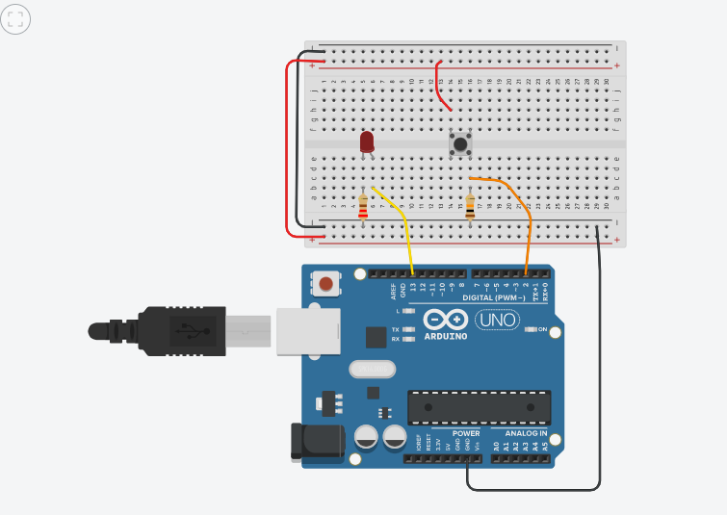

Code

int buttonstate = 0;

void setup()

{

pinMode(2, INPUT);

pinMode(LED_BUILTIN, OUTPUT);

}

void loop()

{

buttonstate = digitalRead(2);

if (buttonstate == HIGH) {

digitalWrite(LED_BUILTIN, HIGH);

}

delay(10); // Delay a little bit to improve simulation performance}

5)  Potentiometer

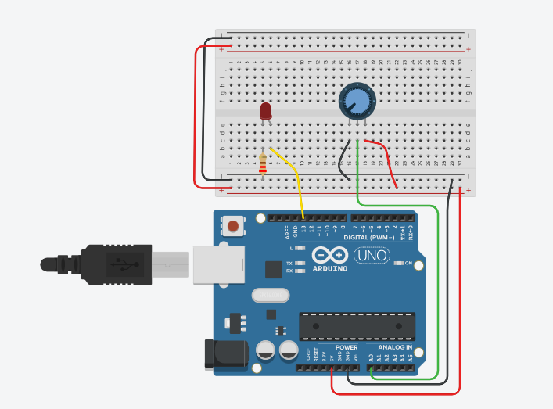

6)Ultrasonic sensor

