**NEURAL NETWORK PROJECT**

**- VIDEO 7/12 - Linear Regression**

**IMPORTANT FORMULAS:**

**SIGMOID, PERCEPTRON:**

sigmoid(m1 * w1+ m2 * w2 +b)

**BASIC CALCULUS**

Limits: lim f(x) x -> a

Derivatives: d f(x)

dx

Integrals

Power Rule

Linear Regression

Linear Regression Cost:

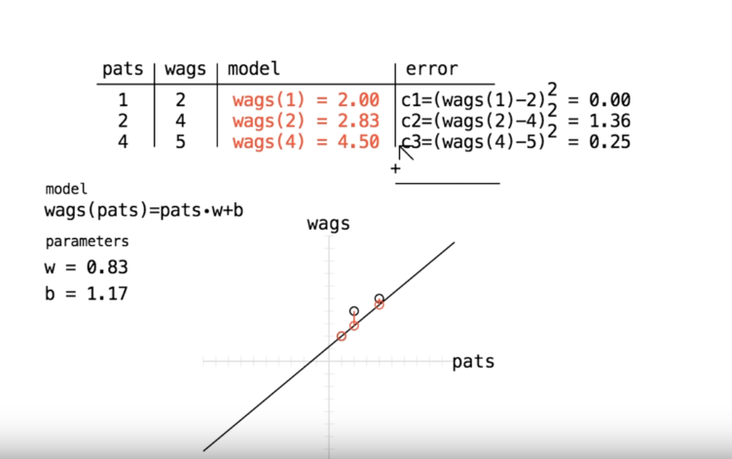

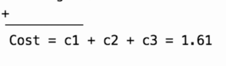

COST FUNCTION, NUMERICALLY SHOWN:

cost(b) = (b-4)^2

(simplified, without h) slope(b) = 2(b-4) (also derivative of cost(b))

(not simplified) slope(b) = cost(b+h) - cost(b)

h

~~- Installed numpy~~

~~- Installed Jupyter (weird error might wanna recheck if it works - command is 'jupyter notebook'~~

~~- RECONFIGURE ON LINUX~~