I have tried to understand the requirement and converted to coding language.

Below is the complete flow, code structure, test case after understanding SmartEquip docs.

## Code: [Shraban-oup/smartequip (github.com)](https://github.com/Shraban-oup/smartequip)

## Technology: Java 8, Spring boot annotation based, Spring REST, Junit and Mockito.

## Test Coverage:

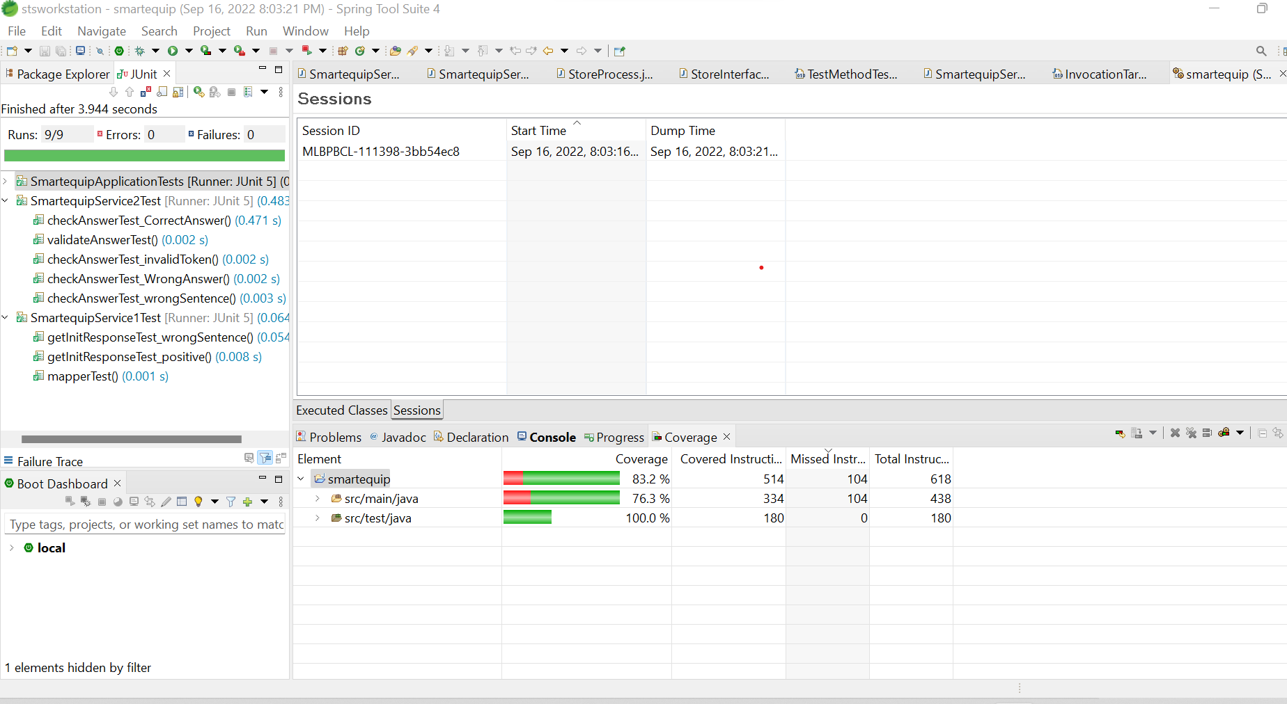

## Workflow:

* Application port has been moved to application. Properties.

If port need to change then simply 9090 to any port (ex. 8080)

server.port = 9090

* As per requirement There must be one API end point “/”. Which has been developed.
* Initial API details( 1st request):

Method: POST

URL: http://localhost:9090/

Header: bearer (It is optional token for 1st request; 2nd request onwards it required)

Body: Hey Service, can you provide me a question with numbers to add?

This is client request.

Once we got request, Application checking bearer token , as it is client 1st request so it is empty.

As per requirement Application sending this to Service 1 .

There we are validating that request Body contains "question with numbers to add?" or not.

1.NO: Response will back here. Not proceed anymore.

Response:

HttpStatus: 400 Bad Request.

Body: Please ask valid question or corrent the sentence please

2. YES: then Application will generate bearerToken and find random 3 number . Then Response will back to Client. And It will store in cache maintained by ConcurrentHashMap.

Response:

HttpStatus: 200 OK.

Body: Here you go, solve the question: "Please sum the numbers 23,44,57".

Header: bearer 1663339713079-6a2ac52d-341a-482a-ba70-e64bfc68afcc

* 2nd request i.e, Answer request.

Method: POST

URL: http://localhost:9090/

Header: bearer 1663339713079-6a2ac52d-341a-482a-ba70-e64bfc68afcc

Body: Great. The original question was “Please sum the numbers 23,44,57” and the answer is 65.

Once request receive first it will check header contain “bearer” or not.

1. If not , it will consider as new request and Initial API details( 1st request) continue.( above discussed)
2. If Yes. It will call to Service 2.

First it will check token exits or not in Cache.

If No: return response to user:

Response:

HttpStatus: 400 Bad Request.

Body: "Invalid token"

If Yes: Application will check request body contains “Please sum the numbers 23,44,57” and "the answer is" sentence or not.

If No then:

Response:

HttpStatus: 400 Bad Request.

Body: "That’s wrong. Please try again. Expected format as an example: "The original question was “Please sum the numbers 9,5,3” and the answer is 17"";

If Yes: proceed further and validate the answer 65 with Cache answer which is 65.

If Matching:

No:

Response:

HttpStatus: 200 OK.

Body: "That’s wrong. Please try again."

Yes:

Response:

HttpStatus: 200 OK.

Body: "That’s great"

## Executable jar file run:

Run below command:

java -jar smartequip.jar

If port need to change then run below command:

java -Dserver.port=8080 -jar smartequip.jar