WEEK 1 TASK
DATA CLEANING AND PRELIMINARY ANALYSIS WITH R
Dataset: Titanic – Machine Learning from Disaster

Course / Program: Virtual R Data Analyst
Student Name: Shraddha Pavashe

1. Executive Summary
This project demonstrates a complete data-cleaning and preliminary exploratory-analysis workflow in R using the Titanic passenger dataset. The analysis covers dataset inspection, missing-value assessment, imputation, outlier detection, feature transformation, normalization, categorical encoding, descriptive statistics, correlation analysis, and visual exploration.
The dataset contains 891 passenger records and 12 variables. It includes numerical variables such as age and fare and categorical variables such as sex, passenger class, and embarkation port. Missing values are present in Age, Cabin, and Embarked, making it appropriate for the assignment requirements.
Key findings from the preliminary analysis are that the overall survival rate is 38.38%, female passengers had a survival rate of 74.20%, while male passengers had a survival rate of 18.89%. First-class passengers had a survival rate of 62.96%, compared with 24.24% for third-class passengers.

2. Dataset Selection and Source
The Titanic dataset was selected because it contains a useful mixture of numerical and categorical variables and naturally occurring missing values. The Kaggle Titanic competition provides 891 training records with the survival outcome available for analysis. The variables include passenger class, sex, age, family-related counts, fare, cabin and embarkation port.
Source: Kaggle Titanic – Machine Learning from Disaster. A public CSV mirror was used to prepare the working file. The original dataset documentation identifies train.csv as the 891-row training set.
Reference: Kaggle Titanic dataset documentation (https://www.kaggle.com/competitions/titanic/overview).

3. Dataset Overview
Item | Value
Rows | 891
Columns | 12
Numerical variables | 7 (including binary/integer fields)
Categorical variables | 5
Target variable | Survived
Missing-value columns | Age, Cabin, Embarked

The target variable Survived is binary: 0 indicates that the passenger did not survive and 1 indicates survival. PassengerId is an identifier and is not treated as a predictive numerical measurement.

4. Variable Description
Variable | Role | Type | Description
PassengerId | Identifier | Numeric | Unique passenger identifier
Survived | Target | Binary | 0 = No, 1 = Yes
Pclass | Feature | Categorical/ordinal | Passenger class: 1, 2, 3
Name | Feature | Text | Passenger name
Sex | Feature | Categorical | Male / Female
Age | Feature | Numeric | Age in years
SibSp | Feature | Numeric | Siblings/spouses aboard
Parch | Feature | Numeric | Parents/children aboard
Ticket | Feature | Text | Ticket identifier
Fare | Feature | Numeric | Passenger fare
Cabin | Feature | Categorical/text | Cabin number; highly incomplete
Embarked | Feature | Categorical | Port C, Q or S

5. Initial Data Inspection in R
The first stage is to understand dimensions, data types, and basic distributions before changing any values.
titanic <- read.csv("titanic_train.csv", stringsAsFactors = FALSE)
str(titanic)
summary(titanic)
dim(titanic)
Expected dimensional output:
891 rows × 12 columns
The str() function is important because it confirms which variables are numeric, character, or suitable for conversion to factors.

6. Missing-Value Analysis
Missing values were quantified before imputation. This prevents arbitrary cleaning and provides evidence for why each treatment was selected.
Variable | Missing Count | Missing %
PassengerId | 0 | 0.0
Survived | 0 | 0.0
Pclass | 0 | 0.0
Name | 0 | 0.0
Sex | 0 | 0.0
Age | 177 | 19.87
SibSp | 0 | 0.0
Parch | 0 | 0.0
Ticket | 0 | 0.0
Fare | 0 | 0.0
Cabin | 687 | 77.1
Embarked | 2 | 0.22
Age has 177 missing observations (19.87%), Cabin has 687 missing observations (77.10%), and Embarked has 2 missing observations (0.22%). Cabin is too incomplete for direct imputation in this preliminary analysis, so it is removed. Age is imputed with the median, which is robust to skew and outliers. Embarked is imputed with its most frequent category, S.
age_median <- median(titanic$age, na.rm = TRUE)
titanic$age[is.na(titanic$age)] <- age_median
mode_embarked <- names(sort(table(titanic$embarked), decreasing = TRUE))[1]
titanic$embarked[is.na(titanic$embarked)] <- mode_embarked
titanic$cabin <- NULL

7. Data Cleaning and Transformation

7.1 Age Imputation
The median Age before imputation is 28 years. Median imputation avoids losing 177 passenger records and is less affected by extreme ages than mean imputation.

7.2 Embarked Imputation
The mode of Embarked is S. Only two observations are missing, so replacing them with the mode has minimal impact on the dataset.

7.3 Cabin Treatment
Cabin is removed because 687 of 891 observations are missing. In a more advanced project, the cabin value could be transformed into a deck-level feature before deciding whether to retain it.

7.4 Feature Engineering
FamilySize was created as SibSp + Parch + 1. IsAlone was then created to identify passengers travelling without family members in the dataset.
titanic <- titanic %>%
mutate(
family_size = sib_sp + parch + 1,
is_alone = if_else(family_size == 1, "Yes", "No")
)

8. Outlier Detection
Outliers were assessed using the IQR rule. Observations below Q1 − 1.5×IQR or above Q3 + 1.5×IQR are flagged. The purpose at this stage is detection rather than automatic deletion because high fares can represent genuine first-class purchases rather than data errors.
Variable | Q1 | Q3 | IQR | Lower Bound | Upper Bound | Outliers
Age | 20.125 | 38.0 | 17.875 | -6.688 | 64.812 | 11
Fare | 7.91 | 31.0 | 23.09 | -26.724 | 65.634 | 116

The analysis identifies 116 Fare observations outside the IQR limits. For Age, the original missing values are excluded from the outlier calculation; 11 observed ages are flagged by the rule. These values are retained because they are plausible passenger ages/fares and there is no evidence that they are data-entry errors.
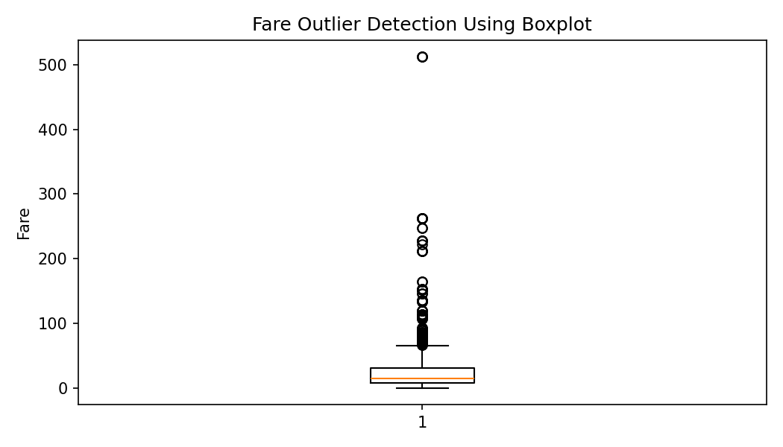
Figure 1. Fare boxplot used for outlier detection.

9. Normalization / Standardization
Age and Fare have very different scales. Standardization converts each variable into a z-score with approximately mean 0 and standard deviation 1. This is useful when numerical variables are later used in distance-based or regularized models.
titanic <- titanic %>%
mutate(
age_z = as.numeric(scale(age)),
fare_z = as.numeric(scale(fare))
)
Normalization is applied after missing-value treatment so that the mean and standard deviation are calculated from a complete Age variable.

10. Encoding Categorical Variables
R factors are used for categorical analysis. For model-ready data, model.matrix() converts categorical variables into indicator/dummy variables. This preserves category information in numerical form.
titanic$sex <- factor(titanic$sex)
titanic$embarked <- factor(titanic$embarked)
titanic$is_alone <- factor(titanic$is_alone)
encoded_data <- model.matrix(
~ sex + embarked + is_alone + pclass - 1,
data = titanic
)
encoded_data <- as.data.frame(encoded_data)

11. Exploratory Data Analysis

11.1 Descriptive Statistics
Variable | count | mean | std | min | 25% | 50% | 75% | max
Survived | 891.0 | 0.384 | 0.487 | 0.0 | 0.0 | 0.0 | 1.0 | 1.0
Pclass | 891.0 | 2.309 | 0.836 | 1.0 | 2.0 | 3.0 | 3.0 | 3.0
Age | 714.0 | 29.699 | 14.526 | 0.42 | 20.125 | 28.0 | 38.0 | 80.0
SibSp | 891.0 | 0.523 | 1.103 | 0.0 | 0.0 | 0.0 | 1.0 | 8.0
Parch | 891.0 | 0.382 | 0.806 | 0.0 | 0.0 | 0.0 | 0.0 | 6.0
Fare | 891.0 | 32.204 | 49.693 | 0.0 | 7.91 | 14.454 | 31.0 | 512.329

The average passenger age among observed ages is 29.70 years and the average fare is 32.20. The survival proportion is 38.38%.

11.2 Survival Distribution
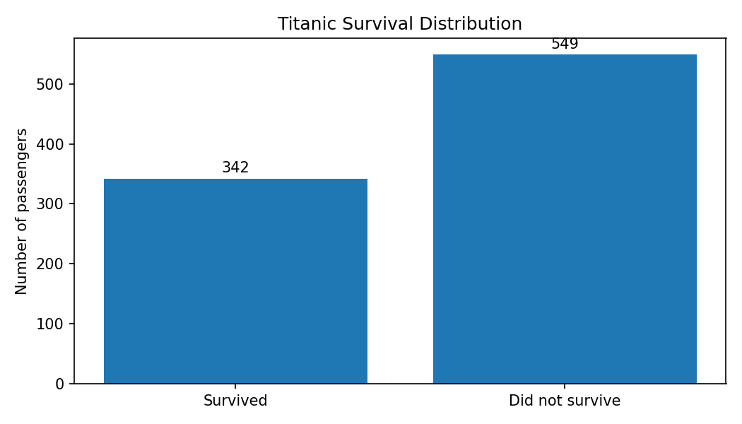
Figure 2. Overall survival distribution.
There were 342 survivors and 549 non-survivors.

11.3 Survival by Gender
Gender | Value | 1
female | 25.8 | 74.2
male | 81.10000000000001 | 18.9
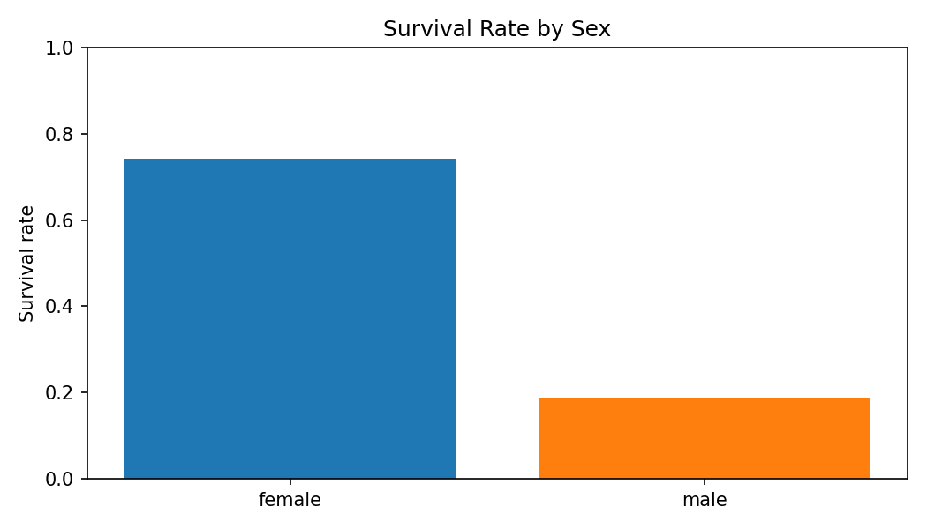
Figure 3. Survival rate comparison by gender.
Female survival was 74.20% compared with 18.89% for males. This is a strong descriptive association, although it should not be interpreted as a causal effect.

11.4 Survival by Passenger Class
Pclass | Did not survive (%) | Survived (%)
1.0 | 37.0 | 63.0
2.0 | 52.7 | 47.3
3.0 | 75.8 | 24.2

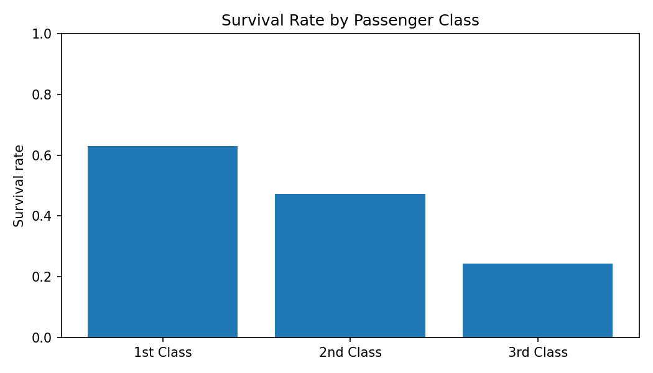
Figure 4. Survival rate by passenger class.
Survival was 62.96% in first class, 47.28% in second class, and 24.24% in third class.

11.5 Age Distribution
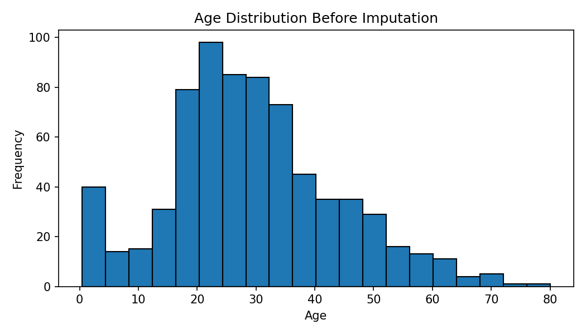
Figure 5. Age distribution before imputation.

11.6 Correlation Analysis
Variable | Survived | Pclass | Age | SibSp | Parch | Fare
Survived | 1.0 | -0.338 | -0.077 | -0.035 | 0.082 | 0.257
Pclass | -0.338 | 1.0 | -0.369 | 0.083 | 0.018 | -0.549
Age | -0.077 | -0.369 | 1.0 | -0.308 | -0.189 | 0.096
SibSp | -0.035 | 0.083 | -0.308 | 1.0 | 0.415 | 0.16
Parch | 0.082 | 0.018 | -0.189 | 0.415 | 1.0 | 0.216
Fare | 0.257 | -0.549 | 0.096 | 0.16 | 0.216 | 1.0

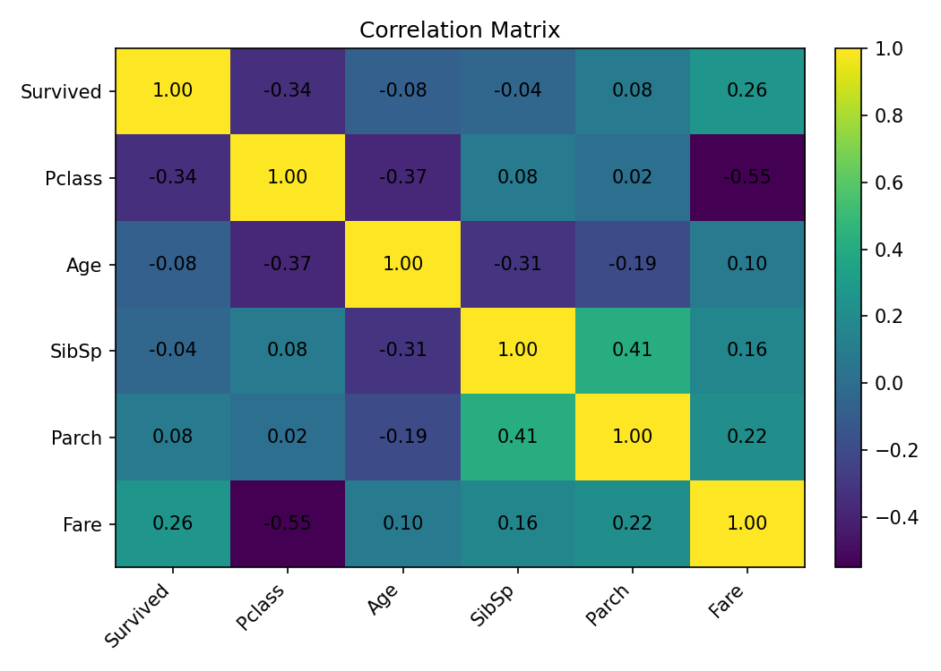
Figure 6. Correlation matrix for selected numerical variables.
The correlation between Pclass and Survived is approximately -0.338, indicating that higher numeric class values (third class) are associated with lower survival. Fare and Survived show a positive correlation of about 0.257. Correlation describes association and does not establish causation.

12. R Code for Exploratory Visualizations
ggplot(titanic, aes(x = survived)) +
geom_bar() +
labs(title = "Titanic Survival Distribution",
x = "Survived", y = "Number of Passengers")
ggplot(titanic, aes(x = sex, fill = survived)) +
geom_bar(position = "fill") +
scale_y_continuous(labels = percent)
ggplot(titanic, aes(x = pclass, fill = survived)) +
geom_bar(position = "fill") +
scale_y_continuous(labels = percent)
ggplot(titanic, aes(x = age)) +
geom_histogram(bins = 20, color = "black")
ggplot(titanic, aes(y = fare)) +
geom_boxplot()

13. Initial Insights
- The dataset contains substantial missingness in Cabin, moderate missingness in Age, and minimal missingness in Embarked.
- Median imputation is suitable for Age in this preliminary workflow because it limits the influence of skew and extreme values.
- Cabin was removed because more than three quarters of its values are missing; a future project could extract deck information before dropping it.
- Fare contains a noticeable number of IQR-based outliers. These were retained because they may represent genuine high-value fares.
- Female passengers show a much higher descriptive survival rate than male passengers.
- First-class passengers show a higher descriptive survival rate than second- and third-class passengers.
- Pclass and Fare have a moderate negative correlation, reflecting that higher passenger-class numbers correspond to lower classes and generally lower fares.
- Standardized Age and Fare variables are ready for later modeling workflows.

14. Data Quality Decisions and Rationale
Issue | Action | Rationale
Missing Age | Median imputation | Preserves records; robust to skew/outliers
Missing Embarked | Mode imputation | Only two missing values; categorical variable
Cabin | Dropped | 77.10% missing; direct imputation would add substantial uncertainty
Fare outliers | Detected and retained | Potentially genuine high fares; no evidence of data-entry error
Age outliers | Detected and retained | Plausible passenger ages; no clear data error
Categorical variables | Factors + dummy encoding | Required for statistical/modeling workflows
Age and Fare | Z-score standardization | Places numerical variables on comparable scale

15. Reproducibility and Output Files
The analysis is reproducible using the supplied R script. Place titanic_train.csv and week1_titanic_analysis.R in the same working directory and run the script in RStudio.
- titanic_train.csv
- titanic_cleaned_encoded.csv
- week1_titanic_analysis.R

16. Conclusion
This project completed the required Week 1 data-cleaning and preliminary-analysis workflow. The Titanic dataset was inspected, missing values were quantified and treated, outliers were detected using the IQR method, new features were created, numerical variables were standardized, and categorical variables were encoded. Exploratory analysis using summary statistics, cross-tabulations, correlation analysis, and visualizations identified clear descriptive relationships between survival, sex, passenger class, and fare.
The cleaned dataset is suitable for the next stage of analysis, such as predictive modeling, feature selection, or deeper statistical investigation. The decisions made in this report are documented so that they can be reviewed and modified in later project stages.

17. Appendix A – Complete R Script
# Week 1: Data Cleaning and Preliminary Analysis with R
# Dataset: Titanic train.csv (891 rows, 12 columns)
# Source: Kaggle Titanic competition / public mirror
# Required packages: tidyverse, janitor, scales
library(tidyverse)
library(janitor)
library(scales)
# 1. Import data
titanic <- read.csv("titanic_train.csv", stringsAsFactors = FALSE)
titanic <- clean_names(titanic)
# 2. Inspect structure and summary
str(titanic)
summary(titanic)
dim(titanic)
# 3. Missing-value audit
missing_summary <- data.frame(
variable = names(titanic),
missing_count = sapply(titanic, function(x) sum(is.na(x))),
missing_percent = round(sapply(titanic, function(x) mean(is.na(x))*100), 2)
)
missing_summary
# 4. Data cleaning
# Age: median imputation because Age is numeric and contains 177 missing values
age_median <- median(titanic$age, na.rm = TRUE)
titanic$age[is.na(titanic$age)] <- age_median
# Embarked: mode imputation because only two values are missing
mode_embarked <- names(sort(table(titanic$embarked), decreasing = TRUE))[1]
titanic$embarked[is.na(titanic$embarked)] <- mode_embarked
# Cabin has 687 missing values (77.10%); remove it for this preliminary analysis
titanic$cabin <- NULL
# 5. Feature transformation
titanic <- titanic %>%
mutate(
family_size = sib_sp + parch + 1,
is_alone = if_else(family_size == 1, "Yes", "No"),
sex = factor(sex),
embarked = factor(embarked),
pclass = factor(pclass),
survived = factor(survived, levels = c(0,1),
labels = c("No","Yes"))
)
# 6. Outlier detection using IQR
fare_q1 <- quantile(titanic$fare, 0.25)
fare_q3 <- quantile(titanic$fare, 0.75)
fare_iqr <- fare_q3 - fare_q1
fare_low <- fare_q1 - 1.5 * fare_iqr
fare_high <- fare_q3 + 1.5 * fare_iqr
fare_outliers <- titanic %>%
filter(fare < fare_low | fare > fare_high)
nrow(fare_outliers)
age_q1 <- quantile(titanic$age, 0.25)
age_q3 <- quantile(titanic$age, 0.75)
age_iqr <- age_q3 - age_q1
age_low <- age_q1 - 1.5 * age_iqr
age_high <- age_q3 + 1.5 * age_iqr
age_outliers <- titanic %>%
filter(age < age_low | age > age_high)
nrow(age_outliers)
# 7. Normalization / standardization
titanic <- titanic %>%
mutate(
age_z = as.numeric(scale(age)),
fare_z = as.numeric(scale(fare))
)
# 8. Categorical encoding
# model.matrix creates dummy/indicator variables
encoded_data <- model.matrix(~ sex + embarked + is_alone + pclass - 1, data = titanic)
encoded_data <- as.data.frame(encoded_data)
# 9. Exploratory analysis
summary(titanic)
table(titanic$sex, titanic$survived)
prop.table(table(titanic$sex, titanic$survived), 1)
table(titanic$pclass, titanic$survived)
prop.table(table(titanic$pclass, titanic$survived), 1)
# 10. Correlation of numerical variables
numeric_data <- titanic %>%
transmute(
survived_numeric = as.numeric(survived) - 1,
pclass_numeric = as.numeric(as.character(pclass)),
age, sib_sp, parch, fare
)
cor(numeric_data, use = "complete.obs")
# 11. Visualizations
ggplot(titanic, aes(x = survived)) +
geom_bar() +
labs(title = "Titanic Survival Distribution",
x = "Survived", y = "Number of Passengers")
ggplot(titanic, aes(x = sex, fill = survived)) +
geom_bar(position = "fill") +
scale_y_continuous(labels = percent) +
labs(title = "Survival Proportion by Sex",
x = "Sex", y = "Proportion")
ggplot(titanic, aes(x = pclass, fill = survived)) +
geom_bar(position = "fill") +
scale_y_continuous(labels = percent) +
labs(title = "Survival Proportion by Passenger Class",
x = "Passenger Class", y = "Proportion")
ggplot(titanic, aes(x = age)) +
geom_histogram(bins = 20, color = "black") +
labs(title = "Age Distribution After Imputation",
x = "Age", y = "Frequency")
ggplot(titanic, aes(y = fare)) +
geom_boxplot() +
labs(title = "Fare Outlier Detection",
y = "Fare")
# 12. Export cleaned data
write.csv(titanic, "titanic_cleaned.csv", row.names = FALSE)
write.csv(encoded_data, "titanic_encoded_variables.csv", row.names = FALSE)

18. References
Kaggle. Titanic – Machine Learning from Disaster. Dataset and data dictionary. https://www.kaggle.com/competitions/titanic/overview
GitHub public mirror used for the working CSV: dsindy/kaggle-titanic, train.csv.
Note: The working CSV included with this submission contains the standard 891-row Titanic training dataset.

