**Name** : Shraddha Rajkumar Kotwar

**Class**: TE(B)

**Roll no:** 18

**Batch:** T1

**ASSIGNMENT 2 a**

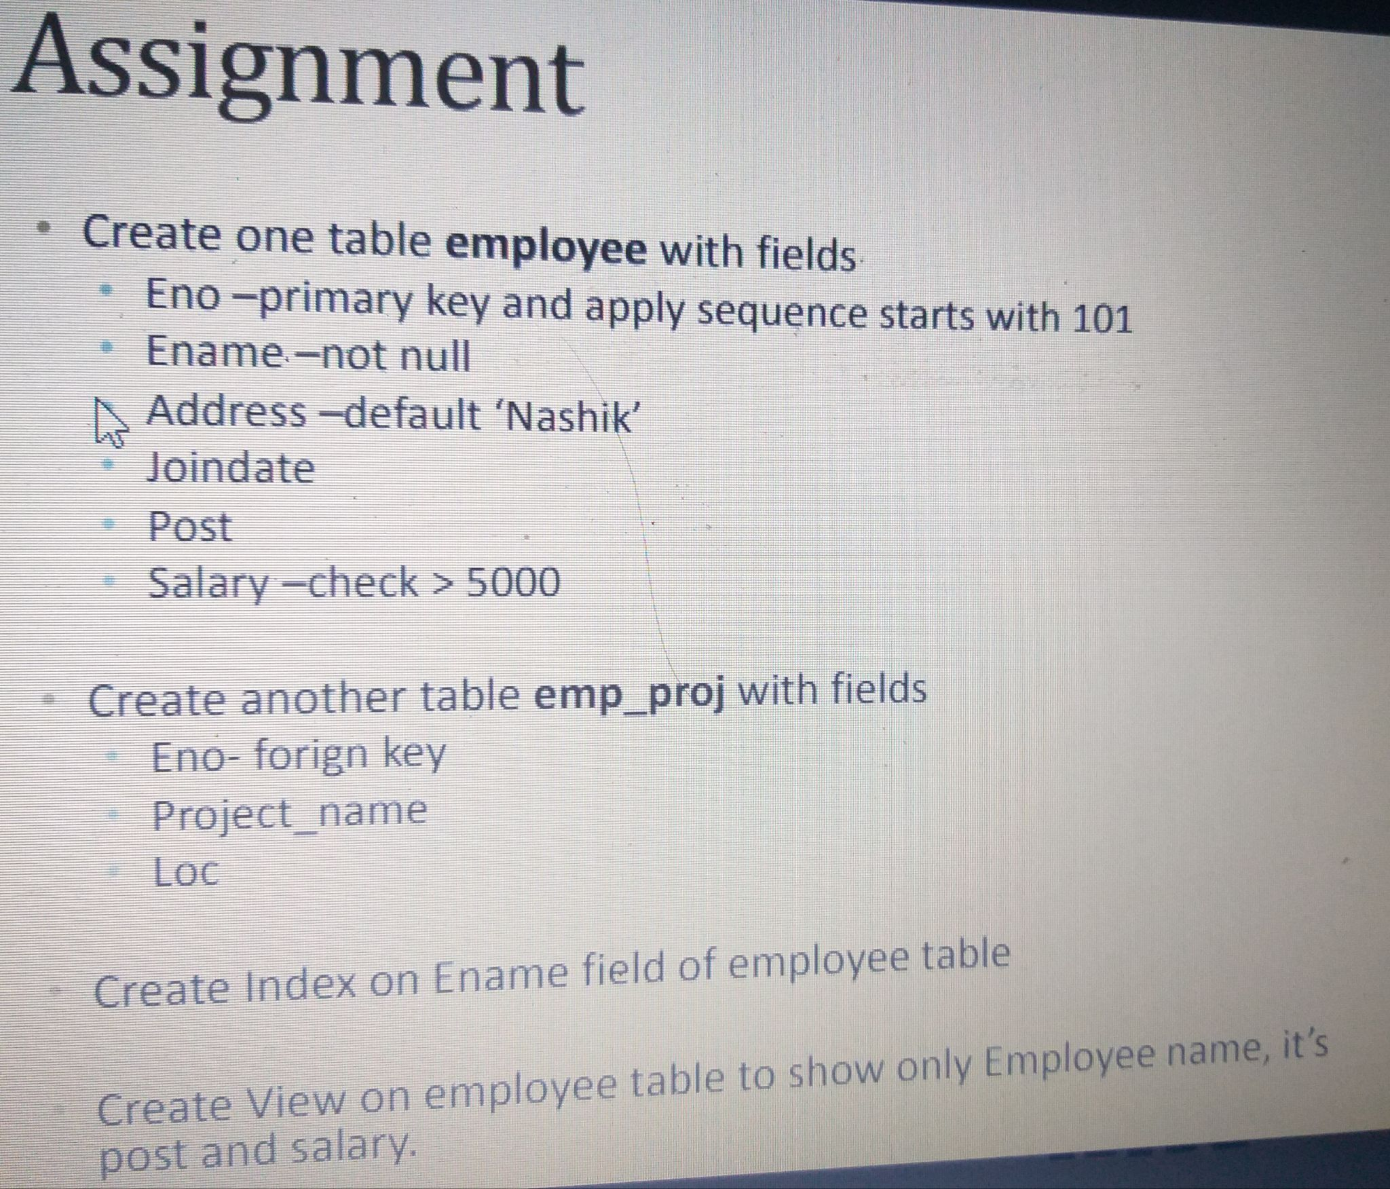

* mysql> create table employee(

Eno int primary key auto_increment,

Ename varchar(12) not null,

Address varchar(20) default "Nashik",

Joindate varchar(12),

Post varchar(20),

salary int,

check(salary>5000))auto_increment=101;

Query OK, 0 rows affected (0.21 sec)

mysql> insert into employee(Ename,Joindate,Post,salary) values ("shraddha","8aug","project_manager",7000);

Query OK, 1 row affected (0.09 sec)

mysql> select *from employee;

+-----+----------+---------+----------+-----------------+--------+

| Eno | Ename | Address | Joindate | Post | salary |

+-----+----------+---------+----------+-----------------+--------+

| 101 | shraddha | Nashik | 8aug | project_manager | 7000 |

+-----+----------+---------+----------+-----------------+--------+

1 row in set (0.00 sec)

mysql> insert into employee(Ename,Address,Joindate,Post,salary) values ("kavita","chandwad","7aug","programmer",8000);

Query OK, 1 row affected (0.07 sec)

mysql> select *from employee;

+-----+----------+----------+----------+-----------------+--------+

| Eno | Ename | Address | Joindate | Post | salary |

+-----+----------+----------+----------+-----------------+--------+

| 101 | shraddha | Nashik | 8aug | project_manager | 7000 |

| 102 | kavita | chandwad | 7aug | programmer | 8000 |

+-----+----------+----------+----------+-----------------+--------+

2 rows in set (0.00 sec)

* mysql> create table emp_project(Eno int reference employee(Eno),

project_name varchar(12),

loc int);

Query OK, 0 rows affected (0.48 sec)

mysql> desc emp_project;

+--------------+-------------+------+-----+---------+-------+

| Field | Type | Null | Key | Default | Extra |

+--------------+-------------+------+-----+---------+-------+

| Eno | int | YES | | NULL | |

| project_name | varchar(12) | YES | | NULL | |

| loc | int | YES | | NULL | |

+--------------+-------------+------+-----+---------+-------+

3 rows in set (0.10 sec)

* mysql> create index i1 on employee(Ename);

Query OK, 0 rows affected (0.49 sec)

Records: 0 Duplicates: 0 Warnings: 0

mysql> show index from employee;

+----------+------------+----------+--------------+-------------+-----------+-------------+----------+--------+------+------------+---------+---------------+---------+------------+

| Table | Non_unique | Key_name | Seq_in_index | Column_name | Collation | Cardinality | Sub_part | Packed | Null | Index_type | Comment | Index_comment | Visible | Expression |

+----------+------------+----------+--------------+-------------+-----------+-------------+----------+--------+------+------------+---------+---------------+---------+------------+

| employee | 0 | PRIMARY | 1 | Eno | A | 2 | NULL | NULL | | BTREE | | | YES | NULL |

| employee | 1 | i1 | 1 | Ename | A | 2 | NULL | NULL | | BTREE | | | YES | NULL |

+----------+------------+----------+--------------+-------------+-----------+-------------+----------+--------+------+------------+---------+---------------+---------+------------+

2 rows in set (0.02 sec)

* mysql> create view v1 as select Ename,Post,salary from employee;

Query OK, 0 rows affected (0.07 sec)

mysql> select *from v1;

+----------+-----------------+--------+

| Ename | Post | salary |

+----------+-----------------+--------+

| shraddha | project_manager | 7000 |

| kavita | programmer | 8000 |

+----------+-----------------+--------+

2 rows in set (0.00 sec)