**Name :** Shraddha Rajkumar Kotwar

**Class :** TE-Comp-B

**Roll no:** 18

**Batch:** T1

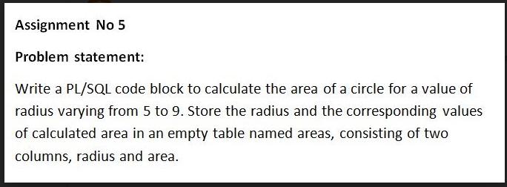

mysql> use dbms;

Database changed

mysql> create table C_Area(radius int,area float);

Query OK, 0 rows affected (0.04 sec)

mysql> desc C_Area;

+--------+-------+------+-----+---------+-------+

| Field | Type | Null | Key | Default | Extra |

+--------+-------+------+-----+---------+-------+

| radius | int | YES | | NULL | |

| area | float | YES | | NULL | |

+--------+-------+------+-----+---------+-------+

2 rows in set (0.01 sec)

mysql> delimiter //

mysql> create function CArea() returns float

-> deterministic

-> begin

-> declare r int;

-> declare area float;

-> declare pi float default 3.14;

-> set r=5;

-> while r<=9 do

-> set area=pi*r*r;

-> insert into C_Area(radius,area) values(r,area);

-> set r=r+1;

-> end while;

-> return area;

-> end

-> //

Query OK, 0 rows affected (0.01 sec)

mysql> select * from C_Area //

+--------+--------+

| radius | area |

+--------+--------+

| 5 | 78.5 |

| 6 | 113.04 |

| 7 | 153.86 |

| 8 | 200.96 |

| 9 | 254.34 |

+--------+--------+

5 rows in set (0.00 sec)