**Name:** Shraddha Rajkumar Kotwar

**Class:** TE-Comp-B

**Roll No:** 18

**Batch:** T1

**Assignment No. 8**

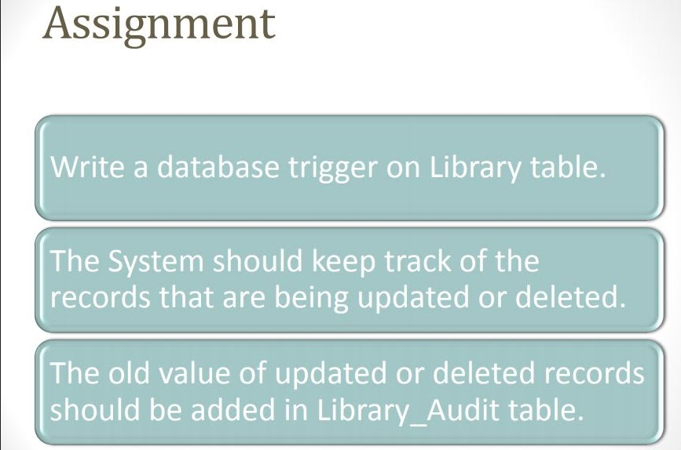

mysql> use dbms;

Database changed

mysql> create table library(id int,Bookname varchar(20),price int);

Query OK, 0 rows affected (0.03 sec)

mysql> insert into library values(1,"DBMS",300),(2,"CN",400),(3,"DSA",700);

Query OK, 3 rows affected (0.01 sec)

Records: 3 Duplicates: 0 Warnings: 0

mysql> select * from library;

+------+----------+-------+

| id | Bookname | price |

+------+----------+-------+

| 1 | DBMS | 300 |

| 2 | CN | 400 |

| 3 | DSA | 700 |

+------+----------+-------+

3 rows in set (0.00 sec)

mysql> create table library_audit(id int,Bookname varchar(20),dt datetime,price int,NameofOperation varchar(20));

Query OK, 0 rows affected (0.03 sec)

mysql> desc library_audit;

+-----------------+-------------+------+-----+---------+-------+

| Field | Type | Null | Key | Default | Extra |

+-----------------+-------------+------+-----+---------+-------+

| id | int | YES | | NULL | |

| Bookname | varchar(20) | YES | | NULL | |

| dt | datetime | YES | | NULL | |

| price | int | YES | | NULL | |

| NameofOperation | varchar(20) | YES | | NULL | |

+-----------------+-------------+------+-----+---------+-------+

5 rows in set (0.00 sec)

**—------------ Trigger for after update operation—----------**

mysql> delimiter //

mysql> create trigger t1 after update on library for each row

-> begin

-> insert into library_audit values(old.id,old.Bookname,now(),new.price,"Update");

-> end;

-> //

Query OK, 0 rows affected (0.02 sec)

mysql> update library set price=400 where id=1 //

Query OK, 1 row affected (0.01 sec)

Rows matched: 1 Changed: 1 Warnings: 0

mysql> select * from library;

-> //

+------+----------+-------+

| id | Bookname | price |

+------+----------+-------+

| 1 | DBMS | 400 |

| 2 | CN | 400 |

| 3 | DSA | 700 |

+------+----------+-------+

3 rows in set (0.00 sec)

mysql> select * from library_audit//

+------+----------+---------------------+-------+-----------------+

| id | Bookname | dt | price | NameofOperation |

+------+----------+---------------------+-------+-----------------+

| 1 | DBMS | 2023-09-27 21:01:52 | 400 | Update |

+------+----------+---------------------+-------+-----------------+

1 row in set (0.00 sec)

**—------------ Trigger for after insert operation—----------**

mysql> create trigger t2 after insert on library for each row

-> begin

-> insert into library_audit values(new.id,new.Bookname,now(),new.price,"Insert");

-> end;

-> //

Query OK, 0 rows affected (0.01 sec)

mysql> insert into library values (4,"TOC", 450) //

Query OK, 1 row affected (0.01 sec)

mysql> select * from library//

+------+----------+-------+

| id | Bookname | price |

+------+----------+-------+

| 1 | DBMS | 400 |

| 2 | CN | 400 |

| 3 | DSA | 700 |

| 4 | TOC | 450 |

+------+----------+-------+

4 rows in set (0.00 sec)

mysql> select * from library_audit //

+------+----------+---------------------+-------+-----------------+

| id | Bookname | dt | price | NameofOperation |

+------+----------+---------------------+-------+-----------------+

| 1 | DBMS | 2023-09-27 21:01:52 | 400 | Update |

| 4 | TOC | 2023-09-27 21:05:32 | 450 | Insert |

+------+----------+---------------------+-------+-----------------+

2 rows in set (0.00 sec)

**—------------ Trigger for after delete operation—----------**

mysql> create trigger t3 after delete on library for each row

-> begin

-> insert into library_audit values(old.id,old.Bookname,now(),old.price,"Delete");

-> end;

-> //

Query OK, 0 rows affected (0.01 sec)

mysql> delete from library where id=2//

Query OK, 1 row affected (0.01 sec)

mysql> select * from library//

+------+----------+-------+

| id | Bookname | price |

+------+----------+-------+

| 1 | DBMS | 400 |

| 3 | DSA | 700 |

| 4 | TOC | 450 |

+------+----------+-------+

3 rows in set (0.00 sec)

mysql> select * from library_audit//

+------+----------+---------------------+-------+-----------------+

| id | Bookname | dt | price| NameofOperation |

+------+----------+---------------------+-------+-----------------+

| 1 | DBMS | 2023-09-27 21:01:52 | 400 | Update |

| 4 | TOC | 2023-09-27 21:05:32 | 450 | Insert |

| 2 | CN | 2023-09-27 21:07:51 | 400 | Delete |

+------+----------+---------------------+-------+-----------------+

3 rows in set (0.00 sec)

mysql>