**Name :** Shraddha Rajkumar Kotwar

**Class :** TE ( COMP ) - B

**Roll No.:** 18

**Assignment 8:**

Install and Configure Google App Engine and Implement Binary Search using cpp.

**Step 1:** Open your Github Account and create a new repository and add a new file with name searchbin.cpp

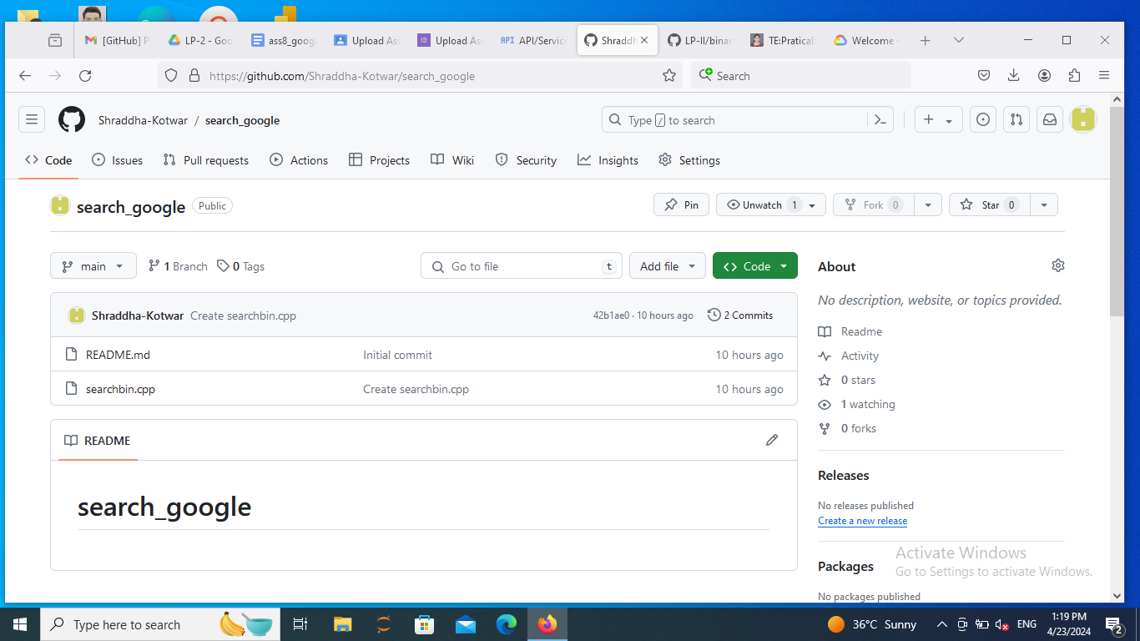

**Step 2:** Open the file and type your binary search code

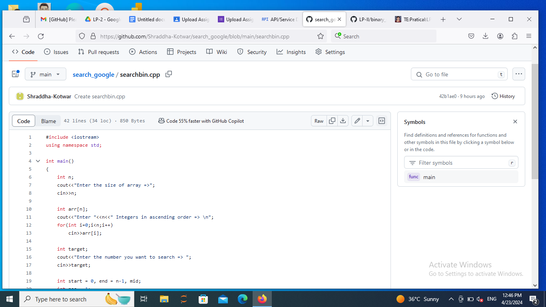

**Step 3:** Go to the code section and copy the HTTP path.

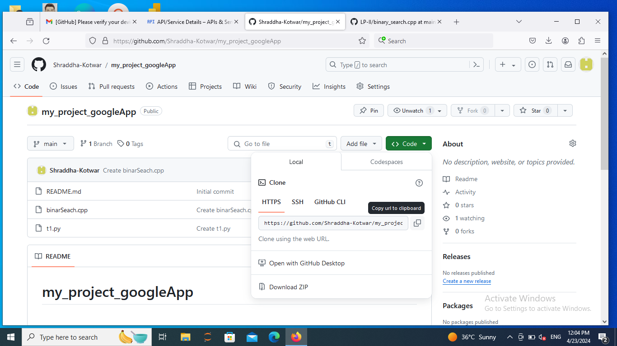

**Step 4:** Go to google and type console google cloud . Click on google cloud console and sign in with your google account.

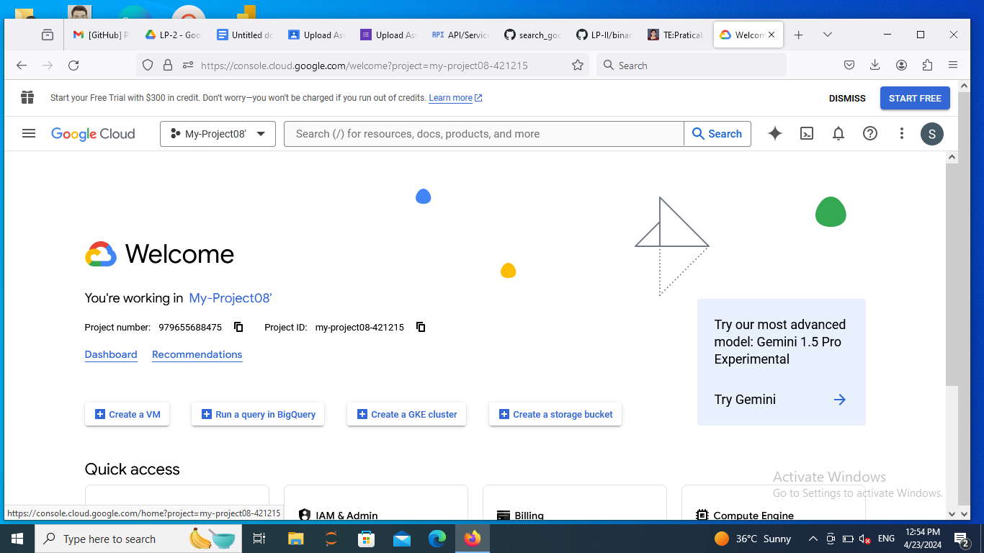

**Step 5:** Go to Overview -> Dashboard from the left navigation menu.

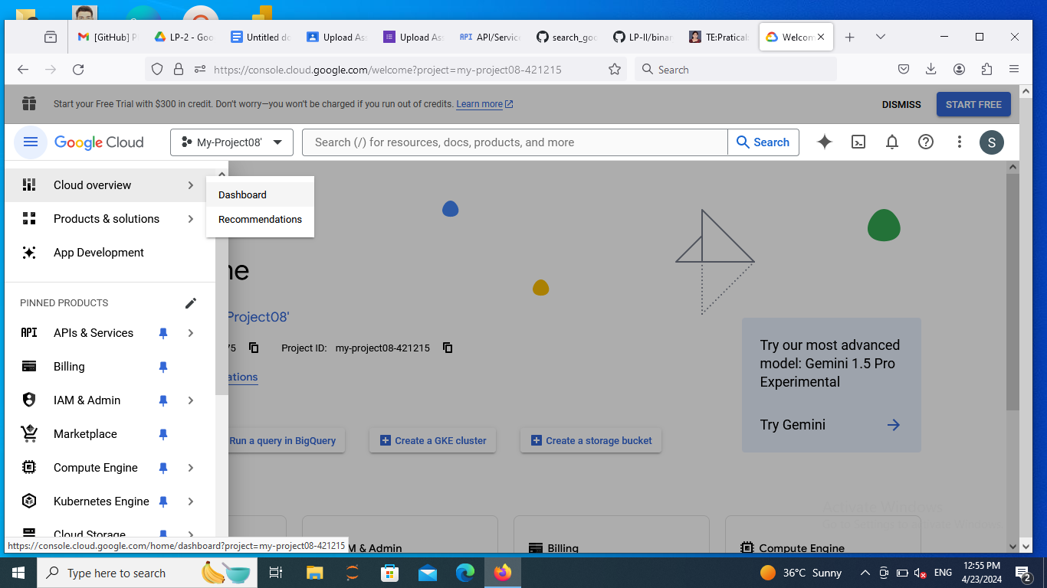

**Step 6:** Go to my_project and create new project

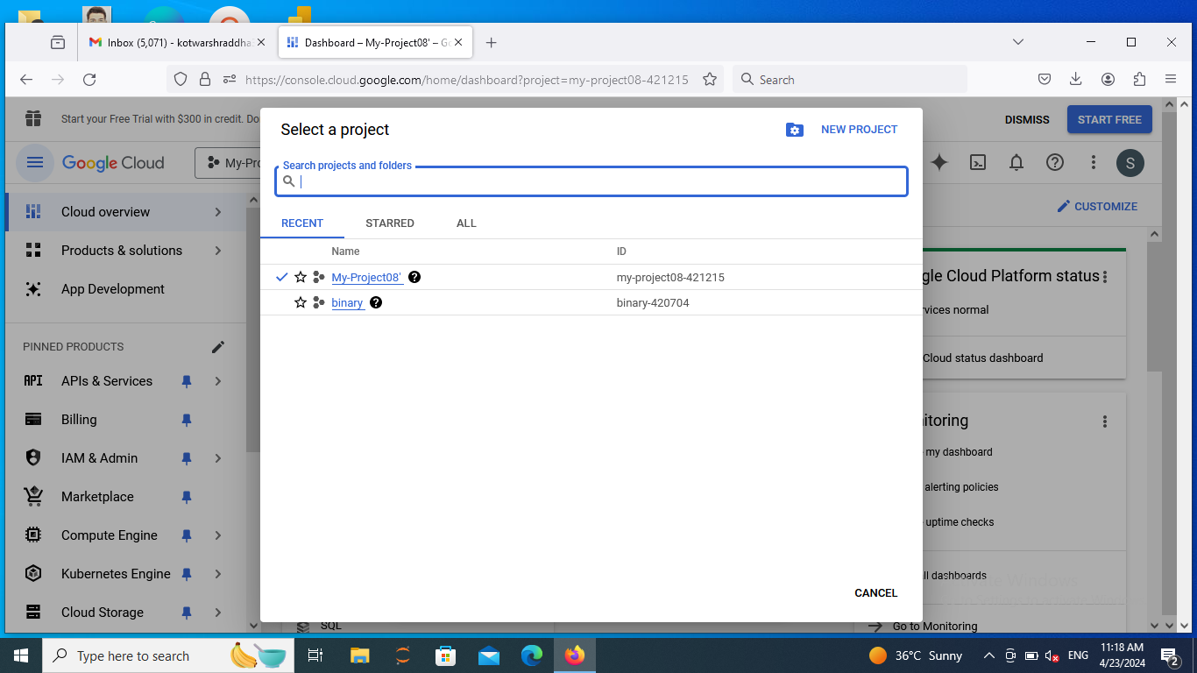

**Step 7:** Type admin API in search bar right of my_project and open it.

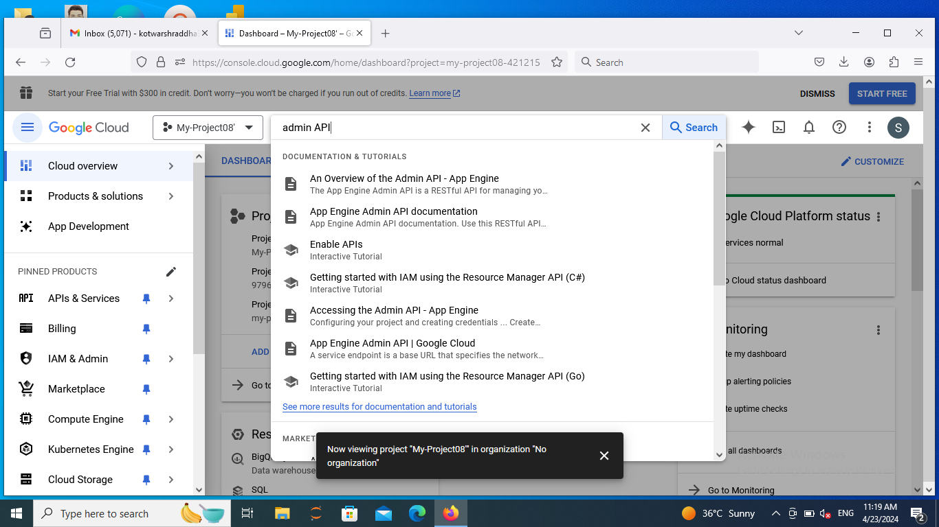

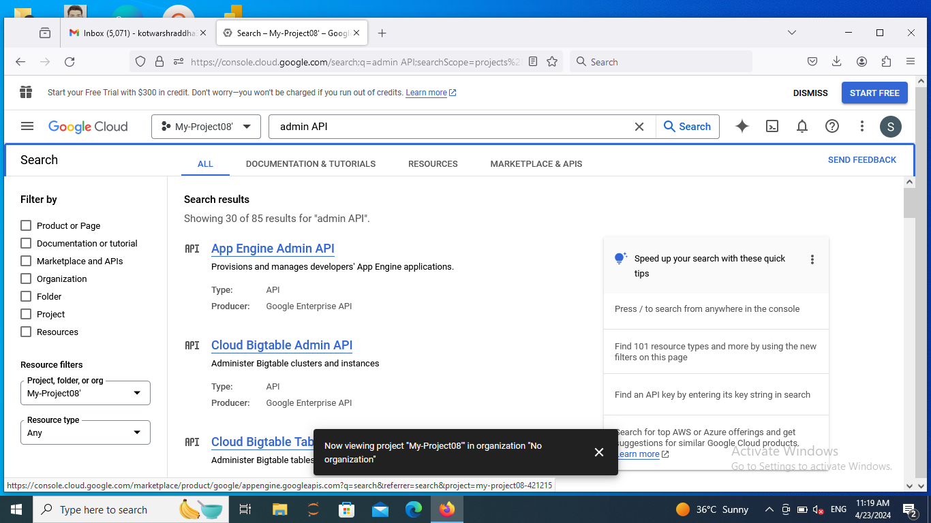

**Step 8:** Enable the App Engine

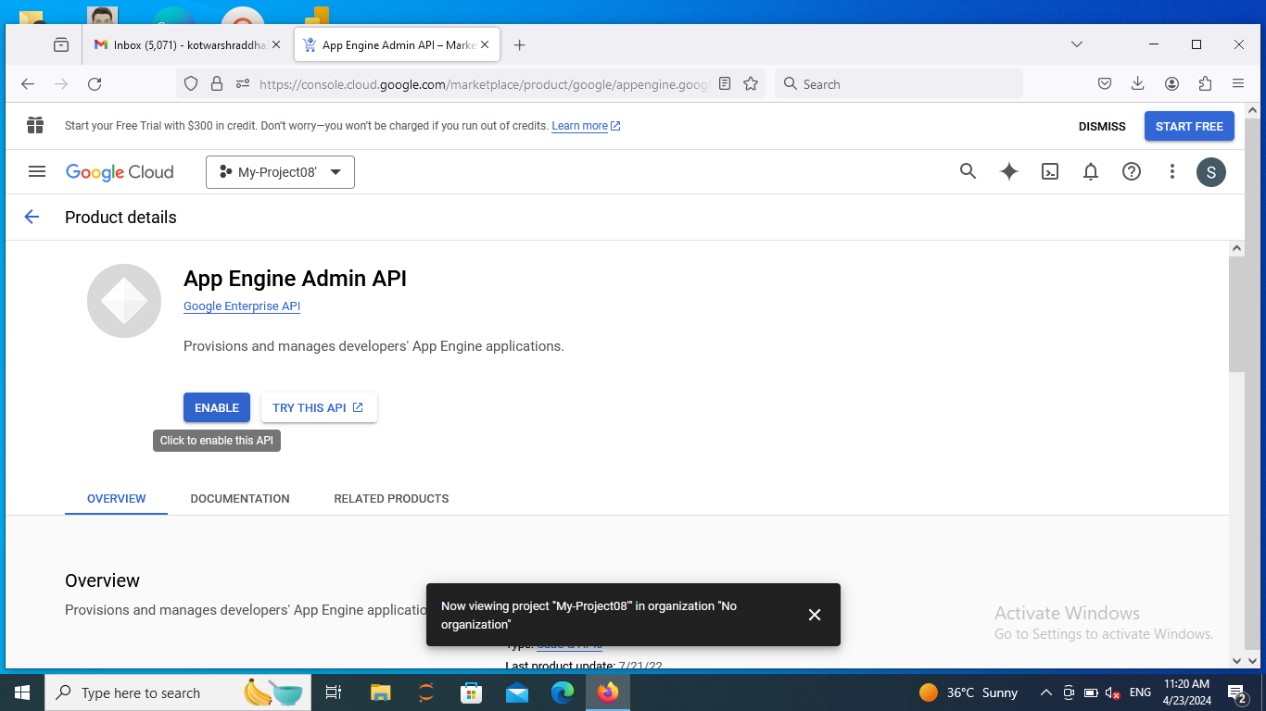

**Step 9:** Activate the Cloud Shell

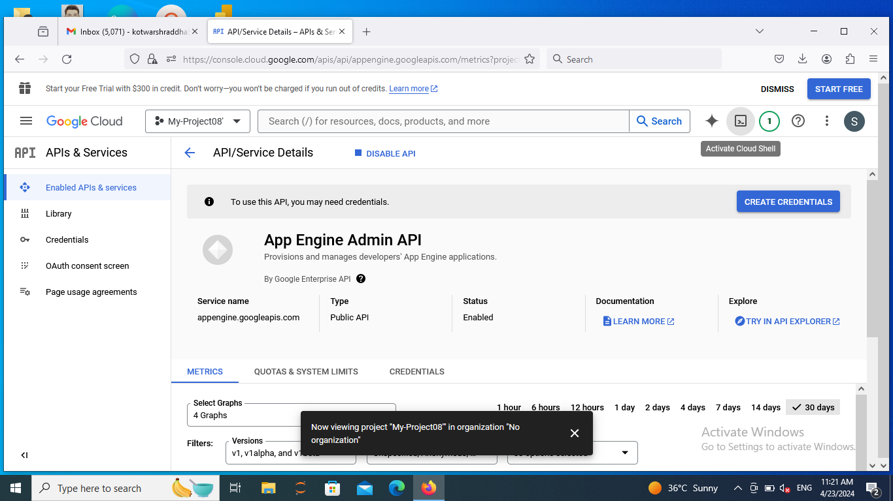

**Step 10:** Type the command in cloud shell as follows:

git clone git-clone-path-copied-from-github

ls

cd repository-name

ls

g++ searchbin.cpp

./a.out

**Final Output:**

