**Name :** Shraddha Rajkumar Kotwar

**Class:** TE ( COMP ) - B

**Roll No.:** 18

**Assignment 9:**

Creating an Application (Linear Search program) in SalesForce.com using Apex programming Language.

**Step 1:** Create and Sign in to the Salesforce.com

<https://developer.salesforce.com/signup>

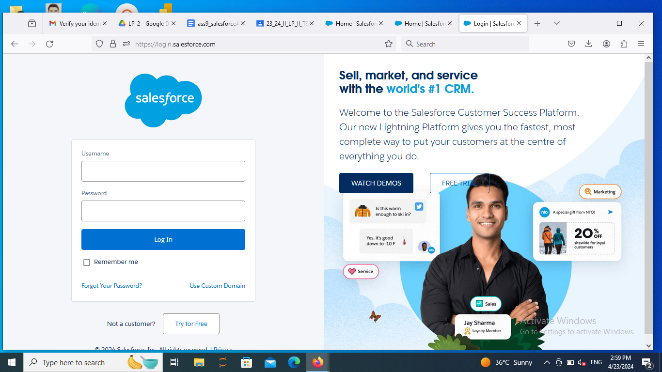

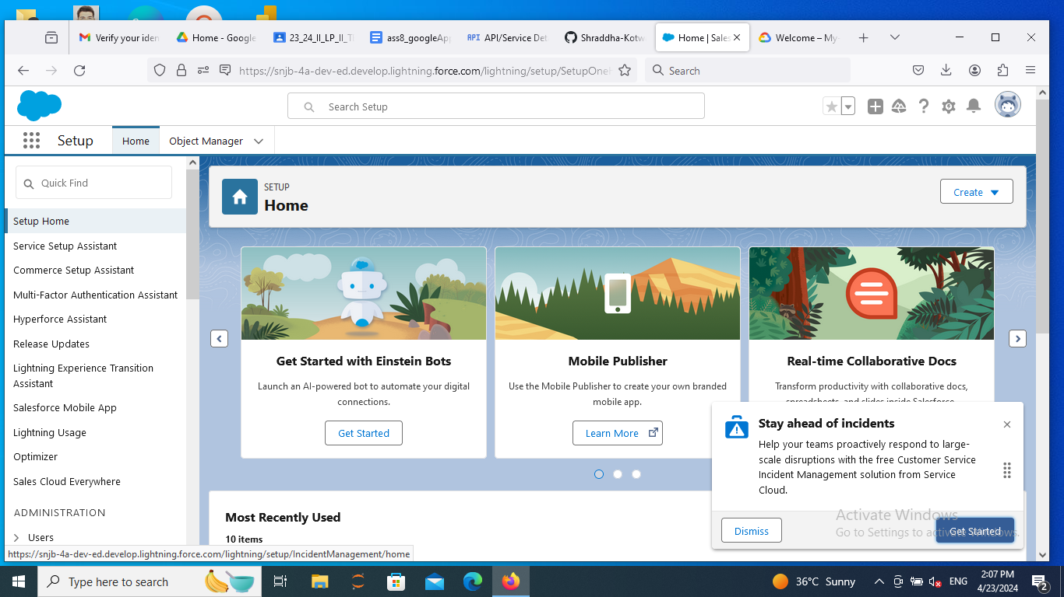

**Step 2:** Go to setup and click on developers console.

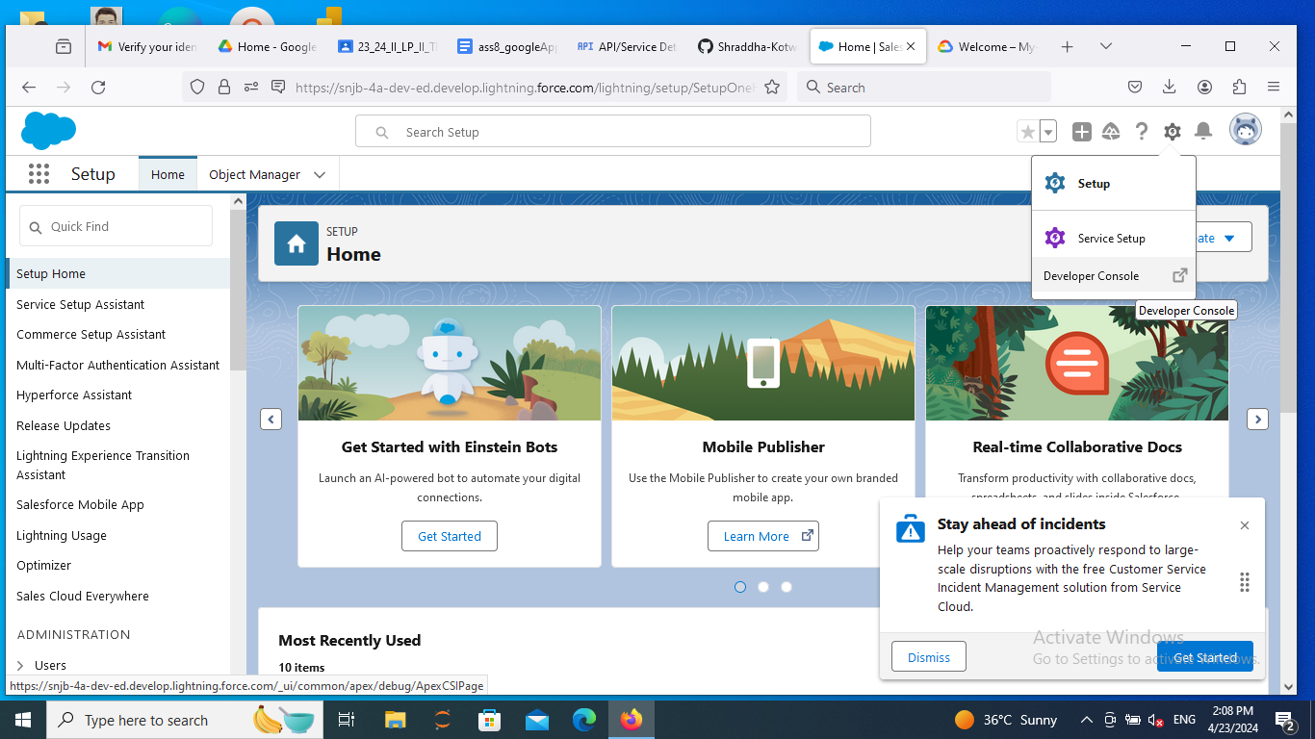

**Step 3:** Go to File -> New -> Apex Class.

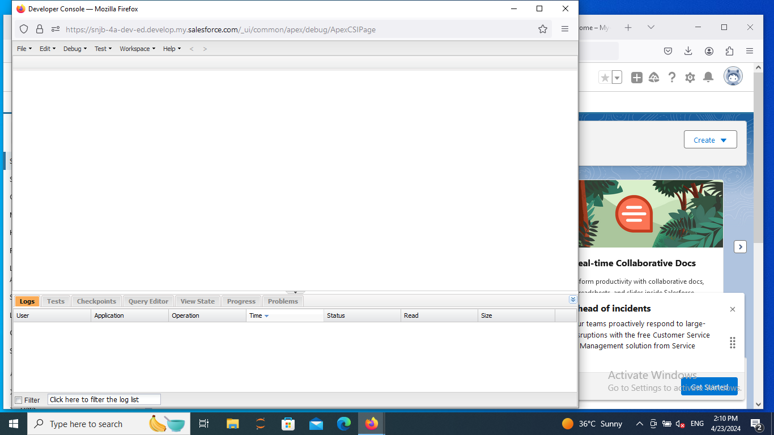

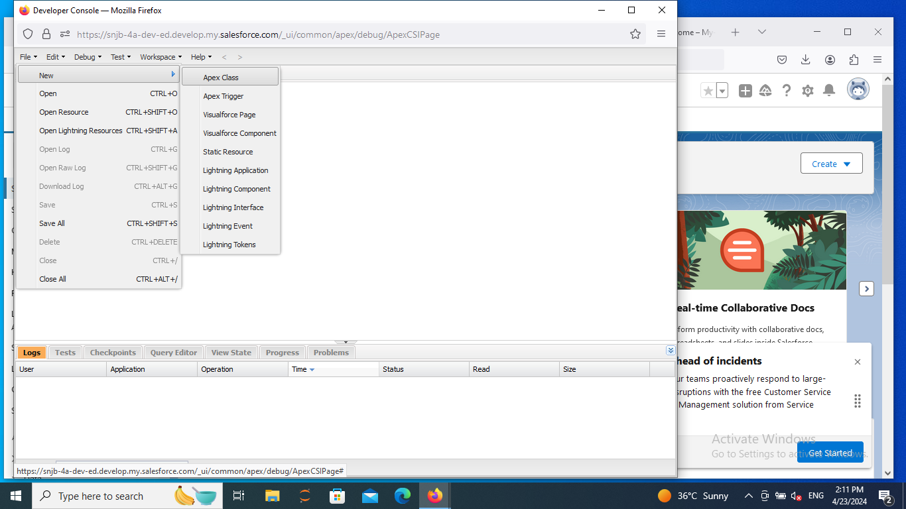

**Step 4:** Enter the Apex Class name

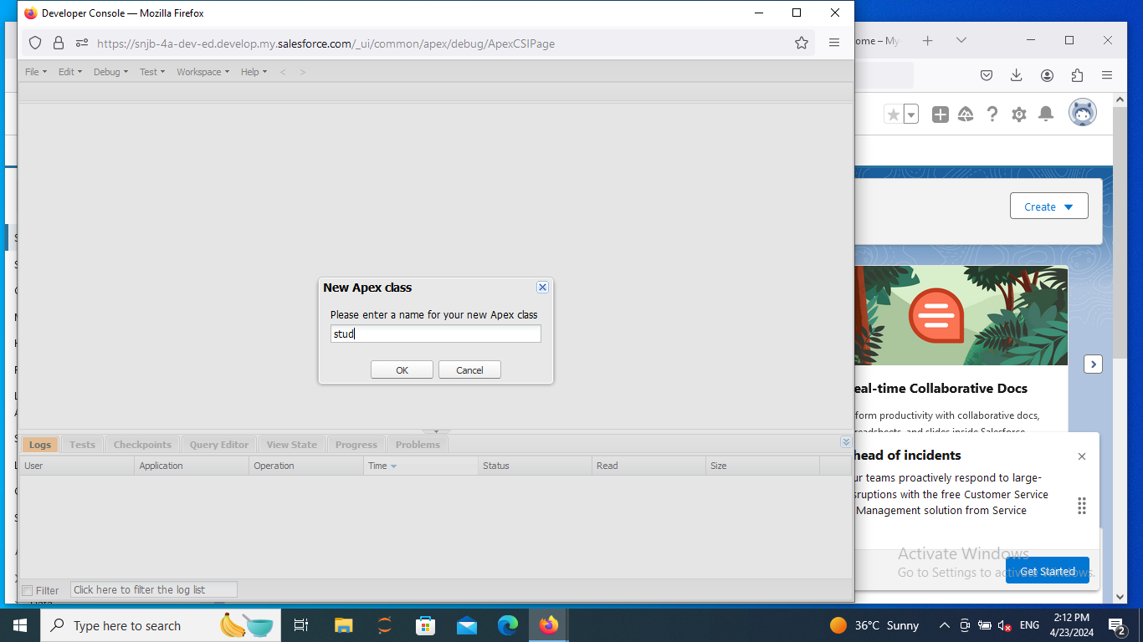

**Step 5:** Type the Linear Search Program

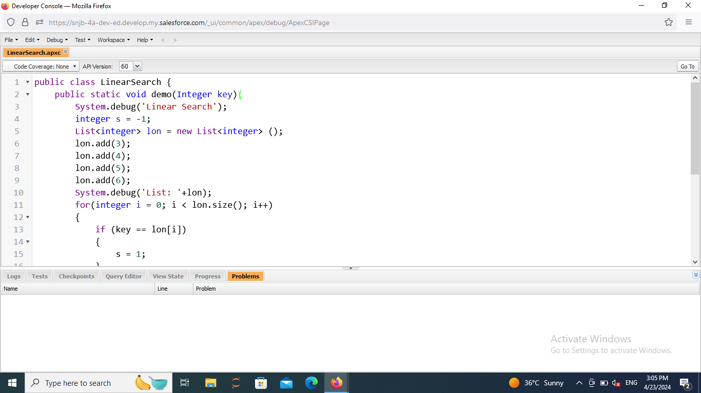

**Step 6:** Save and click on debug -> Open Execute Anonymous window

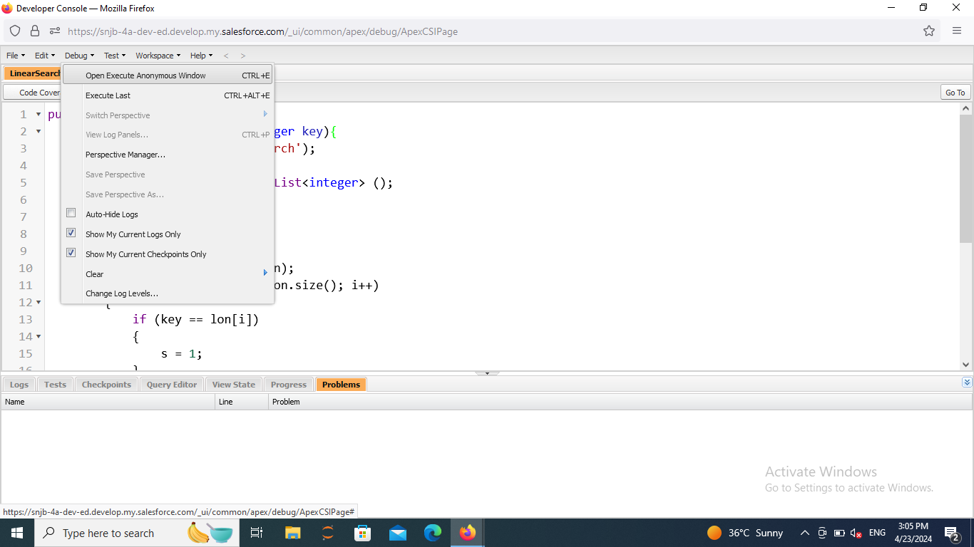

**Step 7:** Click on open log and Execute

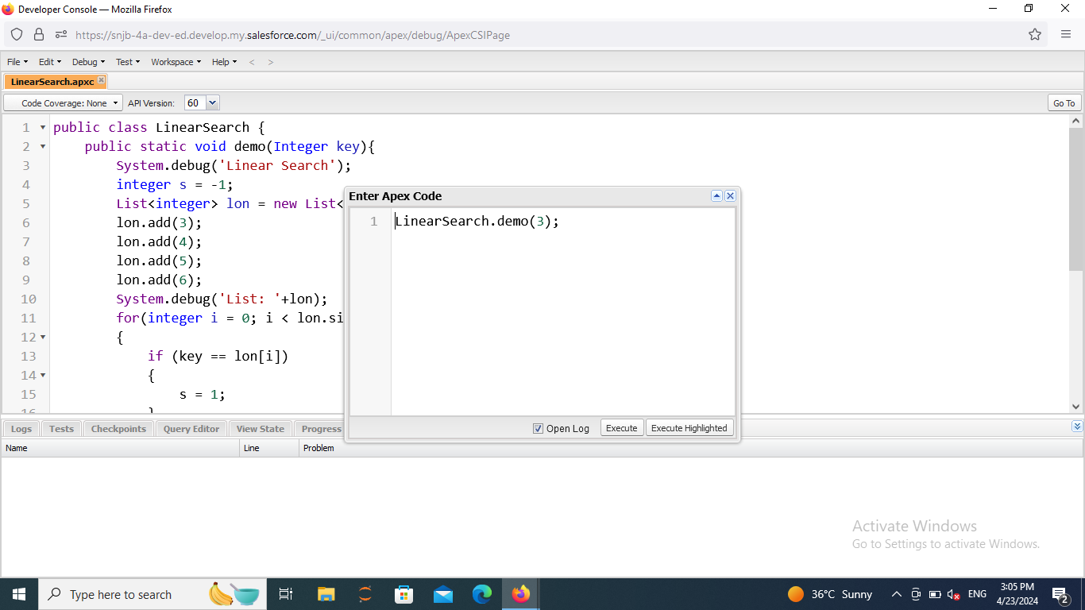

**Step 8:** final Output

