Name: Shraddha Rajkumar Kotwar

Roll No : 18

Class: TE(COMP) -B

**DTD file**:

<!-- DTD file-->

<!DOCTYPE address [

<!ELEMENT employee (eid,ename,salary)>

<!ELEMENT eid (#PCDATA)>

<!ELEMENT ename (#PCDATA)>

<!ELEMENT salary (#PCDATA)>

]>

**XML file:**

<employee>

<emp>

<eid>1</eid>

<ename>Shraddha</ename>

<salary>100000</salary>

</emp>

<emp>

<eid>2</eid>

<ename>Kavita</ename>

<salary>50000</salary>

</emp>

<emp>

<eid>3</eid>

<ename>Kirti</ename>

<salary>9000</salary>

</emp>

<emp>

<eid>4</eid>

<ename>Nishi</ename>

<salary>89000</salary>

</emp>

</employee>

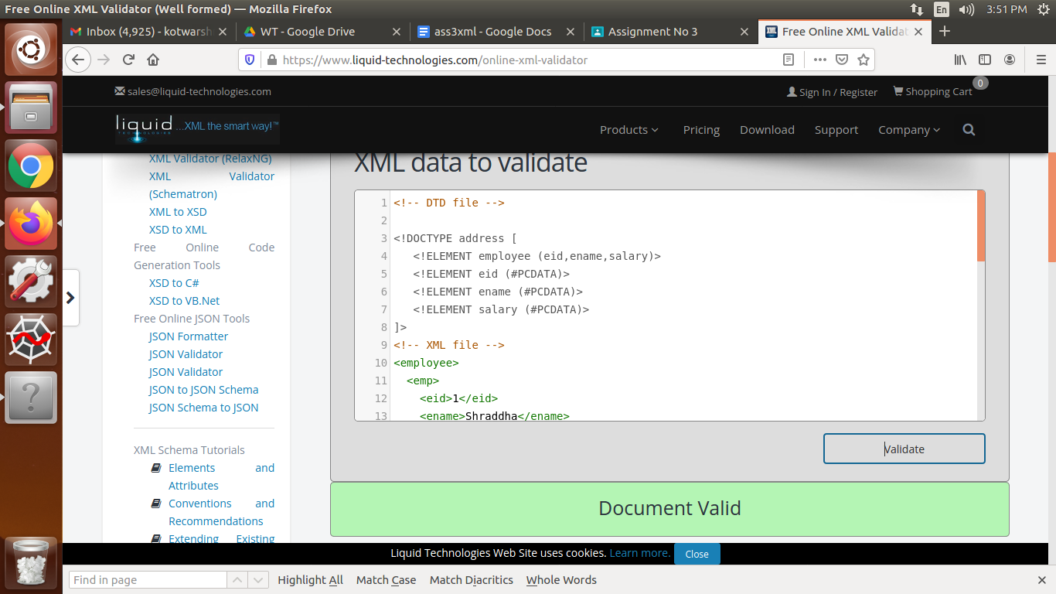

**XSD file**:

<xs:schema xmlns:xs="http://www.w3.org/2001/XMLSchema">

<xs:element name="employee">

<xs:complexType>

<xs:sequence>

<xs:element name="emp">

<xs:complexType>

<xs:sequence>

<xs:element name="eid" type="xs:int"/>

<xs:element name="ename" type="xs:string"/>

<xs:element name="salary" type="xs:int"/>

</xs:sequence>

</xs:complexType>

</xs:element>

</xs:sequence>

</xs:complexType>

</xs:element>

</xs:schema>

