Hive Activities----------------

Activity 1

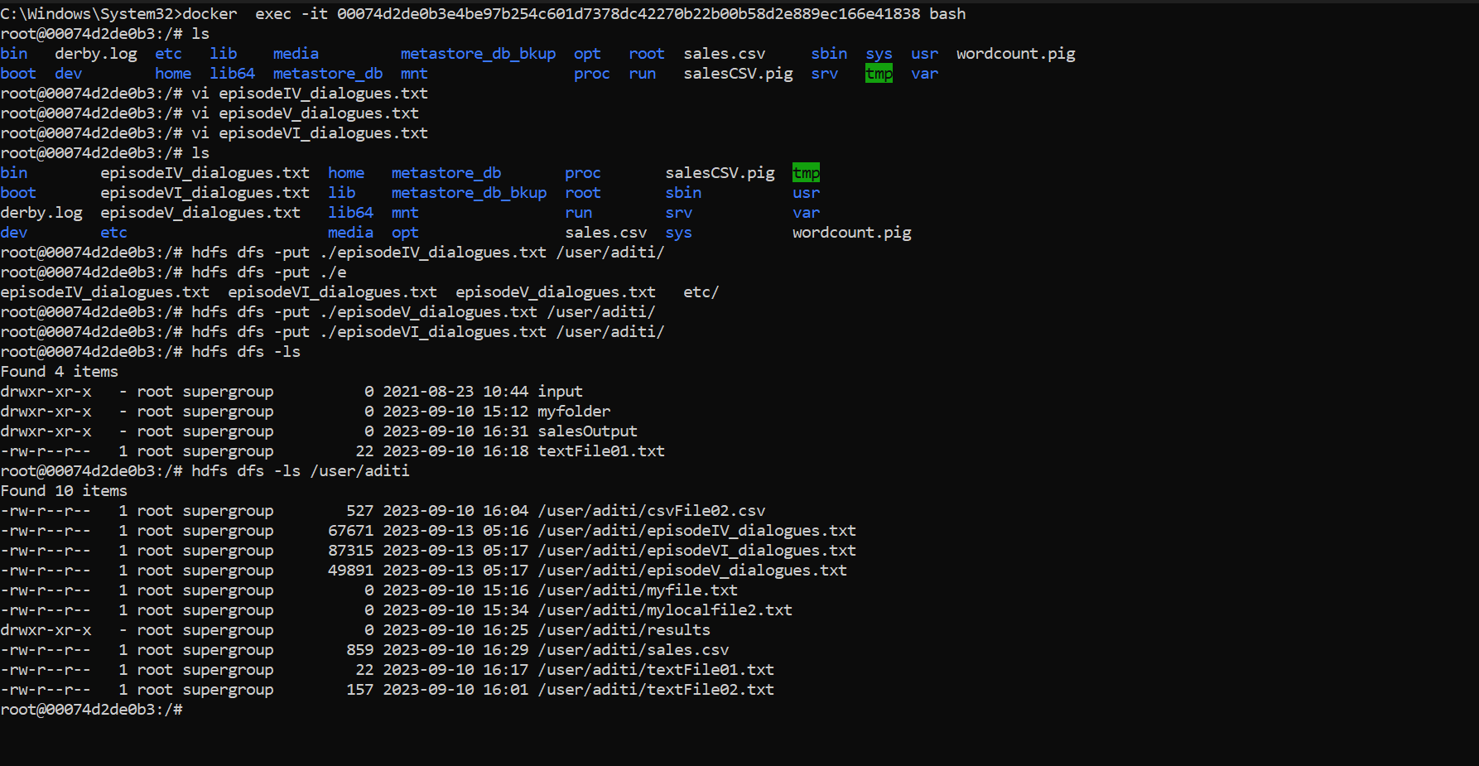

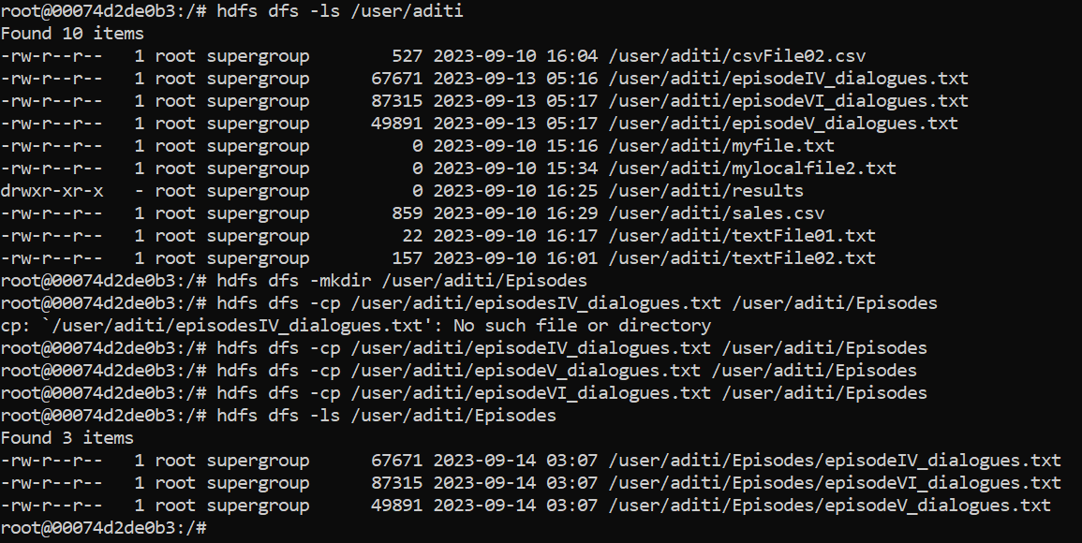

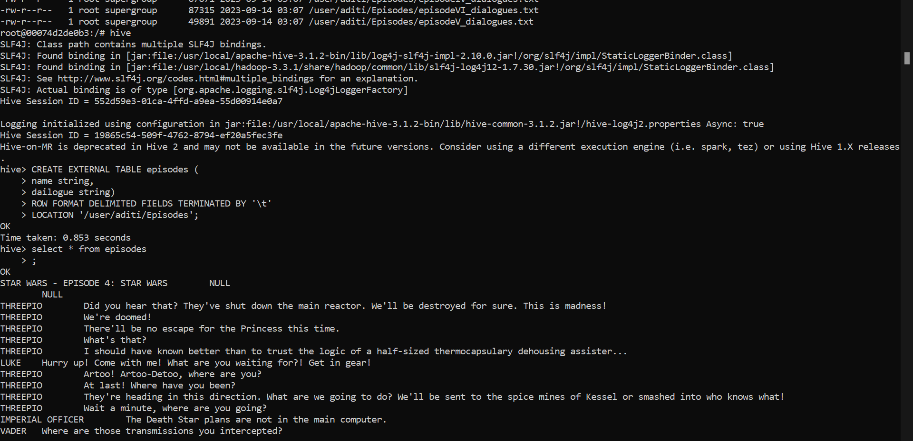



Activity 2

