**MODULE : 1**

1 **:** What is SDLC

ans

The software development lifecycle(SDLC) is a step by step approch to develop a software with high quality, lowest cost in shortest possible time by defining the process for planning,Implantation, testing, documentation, deployment and ongoing maintenance and support.

2:What is software testing?ans:

Software testing is the process to identify correctness, completeness, and quality of developed computer software

3:What is agile methodology?ans:

agile method break the product into small incremental builds.this builds are provided in iterations each iterations is typically lasts from about one to three weeks. every iterations involves cross functional teams working simultaneously on various areas like planning, requirements analysis, design, coding, unit testing and acceptance testing. at the end of the iteration a working product is displayed to customer and important stakeholders.

5: What is oops

Ans:

Oops is object-oriented programming technique that combines data and instructions for processing that data into an object that can be used within the program.

4:What is SRSAns:

SRS is a complete process of behavior of developed system it includes a set of use cases that describe all of the interaction that

The user will have the software and SRS also contains non functional requirements.

6:Write Basic Concepts of oopsAns: these are the basic concepts of oops

Object

Class

Encapsulation

Inheritance

Polymorphism

Overreading

Overloading

Abstraction

7:What is object ans: object is an individual, identifiable item, unit or entity, either real or abstract with a well-defined role in the problem domain

8:What is classans: class is a template definition of the methods and variables in particular kind of object. So,an object is a specific instance of a class

9: What is encapsulationans:

Encapsulation is the practice of including in an object eveything it needs hidden from other objects. The internal state is usually not accessible by other objects.

10:What is inheritance

ans:

Inheritance means that one class inherits the characteristics of another class.

11:What is polymorphism

ans:

Polymorphism means “having many forms ”

It allows different objects to respond to the same message in different ways, the response specific to the type of the object.

12:Draw Usecase on Online book shopping

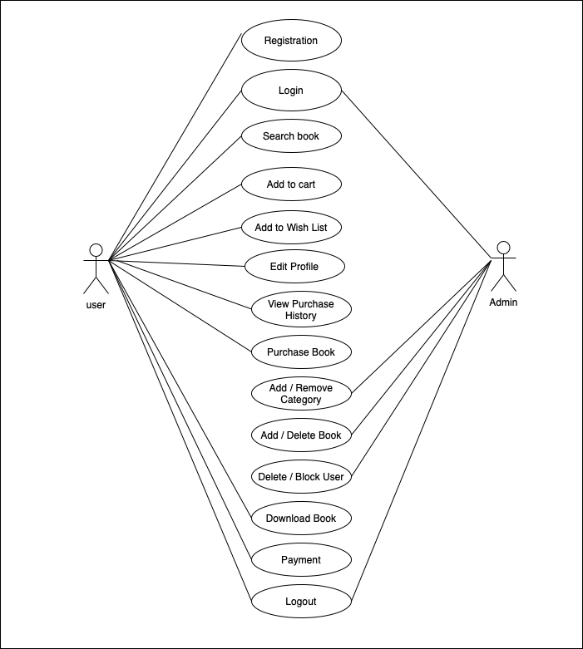

13:Draw Usecase on online bill payment system (paytm)   
ans: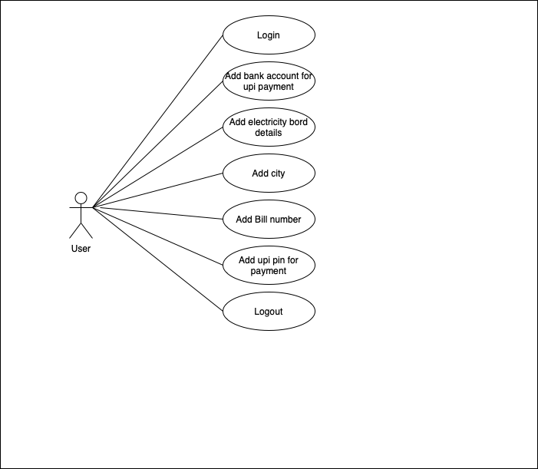

14: Write SDLC phases with basic introductionAns: SDLC Phases

* Requirements Gathering

It Establis Customer Needs

* Analysis

Model And Specify the requirements “what”

* Design

Model And Specify a Solution -”Why”

* Implementation

Construct a solution In Software

* Testing

Validate the Solution against the requirments

* Maintenance

Repair Defect and adapt the solution to the new requirement

15: Explain Phases of the waterfall model   
Ans:

* Analysis

It is the first pheses of waterfall Model,that includes a feasibility study and requirments defination. this is followed by the detailed defination of the requirement,which includes analysis of current situation and target concept. In this complex problems are broken down into small subtasks and appropriate solution strategies are developed.

* Design

In this phase software developers develop the software architecture and a detailed construction plan for the software,concentrating on Specific components such as interfaces, frameworks or libraries.

* Implementation

In this phase the software design is implemented in the desired Programming Language. Individual components are developed separately,checked within th freamwork module testing and integrated step by step into the overall product.

* Testing

This phase includes the integration of the software in to the desired target environment.the eccepance tests developed in the system analysis phase can be used to determine whether the software meets the previously- definedrequirments.

* Maintenance

This is the final phase of waterfall model. It includes delivery,maintenance,and improvement of the software.

16: Write phases of spiral model   
 Ans: this are phases of Spiral Mode

* Planning : Determination of objectives,alternatives and constraints
* Risk Analysis: Analysis of alternatives and identification/resolution of risk
* Engineering: Development of the Next level Product
* Customer Evaluation: Assessment of the results of engineering

17: Write agile manifesto principles

ans:

* Individuals and interactions over processes and tools.
* Working software over comprehensive documentation.
* Customer collaboration over contract negotiation.
* Responding to change over following a project plan.

18: Explain working methodology of agile model and also write pros and cons.   
 Ans:

agile method break the product into small incremental builds.this builds are provided in iterations each iterations is typically lasts from about one to three weeks every iterations involves cross functional teams working simultaneously on various areas like planning, requirements analysis, design, coding, unit testing and acceptance testing. At the end of the iteration a working product is displayed to customers and important stakeholders.

* pros

Is a very realistic approach to software development

Easy to manage

Suitable for fixed or changing requirements

Minimal rules,documentation easily employed

Gives flexibility to developers

* cons

Not suitable for handling complex dependencies

An overall plan, an agile leader and agile PM practice is a must without which it will not work

Depends heavily on customer interaction,so if customer is not clear,team can be driven in the wrong direction

More risk of sustainability,maintainability and extensibility.

19.Draw usecase on Online shopping product using COD.   
 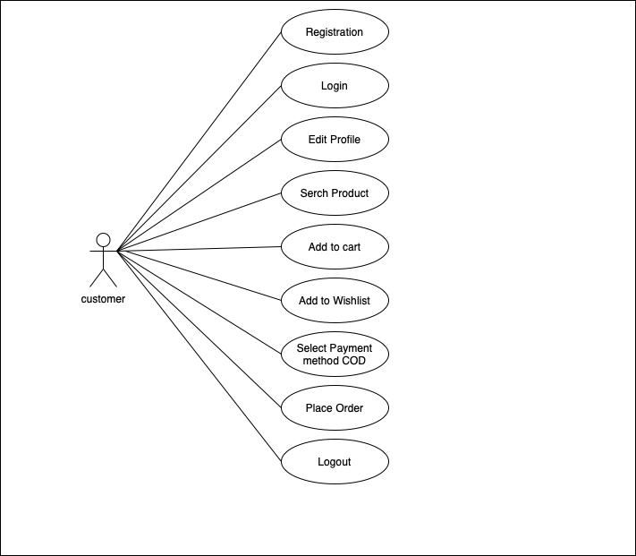

20:Draw usecase on Online shopping product using payment gateway.

