**COMBOOKS**

**A PROJECT REPORT**

***Submitted by***

**MohammedNadeem Maulvi [1418BECE30161]**

**Jay Sojitra [1418BECE30148]**

***In fulfillment for the award of the degree***

***Of***

**BACHELOR OF ENGINEERING**

**In**

**COMPUTER ENGINEERING**



**LDRP INSTITUTE OF TECHNOLOGY AND RESEARCH, GANDHINAGAR**

**Kadi Sarva VishwaVidyalaya, Gandhinagar**

**2016 - 2017**

**LDRP Institute of Technology and Research**

Computer Engineering Department



**CERTIFICATE**

This is to certify that the Project Work entitled **“Combooks”** has been carried out by **MohammedNadeem Maulvi (1418BECE30161) and Jay Sojitra(1418BECE30148)** under my guidance in fulfilment of the degree of Bachelor of Engineering in Computer Engineering (6th Semester) of Kadi Sarva Vishwavidyalaya University, Gandhinagar during the academic year 2016-17.

**Guide:**

**Prof. Vaidehi Patel Dr. Hiren B. Patel**

Internal Guide, HOD – CE,

LDRP ITR. LDRP ITR.

**ACKNOWLEDGEMENT**

I take this opportunity to humbly express our thankfulness to all those concerned with my project.

First of all I am thankful to **LDRP ITR** for undertaking this project. I am sincerely indebted to **Ms. Vaidehi Patel** for giving me the opportunity to work on this project. Her continuous guidance and help have proved to be a key to my success in overcoming the challenges that I have faced during my project work. Her support made the project a pleasantly memorable one .Without her help at all stages in spite of her own work load; the completion of the project would not have been possible.

I express my sincere gratitude to **Dr.Hiren B. Patel** for his valuable guidance and positive feedback.

There are so many persons without whose help I would never have conceived and learnt , to whom I would like to express my gratitude – my friends , colleagues, and of course CE & IT Department of LDRP ITR.

Last but not least I am thankful to almighty GOD and my PARENTS for giving me such a good atmosphere to work hard and to succeed.

**MohammedNadeem Maulvi**

**(1418BECE330148)**

**Jay Sojitra**

**(1418BECE30148)**

**ABSTRACT**

Save time: This web saves your time of roaming for your desired books.

Save money: You can save a large amount of money by referring to our books online.

Available resources: There are a large data available on our web so as to fulfil your

requirement.

Eco friendly: This app allows you to create hardcopies of only that amount of pages

that you require rather than buying whole editions.

My Book: This is the special feature of this website which allows you to create

your own book. This help in solving the problem of buying more books

for single subject.

**LIST OF FIGURES**

|  |  |  |
| --- | --- | --- |
| **NO** | **NAME** | **PAGE NO** |
|  |  |  |
| 1 | Work Breakdown Structure | 10 |
| 2 | Activity Network Requirement | 11 |
| 3 | Gantt Chart 1 | 11 |
| 4 | Gantt Chart 2 | 12 |
| 5 | Functional Diagram of Admin | 24 |
| 6 | Functional Diagram of Consultant | 24 |
| 7 | Functional Diagram of Accountant | 25 |
| 8 | Functional Diagram of Client | 26 |
| 9 | Class Diagram | 29 |
| 10 | Usecase Diagram | 30 |
| 11 | Usecase Diagram of view report | 31 |
| 12 | Sequence Diagram | 32 |
| 13 | Entity Relationship Diagram | 39 |
| 14 | Context Level DFD | 40 |
| 15 | First level DFD of Admin | 41 |
| 16 | Second level DFD of Admin | 42 |
| 17 | First Level DFD of Consultant | 43 |
| 18 | First Level DFD of Client | 44 |
| 19 | First :Level DFD of Accountant | 45 |
| 20 | Activity Diagram of Admin | 46 |
| 21 | Activity Diagram of Consultant | 47 |
| 22 | Activity Diagram of Client | 48 |
| 23 | Activity Diagram of Accountant | 49 |
| 24 | Create Account | 56 |
| 25 | Activate Account | 57 |
| 26 | Deactivate Account | 58 |
| 27 | Admin View Call Log | 59 |
| 28 | Admin Manage Client | 60 |
| 29 | Admin Call Log Report | 61 |
| 30 | Consultant Profile | 62 |
| 31 | View profile Details | 63 |
| 32 | Consultant Call Log | 64 |
| 33 | Schedule Task | 65 |
| 34 | Consultant Home Page | 66 |
| 35 | Accountant Home Page | 67 |
| 36 | Consultant Payment | 68 |
| 37 | Client Payment | 69 |
| 38 | Client Payment Report | 70 |
| 39 | Consultant Payment Report | 71 |
| 40 | Register Issue | 71 |

**LIST OF TABLES**

|  |  |  |
| --- | --- | --- |
| **NO** | **NAME** | **PAGE NO** |
|  |  |  |
| 1 | Login Details | 34 |
| 2 | Consultant Details | 34 |
| 2 | Client Details | 35 |
| 3 | Client Contact Details | 35 |
| 4 | Call log Details | 36 |
| 5 | Transportation Details | 36 |
| 6 | Consultant Payment Details | 37 |
| 7 | Client Payment Details | 37 |
| 8 | Register Issue | 37 |
| 9 | Schedule Task | 38 |
| 10 | Test Case for inconsistent database | 81 |
| 11 | Test Case for foreign key constraint | 81 |
| 12 | Test Case for transportation details addition | 81 |
| 13 | Test Case for deleting call log details | 82 |

**TABLE OF CONTENTS**

|  |  |  |
| --- | --- | --- |
| **NO** | **CHAPTER NAME** | **PAGE NO** |
|  |  |  |
|  | **Acknowledgement** | i |
|  | **Abstract** | ii |
|  | **List of Figures** | iv |
|  | **List of Tables** | v |
|  | **Table of Contents** | vi |
|  |  |  |
| 1 | **Introduction**   * 1. Scope   2. Project Summary and purpose   1.2.1Project Summary  1.2.2Purpose   * 1. Objectives | 1  2  3  3  3 |
| 2 | **System Requirement Study**  2.1 Software and Hardware Requirements  2.2 Assumptions and Dependencies  2.2.1 Assumptions  2.2.2 Dependencies | 15  16  16 |
| 3 | **System Analysis**  3.1 Requirement Validation  3.2 Class Diagram  3.3 Use Case Diagrams | 21  22  22  22 |
| 4 | **System Design**  4.1 Database Dictionary  4.2 Entity Relationship Diagram  4.3 Data Flow Diagram  4.4 Activity Diagram  4.5 Sequence Diagram  4.6 Sate Diagram |  |
| 5 | **Experience, Limitations And Future Enhancement**  5.1 Experience during project development  5.2 Limitations  5.2 Future Enhancement | 84  85  85 |
| 6 | **Bibliography**  6.1 Conclusion  6.2 Bibliography | 86  87  87 |

|  |
| --- |
|  |

1. INTRODUCTION

1.1 Scope

It is new and advance version of traditional learning. Imparting practical knowledge with learning at the same instance. Students can get all type of books. It teaches subjects using animations, to enable easy learning of complex concepts of Engineering, Medical etc. This platform provides vital services to education and students

.

1.2 Project Summary and Purpose

1.2.1 Project Summary

We decided to make a website which gives the facility of online reading to the students. Nowadays there are many online website available for online reading, but our idea is little bit different. In our website we provide all types of books like Engineering Books, Medical Books, Novels, History Books, Safari, Story Books and Competitive Exam Books etc. Students are facing problem regarding to their studies, which is the lack of availability of topics about syllabus in one book, so they have to refer another book, for e.g. if engineering students are preparing for the exams. Each institute have different syllabus, so they recommend different publication's books. If one topic is not present in that publication than they have to purchase another book. This is the major problem in these days. So we provide one feature in our website which is "MY BOOK". In "MY BOOK" student can add the topic which is not present in the book which was recommended. So student can make their own book with necessary topics using "MY BOOK" and anytime student can read that book online.

1.2.2 Purpose

* It is much beneficial to the students.
* Even universities can use this concept for building up their own syllabus.
* Cheaper and fast access for users.
* Diminishing distance issues to users.

2. Software and Hardware Requirement

OPERATING ENVIRONMENT

PARTICULARS CLIENT SYSTEM SERVER SYSTEM

Operating System Windows XP Windows XP

Processor core to duo, 2.9GHz core to duo, 2.9 GHz

Hard disk 1TB 1 TB

RAM 4GB 4GB

* The basic requirement include:-

Internet

USB memory card reader and other data cables

Uninterruptible power supply

* Software requirement for developers:

Any IDE which supports HTML

Star UML 2.0

OS: Windows XP.

2. Assumption and Dependencies

2.1 Assumption

* Requires android version kitkat(4.4.0) or more
* Need efficient memory space for storing videos and books.

2.2 Dependencies

* Internet speed upto 512 kbp/s.
* A smart phone or laptop.
* Intel i3(5th generation) .

3. System Analysis

3.5 Class Diagram

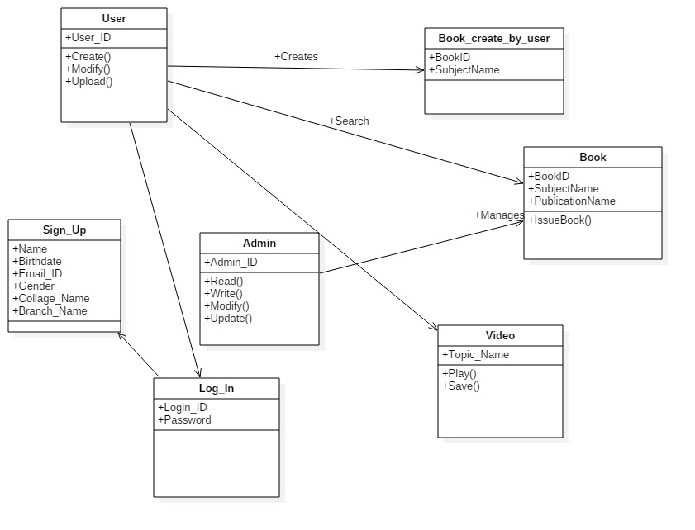

3.6 Usecase Diagram

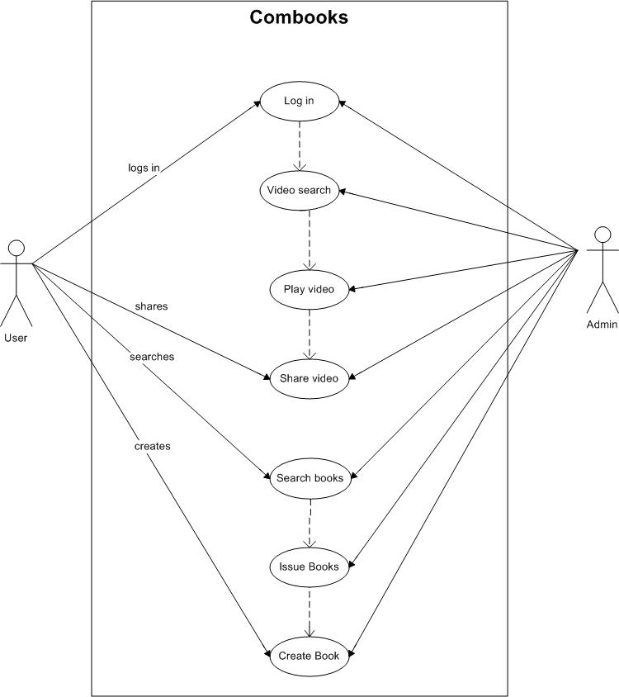

4. Data Dictionary

4.1 Data Dictionary for Classes

1. User

|  |  |  |
| --- | --- | --- |
| Attributes | Datatype | Function |
| User_ID | Varchar2 | Create() |
|  |  | Modify() |
|  |  | Upload() |

2. Book_create_by_user

|  |  |
| --- | --- |
| Attributes | Data type |
| BookID | Varchar2 |
| SubjectName | Varchar2 |

3. Book

|  |  |  |
| --- | --- | --- |
| Attributes | Data type | Function |
| BookID | Varchar2 | IssueBook |
| SubjectName | Varchar |  |
| PublicationName | Varchar |  |

|  |  |  |
| --- | --- | --- |
| Attributes | Data type | Function |
| Admin_ID | Varchar2 | Read |
|  |  | Write |
|  |  | Modify |
|  |  | Update |
|  |  |  |

4. Admin

5. Sign_up

|  |  |  |
| --- | --- | --- |
| Attributes | Data type | Function |
| Name | Varchar |  |
| Birthdate | Varchar2 |  |
| Email_ID | Varchar2 |  |
| Gender | Varchar |  |
| Collage_Name | Varchar2 |  |
| Branch_Name | Varchar2 |  |

6. Log_in

|  |  |  |
| --- | --- | --- |
| Attributes | Data type | Function |
| Log_ID | Varchar2 |  |
| Password | Varchar2 |  |

7. Video

|  |  |  |
| --- | --- | --- |
| Attribute | Data type | Function |
| Topic_Name | Varchar2 | Play |
|  |  | save |

4.2 Entity-Relationship Diagram

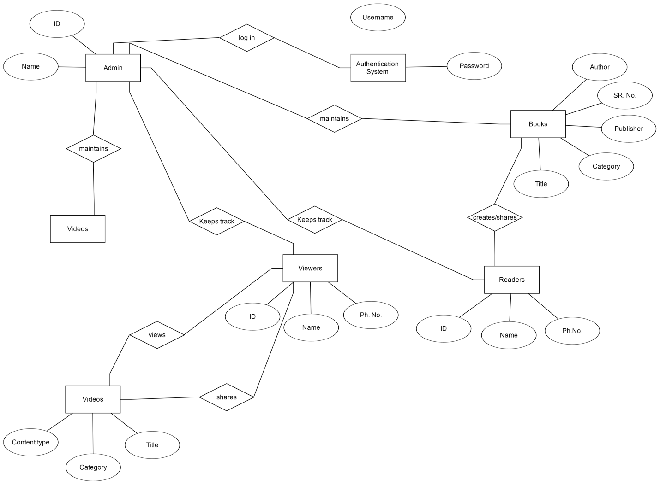

4.3 Data Flow Diagram

Level 0

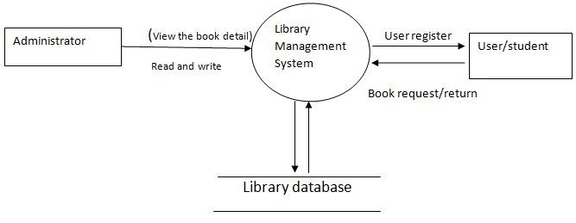

Level 1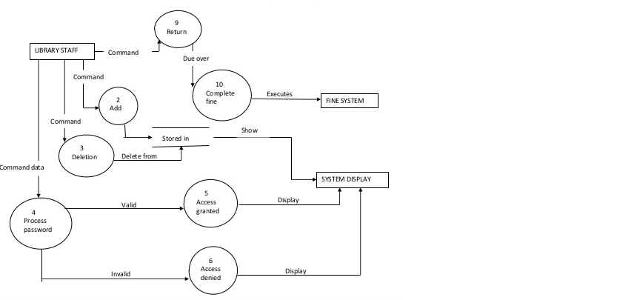

4.4 Activity Diagram

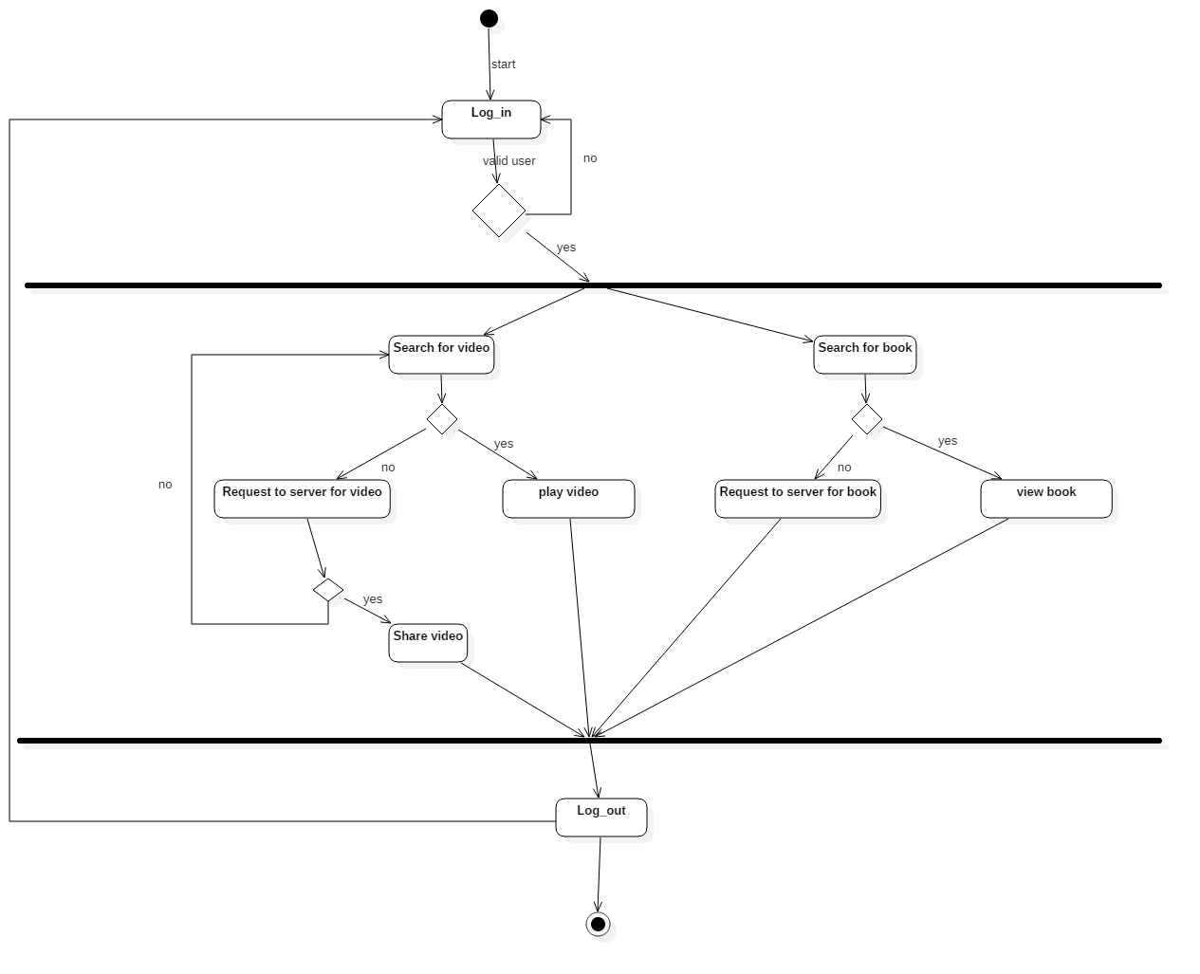

4.5 Sequence Diagram

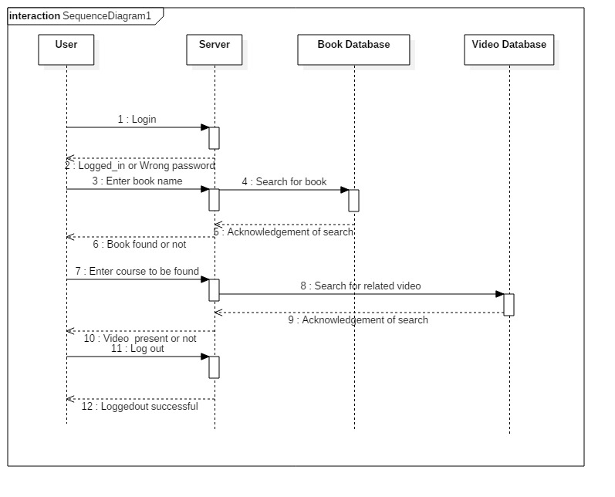

4.6 State Diagram

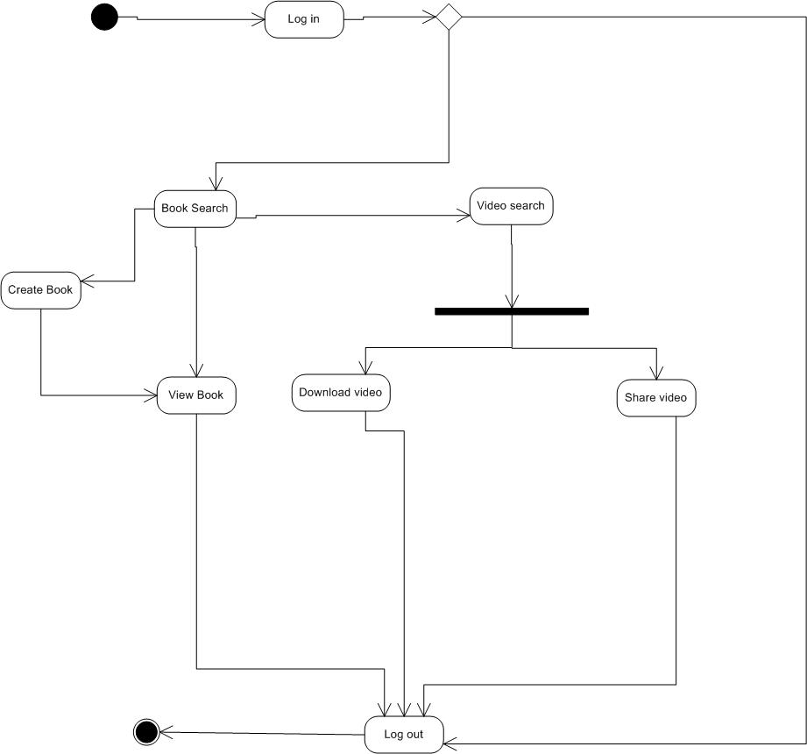

5. Experience, Limitations And Future Enhancement

5.1 Experience during project development

* In the development phase, we experienced the importance of UML diagrams.
* In the testing phase, we came to know about the interrupts that are caused due to external entities.
* In deployment phase, we faced various problem in the proper implementation of the project.

5.2 Limitation

* The copy rights are reserved. So the user is bound to some limitations.
* User can access only it’s own university books and videos.

5.3 Future Enhancement

* Collaboration with new trending publication will be made to keep them in touch with latest publication.
* This is just difficult but I will go into that direction try to increase the functionality of the site**.**

**6. Bibliography**

6.1 Conclusion

* During the period of project I came to know the practical aspects of Web-Site development that sound our knowledge in HTML5 and CSS3.
* HTML5 and CSS3 are brand new technology and I will improvement my skill in these fields.

6.2 Bibliography

* Pro HTML programming

By: Peter Lubbers, Brian Albers, Frank Salim

* Beginning of Software Engineering

By: Rod Stephens.

Websites:

* [www.w3schools.com](http://www.w3schools.com)
* [www.javatpoint.com](http://www.javatpoint.com)
* [www.codeguru.com](http://www.codeguru.com)