Shraddha Dwivedi

UB Person Number: 50290266

Computer Science and Engineering

University at Buffalo

[sdwivedi@buffalo.edu](mailto:sdwivedi@buffalo.edu)

**Edge Detection**

**Source code for Edge Detection**

import cv2

import numpy as np

import math as math

imgPath = 'C:/Users/Shraddha/Desktop/CVIP/Project_1/task1.png'

SxKernel = (1/8) * ( np.array( [ [1,0,-1], [2,0,-2], [1,0,-1] ] ))

SyKernel = (1/8) * ( np.array( [ [-1,-2,-1], [0,0,0], [1,2,1] ] ))

def detectImage(img, outImageName):

#imwrite() save a image to a specified file

cv2.imwrite('C:/Users/Shraddha/Desktop/CVIP/Project_1/OutputImage/Task1'+outImageName+'.jpg', img)

return 1

def convolve_image(img, kernel):

sizeOfKernel = (int)((kernel.shape[0])/2)

img_conv = np.zeros((img.shape[0], img.shape[1]))

for i in np.arange( sizeOfKernel, ((img.shape[0])-sizeOfKernel) ):

for j in np.arange( sizeOfKernel, ((img.shape[1])-sizeOfKernel) ):

temp = 0

for x in np.arange(-1, 2):

for y in np.arange(-1, 2):

coordinateOfKernel = kernel[x+sizeOfKernel, y+sizeOfKernel]

coordinateOfImg = img[i-x, j-y]

temp = temp + (coordinateOfImg*coordinateOfKernel)

img_conv[i][j] = temp

return img_conv

#method 1

def zeros_elimination_m1(img_conv):

outputImage = np.zeros((img_conv.shape[0], img_conv.shape[1]))

min_Value = (img_conv[0,0])

max_Value = (img_conv[0,0])

for i in np.arange( 0, img_conv.shape[0] ):

for j in np.arange( 0, img_conv.shape[1] ):

if (min_Value>(img_conv[i, j])):

min_Value=(img_conv[i, j])

if (max_Value<(img_conv[i, j])):

max_Value=(img_conv[i, j])

for i in np.arange( 0, img_conv.shape[0] ):

for j in np.arange( 0, img_conv.shape[1] ):

outputImage[i, j] = 255.0 * ( (img_conv[i, j] - min_Value) / (max_Value - min_Value) )

return outputImage

#method 2

def zeros_elimination_m2(img_conv):

outputImage = np.zeros((img_conv.shape[0], img_conv.shape[1]))

max_Value = (img_conv[0,0])

for i in np.arange( 0, img_conv.shape[0] ):

for j in np.arange( 0, img_conv.shape[1] ):

if (max_Value<img_conv[i, j]):

max_Value=img_conv[i, j]

for i in np.arange( 0, img_conv.shape[0] ):

for j in np.arange( 0, img_conv.shape[1] ):

outputImage[i, j] = 255.0 * ( img_conv[i, j] / max_Value )

return outputImage

def SxSyKernelMerge(Sx_conv_img, Sy_conv_img):

convoluted_img = np.zeros((Sx_conv_img.shape[0], Sx_conv_img.shape[1]))

for i in np.arange( convoluted_img.shape[0] ):

for j in np.arange( convoluted_img.shape[1] ):

convoluted_img[i, j] = math.sqrt( ((Sx_conv_img[i, j])**2) + ((Sy_conv_img[i, j])**2) )

return convoluted_img

def main():

# imread loads an image from the specified file and returns it

img = cv2.imread(imgPath,0)

#Edge Detection using Sobel kernel X

Sx_conv_img = convolve_image(img, SxKernel)

Sx_conv_img_abs = np.zeros((Sx_conv_img.shape[0], Sx_conv_img.shape[1]))

for i in range(0, Sx_conv_img.shape[0]):

for j in range(0, Sx_conv_img.shape[1]):

Sx_conv_img_abs[i][j]=abs(Sx_conv_img[i][j])

# Edge Detection using Sobel kernel Y

Sy_conv_img = convolve_image(img, SyKernel)

Sy_conv_img_abs = np.zeros((Sy_conv_img.shape[0], Sy_conv_img.shape[1]))

for i in range(0, Sy_conv_img.shape[0]):

for j in range(0, Sy_conv_img.shape[1]):

Sy_conv_img_abs[i][j]=abs(Sy_conv_img[i][j])

detectImage(Sx_conv_img_abs, 'Sx_conv_img_abs')

Sx_conv_img_M1 = zeros_elimination_m1(Sx_conv_img_abs)

detectImage(Sx_conv_img_M1, 'Sx_conv_img_M1')

Sx_conv_img_M2 = zeros_elimination_m2(Sx_conv_img_abs)

detectImage(Sx_conv_img_M2, 'Sx_conv_img_M2')

detectImage(Sy_conv_img_abs, 'Sy_conv_img_abs')

Sy_conv_img_M1 = zeros_elimination_m1(Sy_conv_img_abs)

detectImage(Sy_conv_img_M1, 'Sy_conv_img_M1')

Sy_conv_img_M2 = zeros_elimination_m2(Sy_conv_img_abs)

detectImage(Sy_conv_img_M2, 'Sy_conv_img_M2')

#merging the Sobel kernel X and Sobel kernel Y's output images to get the final image

finalImage = SxSyKernelMerge(Sx_conv_img_abs, Sy_conv_img_abs)

detectImage(finalImage, 'finalImage')

main()

**Image Results for Edge Detection**

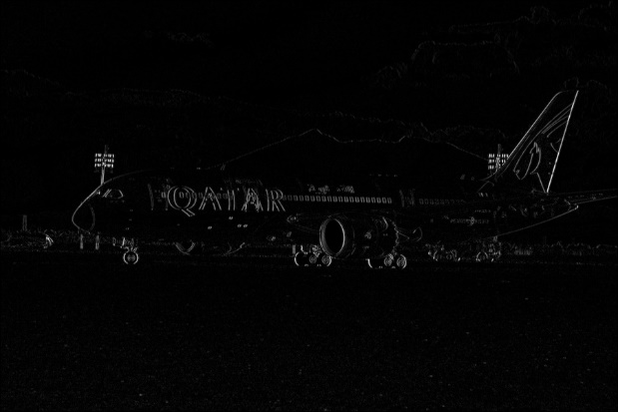

**Fig 1 :** Edge detection along x- direction using method 1

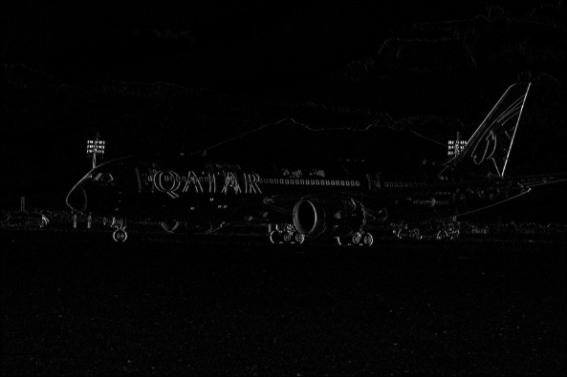

**Fig 2 :** Edge detection along x- direction using method 2

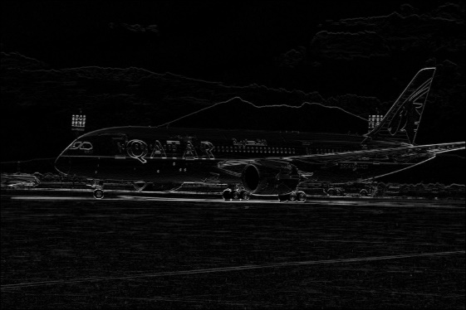

**Fig 3 :** Edge detection along y- direction using method 1

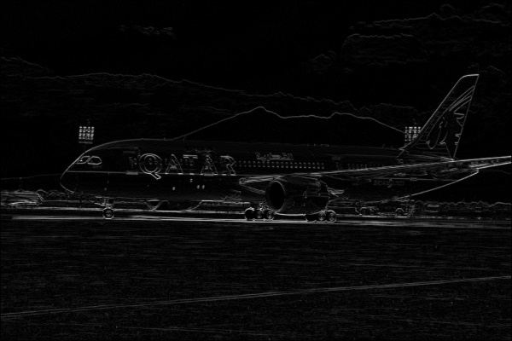

**Fig 4 :** Edge detection along y- direction using method 2

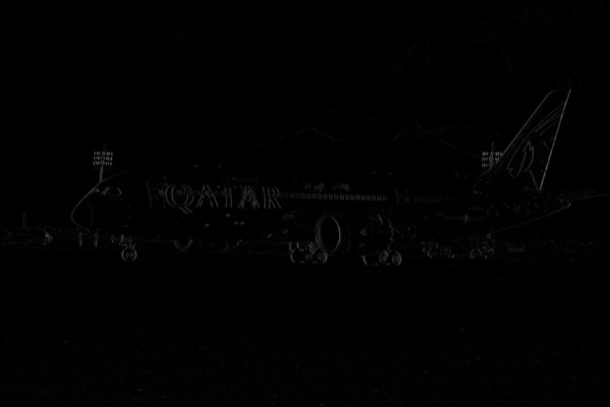

**Fig 5 :** Edge detection along x- direction by calculating the absolute value of x from method 1 and method 2

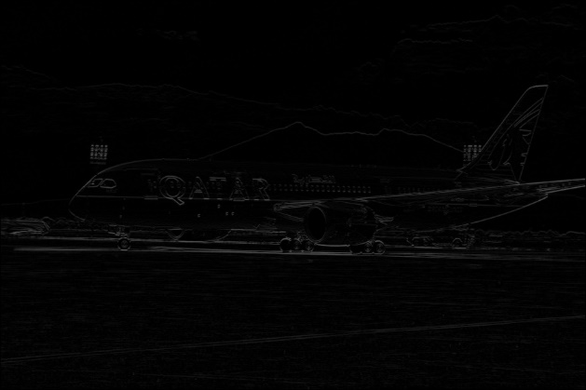

**Fig 6 :** Edge detection along x- direction by calculating the absolute value of y from method 1 and method 2

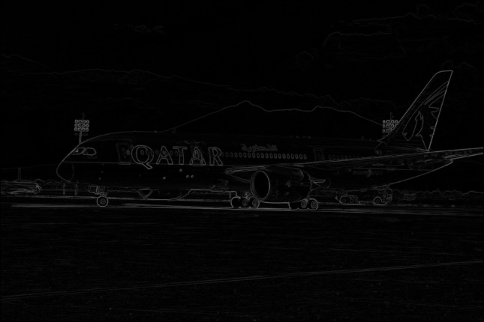

**Fig 7 :** Final image after merging the Sobel Kernel X’ output image and Sobel Kernel Y’ output image

**Keypoint Detection**

**Source code for Keypoint Detection**

import cv2

import numpy as np

import math

from math import pi as CONSTANT_PI, e as CONSTANT_E

img = 'C:/Users/Shraddha/Desktop/CVIP/Project_1/task2.jpg'

noOfOct = 4

imgsPerOct = 5

size = 7

acr_octaveRatio = 2

sigmaVal = (1/(math.sqrt(2)))

octaveRatio = (math.sqrt(2))

def detectImage(img, imageName):

cv2.imwrite('C:/Users/Shraddha/Desktop/CVIP/Project_1/OutputImage/Task2'+imageName+'.jpg', img)

return 1

cv2.imshow(imgTitle, img)

cv2.waitKey(0)

cv2.destroyAllWindows()

def convolve_image(img, kernel):

sizeOfKernel = (int)((kernel.shape[0])/2)

img_conv = np.zeros((img.shape[0], img.shape[1]))

for i in np.arange( sizeOfKernel, ((img.shape[0])-sizeOfKernel) ):

for j in np.arange( sizeOfKernel, ((img.shape[1])-sizeOfKernel) ):

temp = 0

for x in np.arange(-1, 2):

for y in np.arange(-1, 2):

coordinateOfKernel = kernel[x+sizeOfKernel, y+sizeOfKernel]

coordinateOfImg = img[i-x, j-y]

temp = temp + (coordinateOfImg*coordinateOfKernel)

img_conv[i][j] = temp

return img_conv

def getGaussianVal(k, sigma):

if (k%2==0):

k=k+1

kernelSizeHalf = (int)(k/2)

l=-1*kernelSizeHalf

h=kernelSizeHalf

kernel = np.zeros((k, k))

sum=0

for i in np.arange( l, h+1 ):

for j in np.arange( l, h+1 ):

kernel[i+kernelSizeHalf][j+kernelSizeHalf] = (1/( 2*(CONSTANT_PI)*(sigma**2)*( (CONSTANT_E)**( ( ((i)**2)+((j)**2) )/( 2*(sigma**2) ) ) ) ))

sum = sum + kernel[i+kernelSizeHalf][j+kernelSizeHalf]

for i in np.arange( l, h+1 ):

for j in np.arange( l, h+1 ):

kernel[i+kernelSizeHalf][j+kernelSizeHalf] = (kernel[i+kernelSizeHalf][j+kernelSizeHalf]) / sum

return kernel

def resize(img, factor=0.5):

resized_img = np.zeros(( (int)((img.shape[0])*factor) , (int)((img.shape[1])*factor) ))

for resized_img_i in range(0, resized_img.shape[0]):

for resized_img_j in range(0, resized_img.shape[1]):

a = (int)((1/factor)*resized_img_i)

b = (int)((1/factor)*resized_img_j)

resized_img[resized_img_i][resized_img_j] = (int)(img[a][b])

return resized_img

def main():

original_img = cv2.imread(img,0)

# Step 1 - Creating Scale Space images

scaleSpace = []

for i in range(0, noOfOct):

temp=[]

for j in range(0, imgsPerOct):

temp.append(None)

scaleSpace.append(temp)

octaveSigma_startingValue = sigmaVal / acr_octaveRatio

for octaveIndex in range(0, noOfOct):

octaveSigma_startingValue = octaveSigma_startingValue * acr_octaveRatio

sigma = octaveSigma_startingValue / octaveRatio

for imageIndex in range(0, imgsPerOct):

if (imageIndex==0):

if (octaveIndex==0):

scaleSpace[0][0]=original_img

else:

scaleSpace[octaveIndex][0] = resize(scaleSpace[octaveIndex-1][0], factor=0.5)

else:

sigma = sigma * octaveRatio

gaussianKernel = getGaussianVal(size, sigma)

convoluted_img, convoluted_img_abs = convolve(scaleSpace[octaveIndex][imageIndex-1], gaussianKernel)

scaleSpace[octaveIndex][imageIndex] = convoluted_img

for octaveIndex in range(0, numberOfOctaves):

for imageIndex in range(0, imagesPerOctave):

detectImage(scaleSpace[octaveIndex][imageIndex], "ScaleSpace_"+str(octaveIndex)+"_"+str(imageIndex))

dogSpace = []

for i in range(0, numberOfOctaves):

temp=[]

for j in range(0, imagesPerOctave-1):

temp.append(None)

dogSpace.append(temp)

for octaveIndex in range(0, len(dogSpace)):

for imageIndex in range(0, len(dogSpace[0])):

currentDogSpace_l = (scaleSpace[octaveIndex][imageIndex]).shape[0]

currentDogSpace_b = (scaleSpace[octaveIndex][imageIndex]).shape[1]

dogSpace[octaveIndex][imageIndex] = np.zeros(( currentDogSpace_l , currentDogSpace_b ))

for i in range(0, currentDogSpace_l):

for j in range(0, currentDogSpace_b ):

dogSpace[octaveIndex][imageIndex][i][j] = abs(scaleSpace[octaveIndex][imageIndex+1][i][j] - scaleSpace[octaveIndex][imageIndex][i][j])

maxVal = dogSpace[octaveIndex][imageIndex][0,0]

for i in range(0, currentDogSpace_l):

for j in range(0, currentDogSpace_b):

if (maxVal<dogSpace[octaveIndex][imageIndex][i][j]):

maxVal=dogSpace[octaveIndex][imageIndex][i][j]

for i in range(0, currentDogSpace_l):

for j in range(0, currentDogSpace_b):

dogSpace[octaveIndex][imageIndex][i, j] = 255.0 * ( dogSpace[octaveIndex][imageIndex][i][j] / maxVal )

for octaveIndex in range(0, len(dogSpace)):

for imageIndex in range(0, len(dogSpace[0])):

detectImage(dogSpace[octaveIndex][imageIndex], "DOGSpace_"+str(octaveIndex)+"_"+str(imageIndex))

maxMinDogSpace = []

for i in range(0, numberOfOctaves):

temp=[]

for j in range(0, imagesPerOctave-3):

temp.append(None)

maxMinDogSpace.append(temp)

for octaveIndex in range(0, len(maxMinDogSpace)):

for imageIndex in range(0, len(maxMinDogSpace[0])):

maxMinDogSpace[octaveIndex][imageIndex] = np.zeros(( (dogSpace[octaveIndex][0]).shape[0] , (dogSpace[octaveIndex][0]).shape[1] ))

prevImage = dogSpace[octaveIndex][imageIndex]

currentImage = dogSpace[octaveIndex][imageIndex+1]

nextImage = dogSpace[octaveIndex][imageIndex+2]

for i in range(1, (currentImage.shape[0])-1):

for j in range(1, (currentImage.shape[1])-1):

currentPixelVal = currentImage[i][j]

compArray = []

k = -1

l = -1

while(k<2):

while(l<2):

compArray.append(prevImage[i+k][j+l])

compArray.append(currentImage[i+k][j+l])

compArray.append(nextImage[i+k][j+l])

l=l+1

k=k+1

minComp = min(compArray)

maxComp = max(compArray)

if (minComp!=0 and maxComp!=0 and (minComp==currentPixelVal or maxComp==currentPixelVal)):

maxMinDogSpace[octaveIndex][imageIndex][i][j] = 255

for octaveIndex in range(0, len(maxMinDogSpace)):

for imageIndex in range(0, len(maxMinDogSpace[0])):

detectImage(maxMinDogSpace[octaveIndex][imageIndex], "maxMinDogSpace_"+str(octaveIndex)+"_"+str(imageIndex))

main()

**Image Results for Keypoint Detection**

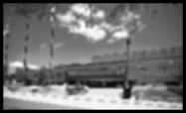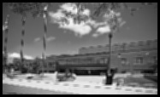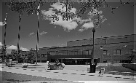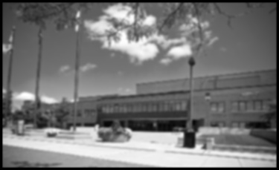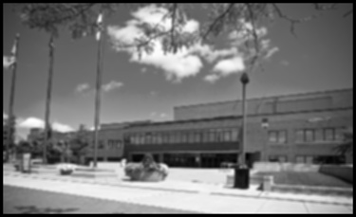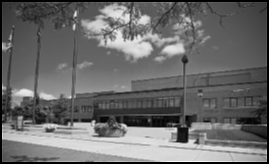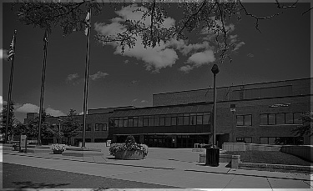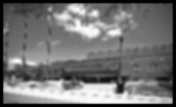

**Cursor Detection**

In this problem, I have applied Laplacian, Gaussian Convolution and then Image sharpening. So first I read the template and then I have applied Laplacian and after that I applied Gaussian to smoothen the image. Cursor is surrounded by rectangle in the template.

**Source code for Cursor Detection**

import numpy as np

import argparse, glob

import cv2

from cv2 import CV_8U as CONST_CV_8U, TM_CCOEFF as CONST_TM_CCOEFF, TM_CCORR as CONST_TM_CCORR

from scipy.ndimage.filters import gaussian_filter

negative_img = 10

positive_img = 15

templateLoc = 'C:/Users/Shraddha/Desktop/CVIP/Project_1/task3/template.png'

posImgLoc_prefix = 'C:/Users/Shraddha/Desktop/CVIP/Project_1/task3/pos_'

posImgLoc_suffix = '.jpg'

negaImgLoc_prefix = 'C:/Users/Shraddha/Desktop/CVIP/Project_1/task3/neg_'

negaImgLoc_suffix = '.jpg'

def detectImage(img, outImageName):

#imwrite() save a image to a specified file

cv2.imwrite('C:/Users/Shraddha/Desktop/CVIP/Project_1/OutputImage/Task3_'+outImageName+'.jpg', img)

return 1

cv2.imshow(imgTitle, img)

cv2.waitKey(0)

cv2.destroyAllWindows()

def main():

print("Process starts")

temp_img = cv2.imread(templateLoc,0)

temp_img = cv2.resize(temp_img , (13,18))

temp_img = cv2.Laplacian(temp_img, CONST_CV_8U)

temp_img = cv2.GaussianBlur(temp_img, (3,3),0)

sharpeningKernel = sharpeningKernel = np.array([ [-1,-1,-1], [-1, 9,-1], [-1,-1,-1] ])

for i in range(1, positive_img+1):

imgLoc = posImgLoc_prefix+str(i)+posImgLoc_suffix

print("Image at '"+imgLoc+"'")

o_test_img= cv2.imread(imgLoc,0) #loading the original test image from the specified location

test_img = o_test_img.copy()

test_img = cv2.Laplacian(test_img, CONST_CV_8U) #it calculates the Laplacian of an image

test_img = cv2.GaussianBlur(test_img, (3,3), 0) #Blurs an image using GaussianFilter

test_img = cv2.filter2D(test_img, -1, sharpeningKernel)

result = cv2.matchTemplate(test_img, temp_img, CONST_TM_CCOEFF)

min_val, max_val, min_loc, max_loc = cv2.minMaxLoc(result)

if (max_val>400000):

print(" Template Found")

o_test_img = np.dstack([o_test_img, o_test_img, o_test_img])

cv2.rectangle(o_test_img, (max_loc[0], max_loc[1]), (max_loc[0]+temp_img.shape[1], max_loc[1]+temp_img.shape[0]), (0, 255, 255), 2)

else:

print(" Template Not Found")

detectImage (o_test_img, "Pos"+str(i))

print("Positive images processed")

for i in range(1, negative_img+1):

if (i==7):

continue

imgLoc = negaImgLoc_prefix+str(i)+negaImgLoc_suffix

print("Image at '"+imgLoc+"'")

o_test_img = cv2.imread(imgLoc,0)

test_img = o_test_img.copy()

test_img = cv2.Laplacian(test_img, CONST_CV_8U)

test_img = cv2.GaussianBlur(test_img, (3,3), 0)

test_img = cv2.filter2D(test_img, -1, sharpeningKernel)

result = cv2.matchTemplate(test_img, temp_img, CONST_TM_CCOEFF)

min_val, max_val, min_loc, max_loc = cv2.minMaxLoc(result)

if (max_val>400000):

print(" Template Found")

o_test_img = np.dstack([o_test_img, o_test_img, o_test_img])

cv2.rectangle(o_test_img, (max_loc[0], max_loc[1]), (max_loc[0]+temp_img.shape[1], max_loc[1]+temp_img.shape[0]), (0, 255, 255), 2)

else:

print(" Template Not Found")

detectImage (o_test_img, "Neg"+str(i))

print("Negative images processed")

print("Process ends")

main()

**Image Results for Cursor Detection**

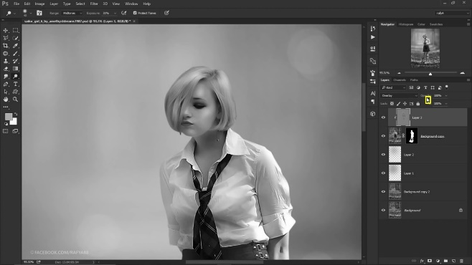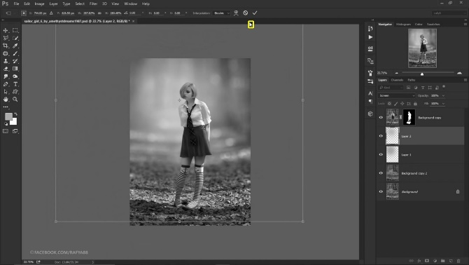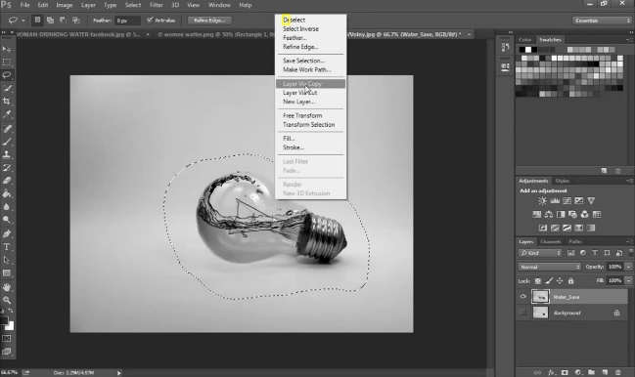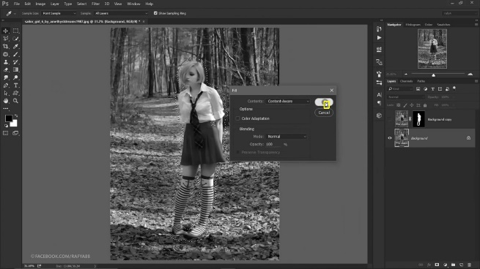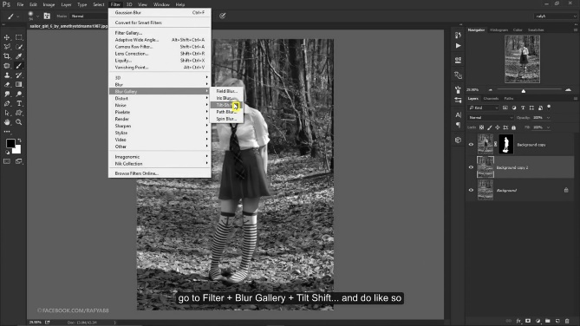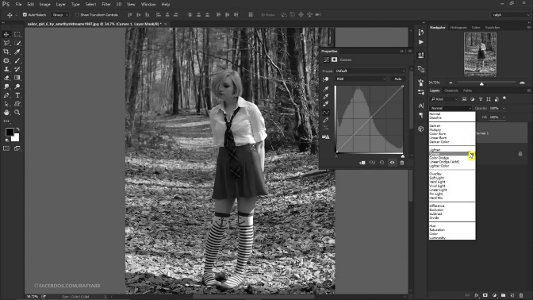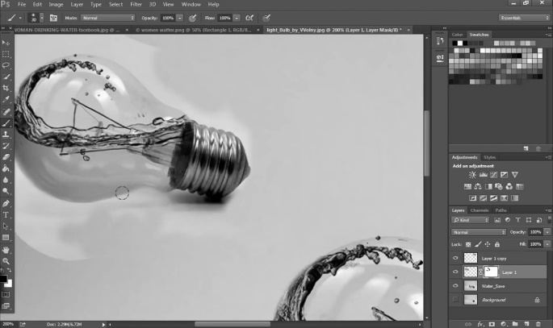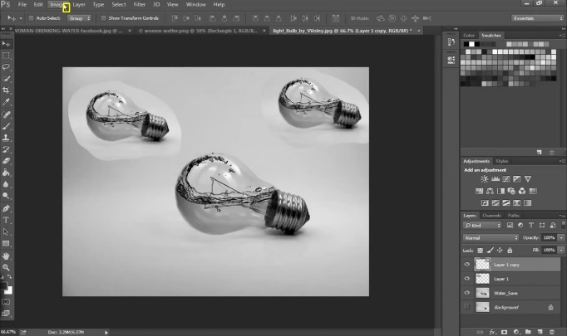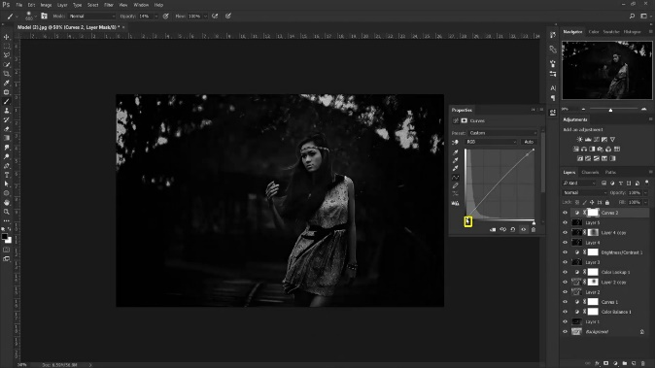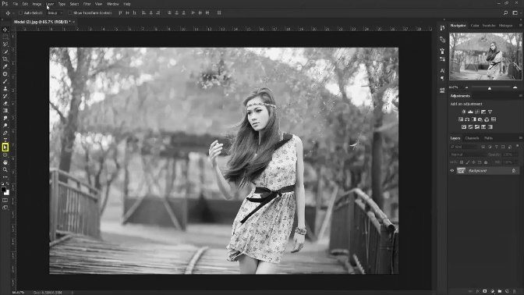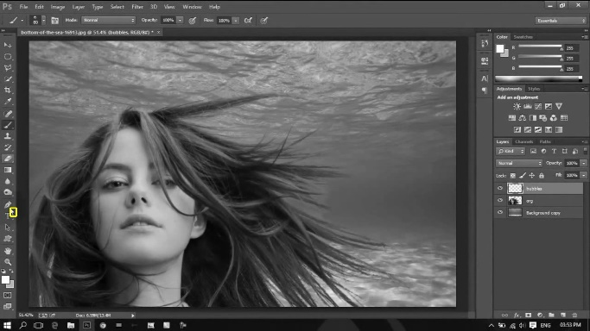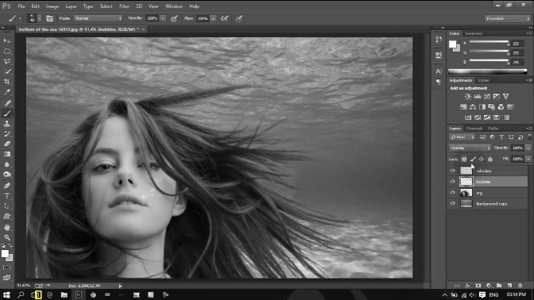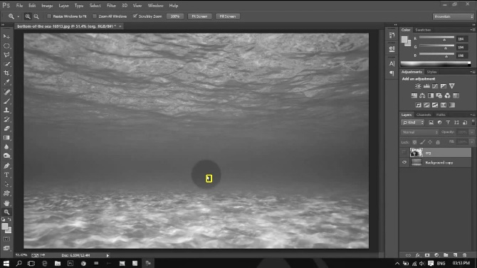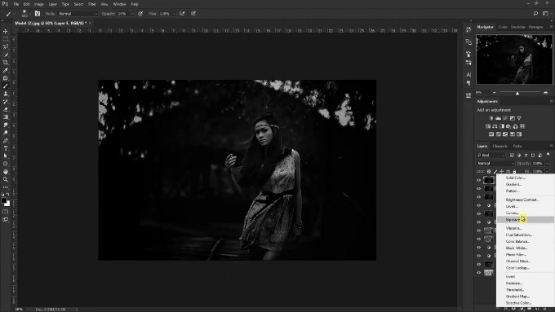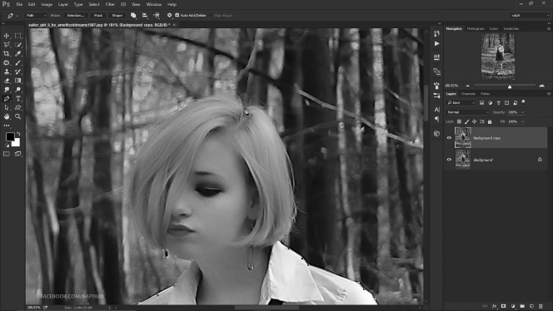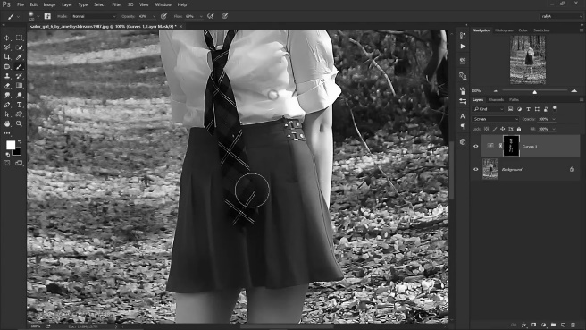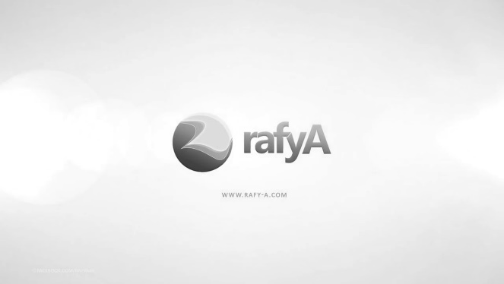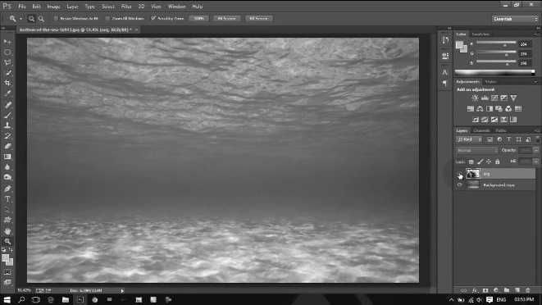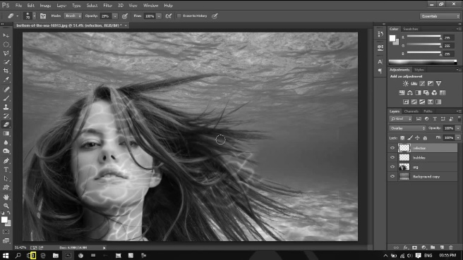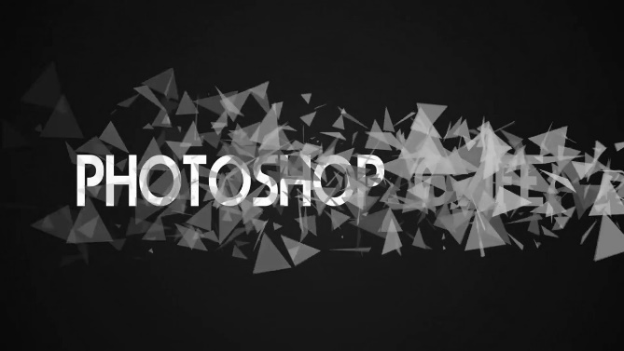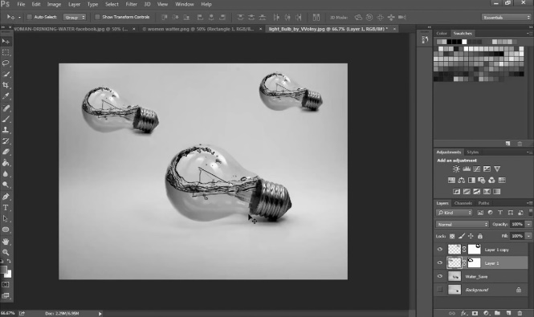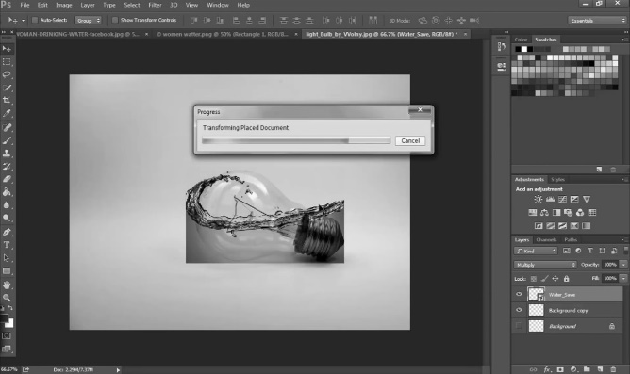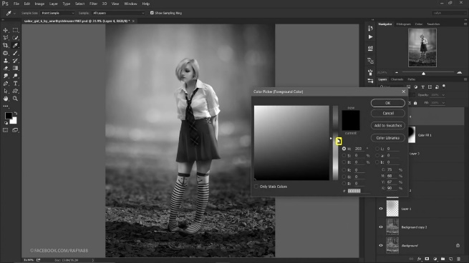

Expected output for all positive images : Template found

Expected output for all negative images : Template not found

|  |  |
| --- | --- |
| **Image name** | **Actual Output** |
| Pos_1.jpg | Template found |
| Pos_1.jpg | Template found |
| Pos_2.jpg | Template found |
| Pos_3.jpg | Template found |
| Pos_4.jpg | Template found |
| Pos_5.jpg | Template found |
| Pos_6.jpg | Template found |
| Pos_7.jpg | Template found |
| Pos_8.jpg | Template not found |
| Pos_9.jpg | Template found |
| Pos_10.jpg | Template found |
| Pos_11.jpg | Template found |
| Pos_12.jpg | Template found |
| Pos_13.jpg | Template found |
| Pos_14.jpg | Template found |
| Pos_15.jpg | Template found |
| neg_1.jpg | Template not found |
| neg_2.jpg | Template not found |
| neg_3.jpg | Template not found |
| neg_4.jpg | Template found |
| neg_5.jpg | Template not found |
| neg_6.jpg | Template not found |
| neg_7.jpg | Template not found |
| neg_8.jpg | Template not found |
| neg_9.jpg | Template not found |
| neg_10.jpg | Template not found |