MAX_EPSILON = 1 # the rate in which an agent randomly decides its action

MIN_EPSILON = 0.05 # min rate in which an agent randomly decides its action

LAMBDA = 0.00005 # speed of decay for epsilon

num_episodes = 10000 # number of games we want the agent to play

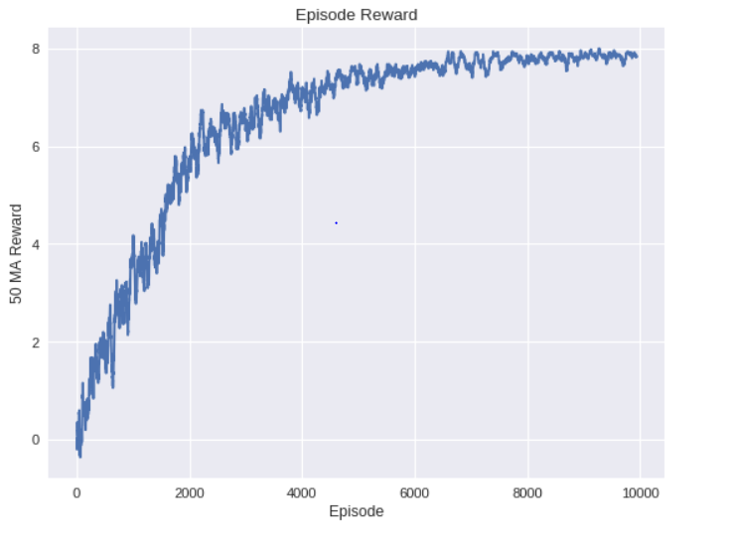

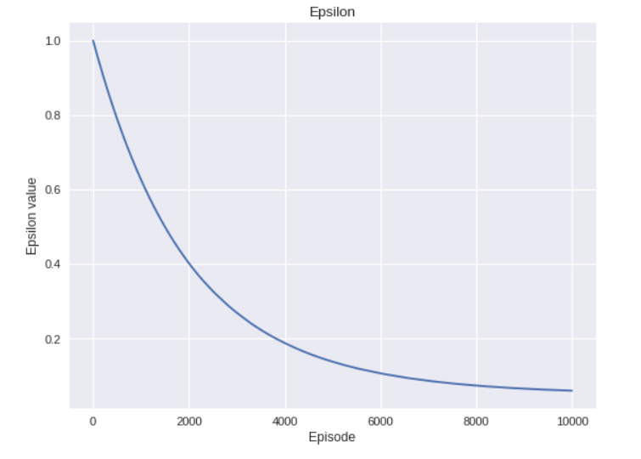

MAX_EPSILON = 1 # the rate in which an agent randomly decides its action

MIN_EPSILON = 0.05 # min rate in which an agent randomly decides its action

LAMBDA = 0.00005 # speed of decay for epsilon

num_episodes = 2000 # number of games we want the agent to play

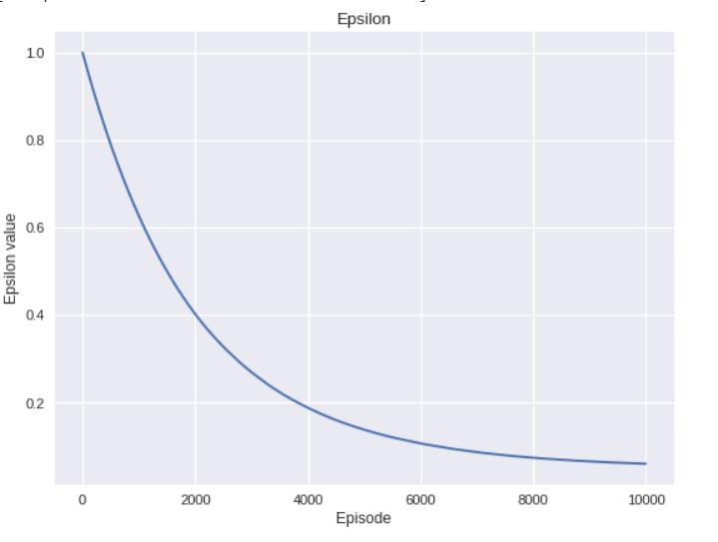

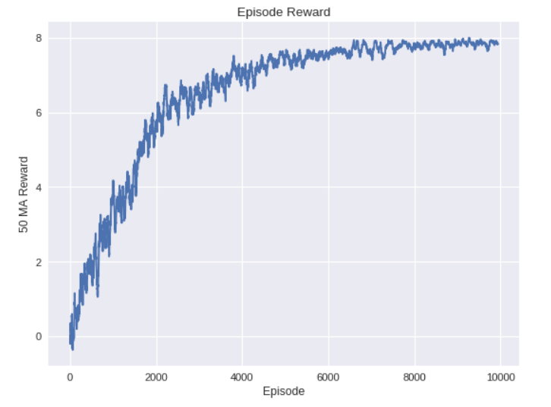

MAX_EPSILON = 1 # the rate in which an agent randomly decides its action

MIN_EPSILON = 0.05 # min rate in which an agent randomly decides its action

LAMBDA = 0.01 # speed of decay for epsilon

num_episodes = 2000 # number of games we want the agent to play

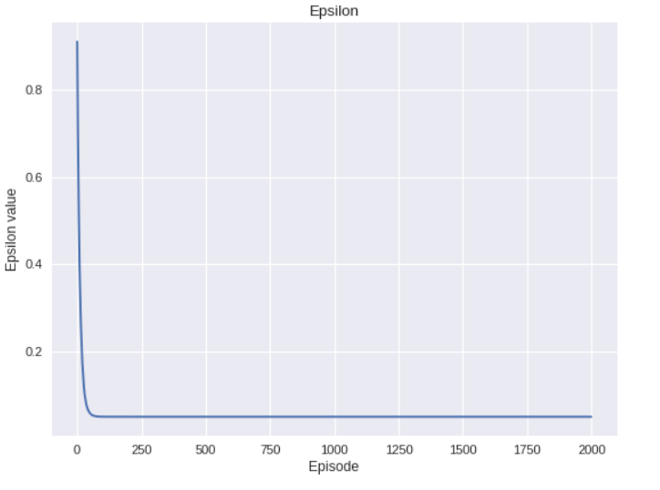

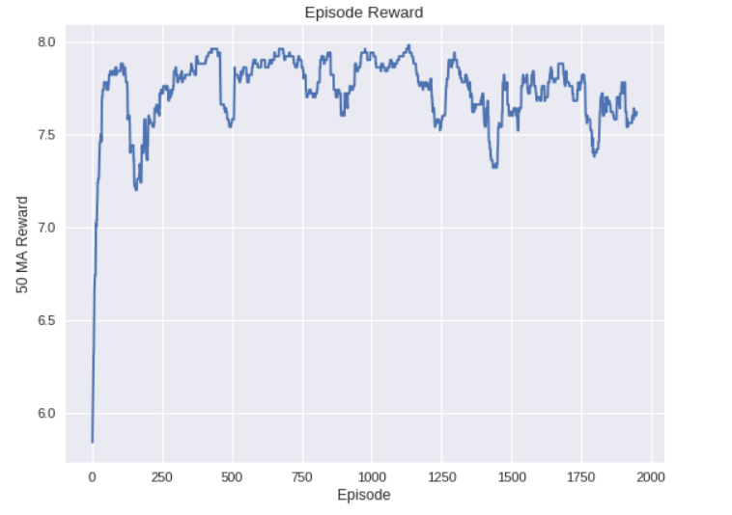

MAX_EPSILON = 1 # the rate in which an agent randomly decides its action

MIN_EPSILON = 0.1 # min rate in which an agent randomly decides its action

LAMBDA = 0.00005 # speed of decay for epsilon

num_episodes = 2000 # number of games we want the agent to play

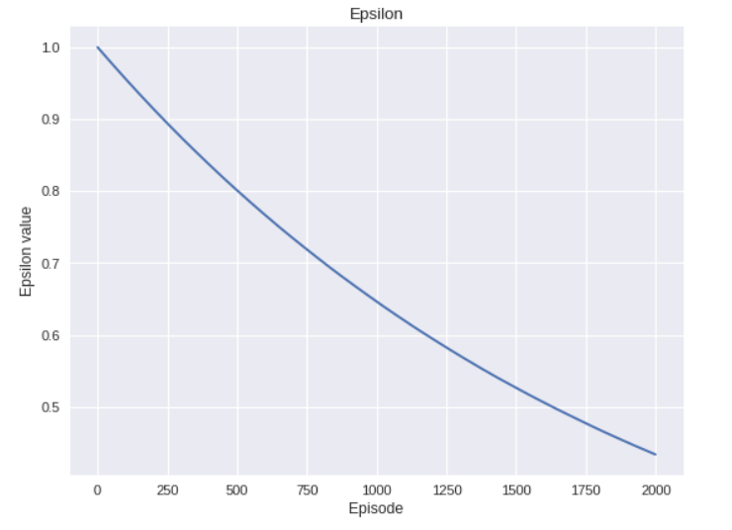

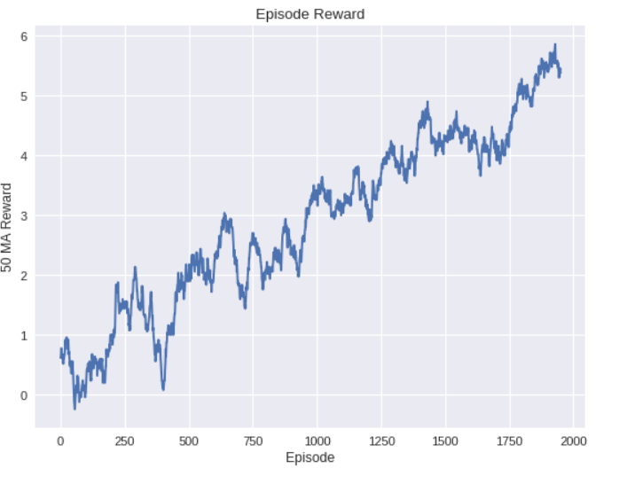

MAX_EPSILON = 10# the rate in which an agent randomly decides its action

MIN_EPSILON = 0.05 # min rate in which an agent randomly decides its action

LAMBDA = 0.00005 # speed of decay for epsilon

num_episodes = 10000 # number of games we want the agent to play

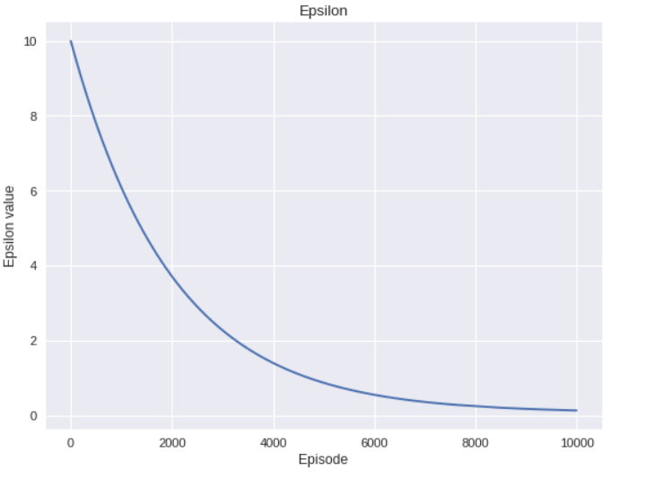

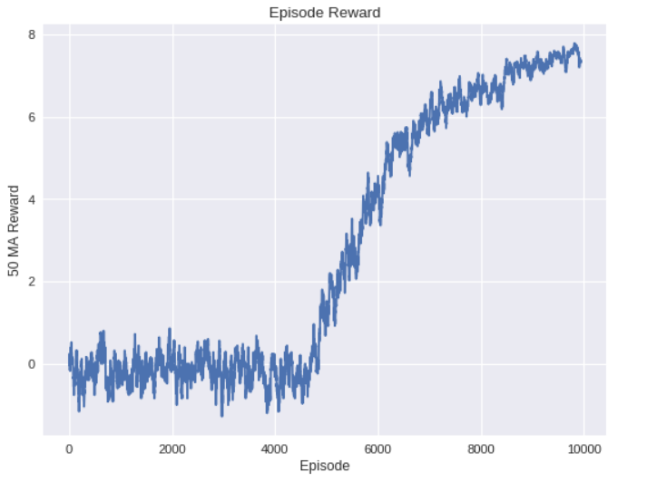

MAX_EPSILON = 1# the rate in which an agent randomly decides its action

MIN_EPSILON = 0.05 # min rate in which an agent randomly decides its action

LAMBDA = 0.00001 # speed of decay for epsilon

num_episodes = 10000 # number of games we want the agent to play

