**Payment Gateway UI Screenshots**

* Home page of Payment Gateway Application

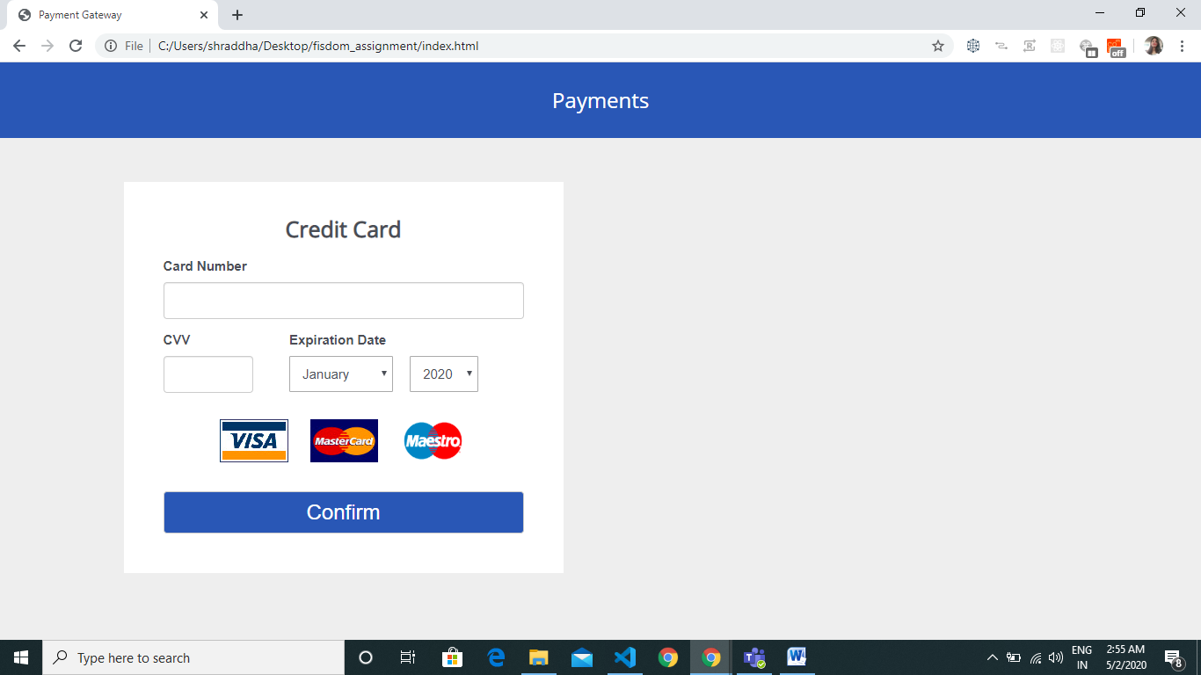

Continue…

* Showing alert if user enters CVV before card number
* Showing images of all supported card types

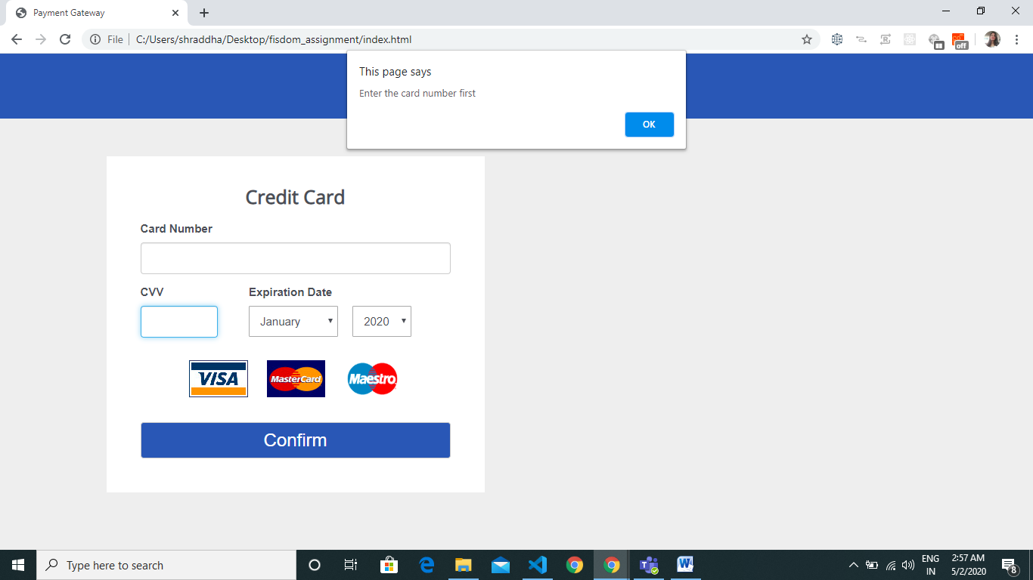

* Validation is implemented on blur event
* Entered card number is valid , so showing green border for card number field. For reference check the next image
* Detecting the card type based on entered card number and showing image of that card type
* Adding the space after every fourth digit
* Showing icon for card type, which changes dynamically with number.

Continue…

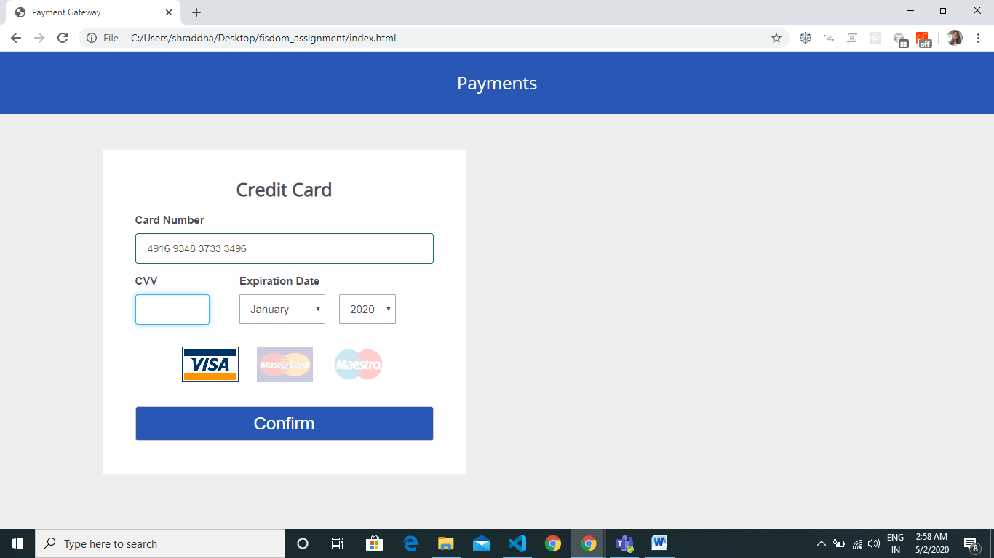

* Entered card number is invalid , so showing red border for card number field
* Entered card number length is not valid

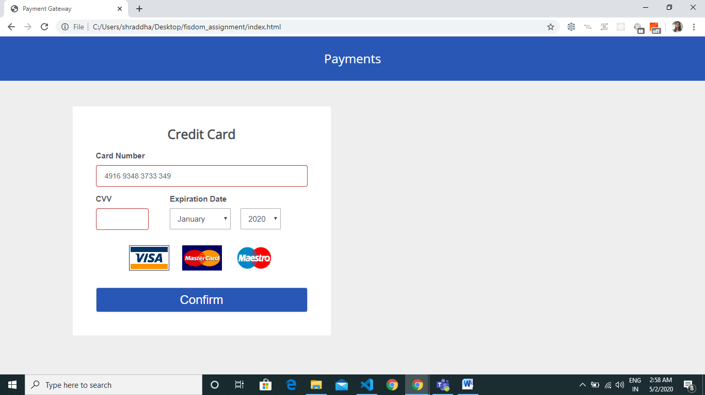

* CVV validation is failed, so showing red border
* Validation is implemented on blur event
* Implemented CVV masking
* CVV should not be plain-text.

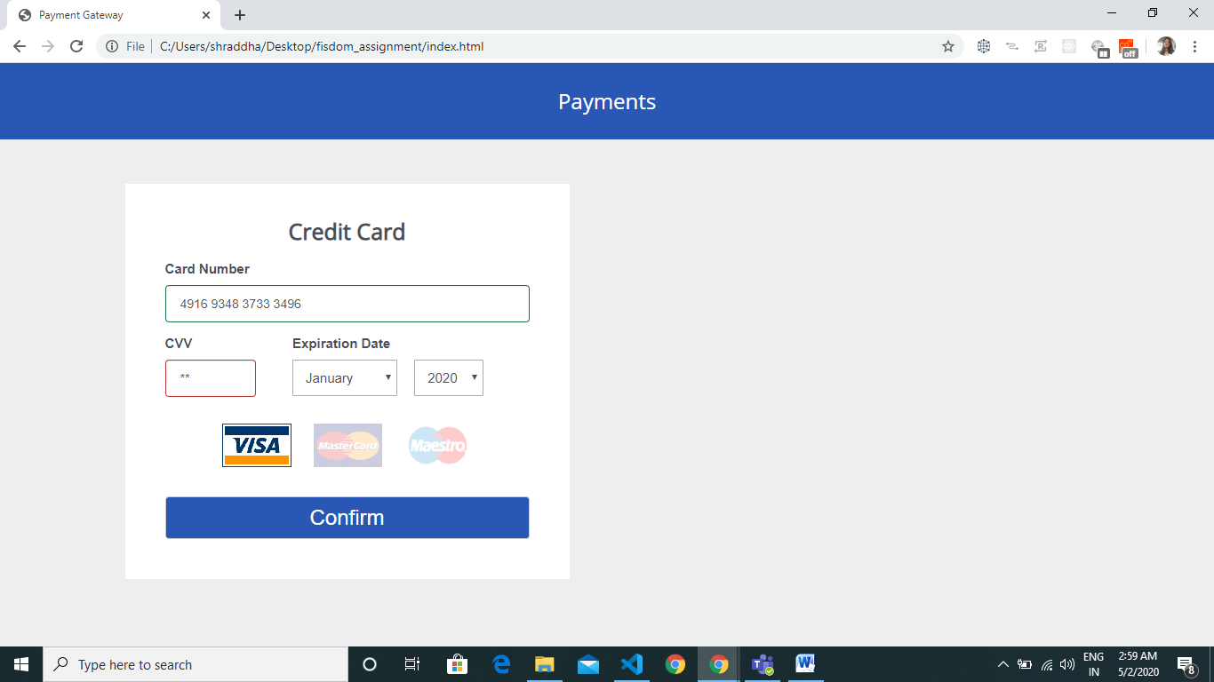

Continue…

* All the fields are valid , so showing green border

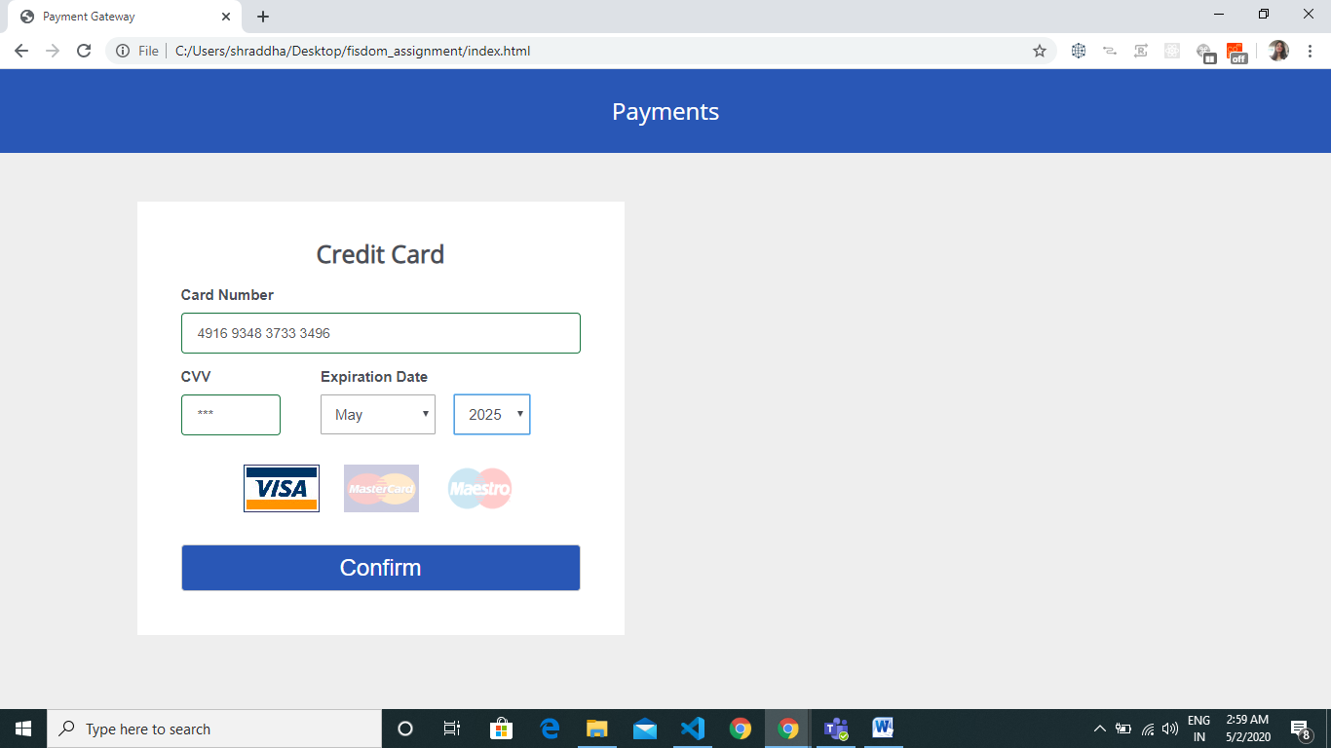

* Submitting the form and adding the card in to list of cards
* After submitting the form, resetting all the form fields

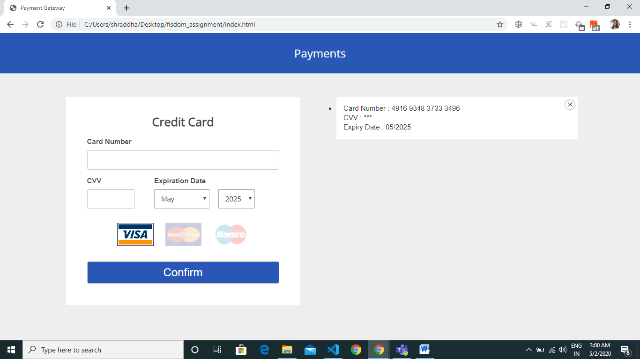

* Added four card (MasterCard , Visa, Maestro)

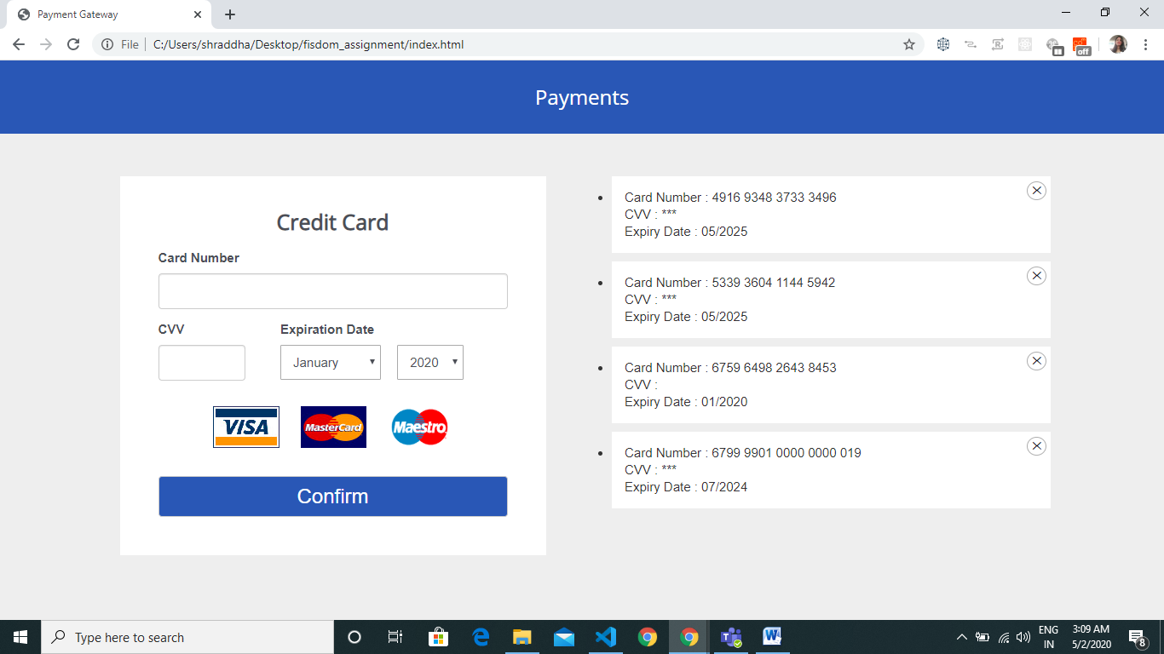

* Deleted one card from the list of cards

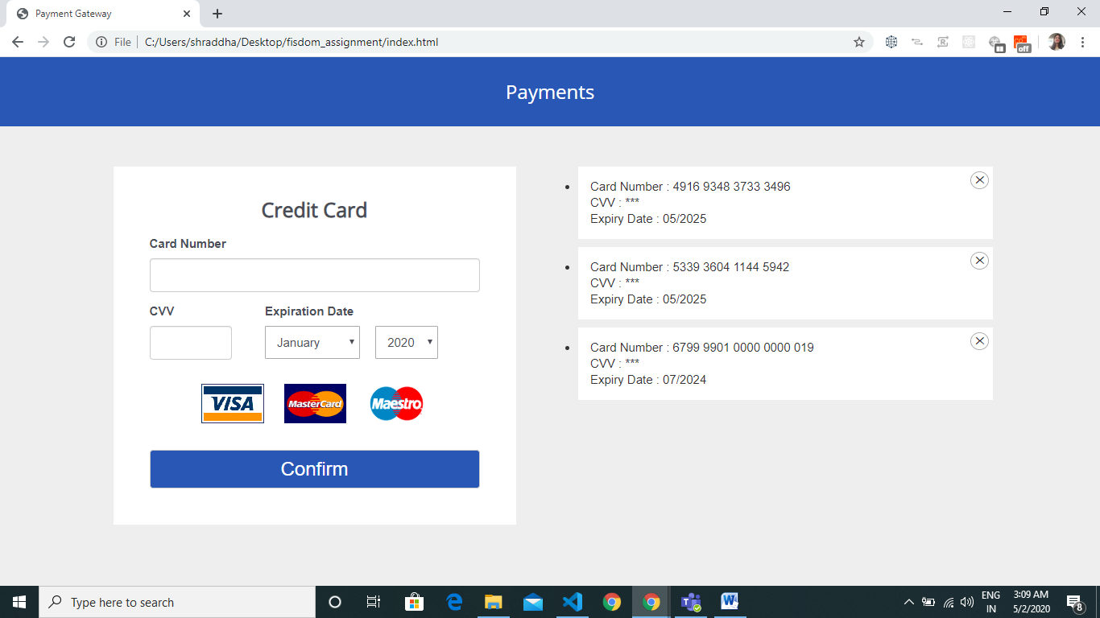

* Even after refreshing the browser/reloading the page user will able to see list of saved cards

