To Upload Html File in S3 And Use Static Website Hosting To Get Direct Link:

Step 1: Make an html file according to the website you want

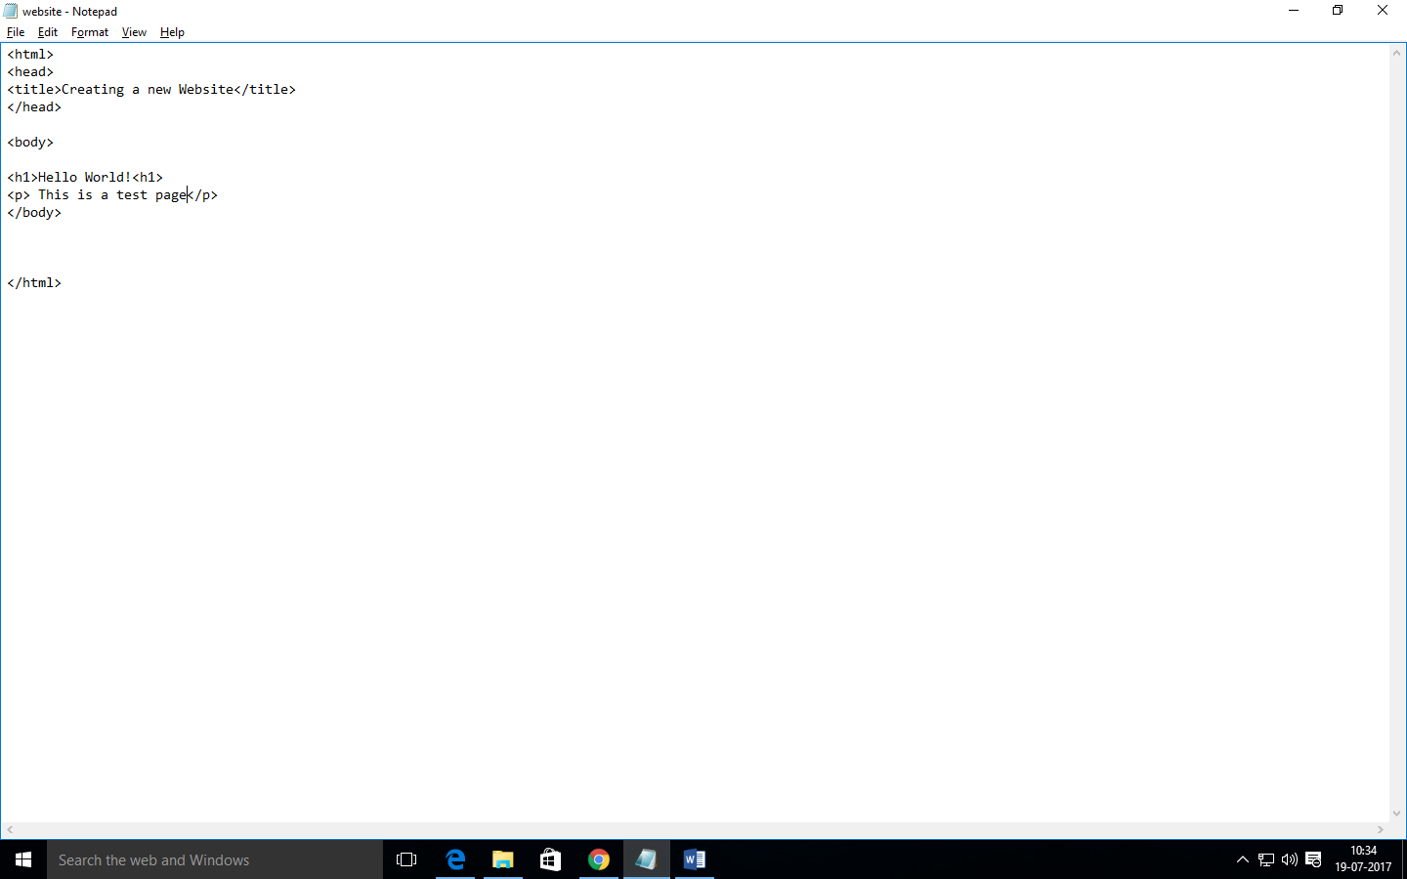

Step 2: Upload the html file in the S3 bucket

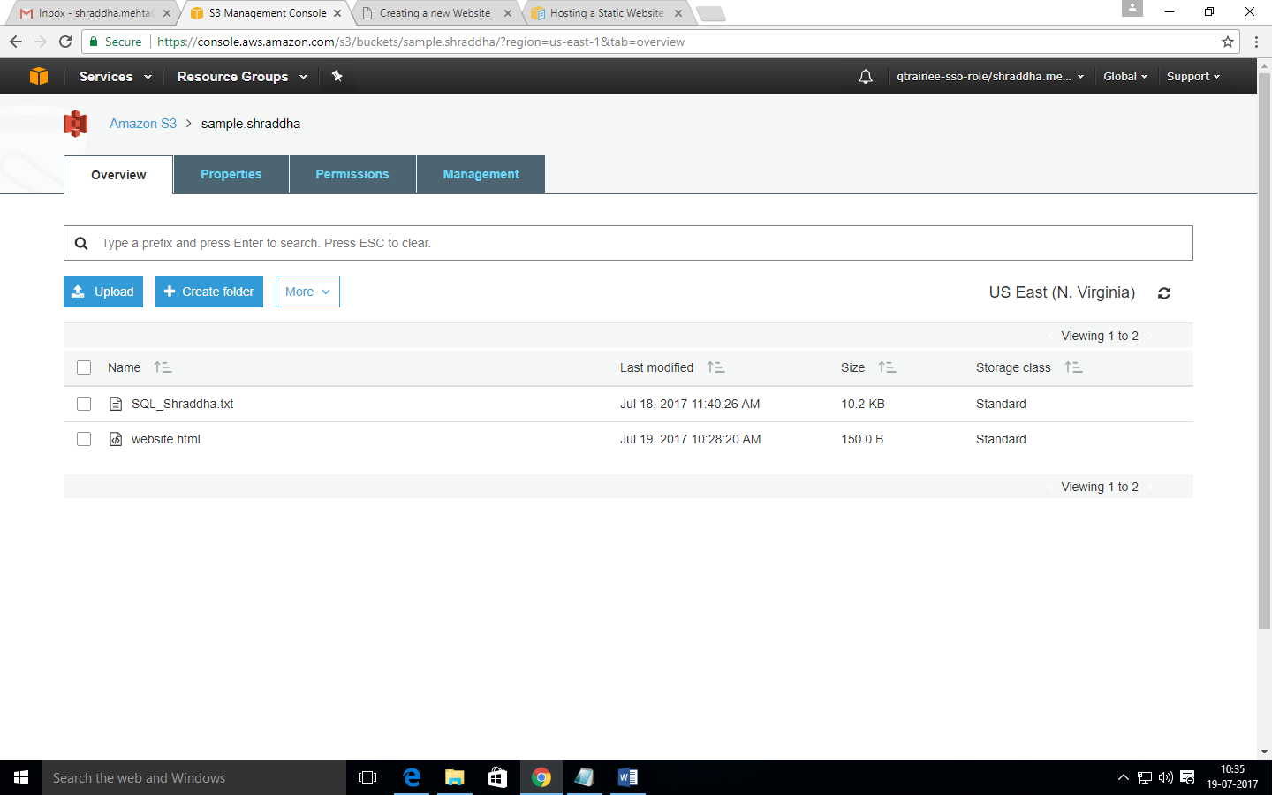

Step 3: Give the permission to make the file public

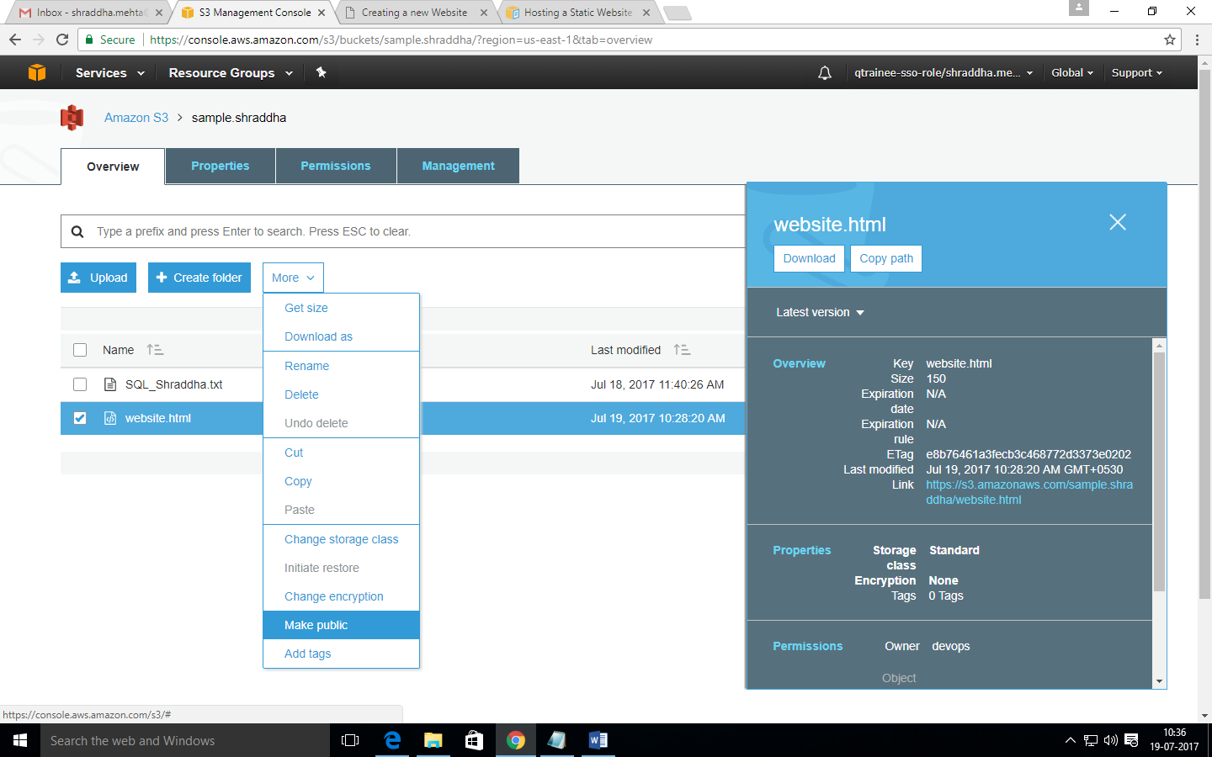

Step 4: Select ‘Use this bucket to host a website’ option in the Static website hosting (in Properties) and enter your html document’s name

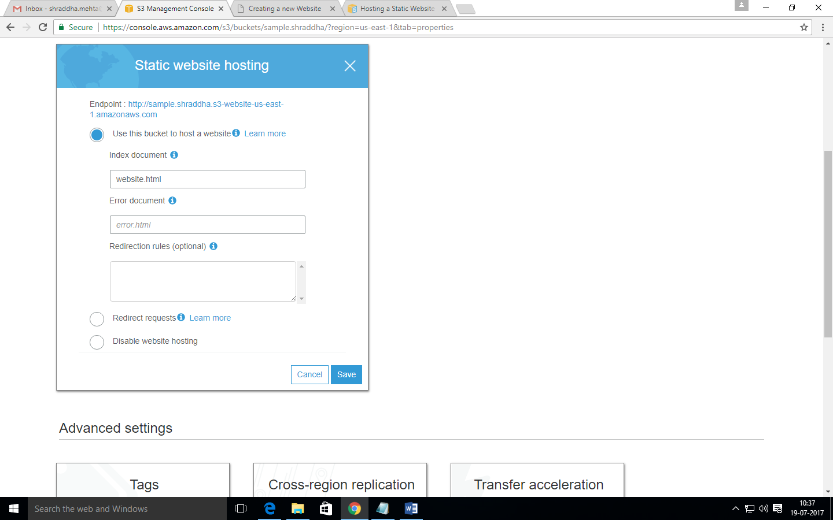

Step 5: You will find the link to your website at the top (see above)