1. I took the big dataset that was provided from our group seession DM-ver2-1.xlsx
2. Delete ‘Month’, ‘Year’ and application status columns

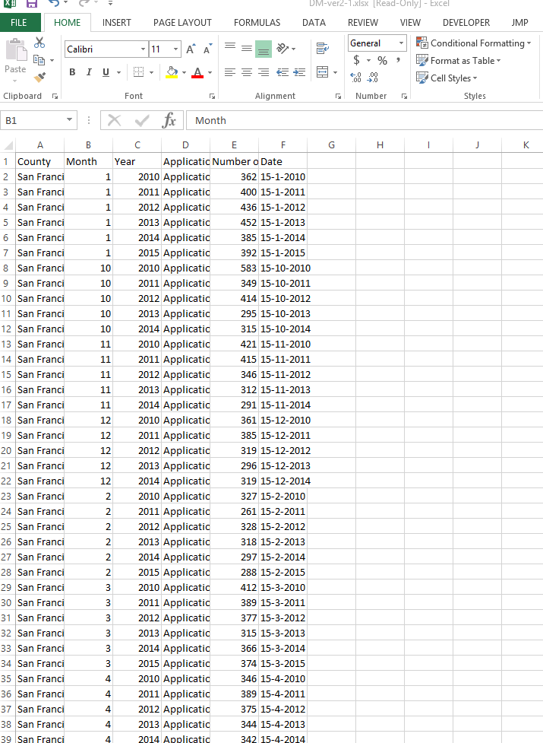

Highlight and save the remaining columns in a new spreadsheet:

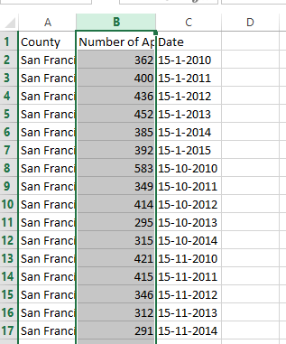

Open SAS guide and open the spreadsheet as a new project:

Select ‘Next’

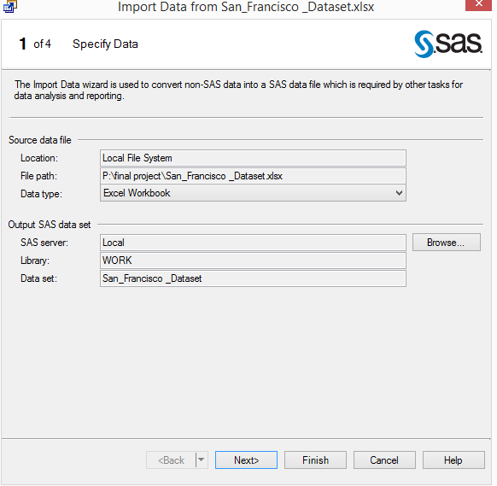

Check ‘Rename columns to comply with SAS naming conventions’ then click next

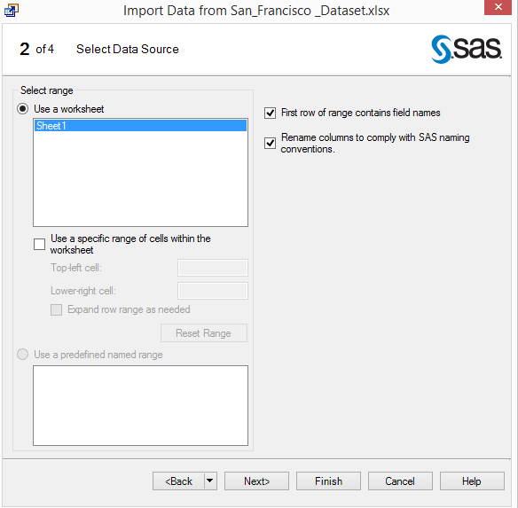

Set the Date column from ‘String’ to’ Date’ then click next

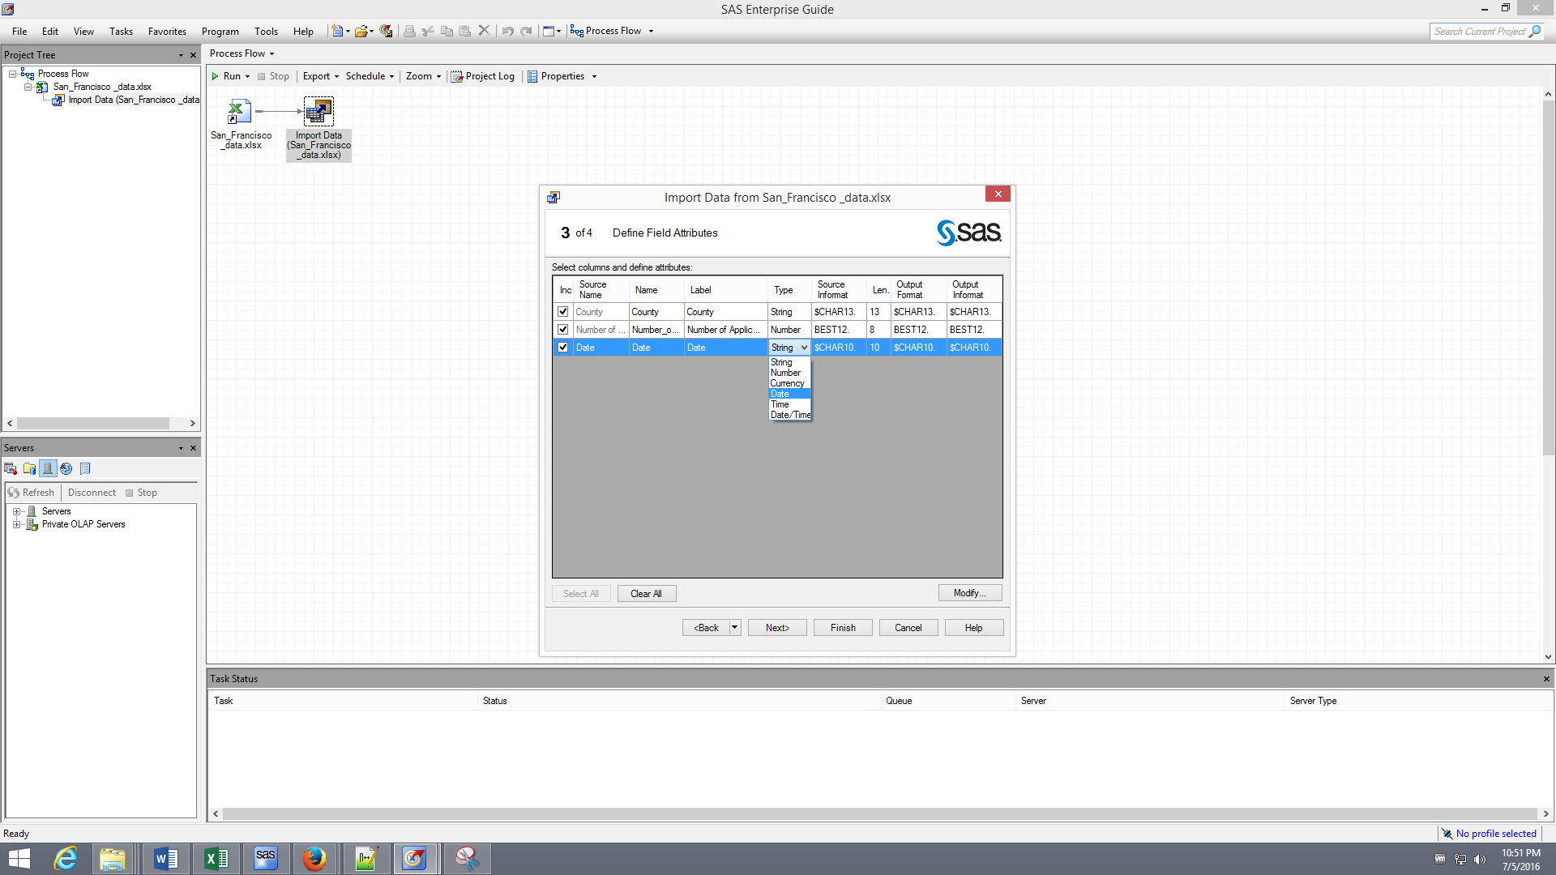

Check Embed ‘Embed the data within the generated SAS code’ and click finish and export the data file

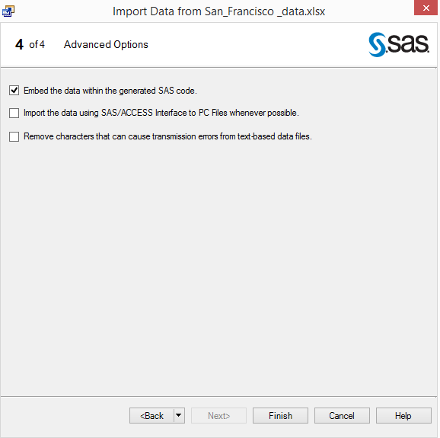

Open SAS to do the forecast

Left click on the ‘Create’ button

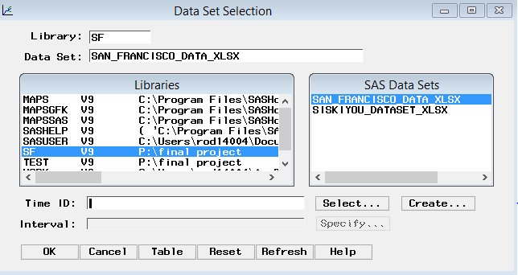

Select create from starting date and frequency

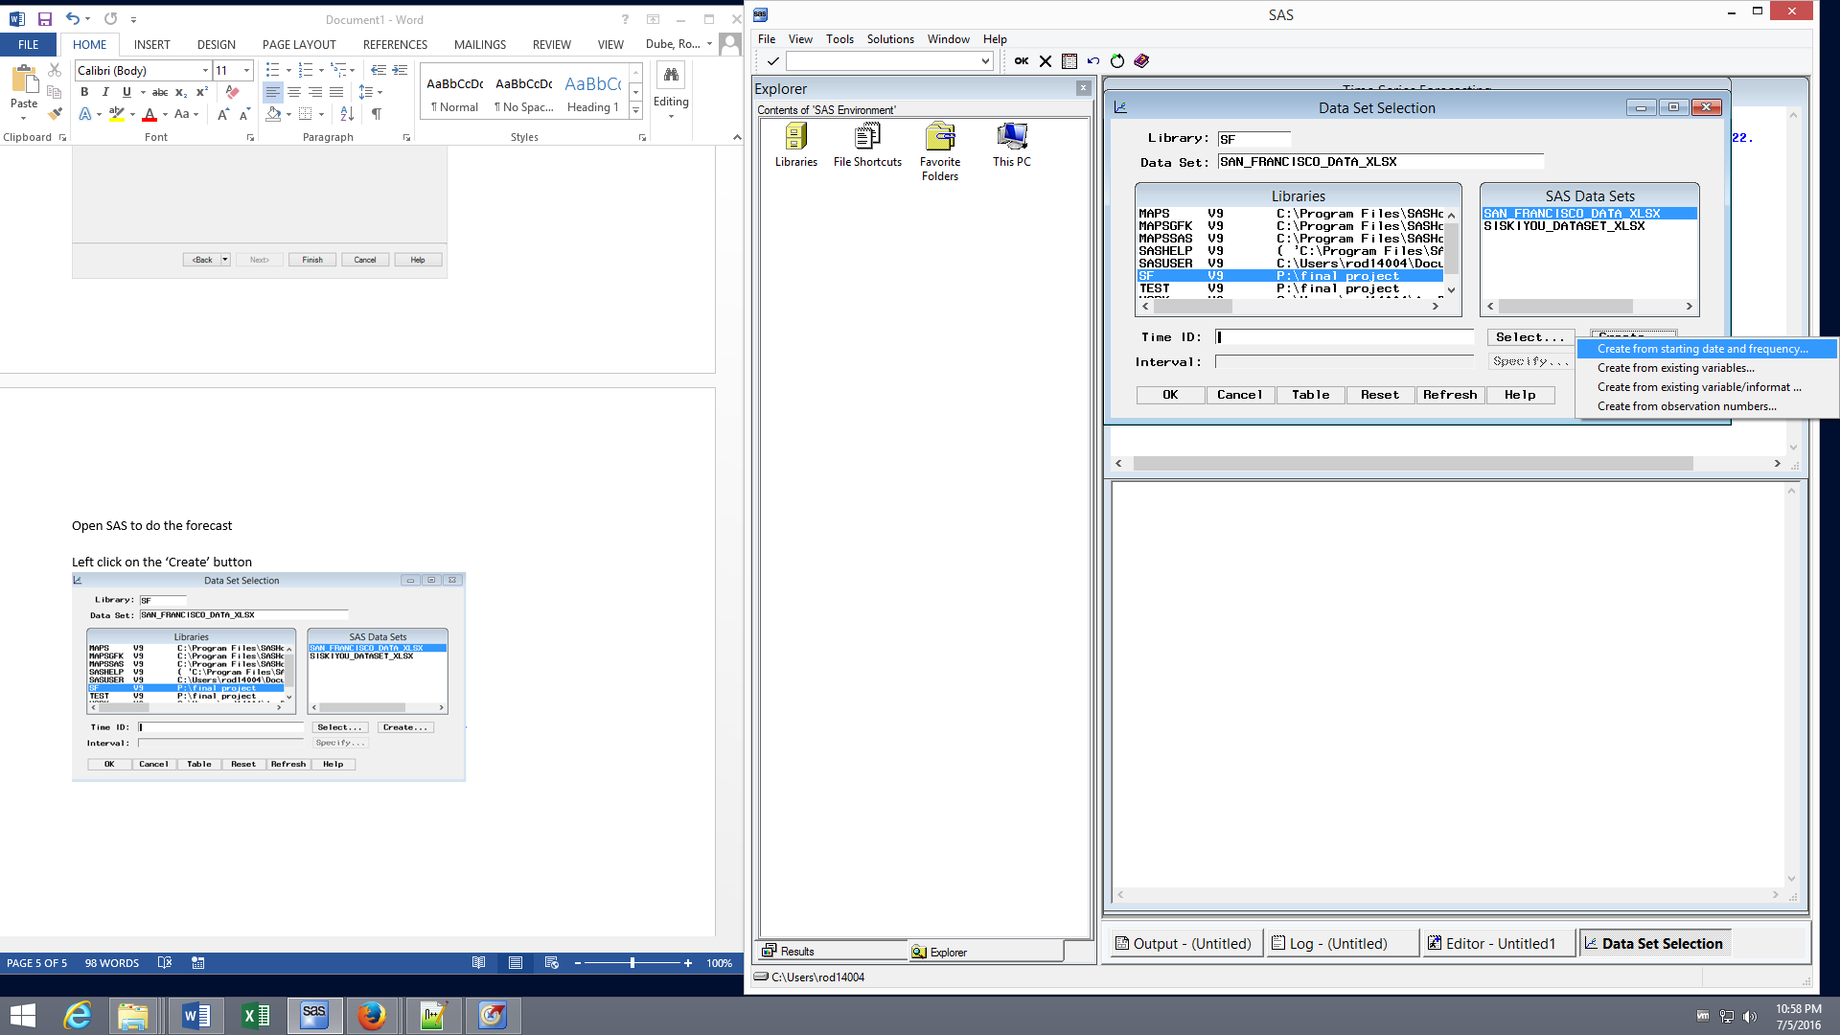

For starting date type in whatever your starting date is, in our case it is Jan2010 our interval is also month.

Select ‘OK’

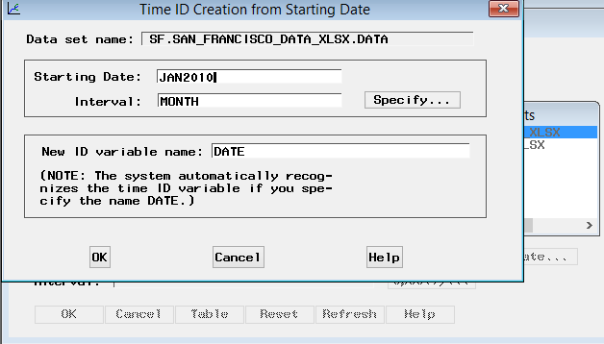

Select ‘OK’ again

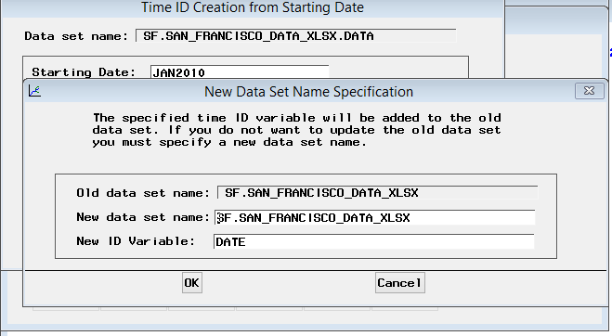

Now it is all set when you get to this screen click ‘OK’

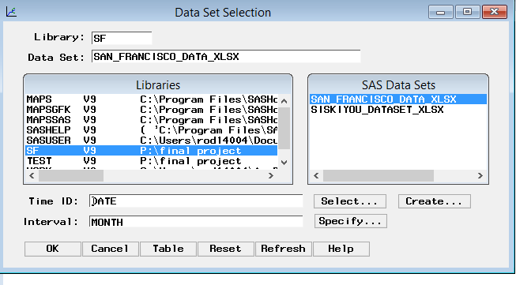

Go to view the series Graphically

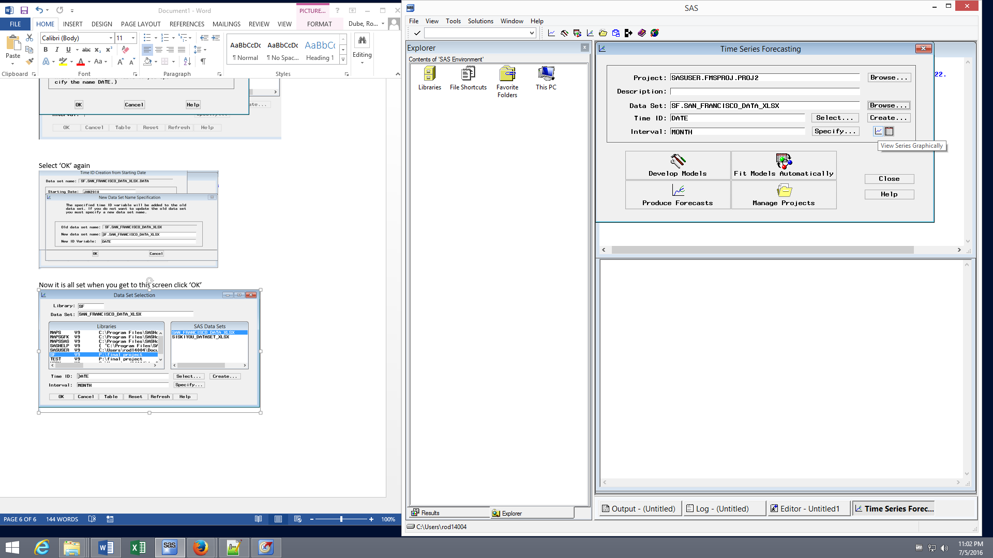

Select the appropriate variable, in this case it is the number of applicants and click graph

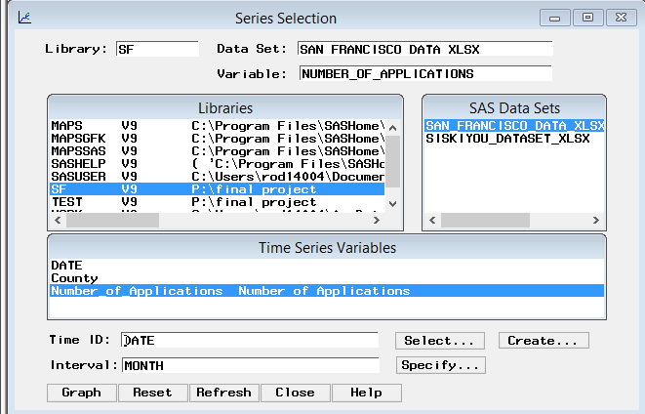

Now we are all set to model

