BUSINESS ANALYSIS AND ASSESSMENTS

ASSIGNMENT 3 –EXECUTIVE DASHBOARDS

|  |  |
| --- | --- |
| Submitted By: | Shraddha Shinde |
| Submission Date: | 01/08/2022 |
| Presentation Date: | 09/08/2022 |

**CONTENT**

1. Document Overview 3

2. Data Analysis 4

2.1. Data Dictionary 5

2.2. Data Quality 5

2.2.1. Date field 5

2.2.2. Market/Province/City consistency of stores 5

2.2.3. Calculated field consistencies 5

2.2.4. Store#, Date, Product uniqueness 6

3. Data Scope 7

3.1.1. KPQs: 8

4. Recommendations & conlcussions 9

5. Executive Dashboard 10

# Document Overview

**Background – The Coffee Cup**

You have been given data for a Canadian national coffee company called The Coffee Cup. The Coffee Cup provides coffee connoisseurs with a wide array of choices that satisfy discriminating palates, while providing prompt and courteous service.

The Coffee Cup’s core values are:

**PASSION FOR PEOPLE** - Respecting one another and creating a harmonious Bon environment

**PASSION FOR SERVICE** - Delivering our uncompromising Integrity, Quality, and Service with a Smile.

**PASSION FOR KNOWLEDGE** - Always staying relevant and ahead of the rest.

**PASSION FOR BUSINESS** - Providing the best in everything Bon.

Their mission statement is: “To provide the world’s ultimate coffee shop experience with the highest-quality products, most inviting stores, friendliest staff and best value.”

**OBJECTIVE**

Analyze the Coffee Cup Dataset and consider a few performance metrics to gain insights from the data which can help Sr. Management Team in decision making.

Performance metrics are as follows:

Cost of Goods, Coffee Store Performance, Customer Loyalty, Profits and Sales, Product Inventory, and any other metrics

# Data Analysis

Analyzing data to summarize important financial aspect of the company so that business decisions can be easily taken by managers and directors of the company

## Data Dictionary

|  |  |  |
| --- | --- | --- |
| Field Name | Datatype | Description |
| Profit | Number | Profit/ Loss data |
| Margin | Number | Margin value |
| Sales | Number | Sales data |
| Cost of Goods Sold | Number | Cost of Goods Sold value |
| Total Expenses | Number | Expenses |
| Marketing | Number | Marketing Expenses Value |
| Inventory | Number | Stock of each product |
| Budget Profit | Number | Expected Income value |
| Budget Margin | Number | Margin of safety |
| Budget Sales | Number | Total revenue in a specific time period |
| Budget COGS | Number | Cost of the production for the goods |
| City | String | City Names |
| Date | Date | Date in dd/m/yyyy format |
| Market | String | Market Names |
| Province | String | Province Names |
| Store | Number | Store Identification Number |
| Market Size | String | Size of Market |
| Product Type | String | Type of Products |
| Product | String | Product Names |
| No.of Stores | Number | Calculated Field |
| Expenses | Number | Calculated Field |

Table 2.1 Data dictionary for Coffee Cup Data

## Data Quality

We discovered various problems with the data during the analysis process, confirming the poor data quality. Here are some of them:

* Incomplete Data: The given file lacks document tracking, which would allow us to keep track of the date and time that the data was extracted.
* Uncertain Data: Uncertainty exists in several of the fields, such as the "Profit" field. It's unclear if the figure refers to "Net Profit," "Gross Profit," "Profit after Tax," etc.
* Profit Values are misleading as it contains negative values. It doesn’t specify the data it has is currency or number of products.

### Date field

* Incorrect Data: We discovered that the date 31/03/2012 was incorrectly recorded as 31/03/2019 after additional review of the data. This has impacted the accuracy of the information presented.
* Daily transactions are not in the database. It impacted in the accuracy of the analysis.
* Date field has values of month end dates only which may occur inaccurate analysis results.

### Market/Province/City consistency of stores

* We discovered lack of uniformity in stores across the market, province, and city
* Misleading Field Names: Some Field names are not clearly labelled and may be confusing. Such as “Product Type," "Product," and "Type" ,

“Market”, “Market Size”

### Calculated field consistencies

* Calculated fields are as follows:

1. No.of Stores = COUNT([Store])
2. Expenses = [Total Expenses]+[Cost of Goods Sold]

This calculated field seems consistent.

### Store#, Date, Product uniqueness

* Store#:
  + This field contains a store number and is not unique. Each Store must have unique identity number, which is missing in this dataset.
  + Also, there should be a Unique Selling Proposition (USP) which makes the business better than the competition. This is missing in the coffee cup business.
* Date:
  + Dates are not unique.
  + All the records are inserted at the end of every month which looses precise and accurate results of analysis.
* Product:
  + Products lower price, Faster delivery, Product Features, Emotional Connection makes product unique.
  + Product must have something unique feature. But it is missing in this dataset.

# Data Scope

Given data for a Canadian national coffee company called **The Coffee Cup** and a few performance metrics to consider are**: Cost of Goods, Coffee Store Performance, Customer Loyalty, Profits and Sales, Product Inventory.**

Coffee Cup has provided with a set of data dated during 2019 – 2020.

Their mission statement is:

**“To provide the world’s ultimate coffee shop experience with the highest-quality products, most inviting stores, friendliest staff and best value.”**

The Coffee Cup’s goal is to be the neighborhood coffee house you know and love, and you think of when you desire a freshly brewed cup of hot coffee or desire a specialty tea selection.

The Coffee Cup corporate values is to earn the trust and loyalty from their guests by showing what they believe in everyday by knowing what they stand for and acting in a way that supports it.

Data provides details of

|  |  |  |
| --- | --- | --- |
| * Profit | * Budget Profit | * City |
| * Margin | * Budget Margin | * Store# |
| * Sales | * Budget Sales | * Market Size |
| * Cost of Goods Sold | * Budget COGS | * Product Type |
| * Total Expenses | * Date | * Product |
| * Marketing | * Market | * Type |
| * Inventory | * Province |  |

### KPQs:

* What is **Total Profit**?
* What is **Total Sales**?
* What is **Total Margin**?
* What is **Total Cost of Goods Sold**?
* What is **Total Expenses**?
* What is **Inventory by Sales**?
* What is the **Total number of stores by Market**?
* What is the **Profit by Market**?
* What is the **Year over year growth**?

**The list of questions that data does not answer but should**

* Even though the dataset is giving information of the financial metrics it doesn’t provide any customer feedbacks or customer ratings which can be used to measure customer loyalty.
* Some of the fields are unclear for example we have a field named as “Profit”. It is not clear that whether its “Net Profit” or “Gross Profit” or “Profit after Tax” etc.
* What are the Number of Orders per Day also need to be in the data.
* Unique ID of each store is must.
* What is Price of each product?
* What is the discount criteria or discount amount need to be in the database.
* Data extracted date is not given which make it difficult for the executives to validate the data and make decisions
* Transaction Details like date, store ID, Customer ID, purchased product, Total bill amount will make analysis easy to evaluate and will come with solutions to every problem.

# Recommendations & conlcusions

**Recommendation:**

We discovered that data quality of Coffee Cup dataset is bad

**Gap in the data which needs to be addressed :**

* + Average spent by customer is not recorded
  + Information regarding number of customers billed is not recorded for analysis
  + Data extraction date should be made available with proper version controls.
  + More relevant data is required for year-on-year comparison.
  + Need much more clarity on data especially with respect to Profit
  + Customer feedbacks in terms of rating should be captured for analysis

**Conclusion:**

Though Data needs to be improved as per the above mentioned recommendations, we analysed about the Region and Products in Loss, Total Profit, Sales, Expenses and Cost of Goods sold.

This information leads us to the conclusion that the North market requires attention because it is generating less revenue. Also, some items have high expenses and low profits, thus attention should be paid to such.

# Executive Dashboard

# <https://public.tableau.com/app/profile/shraddha.shinde6955/viz/TheCoffeeCupDashboard_16593880024570/ExecutiveDashboard>

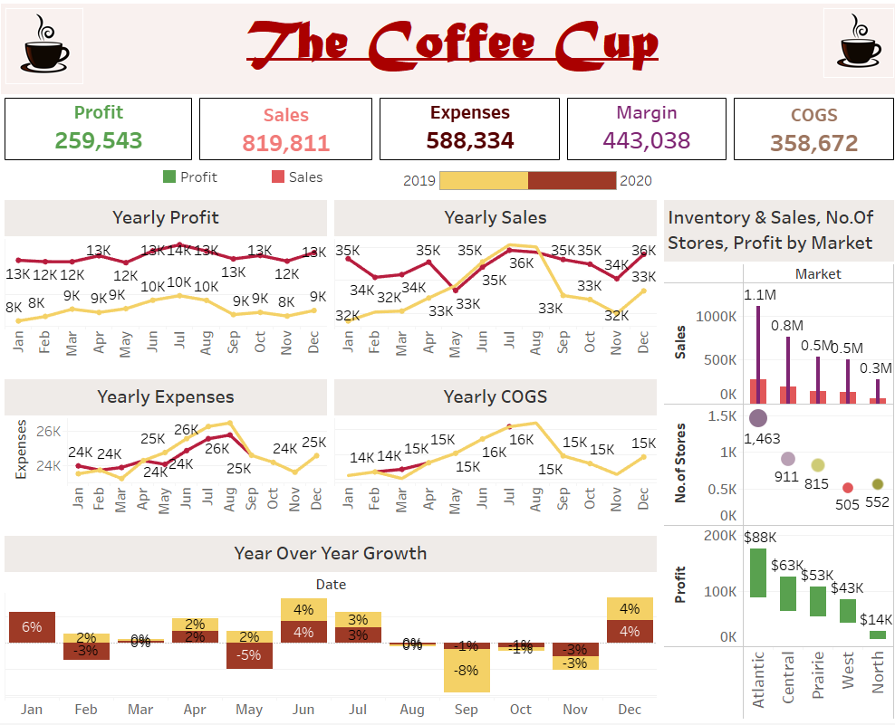

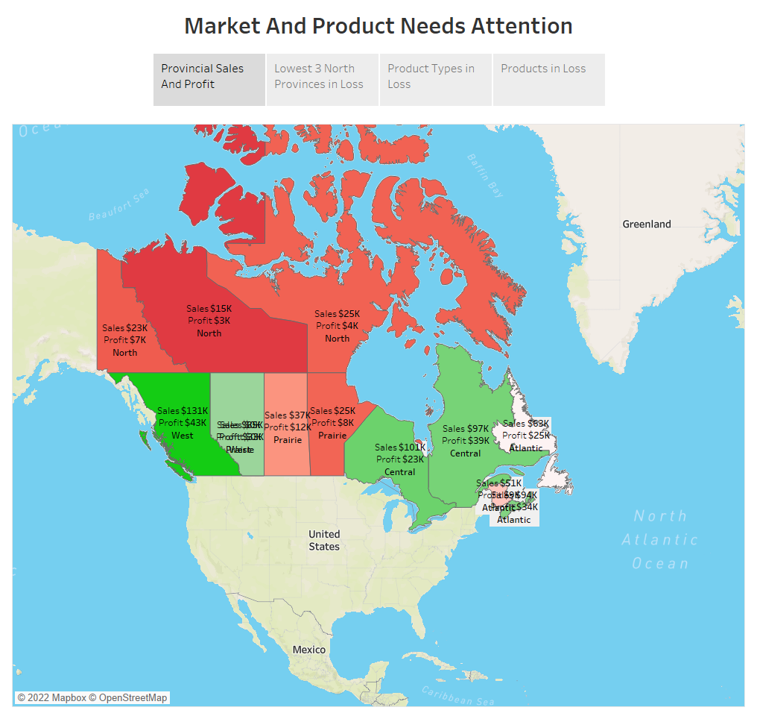

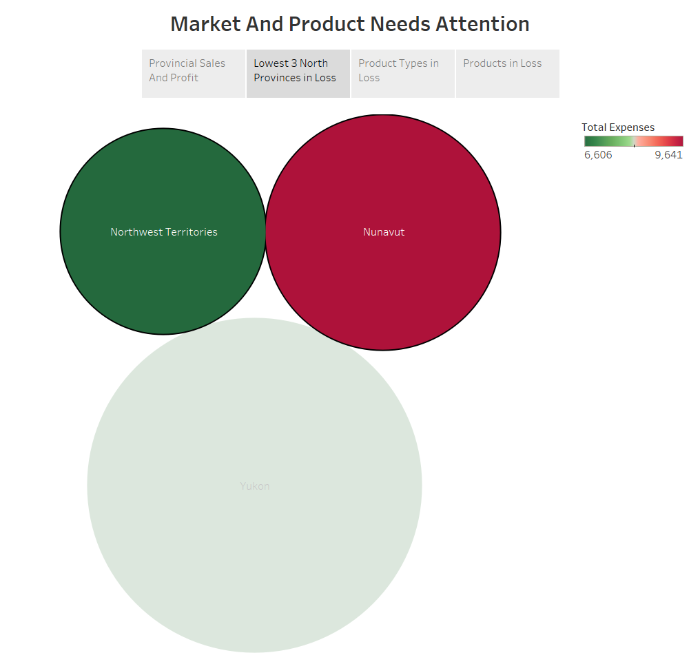

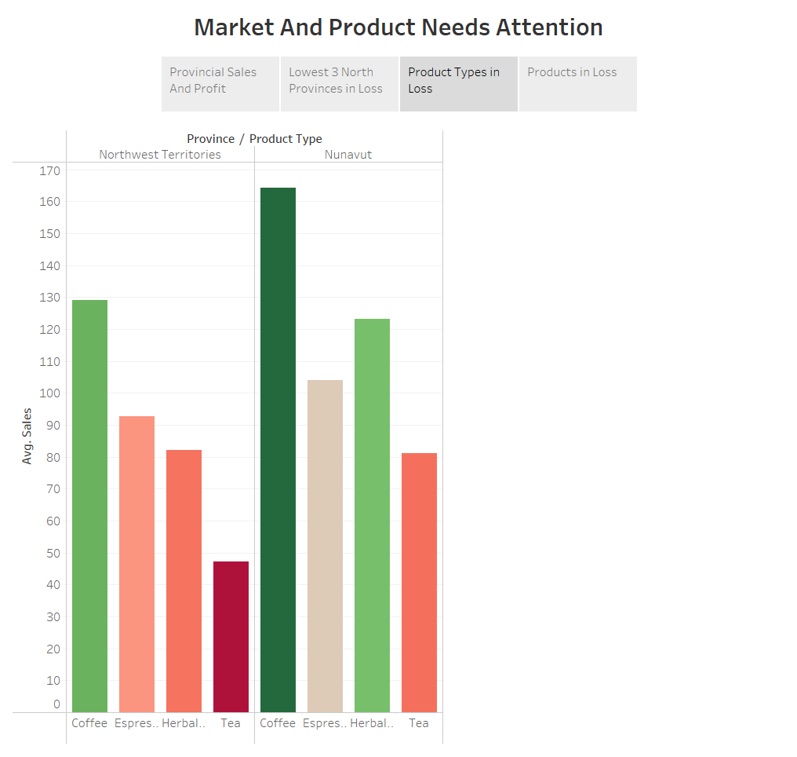

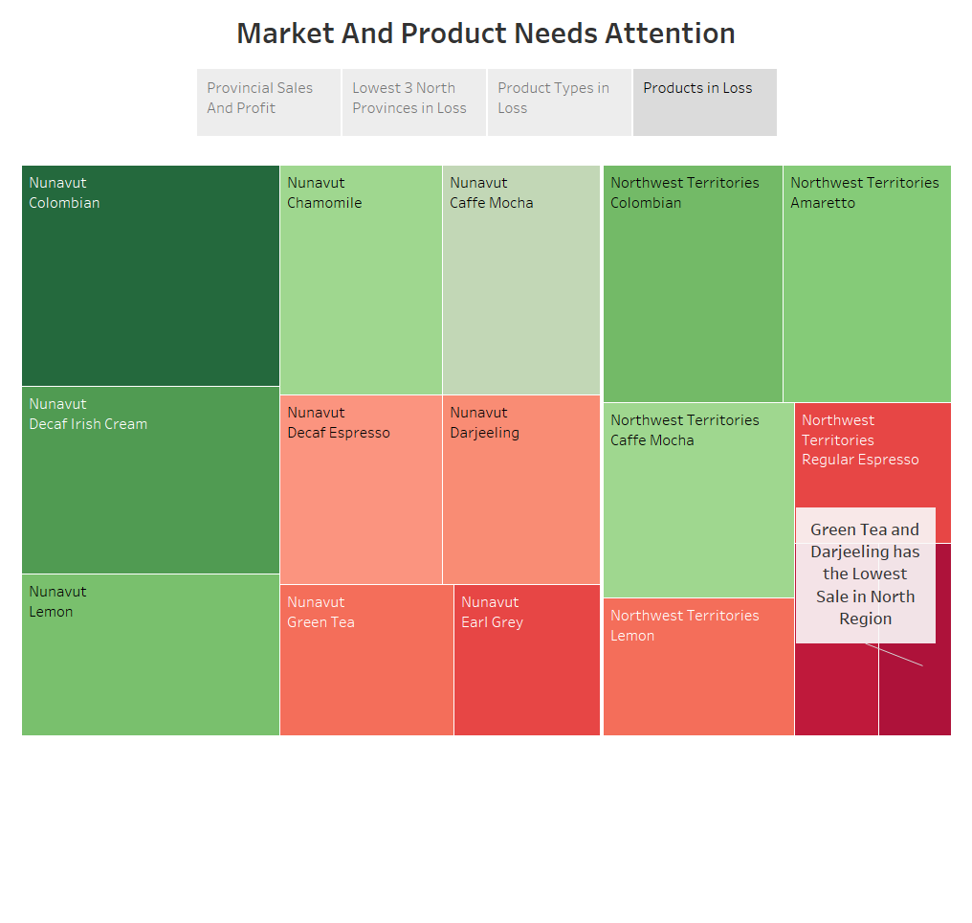

You can access the Tableau dashboard using the following link

# <https://public.tableau.com/app/profile/shraddha.shinde6955/viz/TheCoffeeCupDashboard_16593880024570/ExecutiveDashboard>

You can access the Tableau Story about which Market & Product Needs Attention using the following link

<https://public.tableau.com/app/profile/shraddha.shinde6955/viz/StoryTheCoffeCup/StoryMarketandProductsinLoss>