Sustainable Supply Chain Performance Dashboard using Power BI – P2BATCH _WEEKLY_ASSESMENT_1

STEP 1: Install Power BI from [www.google.com](http://www.google.com)   
 run the .exe file and setup the **Power BI desktop**

STEP2 : Open the **Power BI desktop** , which would look something like this

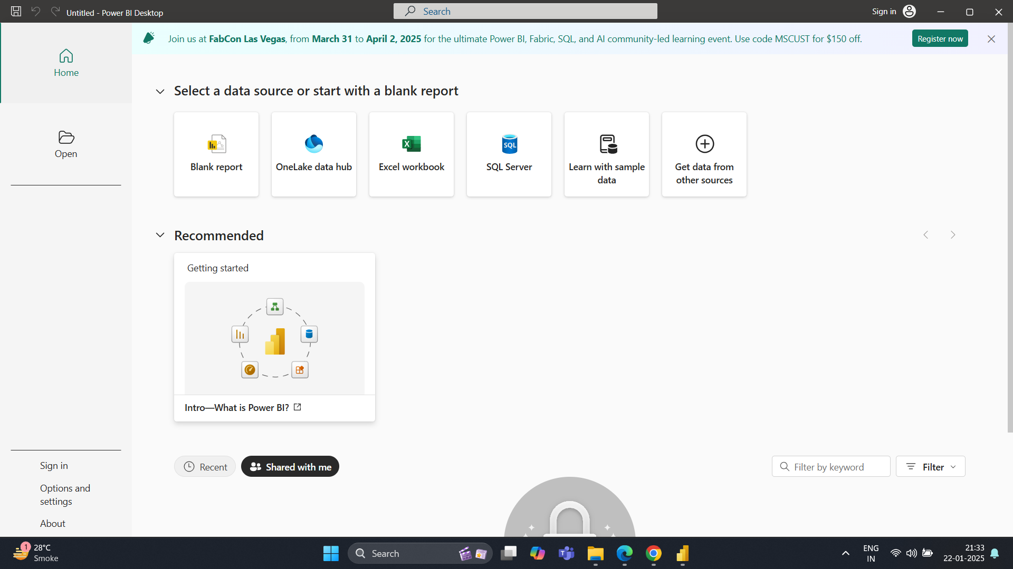

As we are new to this , for our project we need to select on **Blank Report**

STEP 3 : After Clicking on **Blank Repo**rt a Window would appear like this

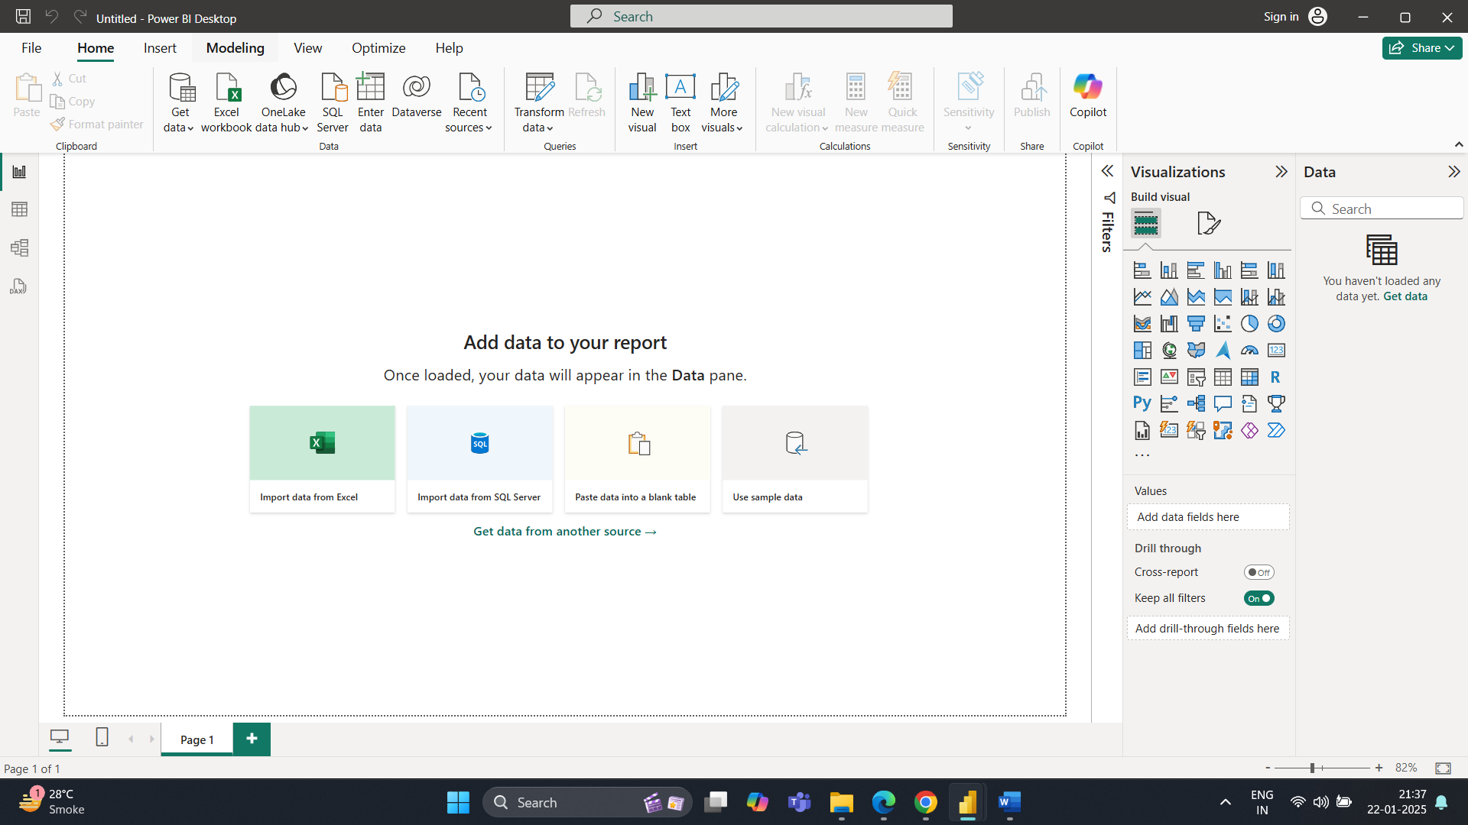

This whole is called as a **Power BI Desktop**

The large white space in between is called as **The Canvas**

STEP 4 : We then explore a lot many features of the **Power BI DESKTOP**

The right end of the corner called as **Visualizations** consists of various types of graphs , charts etc depending upon how we as a Data Analyst want to represent our data in a meaningful way.

The Desktop also consist of a task bar which has features such as Getting the data , Transforming the data , textbox etc

STEP 5 : To Perform any Analysis , Three steps to be followed EXTRACTION TRANSFORMATION AND LOAD [ ETL PROCESS]

STEP 5.A] EXTRACT - It is a process of pulling data from the data sources .

To extract the data in the Power BI Desktop , we have to select the Get Data option provided in the Taskbar .

After clicking the Get Data option , since our dataset is a .CSV file we select Text/CSV

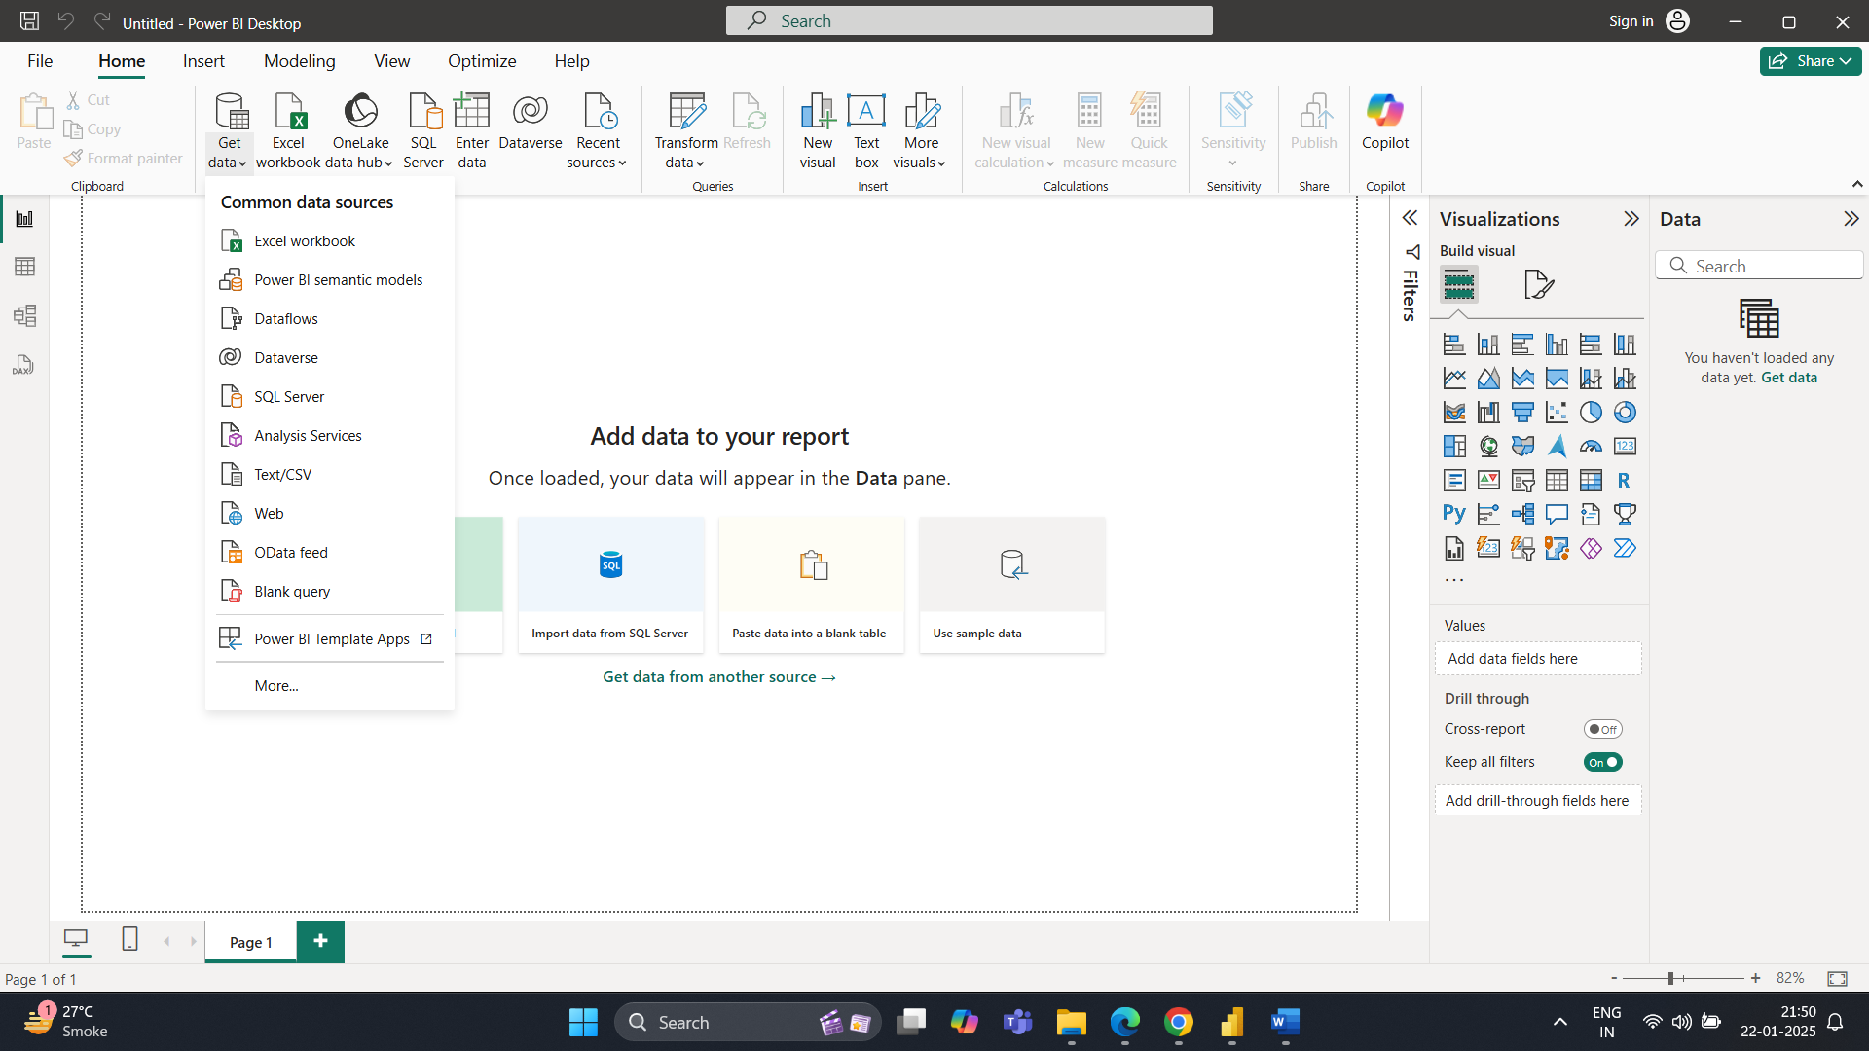

After Selecting Text/CSV a folder popup will appear

Select the csv file and click on Open

STEP5. B] LOAD : This step is essential for further analysis .

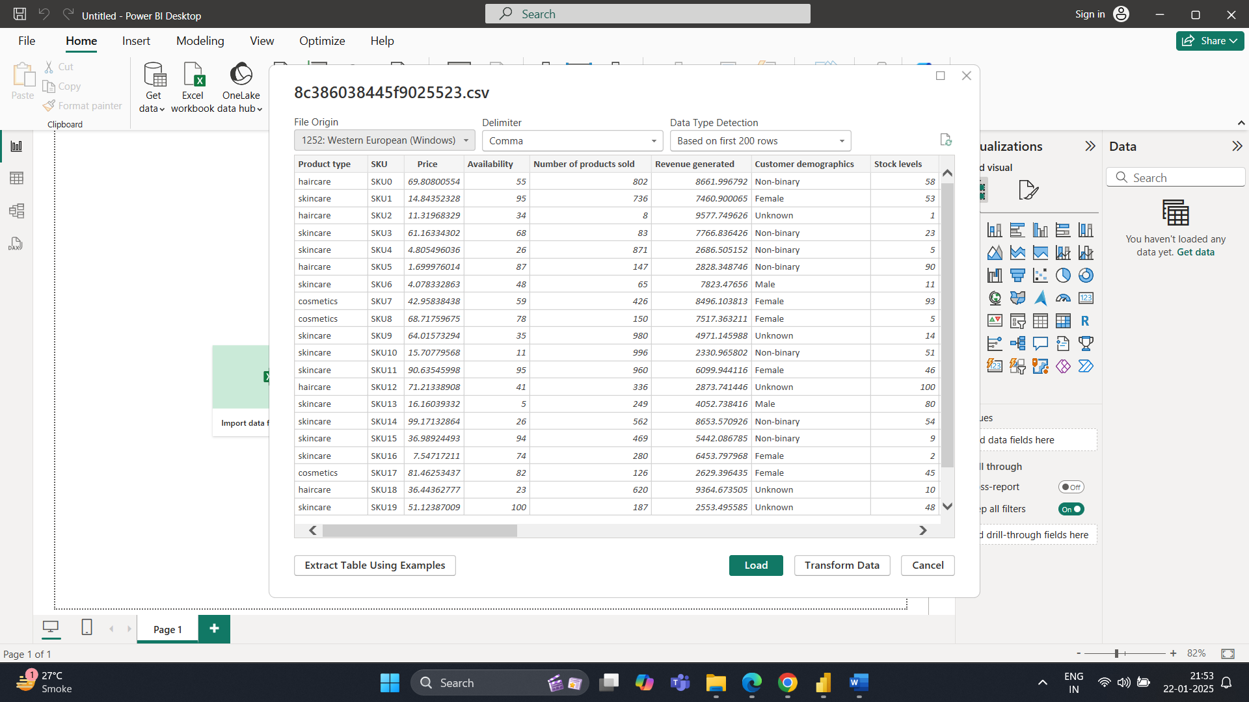

When we click on the Load Option we can see

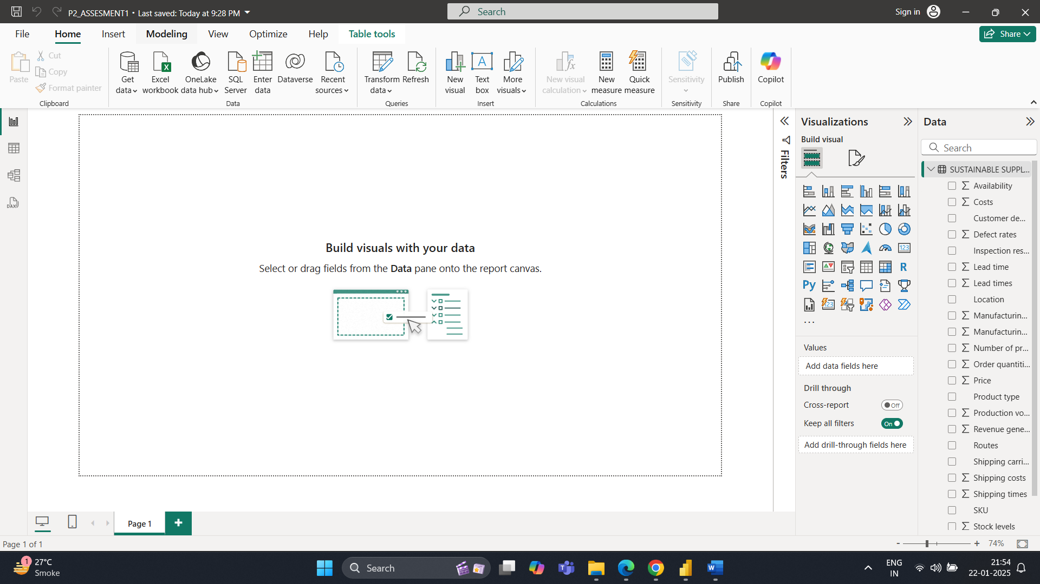

Our dataset in the rightmost corner of the desktop

As we move forward , we can see four different icons , we will explore all these options

STEP 6 :

1. First Icon Is report view , when we click on it , it will show our dataset which we have loaded in a report format

Used for visualization and will look like this



1. Second Icon Is Table View used to see the data , when we click on it , will result like this

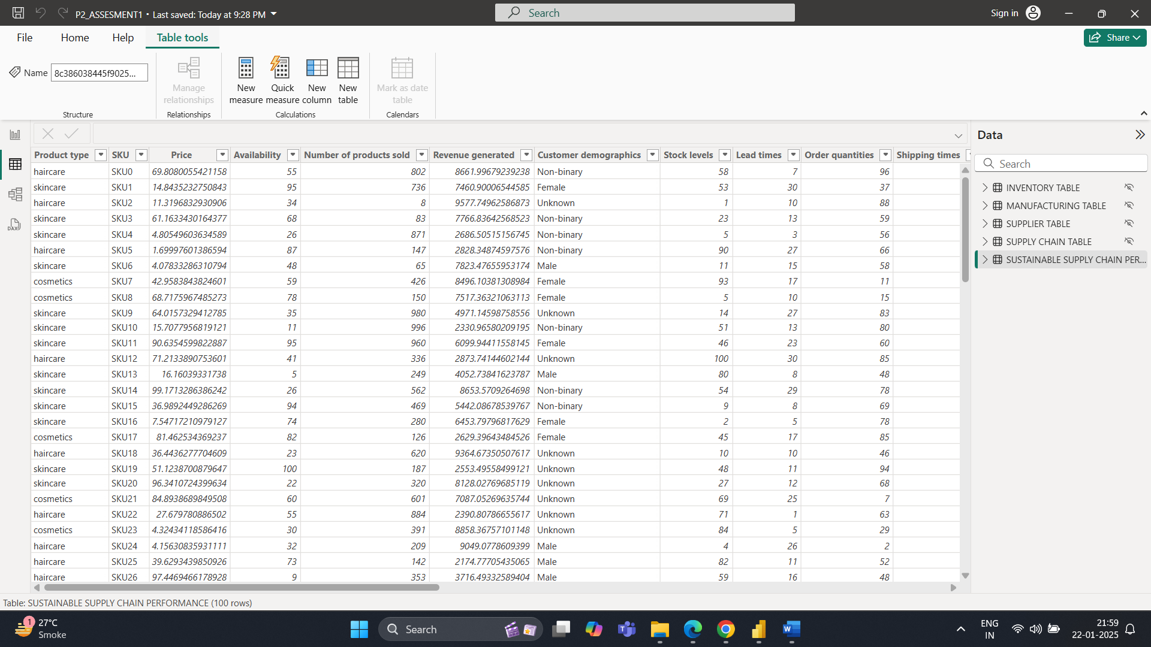

1. Third is the Model View used to create relationships among the data , looks like this

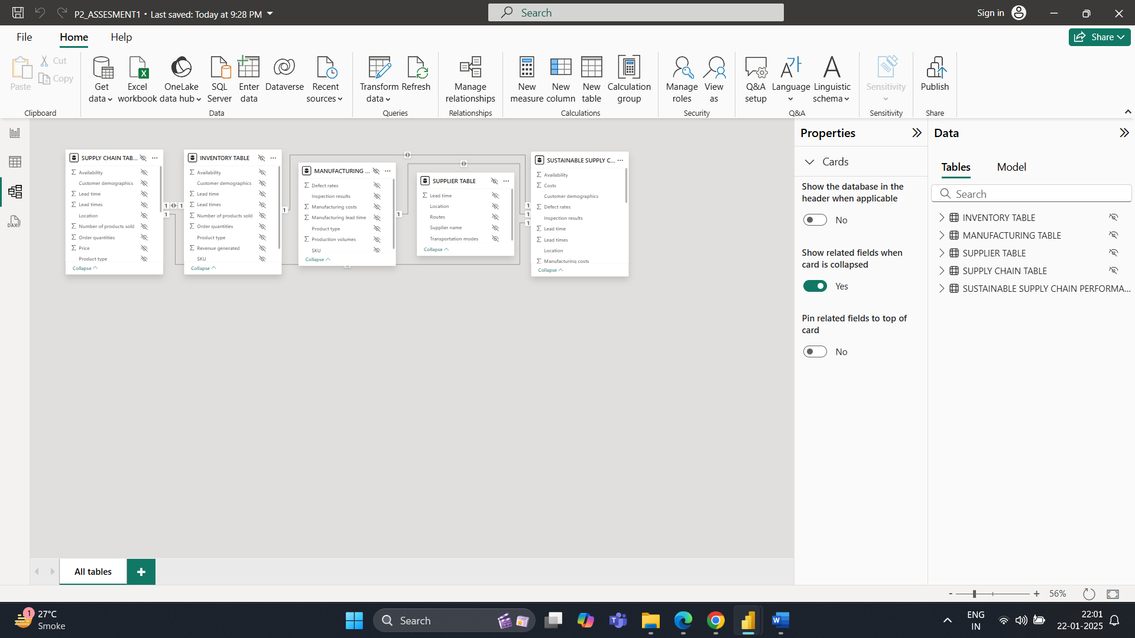

STEP 7. TRANSFORM : It is a process of cleaning the data or also called as processing the data , removing unnecessary data from the dataset

We click the Transform data option in the taskbar

It will open a PowerBI Querry editor and it will look like this

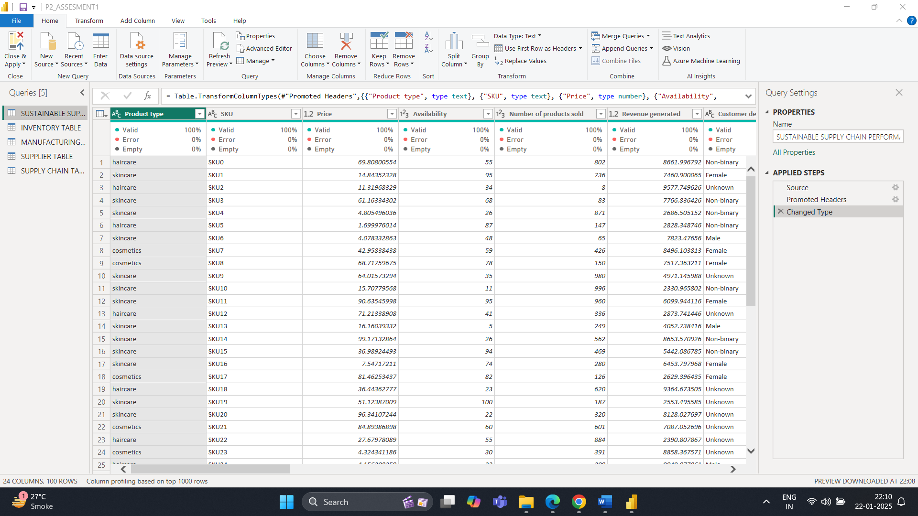

Here We get a lot of features like removing rows and columns, keep rows and columns etc .

STEP 8 : We can check various datatypes by simply clicking on the header tabs like this

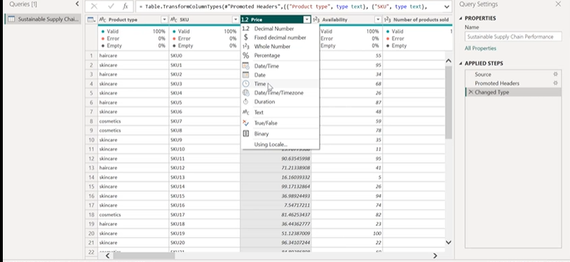

STEP 9 : Check for the data quality

By clicking the view option and the clicking on the checkbox called as data quality it will show

1. The entities which are valid
2. The entities which are having error
3. The entities which are empty or having any null value

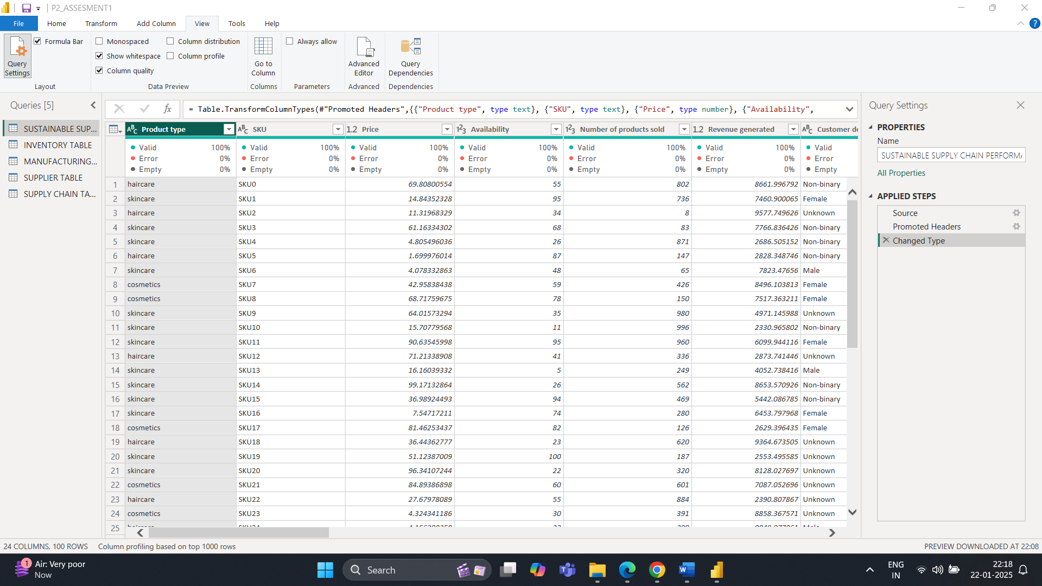

STEP 10 : WE HAVE TO CREATE SEPARATE TABLES FOR DIFFERENT TYPES OF ATTRIBUTES FOR BETTER UNDERSTANDING

A] FIRST WE CREATE A TABLE CALLED

INVENTORY TABLE

* for creating this table we have to right click on the original dataset and create a duplicate copy of it
* then we rename the duplicate copy as our table name
* we edit the rows and columns accordingly
* this table will contain the following

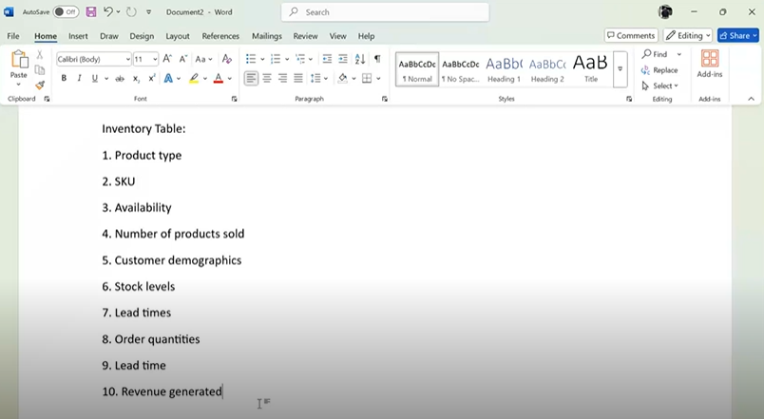

* We keep these and delete the others
* Either we select the column which are not needed and right click on it and then directly remove it
* If we want to remove more than one column then we simply press ctrl + left click , we select the columns and then right click and remove the columns all in one

Hence our inventory table looks like this

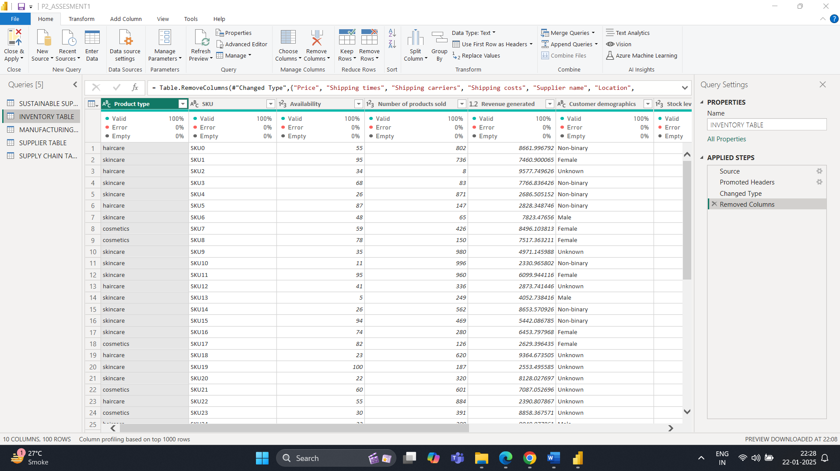

B] Second table called as MANUFACTURING TABLE

The entire process remains the same

1.duplication

2.renaming

3.add/remove the columns accordingly

This table consist of 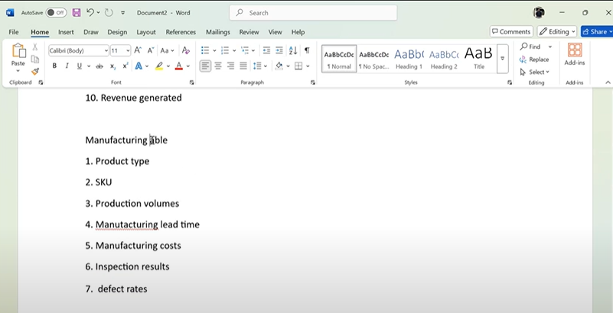

And finally the table looks like this

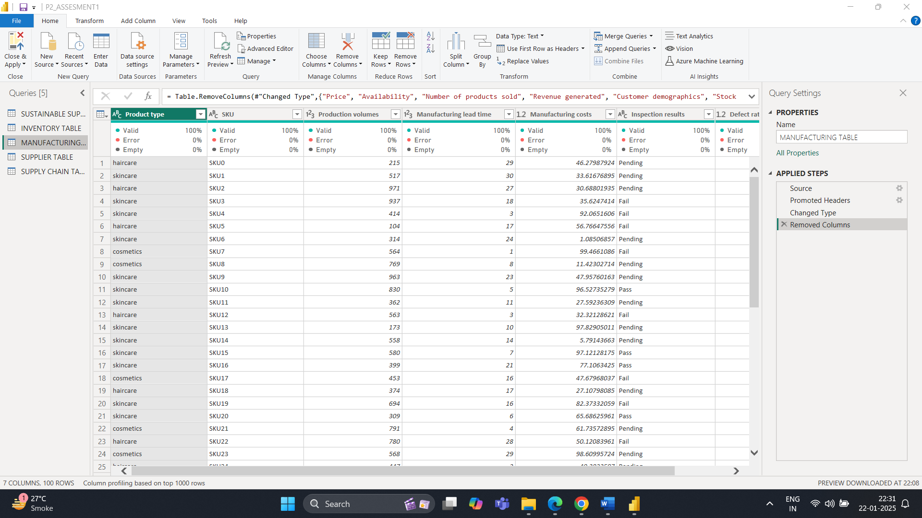

SIMILARLY WE CREATE TWO MORE TABLES

1 .SUPPLIER TABLE

2. SUPPLY CHAIN TABLE WITH THE SAME STEPS .

Because we are doing this on the PowerBI QuerryEditor these changes will not be reflected on the Power BI Desktop

Thus we simple click on save and apply option on the taskbar .

WITH THIS WE HAVE SUCCESFULLY TRANSFORMED OUR DATASET AND CREATED SEPARATE TABLES FOR VARIOUS ATTRIBUTES .