Dockerfile content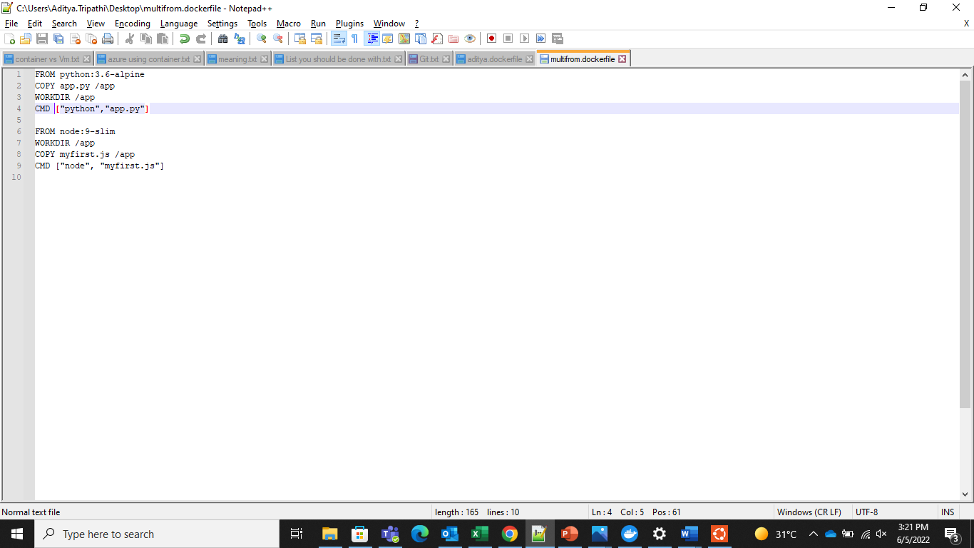

It is not reading the first “FROM” command , only the later one and then giving error.

