SUSPENSION SYSTEM

Physical setup

Designing an automotive suspension system is an interesting and challenging control problem. When the suspension system is designed, a 1/4 model (one of the four wheels) is used to simplify the problem to a 1-D multiple spring-damper system.

The system parameters are as follows

M1=2500

M2=320

K1=80000

K2=500000

B1=350

B2=15020

Kp=832100

Ki=624075

Kd=208025

System Modelling

Suspension system:

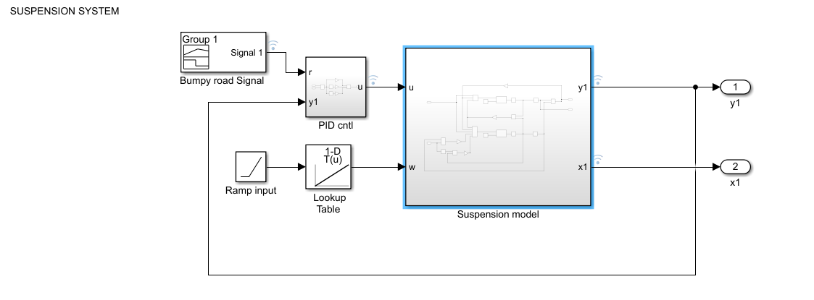

Suspension model:

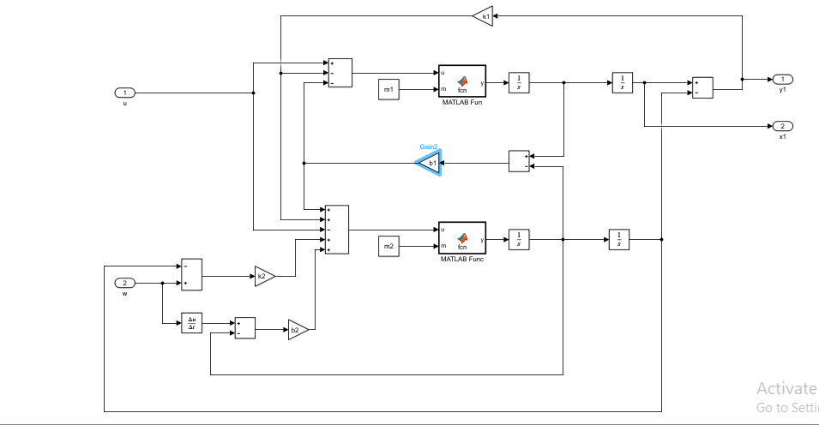

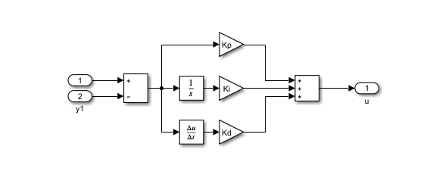PID controller:

1. Callbacks

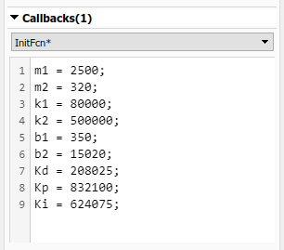

1. Data Inspector

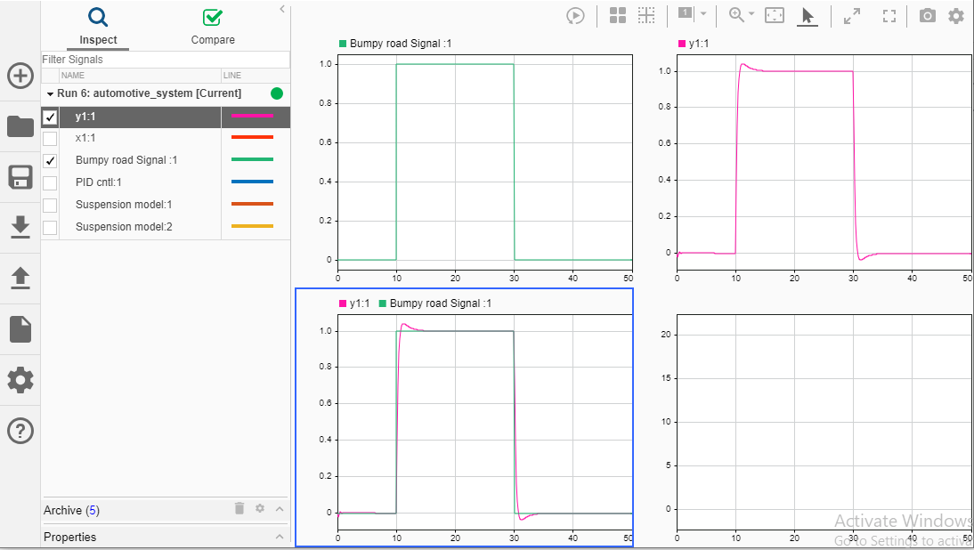

1. 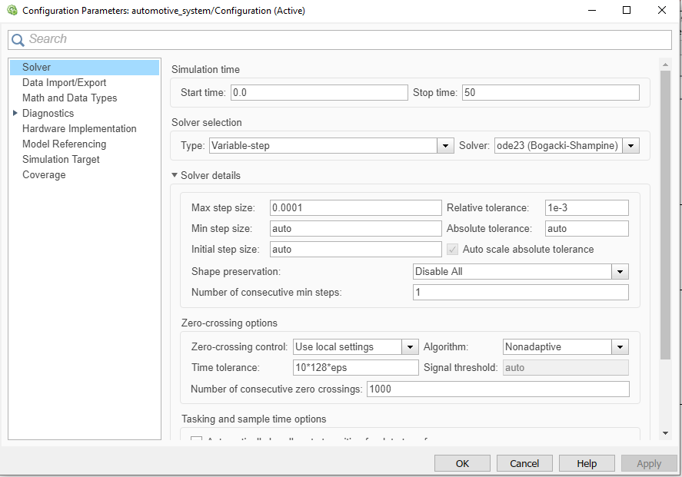Solver selection strategy
2. MATLAB function block

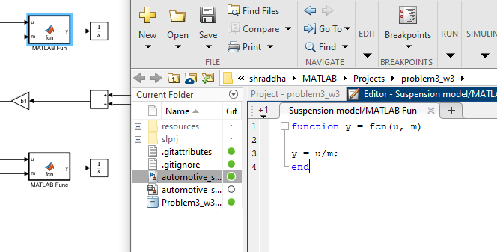

1. Look-up table

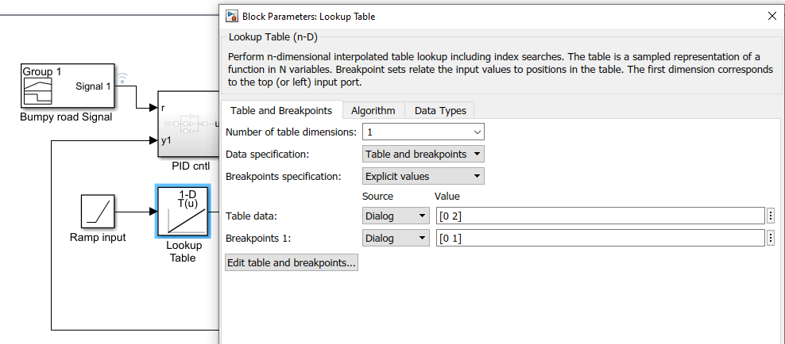

1. Signal Builder to generate test signals.

