ASSIGNMENT 1
SUMMER INTERNSHIP 2020

1. Create Directory Structure.

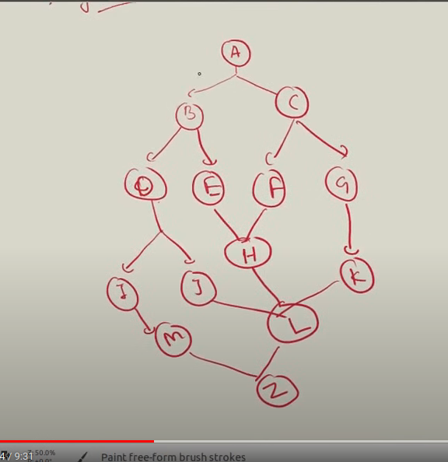

$mkdir -p A/{B/{D/{I/M/J,J/L/Z},E/H/L/Z},C/{F/H/L/Z,G/K/L/Z}}

