**TY B.Tech. (CSE) – II [ 2021-22 ]**

**Software Engineering Tools Lab**

**PRN: 2019BTECS00015**

**Full name: Shraddha Sanjay Kharat**

**Batch: T3**

**Assignment No. 1**

**Module 1- Introduction to OSS**

1. **Weka is a GUI workbench that empowers data wranglers to assemble machine learning pipelines, train models, and run predictions without having to write code.**

**Using Weka tool perform below tasks such as data preprocessing, data classification (use any appropriate ML algorithm) and data visualization efficiently on given dataset.**

**Use the Iris dataset given-**

[**https://drive.google.com/file/d/1A3Fxsfzm6BSfhFZGDrjI47RTe45bSgYP/view**](https://drive.google.com/file/d/1A3Fxsfzm6BSfhFZGDrjI47RTe45bSgYP/view)

**Note-provide screen shots for every task**

**Create a report which will illustrate the details of tasks performed (for e.g to perform preprocessing of data provide details of navigation and selection of appropriate parameters)**

**Weka**

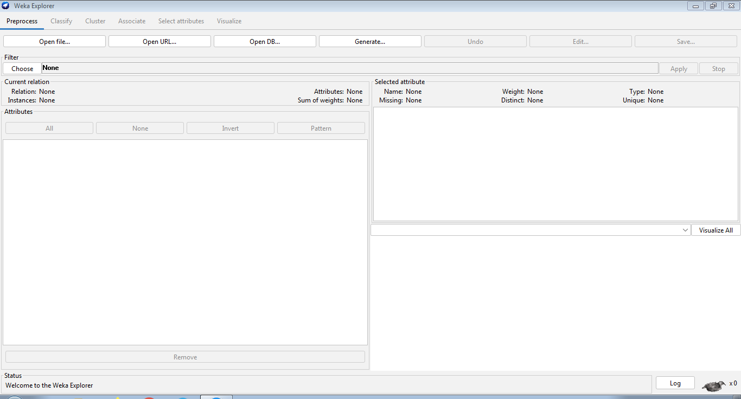

**Preprocess**

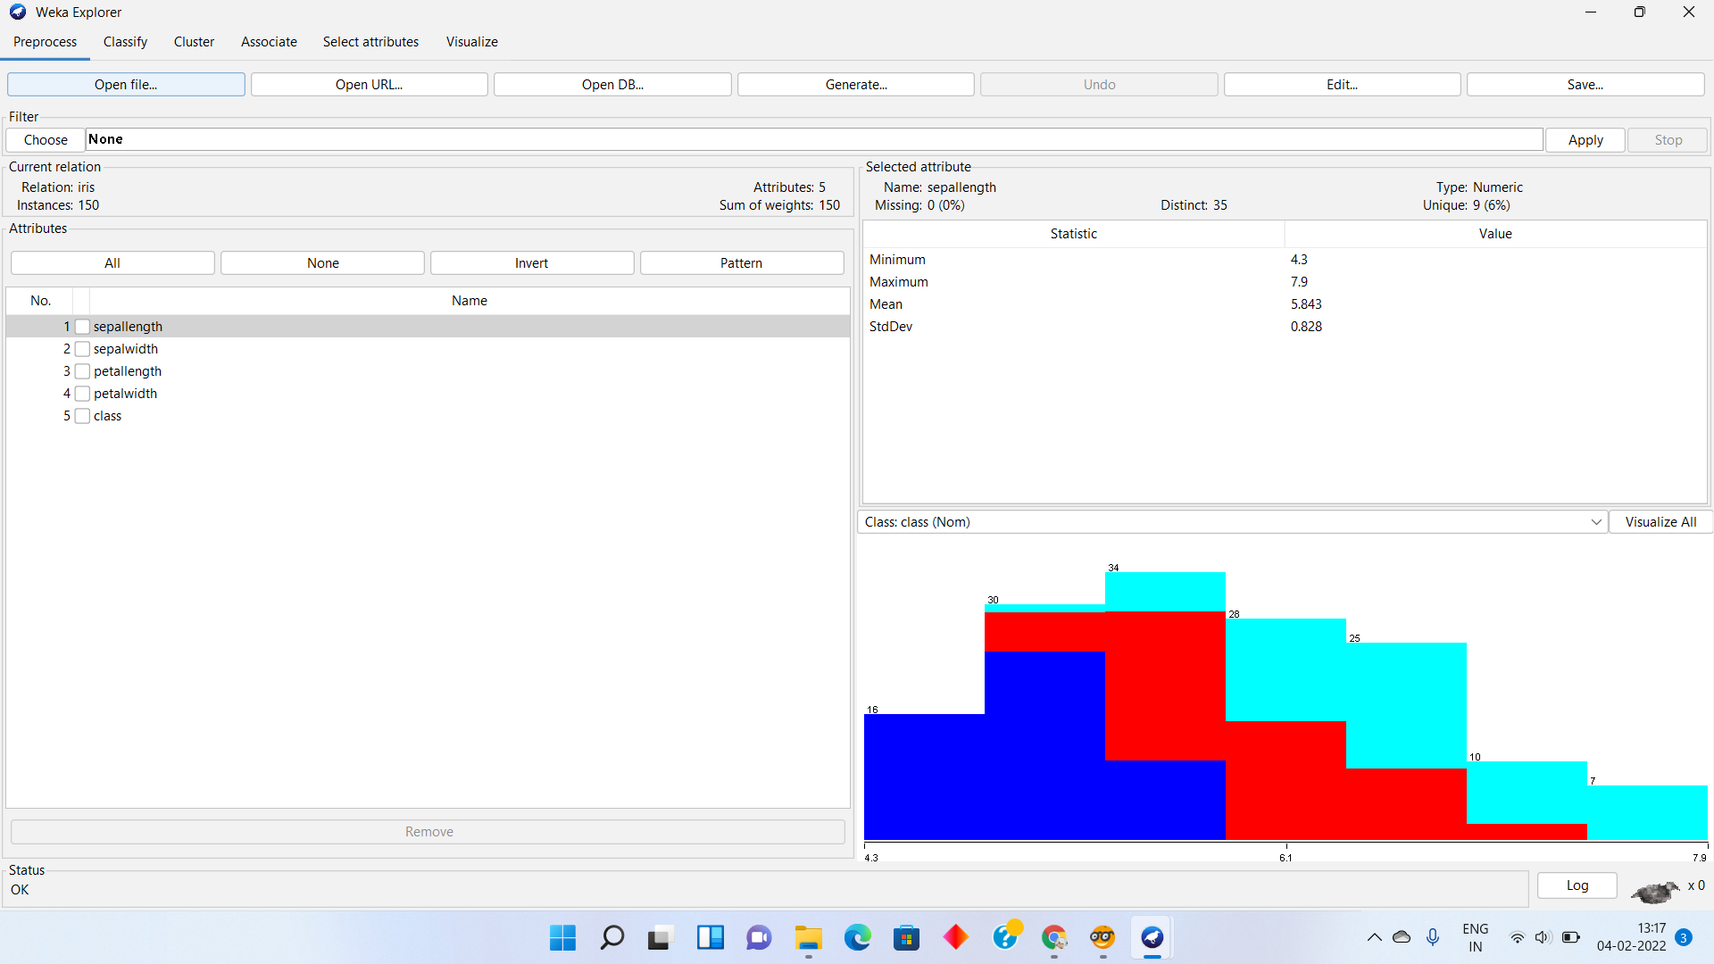

**Visualize All**

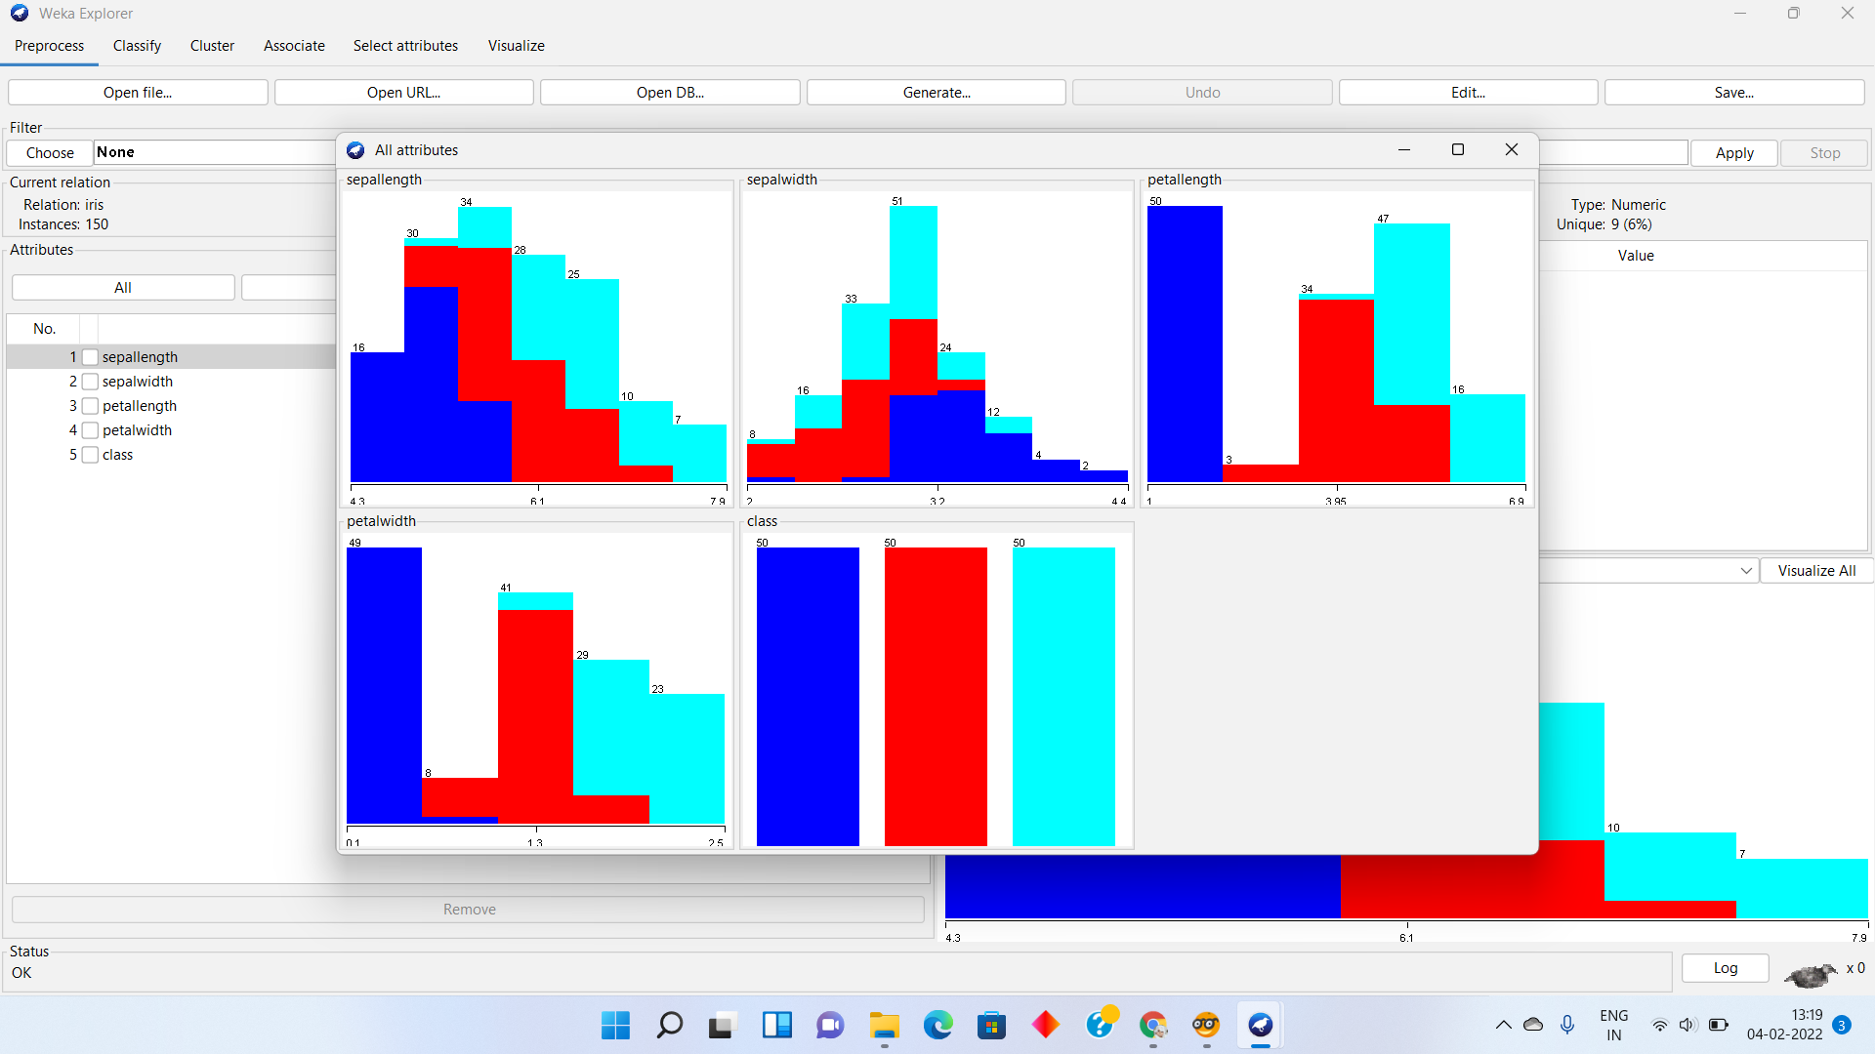

**Classify**

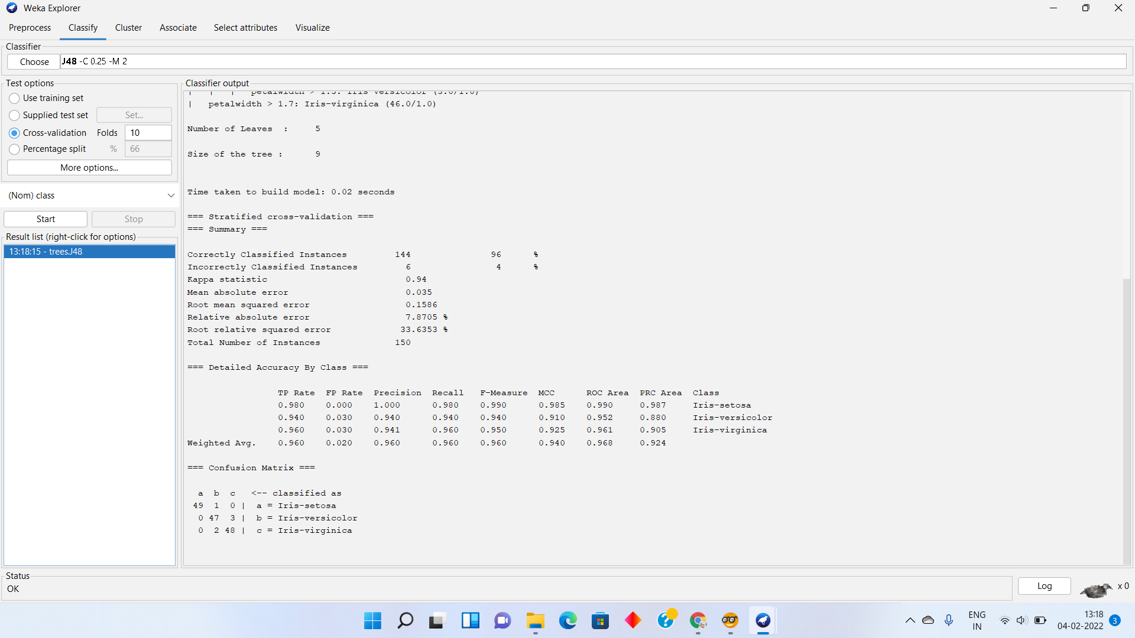

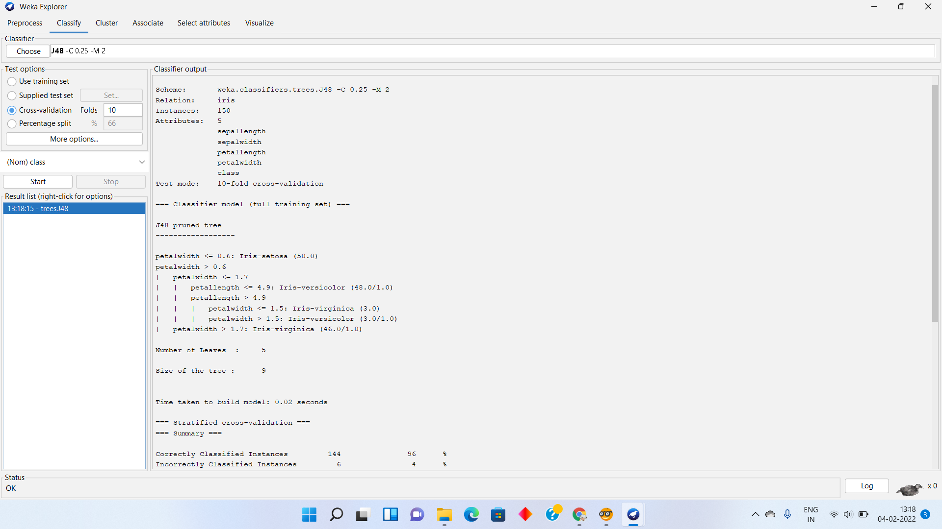

**Visualize**

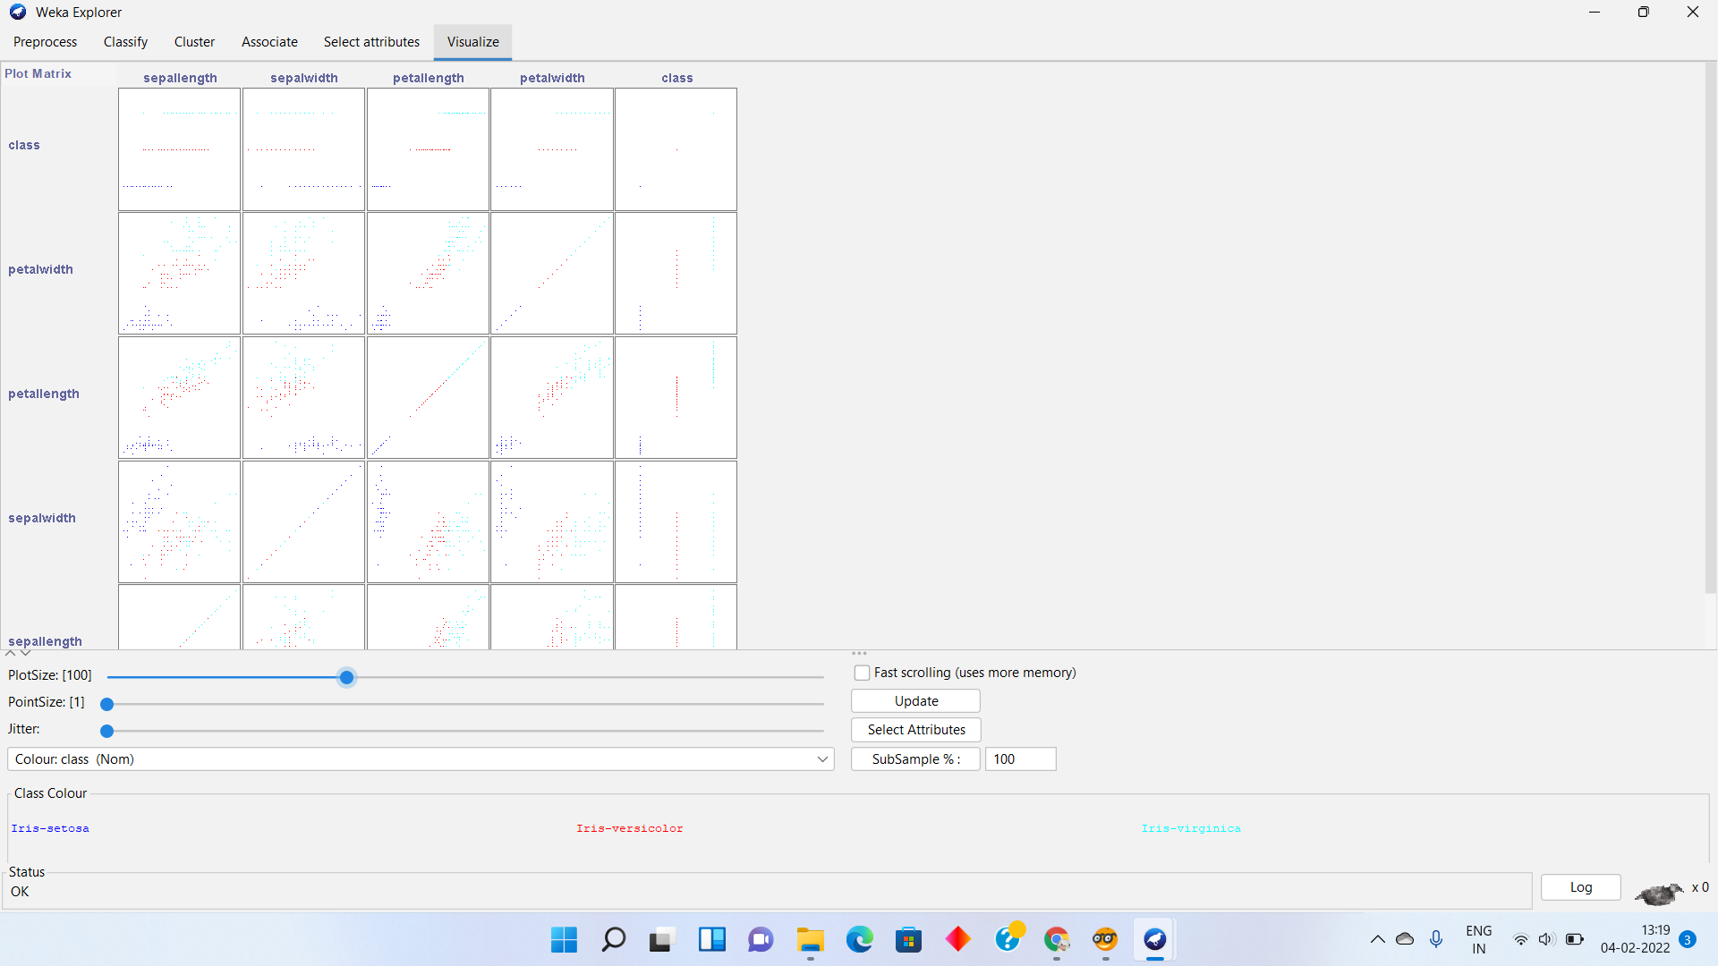

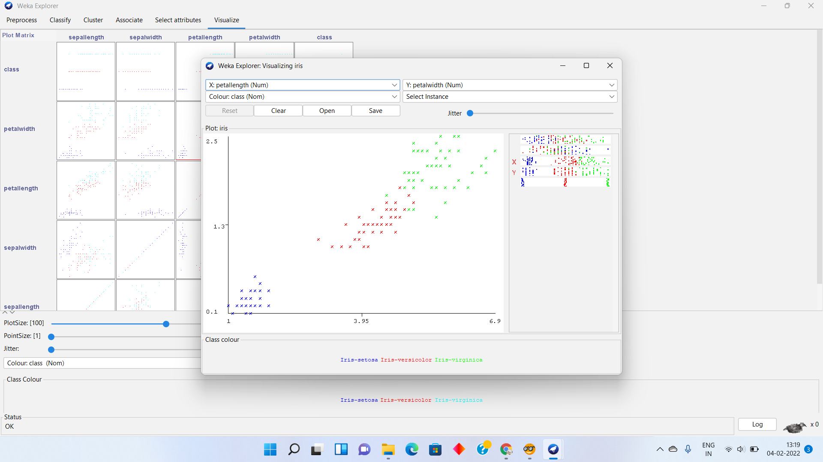

1. **Orange is an easy to use data visualization tool with a large toolkit. In spite of being a GUI-based beginner-friendly tool, you mustn’t mistake it for a light-weight one. It can do statistical distributions and box plots as well as decision trees, hierarchical clustering and linear projections.**

**a. Install orange**

**b. Show data distribution**

**c. Show linear projection**

**d. Show FreeViz**

**Use dataset** [**https://drive.google.com/file/d/1m6sKI1Dap0XK6Bw1edUd5PohwpPwXnd9/view**](https://drive.google.com/file/d/1m6sKI1Dap0XK6Bw1edUd5PohwpPwXnd9/view)

**Create a report for this task and upload screenshots for the same.**

**Orange**

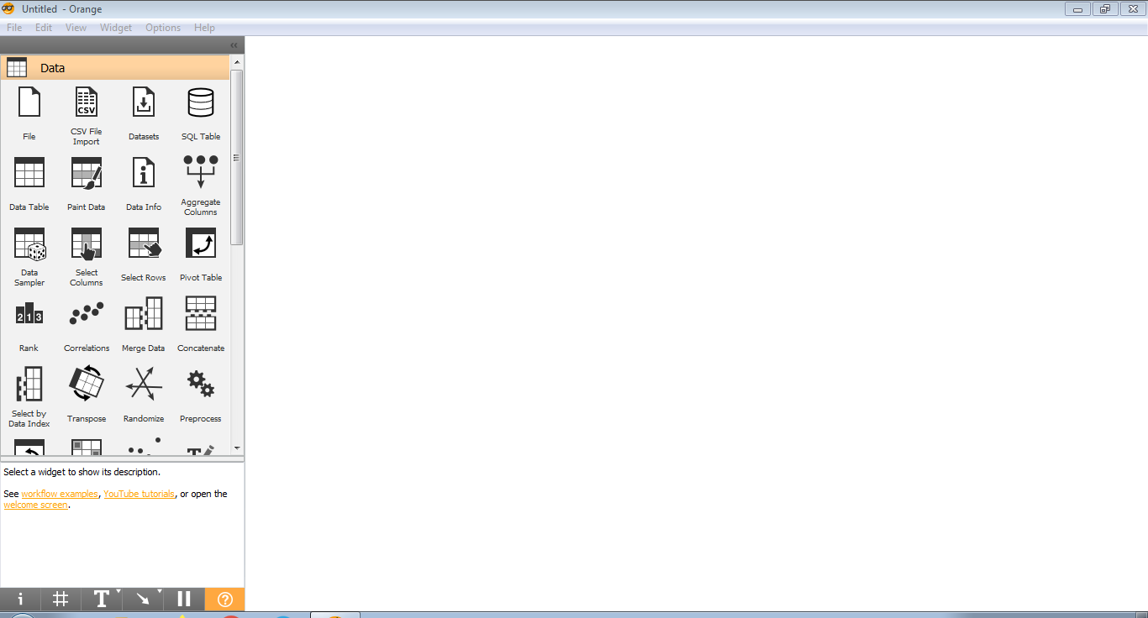

**Distributions**

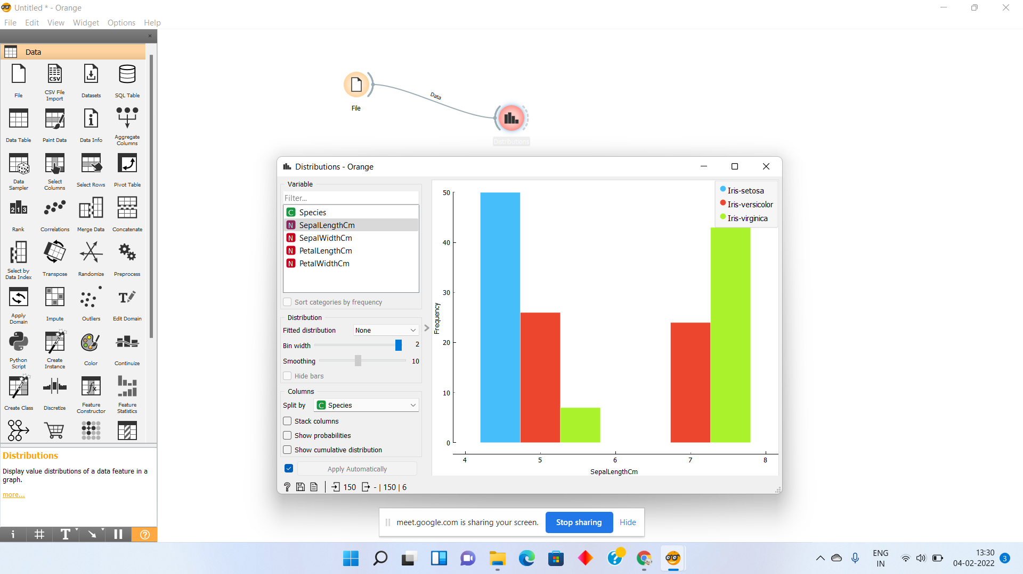

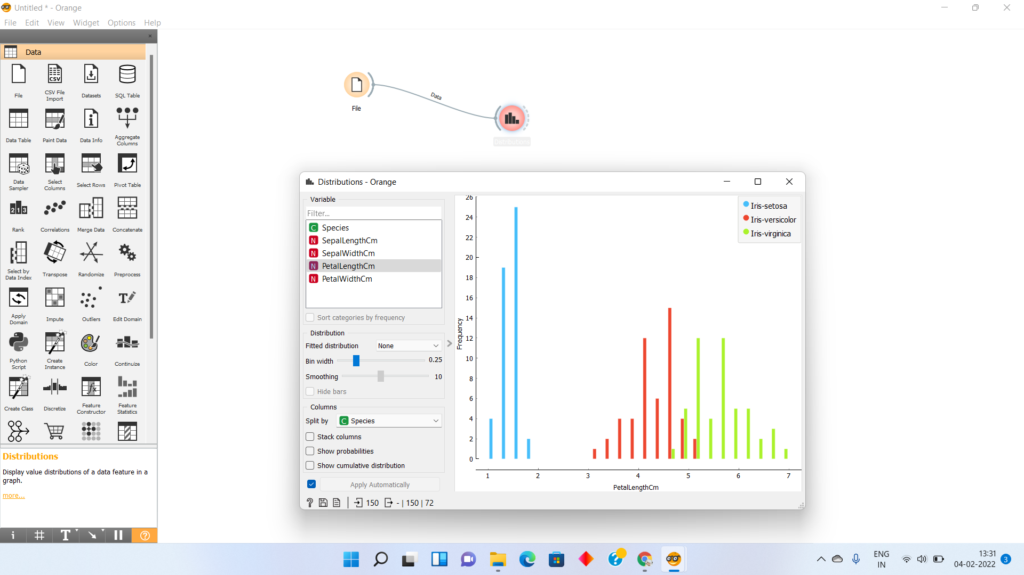

**Linear Projection**

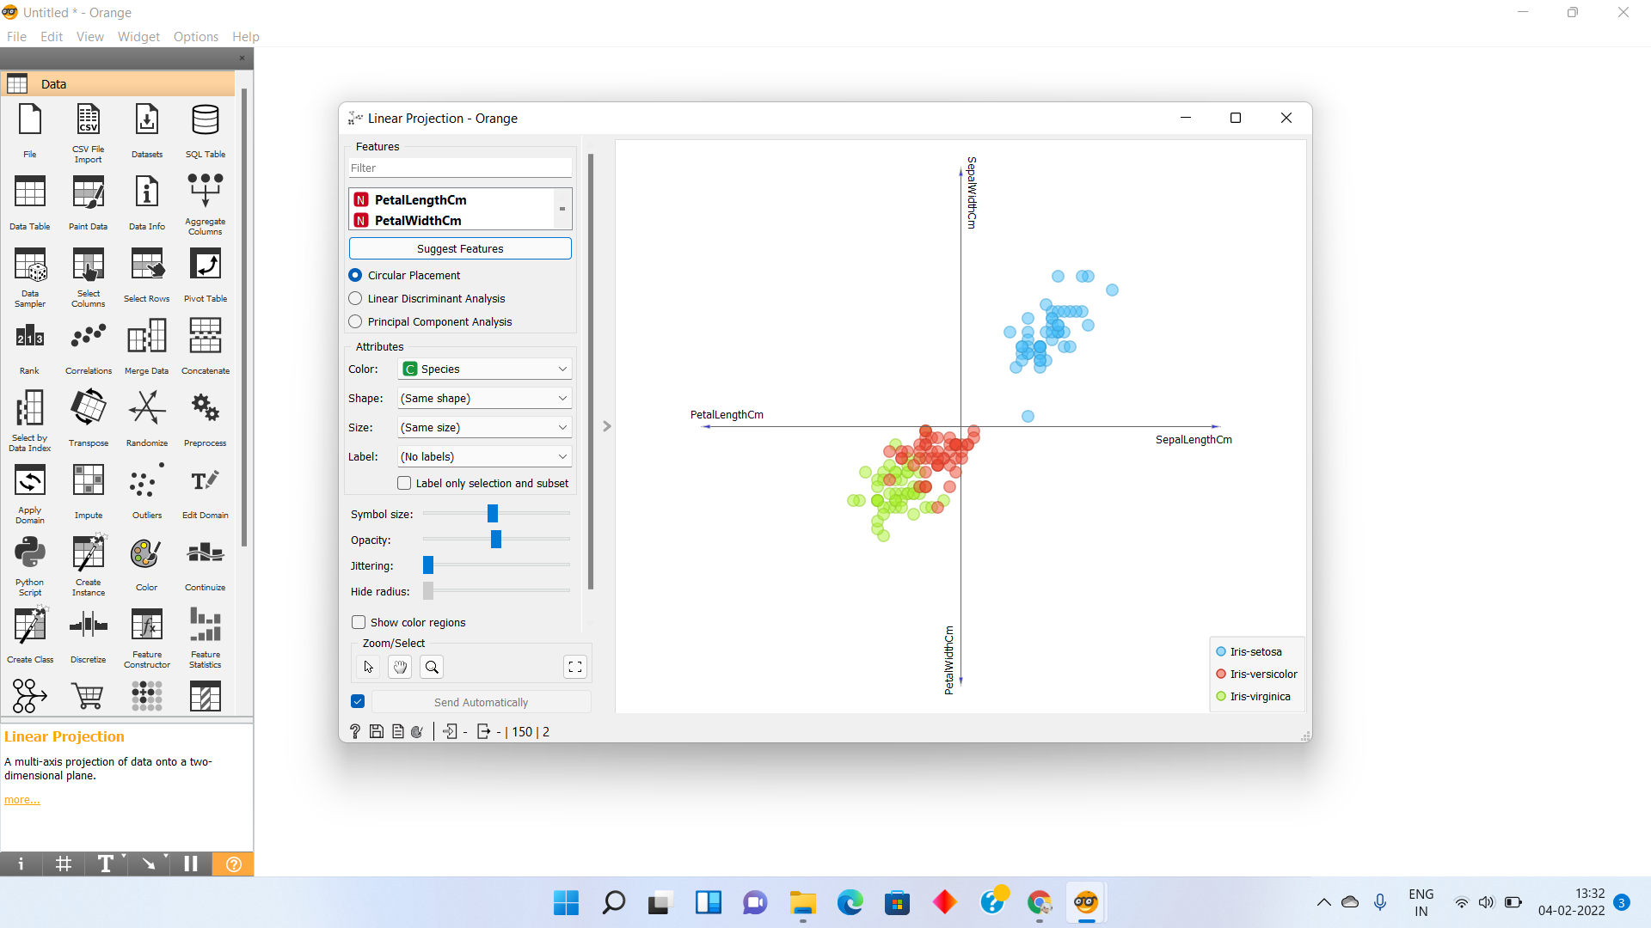

**Freeviz – Multivariate Projection**

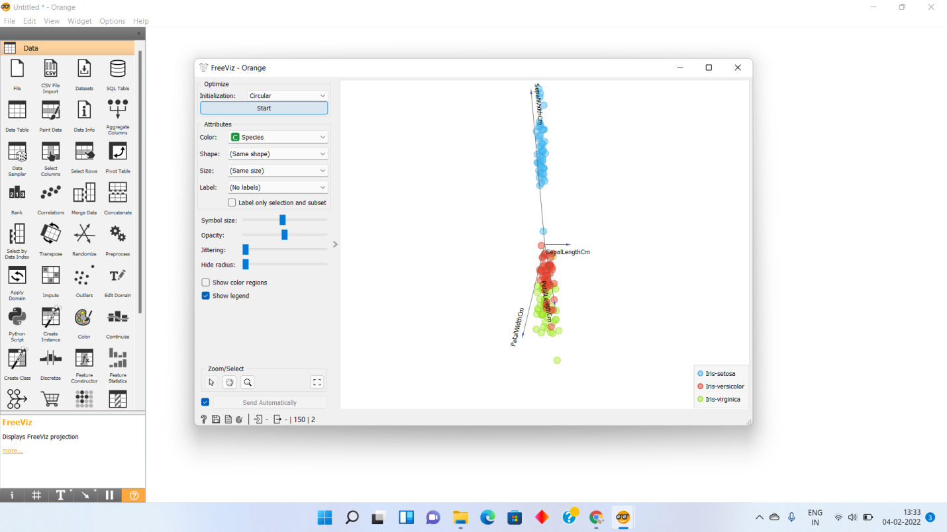

1. **Differentiate in between free software, Open source software and proprietary software with respect to its properties.**

**Free Software :**

* “Free software” means software that respects users' freedom and community. Roughly, it means that **the users have the freedom to run, copy, distribute, study, change and improve the software**.
* A program is free software if the program's users have the four essential freedoms:
* The freedom to run the program as you wish, for any purpose (freedom 0).
* The freedom to study how the program works, and change it so it does your computing as you wish (freedom 1). Access to the source code is a precondition for this.
* The freedom to redistribute copies so you can help others (freedom 2).
* The freedom to distribute copies of your modified versions to others (freedom 3). By doing this you can give the whole community a chance to benefit from your changes. Access to the source code is a precondition for this.
* **Examples** of **free software** applications · The Linux kernel, of course!

**Open Source Software :**

* Open source software is different. Its **authors make its source code available to others who would like to view that code, copy it, learn from it, alter it, or share it**. LibreOffice and the GNU Image Manipulation Program are examples of open source software.
* Open source is considered to have more flexible rules than free software, since it allows companies and developers to impose certain usage restrictions and licenses in order to protect the code’s integrity.
* Examples : Linux operating system ,Android by Google ,Open office ,Firefox browser ,VCL media player ,Moodle ,ClamWinantivirus ,[WordPress](https://en.wikipedia.org/wiki/WordPress) content management system.

**Proprietary software :**

* Proprietary software is any software that is copyrighted and bears limits against use, distribution and modification that are imposed by its publisher, vendor or developer.
* Proprietary software remains the property of its owner/creator and is used by end-users/organizations under predefined conditions.
* Proprietary software may also be called closed-source software or commercial software.
* Examples of proprietary software include **Microsoft Windows, Adobe Flash Player, PS3 OS, iTunes**, Adobe Photoshop, Google Earth, macOS (formerly Mac OS X and OS X), Skype, WinRAR, Oracle's version of Java and some versions of Unix.

1. **Using Anaconda Python create Histogram, Scatter plot and Bar plot for the dataset given below.**

**Dataset-**

[**https://drive.google.com/file/d/1i11BZFe8Xj9kNq7eeE9KOa_Iz1KhEdXJ/view**](https://drive.google.com/file/d/1i11BZFe8Xj9kNq7eeE9KOa_Iz1KhEdXJ/view)

**a. Scatter plot- Scatter plot of Price Vs Age**

**b. Histogram- for Kilometer and CC**

**c. Bar plot- Bar plot for different fuel types**

**Scatter Plot – Price v/s Age**

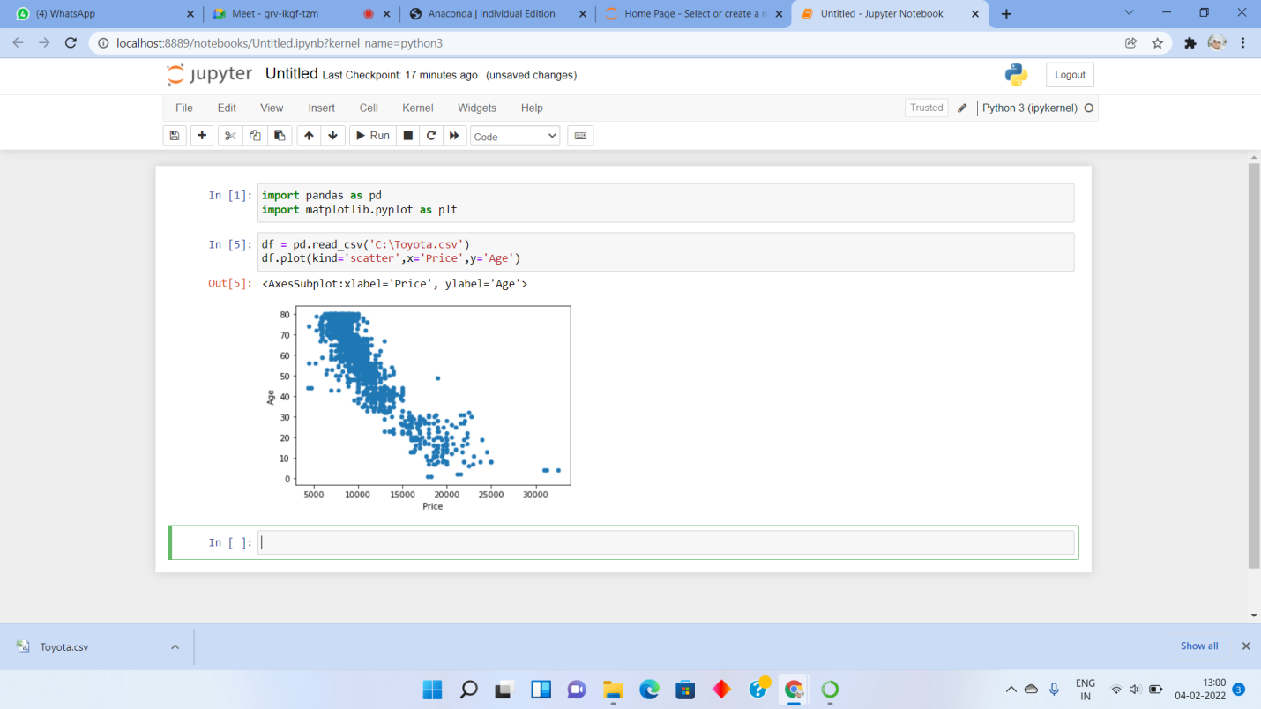

**Histogram – Kilometer**

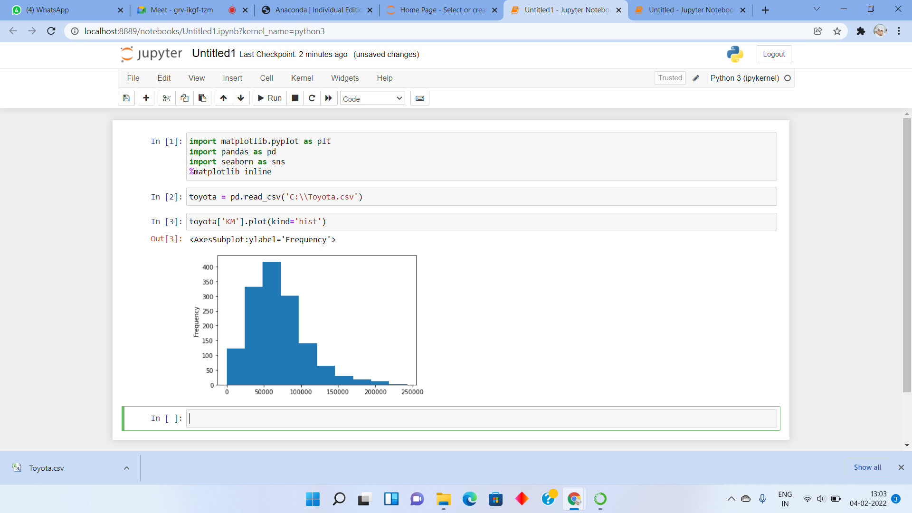

**Histogram – CC**

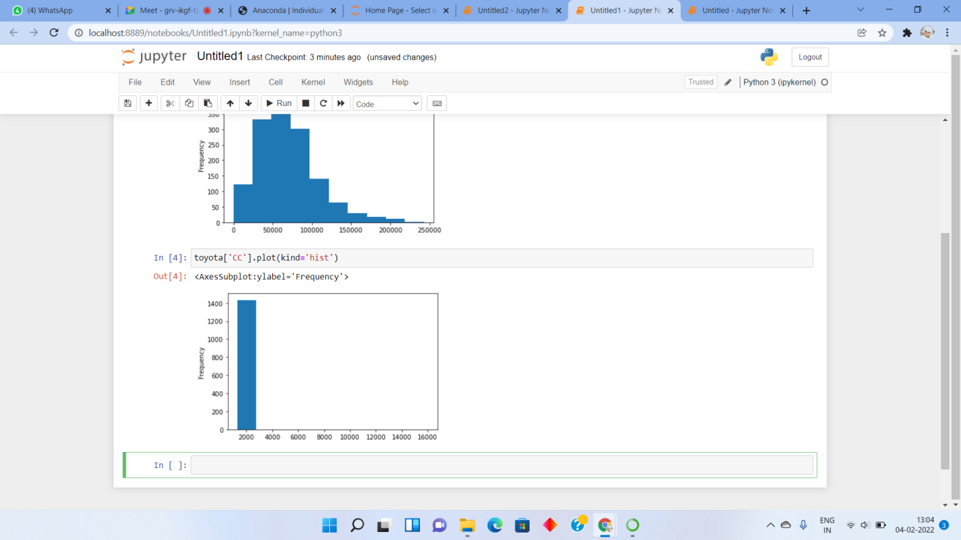

**Bar Plot – Fuel Types**

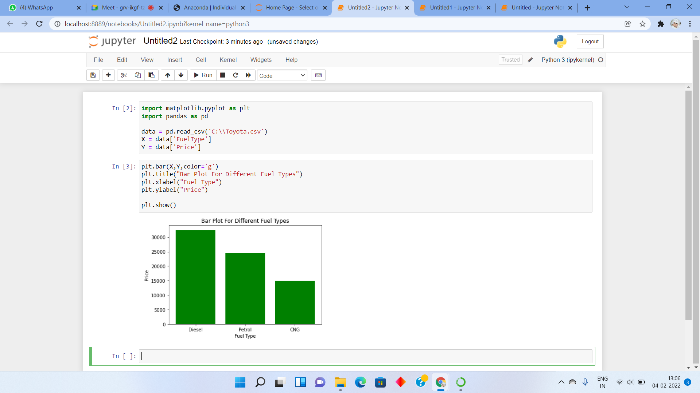

1. **Enlist some examples along with its purpose and properties (at least 10) of FOSS and proprietary software with respect to database.**

**FOSS Software’s**

1. Mozilla Firefox – Mozilla Firefox is a customizable internet browser and free open source software. It offers thousands of plug-ins that are accessible with a single click of your mouse.
2. VLC Media Player – VLC Media Player is one of the most popular open source software examples that you can use for free. This multimedia player is used for video, media and audio files and it plays discs, webcams, streams and devices.
3. Linux – Linux operating system is most commonly used on desktops. What makes this operating system different from the others is that it costs nothing and it is incredibly customizable.
4. Blender – Blender is a 3D graphics and animation tool that supports motion tracking, simulation, animation, video editing, rendering, modelling and much more
5. GNU Compiler Collection – GNU Compiler Collection is a collection of compilation tools for software development in the C, C++ and other programming languages.

**Proprietary Software’s**

1. Microsoft Windows – Windows, is a group of several proprietary graphical operating system families, all of which are developed and marketed by Microsoft.
2. Adobe Flash Player – Adobe Flash Player is computer software for content created on the Adobe Flash platform. Flash Player is capable of viewing multimedia contents, executing rich Internet applications, and streaming audio and video.
3. iTunes – iTunes is a media player, media library, Internet radio broadcaster, mobile device management utility, and the client app for the iTunes Store, developed by Apple Inc.
4. Google Earth - Google Earth is a computer program, that renders a 3D representation of Earth based primarily on satellite imagery.
5. Skype – Skype is a proprietary telecommunications application that specializes in providing VoIP-based video-telephony, videoconferencing and voice calls.