 | Title : Project Registration & Progress Review |  | FF No. 180
Department: Information Technology |  | Academic Year: 2025-2026
Semester : II |  | Group No.: 46
Project Title: Dynamic Privacy Debt Visualizer: A Real-time Browser-based Risk Quantification Framework
Project Area: Cybersecurity, AI, ML
Group Members Details:

Sr. No. | Class & Div. | Roll No. | G.R.No. | Name of Student | Contact No. | Email ID
1 | TY IT-C | 50 | 12311676 | Shraddhesh Tamhane | 8446366885 | shraddhesh.tamhane23@vit.edu
2 | TY IT-C | 51 | 12311421 | Tanishkka Jadhav | 7507644820 | sanjay.tanishkka23@vit.edu
3 | TY IT-C | 53 | 12311418 | Tanmay Singh | 7777051450 | singh.tanmay23@vit.edu
4 | TY IT-C | 54 | 12311489 | Soham Thakkar | 9356852633 | soham.thakkar231@vit.edu
5 | TY IT-C | 44 | 12311972 | Abhishek Sondkar | 9022234467 | abhishek.sondkar23@vit.edu

Name of Internal Guide: Prof. Gurunath Chavan Contact No. & Email ID:
gurunath.chavan@vit.edu

Project approved / Not approved

Guide Project Coordinator Head of Department

T

Project Synopsis

Introduction
The rapid growth of web services, mobile applications, and digital platforms has significantly increased the volume of personal data collected during everyday online activities. Users routinely share personally identifiable information (PII) such as email addresses, passwords, browsing habits, location data, and behavioral patterns across multiple domains. While privacy policies and consent banners aim to inform users, research consistently shows that individuals lack meaningful visibility into how their data exposure accumulates over time.
Existing privacy tools primarily focus on static risk indicators such as tracker detection, cookie counts, or permission lists without modeling how repeated interactions and user behavior contribute to long-term privacy risk. Similar to technical debt in software engineering, privacy shortcuts (e.g., password reuse, excessive data sharing, ignoring privacy settings) accumulate over time, creating what can be conceptualized as Privacy Debt.
Privacy Debt refers to the compounded risk resulting from continuous exposure of personal data without adequate mitigation or corrective action. Despite growing academic interest in privacy visualization and risk communication, there is currently no integrated system that dynamically quantifies, tracks, and visualizes privacy debt over time during a user’s browsing journey.

Literature Review
Author(s) | Objectives claimed by authors | Methodologies used | Research Gap (Relevant to the project)
Santamaria, I., Larrucea, X., et al.  (2023) | To integrate privacy concerns into software development for small entities (VSEs) by treating privacy as technical debt. | Used Net Present Value (NPV) calculations and ISO/IEC 29110 basic profile activities to quantify "Principal" and "Interest." | Static Limitation: Relies on manual questionnaires for developers; lacks real-time user activity tracking.
Larrucea, X., et al.  (2021) | To define the formal concept of "Privacy Debt" as a subset of technical debt and provide a way to identify it in design. | Applied a Perturbative Method and linked privacy weaknesses to Common Weakness Enumeration (CWE) categories. | Lack of Automation: Identification is largely manual and architectural, not a "live" behavioral sensor.
Nanayakkara, P., et al.  (2022) | To help data curators reason about the trade-offs between data utility (accuracy) and privacy risk when releasing datasets. | Developed Visualizing Privacy (ViP), an interactive interface using Differential Privacy (DP) algorithms and probabilistic distributions. | Dataset-Centric: Focuses on static database releases rather than the dynamic browsing journey of an individual user.
Wu, N., et al.  (2025) | To automate the detection and measurement of privacy risks within visual content (images) shared on social media. | Employed Deep Learning (CNNs) and a Privacy-Specific Spatial Attention (PSSA) mechanism to weight sensitive image regions. | Actionability Gap: Identifies risk at a point in time but doesn't visualize it as a "debt" that requires user remediation.
Wagner, I., et al.  (2024) | To move privacy risk assessment from subjective "art" to a "science" through more reliable and accurate quantification. | Systematic review and decomposition of Impact and Likelihood metrics using weighted Likert-scale scoring systems. | Temporal Gap: While it mentions that risk changes over time, it provides no real-time dashboard implementation.

Gaps Identified
- Static Snapshot Limitation
Existing models (e.g., Larrucea et al., 2023) rely on one-time questionnaires, manual audits, or static app analyses. These approaches fail to account for the continuous and evolving nature of data exposure during a user’s browsing journey.
- Lack of Behavioral Integration
Current privacy tools measure site-specific risks (e.g., trackers, cookies, permissions) but do not quantify the cumulative behavioral risk created by user actions such as password reuse across multiple high-risk domains, repeated consent acceptance, or frequent submission of PII.
- Absence of Temporal Accumulation and Decay Modeling
While literature acknowledges conceptual “privacy debt,” there is no practical implementation that models how risk compounds over time if mitigation actions (e.g., clearing cookies, revoking permissions, changing credentials) are ignored. Existing systems do not represent risk growth or interest-like accumulation.
- No Unified Privacy Debt Metric
Current research lacks a standardized, time-weighted privacy risk scoring mechanism that integrates exposure frequency, data sensitivity, domain reputation, and user behavior into a single interpretable metric.

Problem Statement: Create a web-based application that monitors privacy-related events, calculates cumulative Privacy Debt using a scoring model, and visualizes risk growth and reduction through an interactive dashboard while ensuring secure handling of sensitive user data.

Objectives

- To design and implement a real-time browser-based monitoring system that detects privacy-compromising events such as insecure PII transmission, credential reuse, and interaction with high-risk domains.

- To develop a dynamic Privacy Debt scoring model that quantifies cumulative privacy risk based on exposure severity, behavioral patterns, domain risk, and temporal accumulation.

- To create an interactive visualization dashboard that displays privacy debt growth over time and illustrates risk reduction through user-initiated privacy-preserving actions.

Proposed Methodologies:
The proposed system consists of
- User Behavior Simulator
Collects information about user privacy practices.
- Privacy Risk Calculation
Calculates a Privacy Debt Score using rule-based scoring.
- Visualization Dashboard
Displays privacy exposure through charts and metrics.
- Recommendation Engine
Uses Generative AI / Machine Learning to provide personalized privacy improvement suggestions.

The initial implementation uses a rule-based scoring mechanism to simulate privacy risk calculation. In future iterations, this system can be enhanced using supervised machine learning models trained on datasets related to website vulnerabilities, breach incidents, and user behavior patterns to generate adaptive privacy debt scores.
ML features include:
- Domain reputation score
- Website breach history
- User behavior patterns
- Data sensitivity level
Datasets include:
- Data breach datasets
- Phishing website datasets
- vulnerability databases

References:
[1] I. Santamaria, X. Larrucea, and I. Fernandez-Gamiz, “Managing Privacy Debt in Very Small Entities: Integrating Privacy into the ISO/IEC 29110 Framework,” IEEE Access, vol. 11, pp. 24563–24576, 2023.
[2] X. Larrucea, I. Santamaria, C. Ebert, and A. Agrawal, “Privacy Debt: Identifying and Managing Privacy Weaknesses in Software Development,” IEEE Software, vol. 38, no. 1, pp. 28–34, Jan.–Feb. 2021.
[3] P. Nanayakkara, R. A. L. de Oliveira, and N. Mohammed, “ViP: Visualizing Privacy Trade-offs in Differentially Private Data Releases,” IEEE Transactions on Visualization and Computer Graphics, vol. 28, no. 1, pp. 428–438, Jan. 2022.
[4] N. Wu, Y. Zhang, and H. Li, “Privacy Risk Detection in Social Media Images Using Privacy-Specific Spatial Attention,” IEEE Transactions on Multimedia, vol. 27, pp. 1–14, 2025.
[5] I. Wagner and D. Boehm, “Towards Quantitative Privacy Risk Assessment: A Systematic Review of Impact and Likelihood Metrics,” IEEE Security & Privacy, vol. 22, no. 2, pp. 45–53, Mar.–Apr. 2024.

Implementation till review 1:
System Implementation
- A web-based Privacy Debt Visualizer was successfully developed using React for the frontend and Node.js/Express for backend processing.
- The system collects user behavioral privacy inputs through an interactive simulator.
- A rule-based scoring engine calculates a Privacy Debt Score based on weighted behavioral risk factors.
- A Generative AI module provides personalized recommendations for improving privacy practices.
- Results are displayed through interactive charts and dashboard visualizations.

Privacy Risk Scoring Results
- The system successfully computes a Privacy Debt Score between 0 and 100.
- Scores are categorized into:
  - Low Risk (0–30)
  - Medium Risk (31–70)
  - High Risk (71–100)
- Test simulations showed that users with password reuse, public profiles, and many third-party apps received significantly higher scores.

Visualization Outcomes
- The dashboard provides visual insights through:
  - Risk Breakdown Chart showing contributions from different privacy factors.
  - Platform Exposure Chart indicating platform categories used.
  - Data Exposure Chart representing types of personal data shared.
- These visualizations help users quickly understand sources of privacy risk.

Behavioral Risk Observations
- Password reuse was found to be one of the most significant contributors to privacy risk.
- Users with many inactive accounts and connected third-party apps showed higher exposure levels.
- Public visibility settings significantly increased the overall privacy debt score.

Effectiveness of AI Recommendations
- The Generative AI module successfully produced actionable privacy recommendations, such as:
  - enabling two-factor authentication,
  - reducing third-party app permissions,
  - using password managers,
  - deleting inactive accounts.
- These recommendations help users identify concrete steps to reduce privacy debt.

System Limitations
- Current risk calculations rely on a rule-based scoring model, which may not capture all complex behavioral patterns.
- The system currently uses simulated user inputs rather than real-time browsing data.
- Privacy risk predictions may vary depending on user self-reported behavior accuracy.

Next Tasks
- Integration of machine learning models such as Random Forest or Gradient Boosting to improve risk prediction accuracy.
- Incorporation of external datasets (phishing domains, breach databases, vulnerability datasets).
- Development of real-time browser monitoring features to automatically detect privacy-related events.
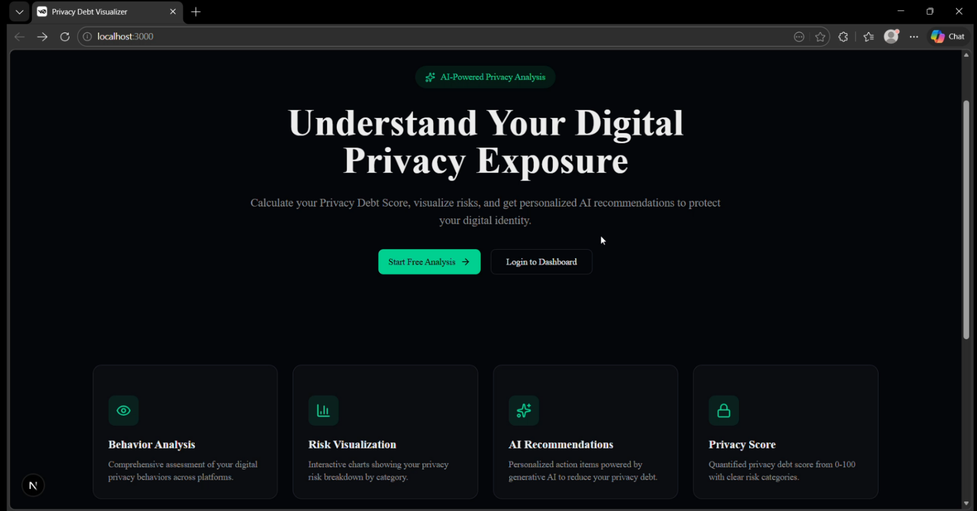
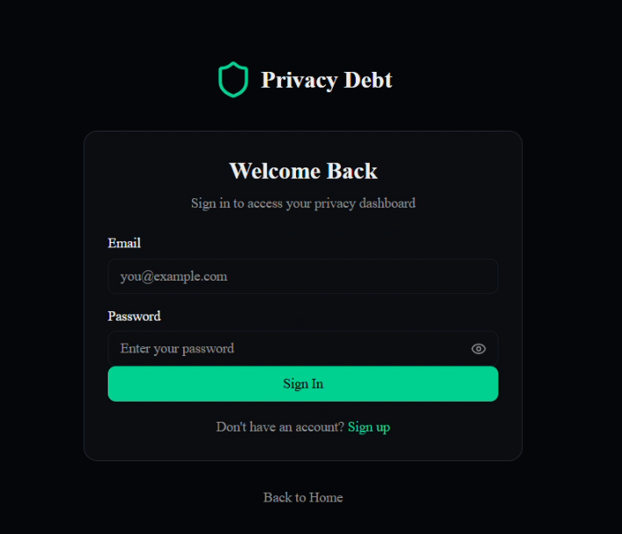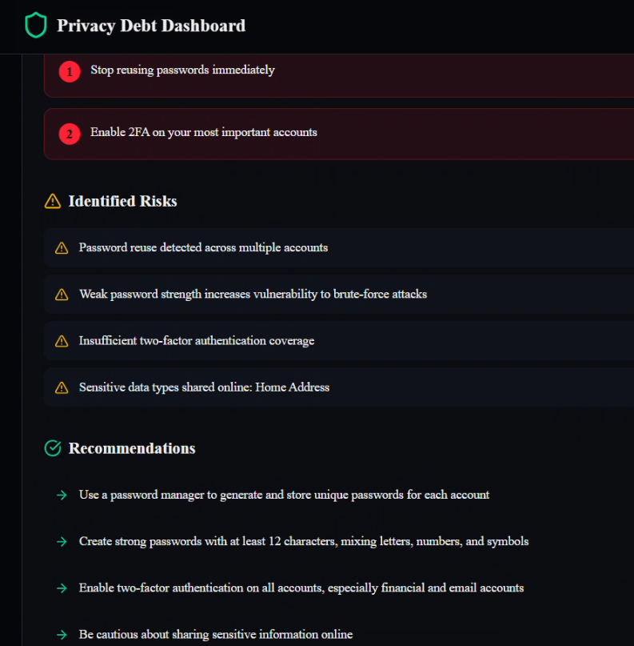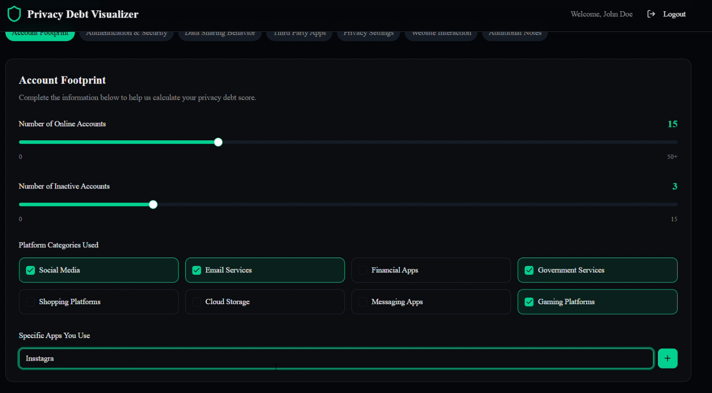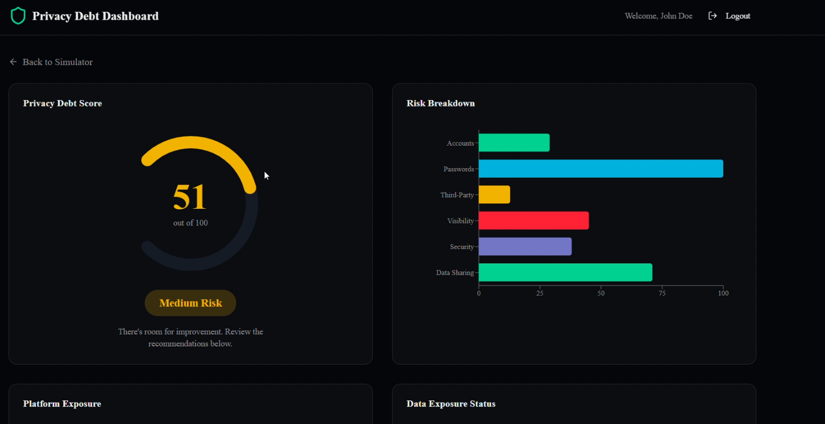

FF No 180

Group No.
Activity | Review Schedule | Progress Review Report submitted | Signature of Guide
Review 1 | Mid Sem. Semester | Yes / No
Review 2 | End of Semester | Yes / No

Format of Progress Review Report:

Review No.: 1 Group No.: 46 Date: 13/23/2026

Progress Review Report

Signature of Guide:

Review No.: 2 Group No.: Date:

Progress Review Report

Signature of Guide:

