A Course Based Project Report on
E - COMMERCE DATA PIPELINE & ANALYTICS SYSTEM
submitted to the
Department of Information Technology
in partial fulfilment of the requirements for the completion of course
DATA ENGINEERING AND MACHINE LEARNING LABORATORY (22PC1AM202)
BACHELOR OF TECHNOLOGY

IN
INFORMATION TECHNOLOGY
Submitted by
G. BHAVANI GOUD | 23071A1288
J. S. SHRADHA | 23071A1292
K. SREE DHARANI KARTHIKA | 23071A1295
A. BHAVANI | 24075A1208

Under the guidance of
Dr V SARITHA

Assistant Professor, Department of IT, VNRVJIET

DEPARTMENT OF INFORMATION TECHNOLOGY
VALLURUPALLI NAGESWARA RAO VIGNANA JYOTHI INSTITUTE OF ENGINEERING & TECHNOLOGY
An Autonomous Institute, NAAC Accredited with ‘A++’ Grade, NBA
Vignana Jyothi Nagar, Pragathi Nagar, Nizampet (S.O), Hyderabad – 500 090, TS, India

MAY 2026

VALLURUPALLI NAGESWARA RAO VIGNANA JYOTHI INSTITUTE OF ENGINEERING AND TECHNOLOGY
An Autonomous Institute, NAAC Accredited with ‘A++’ Grade,
Vignana Jyothi Nagar, Pragathi Nagar, Nizampet(SO), Hyderabad-500090, TS, India


DEPARTMENT OF INFORMATION TECHNOLOGY

CERTIFICATE
This is to certify that the project report entitled “E - Commerce Data Pipeline & Analytics System” is a Bonafide work done under our supervision and is being submitted by Ms. G.BHAVANI GOUD (23071A1288), Ms. J.S. SHRADHA (23071A1292),Ms. K. SREE DHARANI KARTHIKA (23071A1295), Ms. A. BHAVANI (24075A1208) in partial fulfilment for the award of the degree of Bachelor of Technology in Information Technology, of the VNRVJIET, Hyderabad during the academic year 2025-2026.

Dr. N MANGATHYARU Dr. V SARITHA
Professor & HOD, IT Assistant Professor, IT

Course based Projects Reviewer

VALLURUPALLI NAGESWARA RAO VIGNANA JYOTHI INSTITUTE OF ENGINEERING AND TECHNOLOGY
An Autonomous Institute, NAAC Accredited with ‘A++’ Grade,
Vignana Jyothi Nagar, Pragathi Nagar, Nizampet(SO), Hyderabad-500090, TS, India


DEPARTMENT OF INFORMATION TECHNOLOGY

DECLARATION
G. BHAVANI GOUD | 23071A1288
J. S. SHRADHA | 23071A1292
K. SREE DHARANI KARTHIKA | 23071A1295
A. BHAVANI | 24075A1208
We declare that the course based project work entitled “E - Commerce Data Pipeline & Analytics System” submitted in the Department of Information Technology, Vallurupalli Nageswara Rao Vignana Jyothi Institute of Engineering and Technology, Hyderabad, in partial fulfilment of the requirement for the award of the degree of Bachelor of Technology in Information Technology is a bonafide record of our own work carried out under the supervision of Dr V. Saritha Assistant Professor, Department of IT, VNRVJIET. Also, we declare that the matter embodied in this thesis has not been submitted by us in full or in any part thereof for the award of any degree/diploma of any other institution or university previously.

ACKNOWLEDGEMENT
We express our deep sense of gratitude to our beloved President, Sri. D. Suresh Babu, VNR Vignana Jyothi Institute of Engineering & Technology for the valuable guidance and for permitting us to carry out this project.
With immense pleasure, we record our deep sense of gratitude to our beloved Principal, Dr. B. Chennakesava Rao, for permitting us to carry out this project.
We express our deep sense of gratitude to our beloved Professor Dr V. Saritha, Assistant Professor, Department of Information Technology, VNR Vignana Jyothi Institute of Engineering & Technology, Hyderabad-500090 for the valuable guidance and suggestions, keen interest and through encouragement extended throughout the period of project work.
We take immense pleasure to express our deep sense of gratitude to our beloved Guide, Professor Dr V. Saritha ,Assistant Professor, Department of Information
, VNR Vignana Jyothi Institute of Engineering & Technology, Hyderabad, for his/her valuable suggestions and rare insights, for constant source of encouragement and inspiration throughout my project work.
We express our thanks to all those who contributed for the successful completion of our project work.
G. BHAVANI GOUD | 23071A1288
J. S. SHRADHA | 23071A1292
K. SREE DHARANI KARTHIKA | 23071A1295
A. BHAVANI | 24075A1208

TABLE OF CONTENTS
S No | Contents | Page No
1. | ABSTRACT | 1
2. | INTRODUCTION | 2-3
3. | SOURCE CODE | 4-10
4. | OUTPUT | 11-12
5. | CONCLUSION | 13
6. | REFERENCES | 14

ABSTRACT
This project presents the design and implementation of an end-to-end E-commerce Data Pipeline and Analytics System that transforms raw transactional data into meaningful insights. The system begins with the collection of datasets containing information on customers, products, and orders. Data preprocessing techniques such as handling missing values, removing duplicates, and selecting relevant features are applied to ensure data quality and consistency.
Further, feature engineering is performed to derive valuable metrics like total customer spend and order frequency, enabling deeper behavioural analysis. Statistical methods including mean, variance, and correlation are used to uncover patterns and relationships within the data, along with distribution analysis to identify sales trends.
The processed data is stored in a NoSQL database (MongoDB), allowing flexible and scalable data management. Aggregation queries are used to extract insights such as top-performing customers and product trends. Additionally, big data concepts are introduced by simulating large datasets and explaining the Hadoop ecosystem workflow. This project demonstrates practical applications of data engineering, analytics, and database management in an e-commerce context.

1. INTRODUCTION

1.1 PROBLEM DEFINITION
The rapid growth of e-commerce platforms has led to the generation of large volumes of raw and unstructured data, making it difficult to extract meaningful insights for decision-making. Businesses often face challenges in handling missing or inconsistent data, identifying key customer behaviours, and analysing sales trends efficiently. Without a structured data pipeline, valuable information remains underutilized, affecting strategic planning and performance optimization. Therefore, there is a need to design a system that can efficiently preprocess, organize, store, and analyse e-commerce data. This project aims to address these challenges by building a scalable data pipeline and analytics system to transform raw data into actionable insights.

1.2 OBJECTIVE
The objective of this project is to design and implement an efficient e-commerce data pipeline that preprocesses raw data, performs feature engineering and statistical analysis, and stores it in MongoDB. The system aims to generate meaningful insights, such as customer behaviour and sales trends, to support better decision-making.
Key Objectives:
Automated Data Collection & Integration: The system will gather and integrate raw e-commerce datasets (orders, customers, products) from multiple sources, ensuring seamless data flow without manual intervention.
Data Preprocessing & Cleaning: The system will handle missing values, remove duplicates, and filter irrelevant data to improve data quality and reliability for further analysis.
Feature Engineering & Transformation: The tool will generate meaningful features such as total spend, purchase frequency, and customer segments to enhance analytical capabilities.
Statistical Analysis & Trend Identification: The system will apply statistical techniques like mean, variance, and correlation, along with distribution analysis, to identify sales patterns and customer behaviour.
Scalable Data Storage using MongoDB: The processed data will be stored in a NoSQL database (MongoDB), enabling flexible schema design and efficient handling of large datasets.
Query Processing & Insight Generation: The system will use MongoDB queries and aggregation to extract insights such as top customers, best-selling products, and revenue trends.
Big Data Simulation & Conceptual Understanding: The project will simulate large-scale data processing and demonstrate big data concepts, including an overview of Hadoop workflow for handling massive datasets.
User-Friendly Visualization & Reporting: The system will present results through simple visualizations and reports, making it easier for users to interpret and utilize the insights effectively.

1.3 OVERVIEW
The E-commerce Data Pipeline & Analytics System is developed to efficiently transform raw e-commerce data into meaningful insights. The system collects data related to customers, products, and orders, and processes it through data cleaning and preprocessing techniques to ensure accuracy and consistency. It further enhances the dataset using feature engineering to derive useful metrics such as customer spending and purchase frequency. Statistical analysis is performed to identify patterns, relationships, and sales trends. The processed data is stored in MongoDB for scalable and flexible management. The system also demonstrates basic big data concepts, providing a complete pipeline for data processing, storage, and analysis.

2. SOURCE CODE
Main.py
# ============================================
# E-COMMERCE DATA PIPELINE & ANALYTICS SYSTEM
# ============================================

import pandas as pd
import numpy as np
import matplotlib.pyplot as plt
import seaborn as sns
import os
from pymongo import MongoClient
import kagglehub

print("\n🚀 Starting E-commerce Data Pipeline...\n")

# --------------------------------------------
# STEP 1: DATA COLLECTION
# --------------------------------------------
print("📥 Downloading dataset...")

path = kagglehub.dataset_download("carrie1/ecommerce-data")
file_path = os.path.join(path, "data.csv")

df = pd.read_csv(file_path, encoding='ISO-8859-1')

print("✅ Dataset Loaded")
print(df.head())

# --------------------------------------------
# STEP 2: DATA PREPROCESSING
# --------------------------------------------
print("\n🧹 Cleaning Data...")

df.rename(columns={
"InvoiceNo": "OrderID",
"InvoiceDate": "OrderDate",
"UnitPrice": "Price"
}, inplace=True)

# Remove missing & duplicates
df.dropna(subset=["CustomerID"], inplace=True)
df.drop_duplicates(inplace=True)

# Convert date
df["OrderDate"] = pd.to_datetime(df["OrderDate"])

print("✅ Preprocessing Done")

# --------------------------------------------
# STEP 3: FEATURE ENGINEERING
# --------------------------------------------
print("\n⚙️ Creating Features...")

# Total purchase amount
df["TotalAmount"] = df["Quantity"] * df["Price"]

# Order frequency per customer
order_freq = df.groupby("CustomerID")["OrderID"].nunique().reset_index()
order_freq.columns = ["CustomerID", "OrderFrequency"]

df = df.merge(order_freq, on="CustomerID")

print("✅ Features Created")

# --------------------------------------------
# STEP 4: STATISTICAL ANALYSIS
# --------------------------------------------
print("\n📊 Statistical Analysis")

print("Mean Sales:", df["TotalAmount"].mean())
print("Variance:", df["TotalAmount"].var())

print("\nCorrelation Matrix:\n")
print(df.corr(numeric_only=True))

# --------------------------------------------
# STEP 5: VISUALIZATION
# --------------------------------------------
print("\n📈 Generating Graphs...")

df.set_index("OrderDate", inplace=True)

# Monthly trend (optimized)
sales_trend = df["TotalAmount"].resample("M").sum()

plt.figure()
sales_trend.plot()
plt.title("Monthly Sales Trend")
plt.xlabel("Date")
plt.ylabel("Revenue")
plt.show()

# Distribution (sampled for speed)
sns.histplot(df["TotalAmount"].sample(5000), bins=50)
plt.title("Sales Distribution")
plt.show()

# --------------------------------------------
# STEP 6: MONGODB STORAGE
# --------------------------------------------
print("\n💾 Connecting to MongoDB...")

client = MongoClient("mongodb://localhost:27017/")
db = client["ecommerce_db"]
collection = db["orders"]

# Clear old data
collection.delete_many({})

# Insert new data
collection.insert_many(df.reset_index().to_dict("records"))

print("✅ Data Stored in MongoDB")

# --------------------------------------------
# STEP 7: MONGODB QUERIES
# --------------------------------------------
print("\n🔍 Top 5 Customers by Spending:")

pipeline = [
{"$group": {"_id": "$CustomerID", "total_spent": {"$sum": "$TotalAmount"}}},
{"$sort": {"total_spent": -1}},
{"$limit": 5}
]

for doc in collection.aggregate(pipeline):
print(doc)

print("\n🎉 PROJECT COMPLETED SUCCESSFULLY\n")
App.py
# ============================================
# E-COMMERCE DASHBOARD + QUERY CONSOLE
# ============================================

import streamlit as st
import pandas as pd
from pymongo import MongoClient
import matplotlib.pyplot as plt
import json

# --------------------------------------------
# PAGE CONFIG
# --------------------------------------------
st.set_page_config(page_title="E-commerce Dashboard", layout="wide")
st.title("🛒 E-commerce Data Analytics Dashboard")

# --------------------------------------------
# LOAD DATA FROM MONGODB
# --------------------------------------------
@st.cache_data
def load_data():
client = MongoClient("mongodb://localhost:27017/")
db = client["ecommerce_db"]
collection = db["orders"]
data = list(collection.find())
return pd.DataFrame(data)

df = load_data()

if df.empty:
st.error("⚠️ No data found. Run main.py first.")
st.stop()

# --------------------------------------------
# DATA CLEANING
# --------------------------------------------
df["OrderDate"] = pd.to_datetime(df["OrderDate"])
df["TotalAmount"] = pd.to_numeric(df["TotalAmount"], errors="coerce")
df.dropna(subset=["CustomerID"], inplace=True)

# --------------------------------------------
# SIDEBAR FILTERS
# --------------------------------------------
st.sidebar.title("🔍 Filters")

customer_ids = sorted(df["CustomerID"].unique())
selected_customer = st.sidebar.selectbox("Select Customer ID", customer_ids)

# --------------------------------------------
# KPI METRICS
# --------------------------------------------
st.subheader("📌 Key Metrics")

col1, col2, col3 = st.columns(3)
col1.metric("Total Revenue", f"{df['TotalAmount'].sum():,.2f}")
col2.metric("Total Orders", df["OrderID"].nunique())
col3.metric("Total Customers", df["CustomerID"].nunique())

# --------------------------------------------
# SALES TREND
# --------------------------------------------
st.subheader("📈 Monthly Sales Trend")

df.set_index("OrderDate", inplace=True)
sales_trend = df["TotalAmount"].resample("M").sum()

fig, ax = plt.subplots()
sales_trend.plot(ax=ax)
st.pyplot(fig)

# --------------------------------------------
# TOP CUSTOMERS
# --------------------------------------------
st.subheader("🏆 Top 5 Customers")

client = MongoClient("mongodb://localhost:27017/")
collection = client["ecommerce_db"]["orders"]

pipeline = [
{"$group": {"_id": "$CustomerID", "total_spent": {"$sum": "$TotalAmount"}}},
{"$sort": {"total_spent": -1}},
{"$limit": 5}
]

top_customers = list(collection.aggregate(pipeline))
st.dataframe(pd.DataFrame(top_customers))

# --------------------------------------------
# CUSTOM QUERY SECTION ⭐
# --------------------------------------------
st.subheader("🧠 Custom MongoDB Query Console")

st.markdown("Enter a MongoDB **aggregation pipeline (JSON format)**")

default_query = """
[
{"$group": {"_id": "$CustomerID", "total": {"$sum": "$TotalAmount"}}},
{"$sort": {"total": -1}},
{"$limit": 5}
]
"""

query_input = st.text_area("Enter Query", default_query, height=200)

if st.button("Run Query"):
try:
query = json.loads(query_input)

result = list(collection.aggregate(query))
result_df = pd.DataFrame(result)

st.success("✅ Query Executed Successfully")
st.dataframe(result_df)

except Exception as e:
st.error(f"❌ Error: {e}")

# --------------------------------------------
# CUSTOMER DETAILS
# --------------------------------------------
st.subheader(f"👤 Selected Customer: {selected_customer}")

filtered_df = df[df["CustomerID"] == selected_customer]

st.write("Total Orders:", filtered_df["OrderID"].nunique())
st.write("Total Spend:", round(filtered_df["TotalAmount"].sum(), 2))

st.dataframe(filtered_df.head())

# --------------------------------------------
# FOOTER
# --------------------------------------------
st.markdown("---")
st.markdown("🚀 Built with Streamlit + MongoDB + Python")

3. OUTPUT
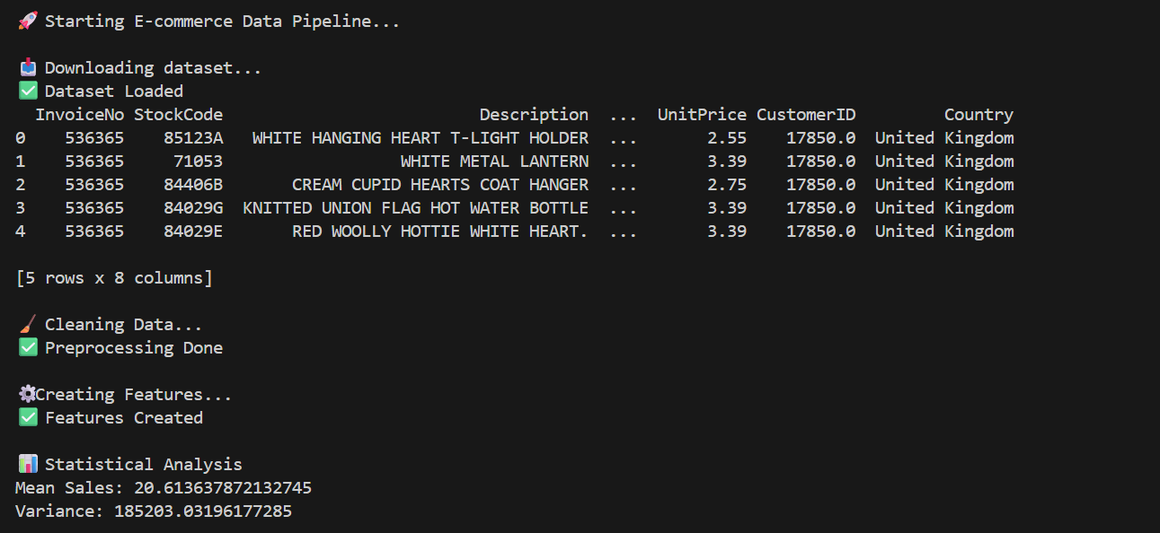
Output:

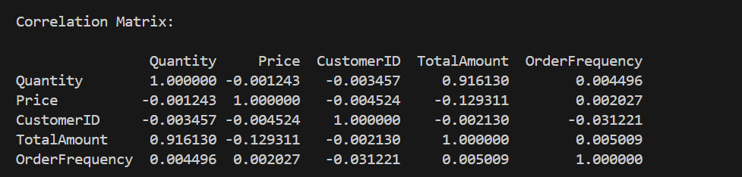
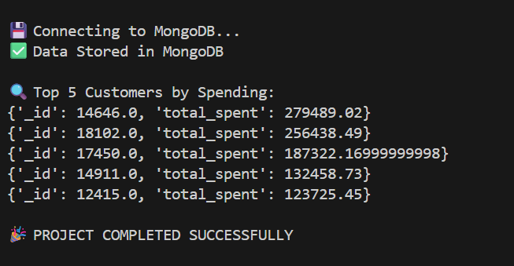

Dashboard:

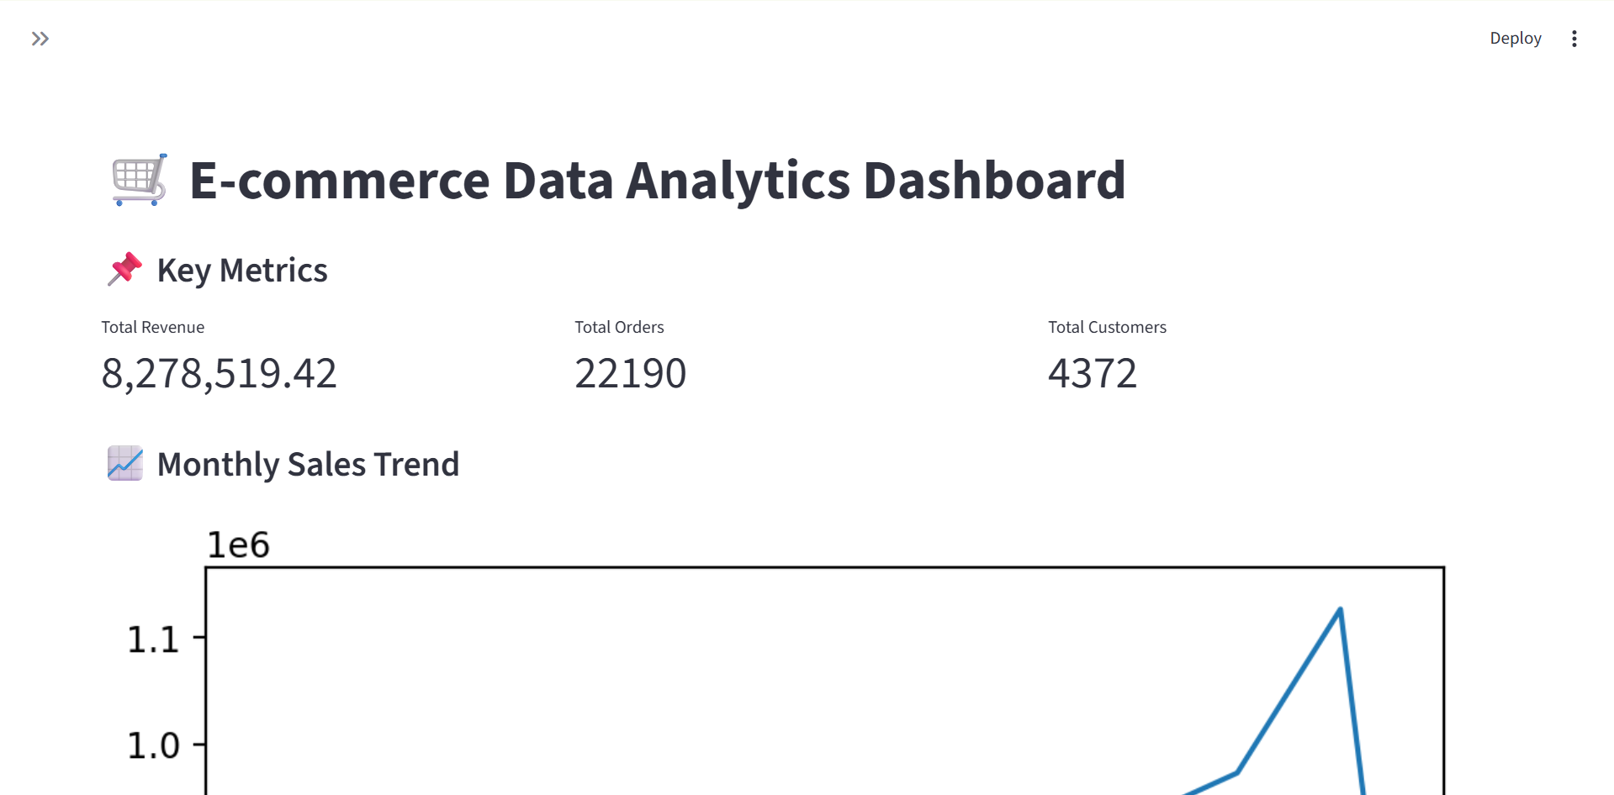
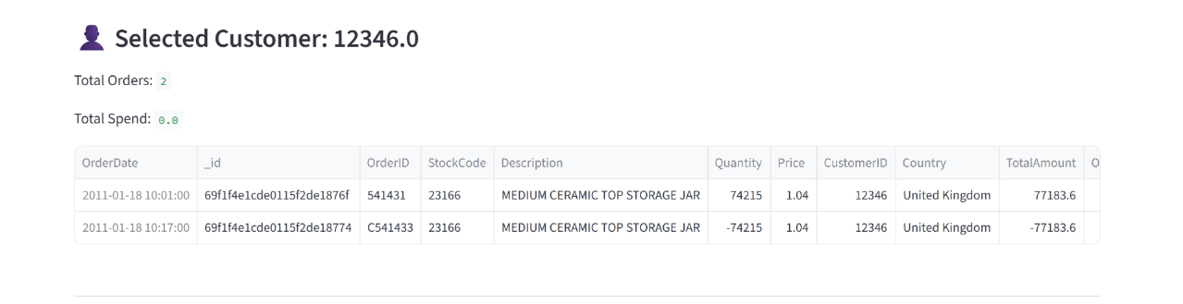
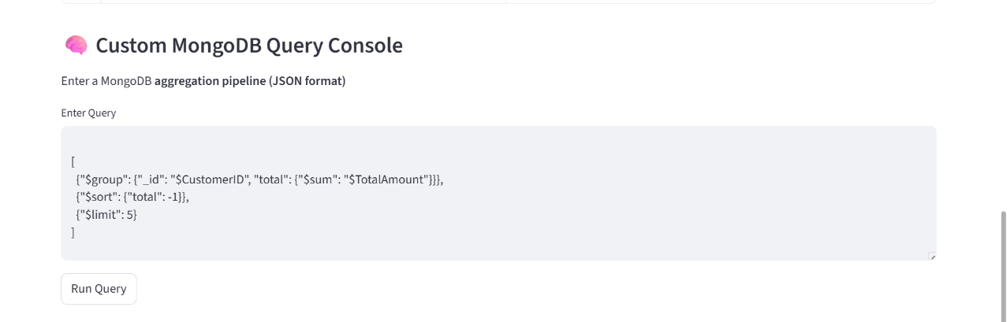
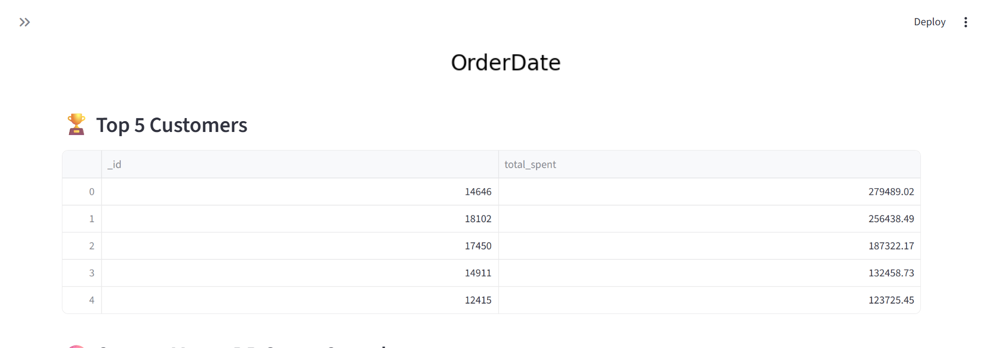

4. CONCLUSION

The E-commerce Data Pipeline & Analytics System successfully demonstrates how raw and unstructured data can be transformed into meaningful insights through a systematic approach. By implementing data preprocessing techniques, the project ensures data quality and consistency, which is essential for accurate analysis. Feature engineering and statistical methods help in uncovering important patterns such as customer behavior, purchasing trends, and product performance. The use of MongoDB provides a flexible and scalable solution for storing and querying large datasets efficiently. Additionally, the inclusion of big data concepts offers an understanding of how such systems can be extended to handle massive real-world data. Overall, this project highlights the importance of data engineering in modern e-commerce and provides a practical foundation for building intelligent, data-driven decision-making systems.

5. REFERENCES
[1] MongoDB, Inc. (2025). MongoDB PyMongo Documentation. MongoDB Docs. A comprehensive reference for the official Python driver (PyMongo), covering installation, connection setup, CRUD operations, aggregation, indexing, and security features for building scalable applications with MongoDB.
[2] MongoDB, Inc. (2025). MongoDB with Python. MongoDB Docs. Guides developers through integrating MongoDB with Python frameworks (Flask, FastAPI, Django), using ORMs like MongoEngine and Beanie, and leveraging PyMongo Async for modern data pipelines in production e-commerce systems.
[3] DataCamp. (2025). “MongoDB Aggregation Pipeline Tutorial in Python with PyMongo.” DataCamp Tutorials. Explains how to design and implement aggregation pipelines in MongoDB using PyMongo, with examples of $match, $group, $lookup, and $project stages—essential for processing customer, order, and product data in e-commerce pipelines.

