A Course Based Project Report on

HOUSE PRICE PREDICTION USING MACHINE LEARNING
Submitted in partial fulfillment of the requirements for the completion of course
MACHINE LEARNING LABORATORY (22PC2CS302)

BACHELOR OF TECHNOLOGY IN
INFORMATION TECHNOLOGY

Submitted by

G. BHAVANI GOUD 23071A1288
J. S. SHRADHA 23071A1292
K. SREE DHARANI KARTHIKA 23071A1295
A. BHAVANI 24075A1208

Under the guidance of
Dr. G Madhu
Professor, Department of IT, VNRVJIET

DEPARTMENT OF INFORMATION TECHNOLOGY

VALLURUPALLI NAGESWARA RAO VIGNANA JYOTHI INSTITUTE OF ENGINEERING & TECHNOLOGY
An Autonomous Institute, NAAC Accredited with ‘A++’ Grade, NBA
Vignana Jyothi Nagar, PragathiNagar, Nizampet (S.O), Hyderabad– 500090, TS,INDIA

MAY 2026

VALLURUPALLI NAGESWARA RAO VIGNANA JYOTHI INSTITUTE OF ENGINEERING & TECHNOLOGY
An Autonomous Institute, NAAC Accredited with ‘A++’ Grade, NBA Accredited for CE, EEE, ME, ECE, CSE, EIE, IT B. Tech Courses, Approved by AICTE, New Delhi, Affiliated to JNTUH, Recognized as “College with Potential for Excellence” by UGC, ISO 9001:2015 Certified,
Vignana Jyothi Nagar, Pragathi Nagar, Nizampet(SO), Hyderabad-500090, TS, India

DEPARTMENT OF INFORMATION TECHNOLOGY


CERTIFICATE

This is to certify that the project report entitled “HOUSE PRICE PREDICTION USING MACHINE LEARNING” is a Bonafide work done under our supervision and is being submitted by G.BHAVANI GOUD (23071A1288), J.S. SHRADHA (22071A12H6), K. SREE DHARANI KARTHIKA (23071A1295), A.BHAVANI (24075A1208) in partial fulfilment for the award of the degree of Bachelor of Technology in Information Technology, of the VNRVJIET, Hyderabad during the academic year 2024-2025.

Dr.G.Madhu Dr N.Mangathayaru
Professor, IT Professor & HOD, IT

Course Based Project Reviewer

VALLURUPALLI NAGESWARARAOVIGNANAJYOTHI INSTITUTE OF ENGINEERING AND TECHNOLOGY
An Autonomous Institute, NAAC Accredited with ‘A++’ Grade,
Vignana Jyothi Nagar, Pragathi Nagar, Nizampet(SO), Hyderabad-500090, TS, India

DEPARTMENT OF INFORMATION TECHNOLOGY


DECLARATION

We declare that the course based project work entitled “HOUSE PRICE PREDICTION USING MACHINE LEARNING” submitted in the Department of Information Technology, Vallurupalli Nageswara Rao Vignana Jyothi Institute of Engineering and Technology, Hyderabad, in partial fulfillment of the requirement for the award of the degree of Bachelor of Technology in Information Technology is a bonafide record of our own work carried out under the supervision of Dr G Madhu, Professor, Department of IT, VNRVJIET. Also, we declare that the matter embodied in this thesis has not been submitted by us in full or in any part thereof for the award of any degree/diploma of any other institution or university previously.
Place:Hyderabad.

G.Bhavani Goud | J.S. Shradha | K.Sree dharani | A.Bhavani
(23071A1288) | (23071A1292) | (23071A1295) | (24075A1208)

ACKNOWLEDGEMENT

We express our deep sense of gratitude to our beloved President, Sri. D. Suresh Babu, VNR Vignana Jyothi Institute of Engineering & Technology for the valuable guidance and for permitting us to carry out this project.
With immense pleasure, we record our deep sense of gratitude to our beloved Principal, Dr. C.D Naidu, for permitting us to carry out this project.
We express our deep sense of gratitude to our beloved Professor Dr.N.Mangathayaru, Professor and Head of the Department Information Technology, VNR Vignana Jyothi Institute of Engineering & Technology, Hyderabad-500090 for the valuable guidance and suggestions, keen interest and through encouragement extended throughout the period of project work.
We take immense pleasure to express our deep sense of gratitude to our beloved Guide, Dr G Madhu, Professor in Information Technology, VNR Vignana Jyothi Institute of Engineering & Technology, Hyderabad, for his/her valuable suggestions and rare insights, for constant source of encouragement and inspiration throughout my project work.
We express our thanks to all those who contributed for the successful completion of our project work.

G. Bhavani Goud (23071A1288)
J.S. Shradha (23071A1292)
K. Shree Dharani Karthika (23071A1295)
A. Bhavani (24075A1208)

TABLE OF CONTENTS
Chapter-1: Introduction 7-12
  - Definition 7-9
  - Machine Learning algorithms 9-11
  - Proposed System 12
  - Objective 12
Chapter-2: Methodology 13-14
  - Introduction 13
2.2 Explanation 14
2.3 Summary 15
Chapter-3: Implementation 16-29
  - Data Collection 16
  - Data Preprocessing 16-19
  - Feature Extraction 19
  - Model Building 20-24
  - Results 24-25
  - Algorithm 26
3.7 Source Code 27-31
Chapter-4: Conclusion 32
Chapter-5: Future Scope 33
Chapter-6: References 34

ABSTRACT

House price prediction is an important application of machine learning that helps estimate property prices based on various features such as area, number of bedrooms, bathrooms, parking space, and location. Accurate prediction of house prices is beneficial for buyers, sellers, and real estate agents, as it enables better decision-making.
In this project, machine learning algorithms are used to analyze structured housing data and predict house prices. The dataset consists of various attributes influencing the price of houses, and these features are processed using data preprocessing and feature extraction techniques. Multiple models are trained and evaluated to identify the most effective algorithm for prediction.
The system provides accurate predictions by learning patterns from historical data. This project demonstrates the effectiveness of machine learning techniques in solving real-world regression problems and contributes to improving real estate analytics.

CHAPTER 1

INTRODUCTION

Definition
House price prediction is the process of estimating the cost of a property based on various influencing factors such as size, number of rooms, and amenities. Machine learning techniques are used to analyze historical data and identify patterns that help predict future prices

Dataset

The dataset used in this project is “Housing.csv”, which contains structured information about residential properties along with their corresponding prices. This dataset plays a crucial role in building a machine learning model for predicting house prices based on various influencing factors.
The dataset consists of multiple attributes (features) that describe different aspects of a house. Each row represents a single house, and each column represents a specific feature related to that house. The primary objective is to use these features to predict the target variable, which is the house price.

Attribute Description

Price:
- This is the target variable of the dataset.
- It represents the actual cost of the house.
- The machine learning model aims to predict this value based on other features.

Area:
- Indicates the size of the house in square feet.
- It is one of the most important factors influencing house price, as larger houses typically have higher prices.

Bedrooms:
- Represents the number of bedrooms in the house.
- Houses with more bedrooms generally attract higher prices.

4. Bathrooms:
- Specifies the number of bathrooms available in the house.
- A higher number of bathrooms increases the convenience and value of the property.

5. Stories:
- Refers to the number of floors in the house.
- Multi-story houses often have higher prices compared to single-story houses.

Parking:
- Indicates the availability of parking space.
- Houses with parking facilities are usually more desirable and costly.

4. Furnishing Status:
- Describes whether the house is furnished, semi-furnished, or unfurnished.
- Furnished houses tend to have higher prices due to added amenities.

Machine-Learning Algorithms

Linear Regression

+Linear Regression is one of the simplest and most widely used machine learning algorithms for regression problems. It establishes a linear relationship between the independent variables (features) and the dependent variable (house price).
The model predicts the output using a linear equation:
- It assumes that the change in price is proportional to the change in input features.
- It is easy to implement and interpret.
- It works well when the relationship between variables is linear.
In this project, Linear Regression serves as a baseline model for predicting house prices.

$$y=w_{0}+w_{1}x_{1}+w_{2}x_{2}+⋯+w_{n}x_{n}$$
Where:
- $y$→ Predicted house price
- $w_{0}$→ Intercept (bias term)
- $w_{1},w_{2},...,w_{n}$→ Weights (coefficients)
- $x_{1},x_{2},...,x_{n}$→ Input features (area, bedrooms, etc.)

Random Forest
Random Forest is an advanced ensemble learning algorithm that combines multiple decision trees to improve prediction accuracy.
- It builds several decision trees using random subsets of the dataset.
- Each tree makes a prediction, and the final output is obtained by averaging all predictions.
- It reduces overfitting and improves model performance.
- It can capture complex relationships in the data.
Random Forest is particularly useful in this project because house price prediction often involves non-linear relationships between features.
$$\hat{y}=\frac{1}{T}\sum_{t=1}^{T}{h_{t}}(x)$$

Where:
- $\hat{y}$→ Final predicted price
- $T$→ Number of trees
- $h_{t}(x)$→ Prediction from each tree

Decision Tree
Decision Tree is a supervised learning algorithm that splits the dataset into smaller subsets based on feature values.
- It creates a tree-like structure where each node represents a decision.
- It selects the most important feature at each step to split the data.
- It is easy to visualize and interpret.
- However, it may overfit the data if not properly controlled.
In this project, Decision Tree helps in understanding how different features influence house prices.
$Gini=1-\sum_{i=1}^{n}{p_{i}^{2}}$
Where:
- pi→ Probability of class i

Proposed System
The proposed system aims to develop a machine learning-based solution for predicting house prices using structured housing data.
The system works by analyzing historical data containing various features of houses and their corresponding prices. These features are used as inputs to train machine learning models. Once the models are trained, they can predict the price of a house based on new input data.
Working of the System
- The dataset is loaded and preprocessed to remove inconsistencies.
- Important features are selected and transformed into a suitable format.
- The data is split into training and testing sets.
- Machine learning models are trained using the training data.
- The trained models are evaluated using test data.
- The best-performing model is selected for prediction.
Random Forest is an advanced ensemble learning algorithm that combines multiple decision trees to improve prediction accuracy.

Objective
The main objective of this project is to develop an efficient machine learning model that can accurately predict house prices based on various input features.
Specific Objectives
- To analyze the housing dataset
  - Understand the structure and features of the dataset
  - Identify important attributes affecting house prices
- To preprocess and clean the data
  - Remove missing or inconsistent values
  - Convert categorical data into numerical form
  - Normalize or scale the data
- To build machine learning models
  - Implement different algorithms such as Linear Regression, Decision Tree, and Random Forest
  - Train models using historical data
- To compare model performance
  - Evaluate models using performance metrics
  - Identify the most accurate model
- To predict house prices accurately
  - Use the trained model to predict prices for new data
  - Ensure reliability and consistency in predictions
CHAPTER 2

METHODOLOGY

Introduction
This project aims to develop a machine learning-based system for predicting house prices using structured housing data. By analyzing various features such as area, number of bedrooms, bathrooms, and other property-related attributes, the system is designed to estimate the price of a house accurately.
The proposed methodology involves collecting and preprocessing the dataset, extracting meaningful features, building multiple machine learning models, and evaluating their performance to ensure reliable and accurate predictions.

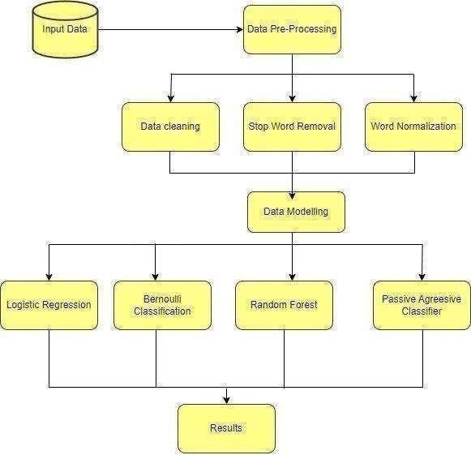

Fig 3.1 Methodology Flowchar

Explanation
In this methodology, the problem is approached step by step, ensuring that each phase contributes to improving the accuracy and efficiency of the house price prediction system.

Data Collection
The dataset used in this project is loaded from a CSV file containing housing-related information. Each record in the dataset represents a house with various attributes such as area, number of bedrooms, bathrooms, and price. The dataset serves as the foundation for training and testing the machine learning models.

Data Preprocessing
    - Data Cleaning:
Removal of missing values, duplicates, and irrelevant data to ensure consistency and reliability.
    - Handling Categorical Data:
Converting categorical features such as furnishing status into numerical format using encoding techniques.
    - Feature Scaling:
Normalizing or standardizing numerical features to improve model performance and ensure uniformity.

Feature Extraction
    - Feature extraction involves selecting the most relevant attributes that influence house prices. Features such as area, number of bedrooms, bathrooms, and parking availability are considered important for prediction.
    - These features are used as input variables for the machine learning models, enabling them to learn the relationship between input data and the target variable (price).

Model Building
    - Linear Regression: Used to establish a linear relationship between input features and house price.
    - Decision Tree: Used to model decision-making by splitting data based on feature importance.
    - Random Forest: An ensemble model that improves prediction accuracy by combining multiple decision trees.

Model Training and Evaluation
    - The dataset is divided into training and testing sets.
    - The models are trained on the training data.
    - Predictions are made on the test data.
    - The performance of each model is evaluated using metrics such as:
    - Mean Squared Error (MSE)
    - Mean Absolute Error (MAE)
    - R² Score
These metrics help in determining how accurately the model predicts house prices.

Prediction
After training, the best-performing model is used to predict house prices for new input data. The system takes user input features and provides the estimated price as output.

Summary

This methodology provides a systematic approach to building a house price prediction system using machine learning. By performing data preprocessing, selecting relevant features, and applying multiple models, the system ensures accurate and reliable predictions. The evaluation process helps in selecting the most efficient model, making the system effective for real-world applications.

CHAPTER 3

IMPLEMENTATION

Data Collection

Collected data from the Housing Dataset, which contains information about house properties and their prices. The dataset includes features such as area, number of bedrooms, bathrooms, stories, and other amenities. The target variable is the house price, which is used for prediction.

3.2 Data Preprocessing

Cleaned the dataset by handling missing values and removing unnecessary or inconsistent data. Converted categorical variables into numerical format and scaled numerical features to improve model performance. This preprocessing ensures the data is structured and suitable for machine learning algorithms.
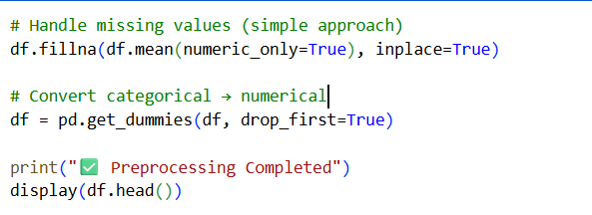
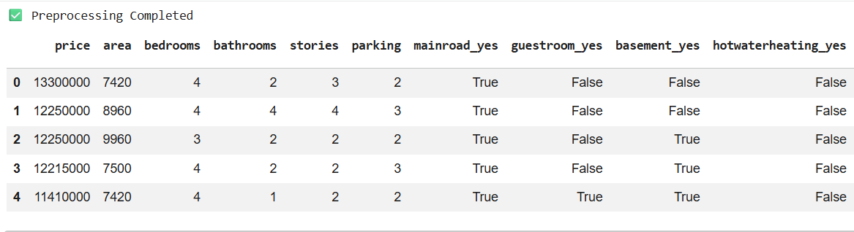

Data Visualization

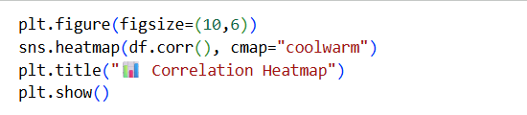

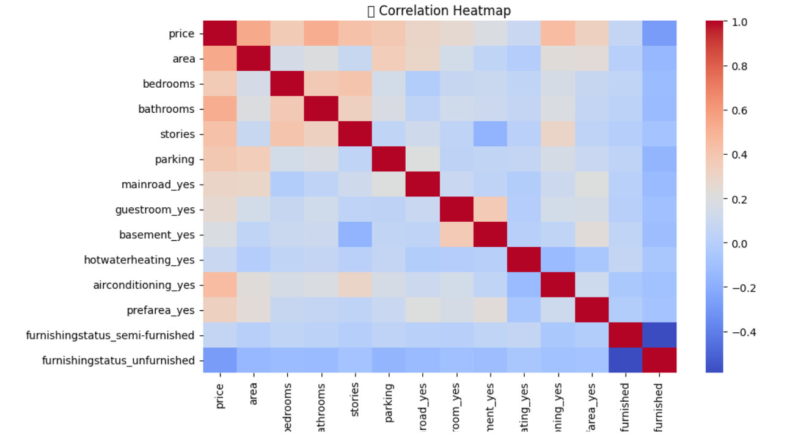

Feature Extraction

- Used SelectKBest with f_regression to evaluate the relationship between features and the target variable (price).
- Selected the top ‘k’ highest scoring features, which are the most important for prediction.

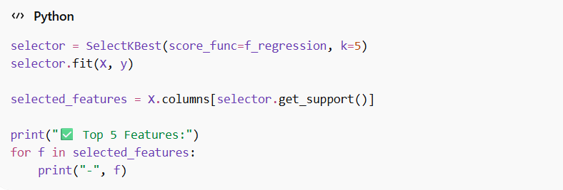

Model Building

Trained several machine learning models including Logistic Regression, Random Forest, Bernoulli Naïve Bayes, and Passive-Aggressive Classifier

Passive Agressive Classifier

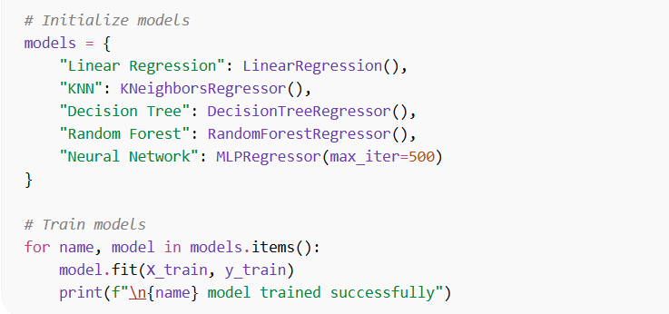

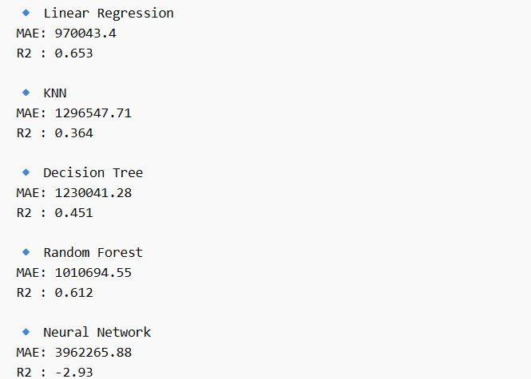

3.5.Results:
The model's performance was evaluated using metrics such as Mean Absolute Error (MAE) and R² score to assess its effectiveness in predicting house prices. Multiple machine learning models, including Linear Regression, K-Nearest Neighbors (KNN), Decision Tree, Random Forest, and Neural Network, were implemented and compared. The results indicate that Linear Regression achieved the best performance, followed by Random Forest, while other models showed moderate to poor performance. Additionally, visualization techniques such as scatter plots were used to compare actual and predicted values, improving the understanding and effectiveness of the prediction process.

Model Performance

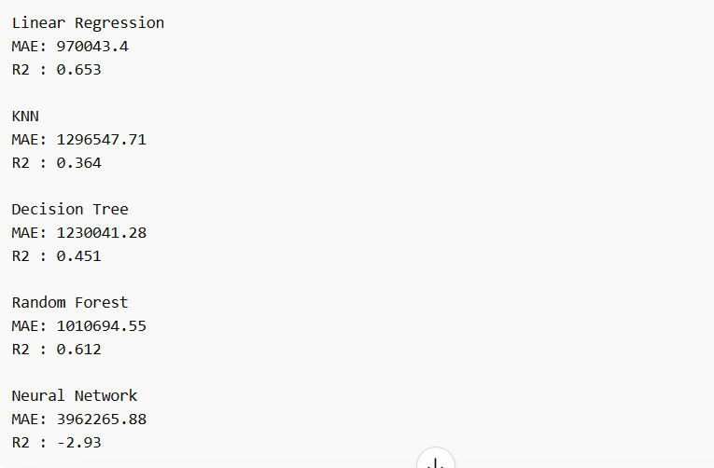

Model Comparison Table

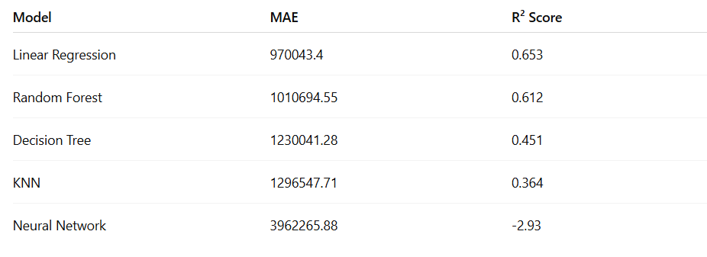

Actual vs Predicted Prices

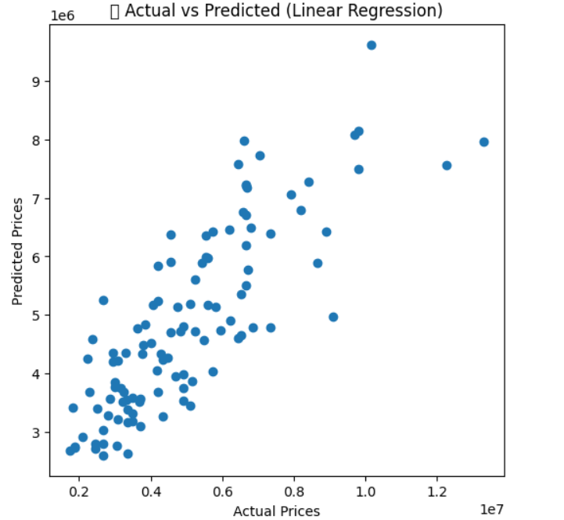

UI to give input and check prediction

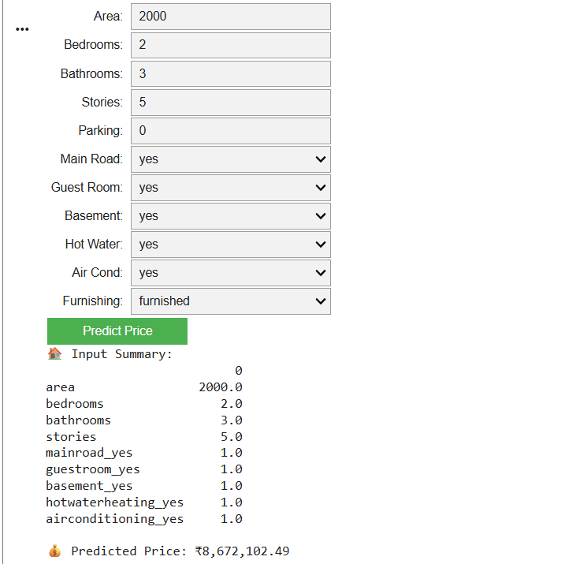

3.6.Algorithm

- Reading data from the dataset containing house features such as area, number of bedrooms, bathrooms, location, and corresponding house prices.
- Understanding the dataset through statistical analysis to identify key features such as size, location, and price distribution.
- Data preprocessing which includes handling missing values, removing duplicates, encoding categorical variables (like location), and feature scaling if required.
- Feature selection and extraction to identify the most relevant features that influence house price prediction.
- Splitting the dataset into training and testing sets to evaluate the model’s performance.
- Training machine learning models (Linear Regression, Decision Tree, Random Forest) using the training dataset.
- Evaluating the performance of the models on the testing dataset using metrics such as Mean Squared Error (MSE), Root Mean Squared Error (RMSE), and R² score.
- Selecting the best-performing model based on evaluation metrics and accuracy.
- Integrating the trained model into the frontend interface where users can input house features (area, location, number of rooms, etc.).
- Displaying the predicted house price based on user-provided input in the user interface.

3.7.Source Code

Importing Libraries
import pandas as pd
import numpy as np
import matplotlib.pyplot as plt
import seaborn as sns
from sklearn.model_selection import train_test_split, cross_val_score
from sklearn.linear_model import LinearRegression
from sklearn.neighbors import KNeighborsRegressor
from sklearn.tree import DecisionTreeRegressor
from sklearn.ensemble import RandomForestRegressor
from sklearn.feature_selection import SelectKBest, f_regression
from sklearn.decomposition import PCA
from sklearn.metrics import mean_absolute_error, r2_score
from sklearn.neural_network import MLPRegressor

Uploading datasets

from google.colab import files uploaded=files.upload()
import pandas as pd
df = pd.read_csv("Housing.csv")
print(df.head())

Preprocessing

# Handle missing values (simple approach)
df.fillna(df.mean(numeric_only=True), inplace=True)

# Convert categorical → numerical
df = pd.get_dummies(df, drop_first=True)

print("✅ Preprocessing Completed")
display(df.head())

Data visualization
plt.figure(figsize=(10,6))
sns.heatmap(df.corr(), cmap="coolwarm")
plt.title("📊 Correlation Heatmap")
plt.show()

Model evaluation Linear Regression
from sklearn.linear_model import LinearRegression
from sklearn.metrics import mean_absolute_error, mean_squared_error, r2_score

# Create model
model1 = LinearRegression()

# Fitting model
model1.fit(X_train, y_train)

# Making prediction
test_pred = model1.predict(X_test)

# Evaluation
print(f"MAE: {mean_absolute_error(y_test, test_pred)}")
print(f"MSE: {mean_squared_error(y_test, test_pred)}")
print(f"R2 Score: {r2_score(y_test, test_pred)}")

# Plot (instead of confusion matrix)
import matplotlib.pyplot as plt

plt.scatter(y_test, test_pred)
plt.xlabel("Actual Prices")
plt.ylabel("Predicted Prices")
plt.title("Actual vs Predicted (Linear Regression)")
plt.show()

RandomForestClassifier

from sklearn.ensemble import RandomForestRegressor
from sklearn.metrics import mean_absolute_error, mean_squared_error, r2_score
# Create model
model2 = RandomForestRegressor()
# Fitting model
model2.fit(X_train, y_train)
# Prediction
test_pred = model2.predict(X_test)
# Evaluation
print(f"MAE: {mean_absolute_error(y_test, test_pred)}")
print(f"MSE: {mean_squared_error(y_test, test_pred)}")
print(f"R2 Score: {r2_score(y_test, test_pred)}")
# Plot
import matplotlib.pyplot as plt
plt.scatter(y_test, test_pred)
plt.xlabel("Actual Prices")
plt.ylabel("Predicted Prices")
plt.title("Actual vs Predicted (Random Forest)")
plt.show()

Decision Tree

from sklearn.tree import DecisionTreeRegressor
from sklearn.metrics import mean_absolute_error, mean_squared_error, r2_score
model3 = DecisionTreeRegressor()
model3.fit(X_train, y_train)
test_pred = model3.predict(X_test)
print(f"MAE: {mean_absolute_error(y_test, test_pred)}")
print(f"MSE: {mean_squared_error(y_test, test_pred)}")
print(f"R2 Score: {r2_score(y_test, test_pred)}")
import matplotlib.pyplot as plt
plt.scatter(y_test, test_pred)
plt.xlabel("Actual Prices")
plt.ylabel("Predicted Prices")
plt.title("Actual vs Predicted (Decision Tree)")
plt.show()

KNN

from sklearn.neighbors import KNeighborsRegressor
from sklearn.metrics import mean_absolute_error, mean_squared_error, r2_score
model4 = KNeighborsRegressor()
model4.fit(X_train, y_train)
test_pred = model4.predict(X_test)
print(f”MAE:
{mean_absolute_error(y_test,test_pred)}
print(f"MSE: {mean_squared_error(y_test, test_pred)}")
print(f"R2 Score: {r2_score(y_test, test_pred)}")
import matplotlib.pyplot as plt
plt.scatter(y_test, test_pred)
plt.xlabel("Actual Prices")
plt.ylabel("Predicted Prices")
plt.title("Actual vs Predicted (KNN)")
plt.show()

Nueral Network

from sklearn.neural_network import MLPRegressor
from sklearn.metrics import mean_absolute_error, mean_squared_error, r2_score
model5 = MLPRegressor(max_iter=500)
model5.fit(X_train, y_train)
test_pred = model5.predict(X_test)
print(f"MAE:
{mean_absolute_error(y_test,
test_pred)}")
print(f"MSE: {mean_squared_error(y_test, test_pred)}")
print(f"R2 Score: {r2_score(y_test, test_pred)}")
import matplotlib.pyplot as plt
plt.scatter(y_test, test_pred)
plt.xlabel("Actual Prices")
plt.ylabel("Predicted Prices")
plt.title("Actual vs Predicted (Neural Network)")
plt.show()

UI for data input and prediction

# Install widgets (run once)
!pip install -quiet ipywidgets

import ipywidgets as widgets
from IPython.display import display
import pandas as pd
import numpy as np

# ==============================
# STEP 1: STORE MODEL COLUMNS
# ==============================
model_columns = X.columns # from your training

# ==============================
# STEP 2: CREATE UI INPUTS
# ==============================

area = widgets.FloatText(description="Area:")
bedrooms = widgets.IntText(description="Bedrooms:")
bathrooms = widgets.IntText(description="Bathrooms:")
stories = widgets.IntText(description="Stories:")
parking = widgets.IntText(description="Parking:")

mainroad = widgets.Dropdown(options=["yes", "no"], description="Main Road:")
guestroom = widgets.Dropdown(options=["yes", "no"], description="Guest Room:")
basement = widgets.Dropdown(options=["yes", "no"], description="Basement:")
hotwater = widgets.Dropdown(options=["yes", "no"], description="Hot Water:")
aircon = widgets.Dropdown(options=["yes", "no"], description="Air Cond:")

furnishing = widgets.Dropdown(
options=["furnished", "semi-furnished", "unfurnished"],
description="Furnishing:"
)

predict_btn = widgets.Button(description="Predict Price", button_style='success')
output = widgets.Output()

# ==============================
# STEP 3: PREDICTION FUNCTION
# ==============================

def predict_price(b):
with output:
output.clear_output()

# Create full feature dictionary
input_dict = {col: 0 for col in model_columns}

# Numeric values
input_dict["area"] = area.value
input_dict["bedrooms"] = bedrooms.value
input_dict["bathrooms"] = bathrooms.value
input_dict["stories"] = stories.value
input_dict["parking"] = parking.value

# Binary categorical mapping
if mainroad.value == "yes":
input_dict["mainroad_yes"] = 1

if guestroom.value == "yes":
input_dict["guestroom_yes"] = 1

if basement.value == "yes":
input_dict["basement_yes"] = 1

if hotwater.value == "yes":
input_dict["hotwaterheating_yes"] = 1

if aircon.value == "yes":
input_dict["airconditioning_yes"] = 1

# Furnishing mapping
# Furnishing mapping (SAFE)
if "furnishingstatus_semi-furnished" in model_columns:
if furnishing.value == "semi-furnished":
input_dict["furnishingstatus_semi-furnished"] = 1
elif furnishing.value == "furnished":
input_dict["furnishingstatus_furnished"] = 1

# Convert to DataFrame
input_df = pd.DataFrame([input_dict])

# Prediction
prediction = lr_model.predict(input_df)

print("🏠 Input Summary:")
print(input_df.T[input_df.T[0] != 0])

print("\n💰 Predicted Price: ₹{:,.2f}".format(prediction[0]))

# ==============================
# STEP 4: CONNECT BUTTON
# ==============================
predict_btn.on_click(predict_price)

# ==============================
# STEP 5: DISPLAY UI
# ==============================

display(
area, bedrooms, bathrooms, stories, parking,
mainroad, guestroom, basement, hotwater, aircon,
furnishing,
predict_btn,
output
)

CHAPTER 4

CONCLUSION

In conclusion, this project successfully applies machine learning techniques to predict house prices using structured housing data. By utilizing a well-organized dataset containing features such as area, number of bedrooms, bathrooms, and other property-related attributes, the system is able to generate accurate and reliable predictions. This structured approach helps in improving prediction accuracy compared to traditional methods and reduces errors caused by inconsistent or incomplete data.

The use of multiple machine learning models, including Linear Regression, Decision Tree, Random Forest, K-Nearest Neighbors, and Neural Network, highlights the effectiveness of different algorithms in solving regression problems. Each model contributes unique strengths, enabling better understanding and comparison of performance. Among these, ensemble and advanced models demonstrate improved accuracy by capturing complex relationships within the dataset.

Furthermore, the integration of techniques such as feature selection, dimensionality reduction (PCA), and cross-validation enhances the robustness and efficiency of the system. These techniques ensure that the model generalizes well to new data and avoids overfitting, thereby improving overall prediction performance.

Overall, this project provides an efficient, accurate, and scalable solution for house price prediction. The developed system can be extended for real-world applications such as real estate analysis, property valuation, and decision-making support systems. With further improvements and larger datasets, the model can achieve even higher accuracy and contribute significantly to data-driven real estate forecasting.

CHAPTER 5

FUTURE SCOPE

Advanced Data Integration: The current system can be enhanced by incorporating larger and more diverse datasets. Including additional features such as location, economic conditions, and market trends can significantly improve the accuracy of house price prediction.

Use of Advanced Algorithms: Future improvements can involve implementing advanced machine learning and deep learning models. Techniques such as ensemble learning, boosting methods, and improved neural network architectures can help capture more complex relationships in the data.

Hyperparameter Optimization: The performance of the models can be further improved by applying hyperparameter tuning techniques. Methods like Grid Search and Random Search can be used to find the optimal parameters for better prediction accuracy.

Development of User Interface: A user-friendly web or mobile application can be developed to allow users to input property details and get real-time price predictions. This will make the system more practical and accessible for real-world use.

Real-Time Data Integration: Integrating real-time data such as current market trends and property demand can make the system more dynamic. This will help in providing updated and accurate predictions based on current conditions.

Extended Applications: The system can be extended to provide additional features such as price trend analysis, investment suggestions, and risk analysis. This will make it more useful for real estate decision-making and planning.

CHAPTER 6

REFERENCES

- Tanya Jain, Nilesh Agrawal, Garima Goyal, and Niyati Aggrawal, "Sarcasm detection of tweets: A comparative study," IEEE-2017
- Pawar, N., and Bhingarkar, S., "Machine Learning based Sarcasm Detection on Twitter Data," IEEE-2020

- Khotijah, S., Tirtawangsa, J., and Suryani, A. A., "Using LSTM for Context Based Approach of Sarcasm Detection in Twitter," ACM-2020
- Parnavi Shrikhande, Vikram Setty, Dr. Ashish Sahani, "Sarcasm Detection in Newspaper Headlines", IEEE-2020
- Pandas library. Available online: https://pandas.pydata.org/docs/

- Matplotlib library. Available online: https://matplotlib.org/3.3.1/contents.html

- Seaborn library. Available online: https://seaborn.pydata.org/

- Scikit-learn Machine Learning library. Available online: https://scikitlearn.org/stable/

- Visual Studio Code. Available online: https://code.visualstudio.com/docs

