BayesianJournal

Shrankhala Jain

2/14/2018

# Discrete Probability Distribution using Bayesian, which uses subjective probability which describes beliefs about unknown quantities.And the method used is through probability distribution. a Spinner is used as a example which is divided into several regions and opt for various outcomes.

# Package Used- "TeachBayes" (available on CRAN).The Special functions for Bayes'rule are- Learning baout a proportion and a mean and comparing two proportions.

## R Markdown

This is an R Markdown document. Markdown is a simple formatting syntax for authoring HTML, PDF, and MS Word documents. For more details on using R Markdown see <http://rmarkdown.rstudio.com>.

When you click the **Knit** button a document will be generated that includes both content as well as the output of any embedded R code chunks within the document. You can embed an R code chunk like this:

# Bayes'rule identifies possible models and contains prior probabilities. For executing collect the data , think of likelihood an dchance of getting the data for each model. Then find the posterior probability for finding the knowledge about model.   
# Define a spinner with five regions: regions  
regions <- c(2,2,2,2,2)  
spinner_plot(regions)

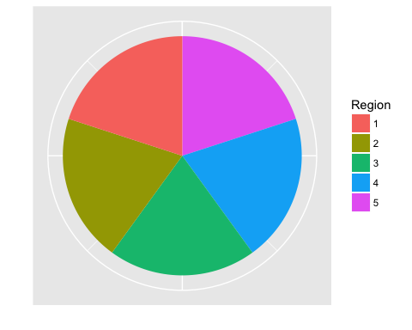

spinner_probs(regions)

## Region Prob  
## 1 1 0.2  
## 2 2 0.2  
## 3 3 0.2  
## 4 4 0.2  
## 5 5 0.2

# Plot the spinner  
spinner_plot(regions)



# Show the probability distribution  
spinner_probs(regions)

## Region Prob  
## 1 1 0.2  
## 2 2 0.2  
## 3 3 0.2  
## 4 4 0.2  
## 5 5 0.2

# Define new spinner: regions  
regions <- c(2, 2, 4)  
  
# Simulation 1000 spins: spins  
spins <- spinner_data(regions, 1000)  
  
# Graph the spin data using bar_plot()  
bar_plot(spins)

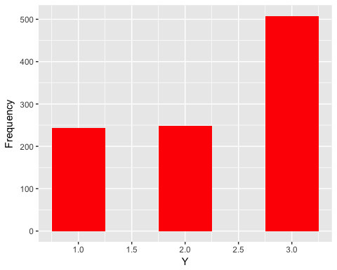

# Construct frequency table of spins  
table(spins)

## spins  
## 1 2 3   
## 244 248 508

# Find fraction of spins equal to 2  
mean(spins == 2)

## [1] 0.248

# Find mean spin value  
mean(spins)

## [1] 2.264

# Create the vector of models: Model  
Model <- c("Spinner A", "Spinner B")  
  
# Define the vector of prior probabilities: Prior  
Prior <- c(1/2, 1/2)  
  
# Define the vector of likelihoods: Likelihood  
Likelihood <- c(1/2, 1/6)  
  
# Make a data frame with variables Model, Prior, Likelihood: bayes_df  
bayes_df <- data.frame(Model, Prior, Likelihood)  
  
# Compute the posterior probabilities  
bayesian_crank(bayes_df)

## Model Prior Likelihood Product Posterior  
## 1 Spinner A 0.5 0.5000000 0.25000000 0.75  
## 2 Spinner B 0.5 0.1666667 0.08333333 0.25

bayes_df

## Model Prior Likelihood  
## 1 Spinner A 0.5 0.5000000  
## 2 Spinner B 0.5 0.1666667

prior_post_plot

## function (d, ...)   
## {  
## N <- dim(d)[1]  
## Size <- 100/N  
## Size <- ifelse(Size > 15, 15, Size)  
## Size <- ifelse(Size < 2, 2, Size)  
## Model <- rep(d[, 1], 2)  
## Probability <- c(d$Prior, d$Posterior)  
## Type <- c(rep("Prior", N), rep("Posterior", N))  
## D1 <- data.frame(Model, Probability, Type)  
## p <- ggplot(D1, aes(Model, Probability, color = Type)) +   
## geom_segment(aes(xend = Model, yend = 0), size = Size,   
## lineend = "butt") + facet_wrap(~Type, ncol = 1)  
## if (nargs() == 2)   
## p <- p + xlab(...)  
## p  
## }  
## <environment: namespace:TeachBayes>

prior_post_plot (bayes_df)

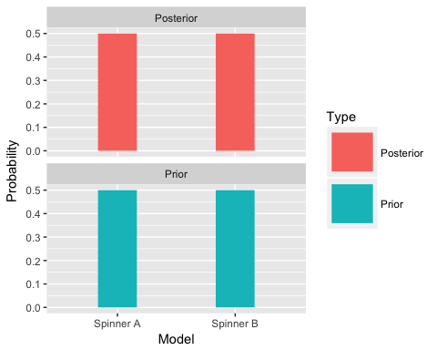

# Display the vector of models: Model  
Model <- c("Spinner A", "Spinner B")  
  
# Define the vector of prior probabilities: Prior  
Prior <- c(0.75, 0.25)  
  
# Define the vector of likelihoods: Likelihood  
Likelihood <- c(1/2, 1/6)  
  
# Make a data frame with variables Model, Prior, Likelihood: bayes_df  
bayes_df <- data.frame(Model, Prior, Likelihood)  
  
# Compute the posterior probabilities  
bayesian_crank(bayes_df)

## Model Prior Likelihood Product Posterior  
## 1 Spinner A 0.75 0.5000000 0.37500000 0.9  
## 2 Spinner B 0.25 0.1666667 0.04166667 0.1

## Including Plots

You can also embed plots, for example:

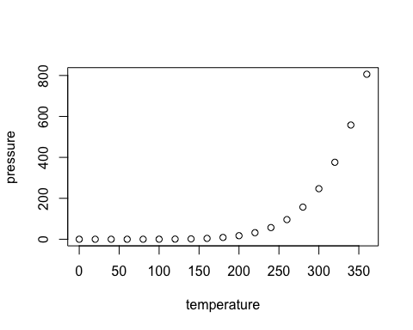

Note that the echo = FALSE parameter was added to the code chunk to prevent printing of the R code that generated the plot.