Knowledge Distillation for Lightweight Models
A Teacher-Student Study on Fashion-MNIST
UML501 Machine Learning Lab Project (Project 4)
Thapar Institute of Engineering and Technology

Submitted by: [Armandeep Singh Taggar, 1024030219] and [Shrasthi Singh Rathore,1024031049]
Instructor: Charchit Chandra

Abstract
Large neural networks are accurate but expensive to store and run. Knowledge distillation trains a small student network to imitate a larger teacher, aiming to keep accuracy while reducing size and latency. We study this on Fashion-MNIST. A 3.58M-parameter CNN teacher reaches 93.46% test accuracy. We train three students (6.8k, 26.7k and 106k parameters), each with labels only and with distillation, over three random seeds, and sweep the temperature and the loss weight. Distillation improved the medium student by 0.55 accuracy points on average (positive in all three seeds), the small student by 0.21 points, and gave no reliable gain for the tiny student. The students are 34x to 526x smaller than the teacher and about 7x to 14x faster on CPU, at an accuracy cost of 1.2 to 4.6 points. The hardest class throughout is Shirt, which is confused with T-shirt, Pullover and Coat.

1. Problem Definition and Background

1.1 Problem statement
Determine whether a compact student network can learn from a larger teacher and outperform the same student trained only on ground-truth labels.

1.2 Objectives and research questions
- Train a teacher network and several smaller student networks.
- Train a student with labels only (baseline) and a student of identical architecture using the teacher's soft targets and a stated distillation loss.
- RQ1: Does distillation improve a student of fixed size, and is the improvement larger than seed-to-seed variation?
- RQ2: How does the benefit depend on student size, temperature and loss weight?
- RQ3: What accuracy is traded for the gain in model size and inference speed?

1.3 Motivation
Deploying models on phones, embedded devices or CPU-only servers requires small, fast networks. Small networks trained directly on labels usually lose accuracy relative to large ones. Distillation offers a way to transfer some of the large model's behaviour into a small one without changing the small model's architecture or inference cost.

1.4 Background
The idea of compressing a large model into a smaller one was explored by Bucila, Caruana and Niculescu-Mizil (2006) and by Ba and Caruana (2014), who trained shallow networks to mimic deeper ones. Hinton, Vinyals and Dean (2015) popularised the term knowledge distillation. Their key observation is that a trained network's output probabilities carry information beyond the correct label: an image of a shirt may receive small but non-zero probabilities for T-shirt and Pullover, which tells the student which classes are similar. A temperature T softens the probabilities so that this information is easier to learn from.
With teacher logits z_t and student logits z_s, the loss used in this project is:
L = alpha * T^2 * KL( softmax(z_t / T) || softmax(z_s / T) ) + (1 - alpha) * CE(z_s, y)
The first term makes the student match the teacher's softened distribution; the second is ordinary cross-entropy on the true label. The factor T^2 keeps the gradient magnitude of the first term comparable across temperatures. Setting alpha = 0 recovers plain label training, which we use as a control.

2. Dataset Documentation
Item | Description
Name and source | Fashion-MNIST, Zalando Research (Xiao, Rasul and Vollgraf, 2017). https://github.com/zalandoresearch/fashion-mnist
Usage terms | Released by Zalando Research under the MIT license; free for research and education. We cite the source.
Samples | 70,000 images: 60,000 official train and 10,000 official test.
Features | Each sample is a 28 x 28 grayscale image (784 pixel values, 0 to 255).
Target | Clothing category, 10 classes: T-shirt/top, Trouser, Pullover, Dress, Coat, Sandal, Shirt, Sneaker, Bag, Ankle boot.
Split used | 55,000 train / 5,000 validation (random hold-out from official train, seed 42) / 10,000 test (official).
Class balance | Balanced: about 5,500 training images per class.
Limitations | Low resolution, centred and clean product images, single domain; benchmark is easy, so model differences are small. Results may not transfer to realistic photographs.

3. Exploratory Data Analysis
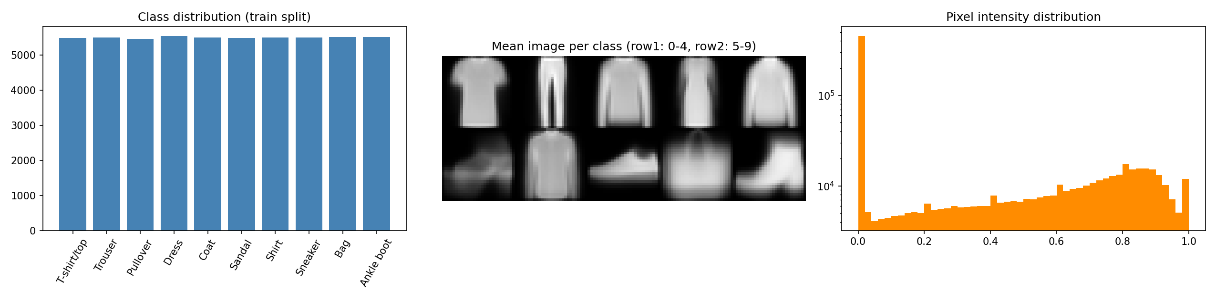
Figure 1: Class distribution, mean image per class, and pixel intensity distribution (training split).
Class balance. All ten classes have almost the same number of training images, so no resampling or class weighting is needed and accuracy is a fair metric. We still report macro-F1 to confirm that no class is neglected.
Mean images. The average image of Pullover, Coat and Shirt looks very similar (long-sleeved garments with a similar silhouette), and T-shirt is close to them. Trouser, Sandal, Sneaker, Bag and Ankle boot have clearly distinct shapes. We therefore expect confusion mainly among upper-body garments.
Pixel intensities. The histogram is dominated by a large spike at 0 (black background) with the remaining pixels spread between 0.4 and 1.0. Pixel values are therefore far from Gaussian, which motivates standardisation, and no outlier handling is required because values are bounded in [0, 1].
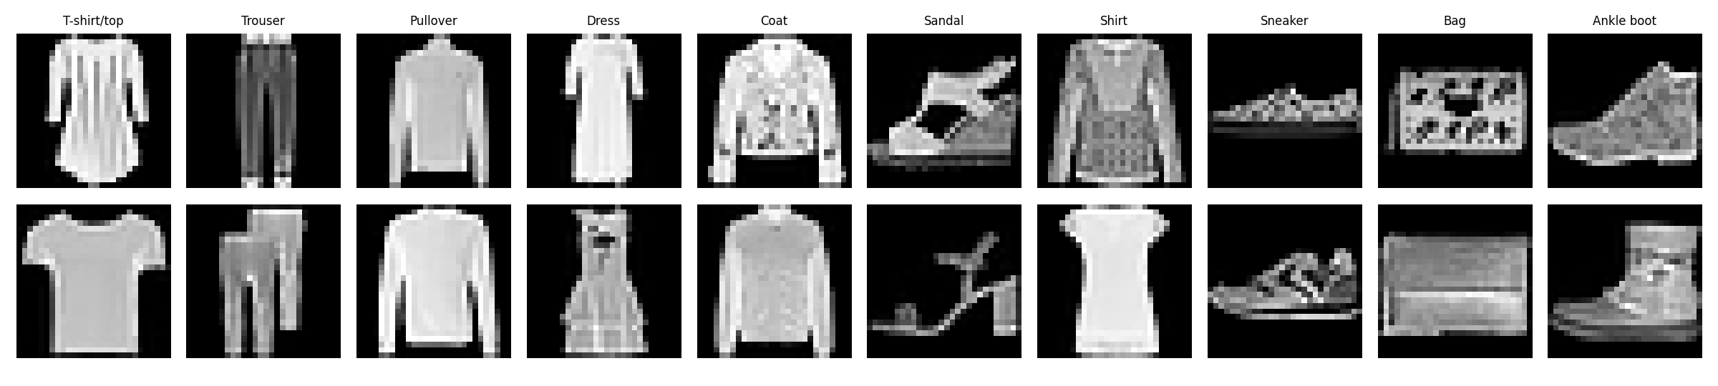
Figure 2: Two sample images per class.
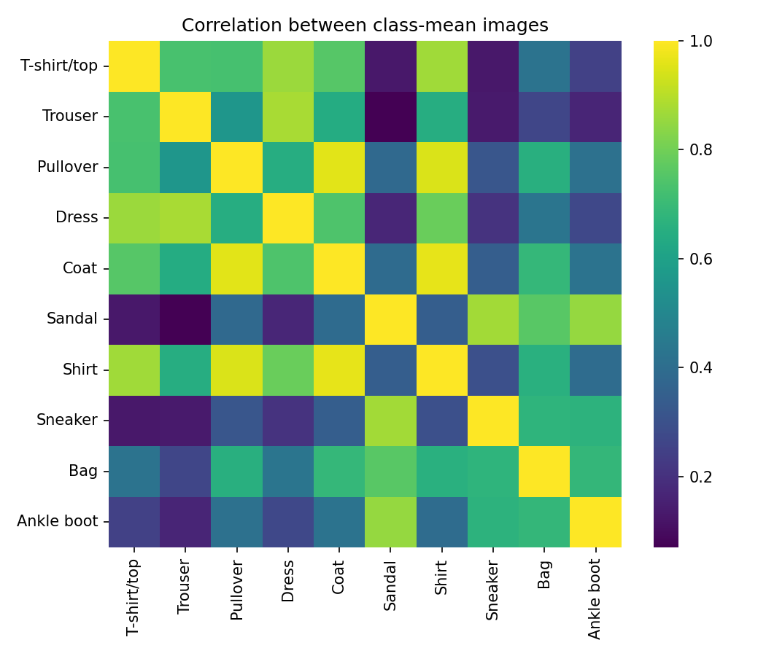
Figure 3: Correlation between class-mean images.
Class similarity. The correlation heatmap quantifies the visual impression: the upper-body garment classes are strongly correlated with each other, while footwear and bags form separate groups. There are no missing values in the dataset (fixed-size integer images).

4. Preprocessing Pipeline
- Scaling: pixel values divided by 255 to lie in [0, 1].
- Standardisation: subtract the mean (0.2859) and divide by the standard deviation (0.3529), both computed on the 55,000-image training split only, then applied unchanged to validation and test data. This prevents leakage of test information.
- Splitting: 5,000 images randomly held out from the official training set as validation (fixed seed 42); the official test set is untouched until final evaluation.
- Encoding: not needed; labels are integers 0 to 9.
- Imbalance handling: not needed; classes are balanced.
- Augmentation: deliberately not used, so that differences between students come from distillation rather than from data augmentation.

5. Baseline and Proposed Method

5.1 Architectures
All networks are CNNs built from Conv-BatchNorm-ReLU blocks with 3 x 3 kernels and max pooling, followed by a fully connected hidden layer and a 10-way output. They differ only in width, so size is the main variable.
Model | Layers (conv channels, hidden units) | Parameters | File size (KB)
Teacher | Conv 64, 128, 256; FC 256; dropout 0.3 | 3,584,650 | 14,013.8
Student-tiny | Conv 4, 8; FC 16 | 6,818 | 32.7
Student-small | Conv 8, 16; FC 32 | 26,746 | 110.7
Student-medium | Conv 16, 32; FC 64 | 105,962 | 420.1

5.2 Baseline and proposed method
Baseline: the student trained with cross-entropy on true labels only.
Proposed method: the same student trained with the distillation loss above, using the trained teacher's logits on the training images (computed once, since no augmentation is applied). Main setting: T = 4 and alpha = 0.7.

5.3 Training details
Adam optimizer, learning rate 2e-3 with cosine annealing, batch size 128, 15 epochs for the teacher and for every student. After every epoch the model is scored on the validation set and the best epoch is kept. The test set is never used for selection. Students are trained with seeds 0, 1 and 2; the teacher uses seed 42.

6. Experiments
No. | Experiment | Controlled variables and settings
1 | Student size x training mode | Sizes: tiny, small, medium. Modes: labels only, distillation (T = 4, alpha = 0.7). 3 seeds each (18 runs).
2 | Temperature sweep | Small student, alpha = 0.7. T in {1, 2, 4, 8, 16}. 3 seeds each (15 runs).
3 | Loss weight sweep | Small student, T = 4. alpha in {0, 0.25, 0.5, 0.75, 0.9}. 3 seeds each (15 runs).
Hardware and software: Google Colab CPU runtime with a single thread, torch 2.11.0+cpu, Python Python 3.13.16. The full pipeline ran in about 3 hours. Latency is the mean time to classify a single image (batch size 1) on this CPU after a warm-up; it is noisy, so only large differences are meaningful.

7. Evaluation

7.1 Main results
Model | Mode | Accuracy | Std | Macro-F1 | Params | Size (KB) | Latency (ms)
Teacher | labels | 0.9346 | n/a | 0.9345 | 3,584,650 | 14,013.8 | 3.81
Student-tiny | labels | 0.8895 | 0.0012 | 0.8888 | 6,818 | 32.7 | 0.28
Student-tiny | distill | 0.8890 | 0.0050 | 0.8887 | 6,818 | 32.7 | 0.29
Student-small | labels | 0.9073 | 0.0036 | 0.9068 | 26,746 | 110.7 | 0.36
Student-small | distill | 0.9094 | 0.0039 | 0.9088 | 26,746 | 110.7 | 0.40
Student-medium | labels | 0.9170 | 0.0001 | 0.9167 | 105,962 | 420.1 | 0.54
Student-medium | distill | 0.9225 | 0.0018 | 0.9225 | 105,962 | 420.1 | 0.55
Table 1: Test results, mean over 3 seeds for students (single run for the teacher). Std is the standard deviation of accuracy across seeds.
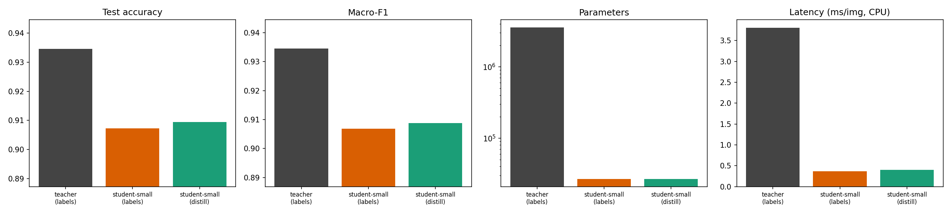
Figure 4: Teacher versus small student (labels-only and distilled): accuracy, macro-F1, parameters (log scale) and latency.
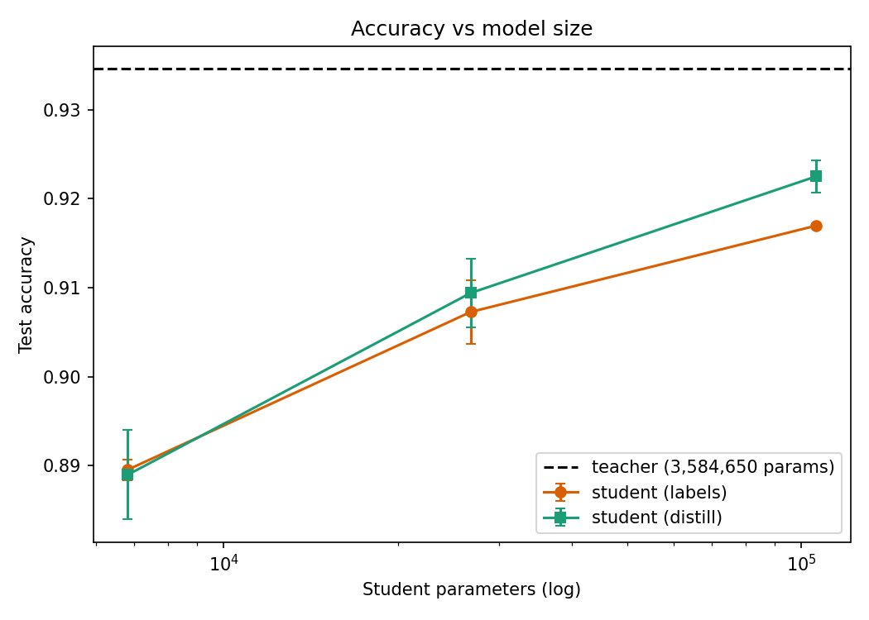
Figure 5: Test accuracy versus student size. Error bars show standard deviation over seeds.

7.2 Paired gain from distillation
Student | Seed 0 | Seed 1 | Seed 2 | Mean +/- std | Paired t-test p
Medium | +0.71 | +0.34 | +0.61 | +0.55 +/- 0.19 | 0.038
Small | +0.36 | +0.06 | +0.22 | +0.21 +/- 0.15 | 0.133
Tiny | +0.36 | +0.24 | -0.77 | -0.06 +/- 0.62 | 0.889
Table 2: Accuracy difference (distilled minus labels-only) in percentage points for each seed. With three seeds (2 degrees of freedom) the p-values are indicative only.

7.3 Temperature and loss weight
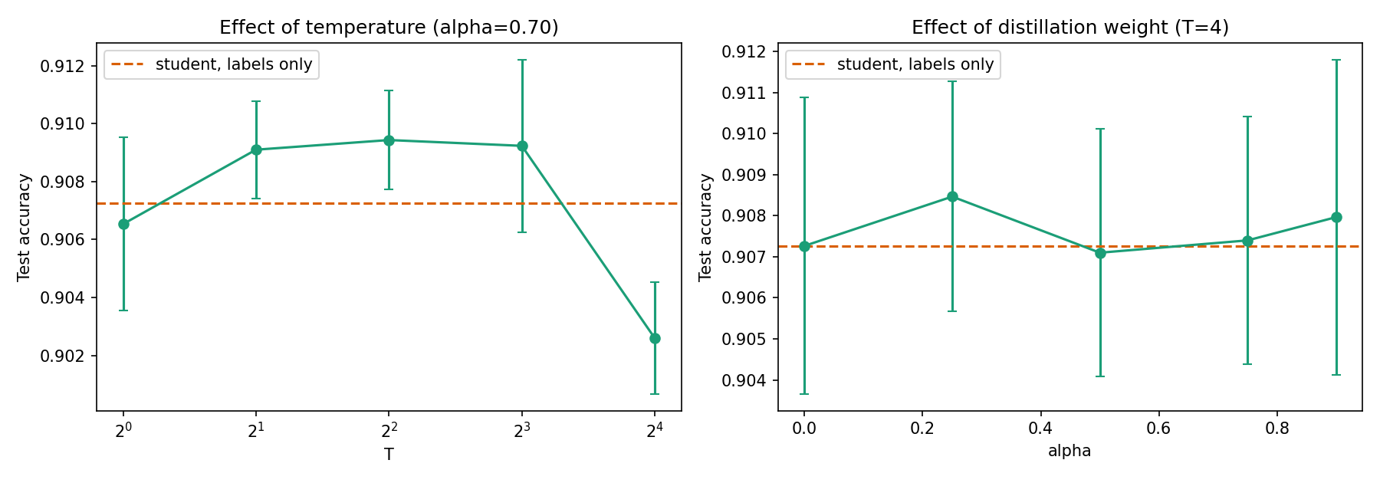
Figure 6: Effect of temperature (left, alpha = 0.7) and loss weight (right, T = 4) for the small student. The dashed line is the labels-only student.
Temperature T | 1 | 2 | 4 | 8 | 16
Accuracy | 0.9065 | 0.9091 | 0.9094 | 0.9092 | 0.9026
Std | 0.0030 | 0.0017 | 0.0017 | 0.0030 | 0.0019

Alpha | 0.00 | 0.25 | 0.50 | 0.75 | 0.90
Accuracy | 0.9073 | 0.9085 | 0.9071 | 0.9074 | 0.9080
Std | 0.0036 | 0.0028 | 0.0030 | 0.0030 | 0.0038
Table 3: Hyperparameter sweeps for the small student (mean and std over 3 seeds).

8. Analysis and Conclusion

8.1 What changed and why
Distillation helps modestly, and more for larger students. The medium student gained 0.55 points on average and improved in every seed; the gain is about three times the seed standard deviation. The small student gained 0.21 points, positive in all seeds but with one seed close to zero. The tiny student showed no reliable benefit: its mean change was -0.06 points and one of three seeds got worse by 0.77 points. A possible explanation, which we did not test, is that a student with only 6.8k parameters lacks the capacity to absorb the additional information in the teacher's soft targets, whereas larger students can use it.
Temperature matters at the extremes. Between T = 2 and T = 8 the small student scored about 0.909, slightly above the 0.9073 baseline but within roughly one standard deviation. T = 1 (little softening) was weaker and T = 16 fell below the baseline, which suggests that over-softened targets lose useful information.
Loss weight had no clear effect. All alpha values lie between 0.9071 and 0.9085, inside the seed variation. Alpha = 0 reproduces the labels-only score exactly (0.9073), which confirms that the implementation reduces to plain training when the teacher term is switched off.

8.2 Trade-offs
Distilled student | Parameters vs teacher | File size vs teacher | CPU speed-up | Accuracy cost
Medium | 34x fewer | 33x smaller | about 7x | 1.2 points
Small | 134x fewer | 127x smaller | about 10x | 2.5 points
Tiny | 526x fewer | 428x smaller | about 13x | 4.6 points

Speed-ups are computed from the labels-only latencies of each size (the architectures are identical, so distillation does not change latency). The smaller the student, the larger the efficiency gain but also the larger the accuracy loss. The medium student offers the best balance in this study: it keeps 98.7% of the teacher's accuracy with 34 times fewer parameters, and it is the setting where distillation provides the clearest benefit.

8.3 Failure cases
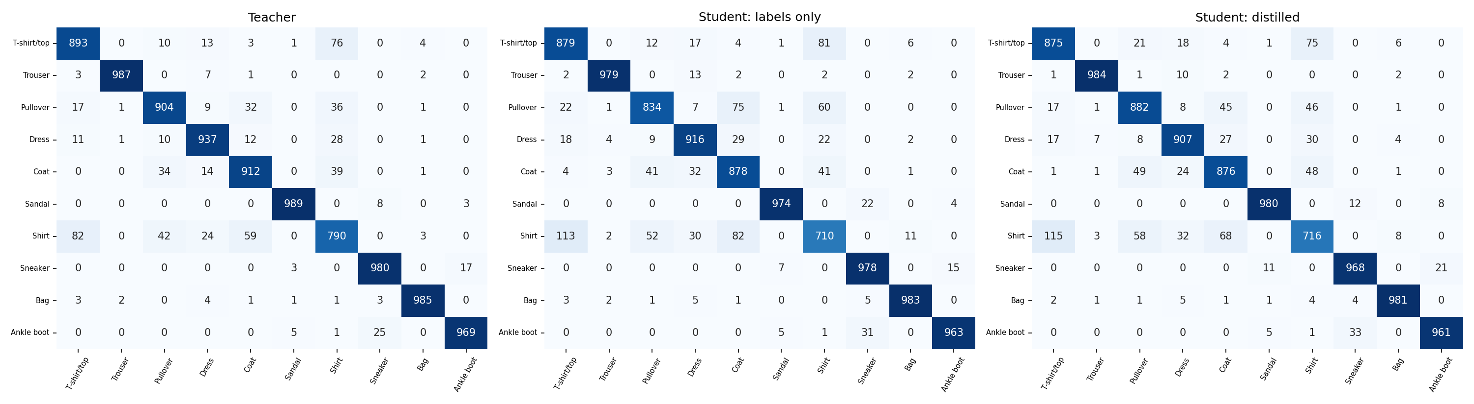
Figure 7: Confusion matrices on the test set for the teacher, the labels-only small student and the distilled small student (seed 0).
Shirt is the hardest class for every model: only 790 of 1,000 test shirts are correct for the teacher and about 710 to 716 for the small students, with most errors going to T-shirt, Pullover and Coat. This matches the EDA, where these classes have highly correlated mean images. Footwear and trousers are almost always correct. In this single seed, distillation raised Pullover from 834 to 882 correct, mainly by reducing confusion with Coat and Shirt, while Dress dropped slightly from 916 to 907. These matrices come from one seed and are illustrative rather than statistically established.

8.4 Limitations
- Only three seeds and one dataset. Fashion-MNIST is easy, so differences between models are small and the p-values in Table 2 (2 degrees of freedom) should not be over-interpreted.
- Pairing between labels-only and distilled runs is approximate: the student weights are initialised before the seed is set inside the training function, so runs with the same seed share batch order but not exactly the same initial weights.
- The teacher reached a training loss of about 0.005, so its soft targets on training images may be close to one-hot, which could limit what students learn from them. This is a hypothesis we did not test.
- Latency was measured on a shared single-thread Colab CPU and varies between runs; differences between students of the same size are measurement noise.
- Epochs and hyperparameters other than T and alpha were not tuned.

8.5 Conclusion
A teacher-student setup can shrink a Fashion-MNIST classifier by 34x to 526x in parameters and make it 7x to 14x faster on CPU at an accuracy cost of 1.2 to 4.6 points. Distillation gave a small but consistent improvement for the medium student (+0.55 points), a weaker one for the small student (+0.21), and no reliable improvement for the tiny student. Moderate temperatures (2 to 8) were safe, very high temperature (16) hurt, and the loss weight made no measurable difference. Future work could use more seeds, stronger or better-calibrated teachers, data augmentation, and harder datasets where the teacher-student gap is larger.

9. Reproducibility
- Code: kd_fashion_mnist.py (complete pipeline, one file, cells marked with # %%). A README with run instructions and all result tables is included in the repository.
- Environment: pip install torch torchvision numpy pandas matplotlib seaborn scikit-learn. Dataset downloads automatically.
- Seeds: 42 for the split and teacher; 0, 1, 2 for students. Hyperparameters are listed in Section 5.3.
- Outputs: figures/ folder and results_table.csv, results_all_runs.csv, results_temperature.csv, results_alpha.csv.
- Repository link: https://github.com/ShrasthiSinghR/Machine_Learning_Knowledge_Distillation/tree/main

References
- Hinton, G., Vinyals, O. and Dean, J. (2015). Distilling the Knowledge in a Neural Network. arXiv:1503.02531.
- Bucila, C., Caruana, R. and Niculescu-Mizil, A. (2006). Model Compression. Proceedings of the 12th ACM SIGKDD International Conference on Knowledge Discovery and Data Mining.
- Ba, J. and Caruana, R. (2014). Do Deep Nets Really Need to be Deep? Advances in Neural Information Processing Systems 27.
- Xiao, H., Rasul, K. and Vollgraf, R. (2017). Fashion-MNIST: a Novel Image Dataset for Benchmarking Machine Learning Algorithms. arXiv:1708.07747.
- Paszke, A. et al. (2019). PyTorch: An Imperative Style, High-Performance Deep Learning Library. NeurIPS 32.
- Pedregosa, F. et al. (2011). Scikit-learn: Machine Learning in Python. JMLR 12.

