1. INITIAL GRAPH

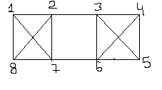

1. CONTRACTING (2,7)

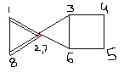

1. CONTRACTING (6,7) THEN (4,(6,7))

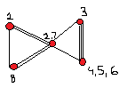

1. CONTRACTING (1,8) THEN ({1,8),(2,7))

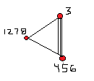

1. CONTRACTING (3,(4,5,6))

