MODEL EVALUATION REPORT

Stress Detection — Multi-Model Performance Comparison
This report consolidates the evaluation results from the model_evaluation.ipynb notebook, comparing seven machine learning classifiers — Logistic Regression, Decision Tree, Random Forest, SVM, K-Nearest Neighbors, Naive Bayes, and Gradient Boosting — trained to detect physiological stress from ADC, pulse, and SPO2 sensor readings. Each model was evaluated across three train-test split configurations (80-20, 70-30, and 60-40) to assess both accuracy and stability.

1. Dataset Overview
The dataset consists of 500 sensor readings used to classify a person's state as Normal or Stressed, based on three physiological features. The table below summarizes the dataset's key characteristics.
Total Samples | 500
Features Used | ADC, Pulse, SPO2
Target Classes | 2 (Normal, Stressed)
Normal Class Count | 368 (73.6%)
Stressed Class Count | 132 (26.4%)
Feature Scaling | StandardScaler applied to all features

Train-Test Split Configurations
Three different split ratios were used to evaluate how each model performs as the amount of available training data changes.
Split Configuration | Training Samples | Test Samples | Test Proportion
80% Train / 20% Test | 400 | 100 | 20%
70% Train / 30% Test | 350 | 150 | 30%
60% Train / 40% Test | 300 | 200 | 40%

2. Model Performance by Split
The following tables report Accuracy, Precision, Recall, and F1-Score (weighted average) for all seven models under each train-test split. The top-performing model in each split is highlighted in green.

80% Train / 20% Test Split (Train: 400 • Test: 100)
Model | Accuracy | Precision | Recall | F1-Score
Logistic Regression | 0.9300 | 0.9364 | 0.9300 | 0.9270
Decision Tree ★ | 0.9900 | 0.9901 | 0.9900 | 0.9900
Random Forest | 0.9600 | 0.9622 | 0.9600 | 0.9591
SVM | 0.9600 | 0.9622 | 0.9600 | 0.9591
K-Nearest Neighbors | 0.9400 | 0.9447 | 0.9400 | 0.9379
Naive Bayes | 0.9700 | 0.9699 | 0.9700 | 0.9699
Gradient Boosting | 0.9800 | 0.9806 | 0.9800 | 0.9798

70% Train / 30% Test Split (Train: 350 • Test: 150)
Model | Accuracy | Precision | Recall | F1-Score
Logistic Regression | 0.9467 | 0.9503 | 0.9467 | 0.9446
Decision Tree ★ | 0.9933 | 0.9934 | 0.9933 | 0.9933
Random Forest | 0.9733 | 0.9743 | 0.9733 | 0.9729
SVM | 0.9733 | 0.9743 | 0.9733 | 0.9729
K-Nearest Neighbors | 0.9533 | 0.9561 | 0.9533 | 0.9518
Naive Bayes | 0.9800 | 0.9799 | 0.9800 | 0.9799
Gradient Boosting | 0.9867 | 0.9869 | 0.9867 | 0.9866

60% Train / 40% Test Split (Train: 300 • Test: 200)
Model | Accuracy | Precision | Recall | F1-Score
Logistic Regression | 0.9550 | 0.9576 | 0.9550 | 0.9536
Decision Tree ★ | 0.9850 | 0.9853 | 0.9850 | 0.9849
Random Forest | 0.9750 | 0.9758 | 0.9750 | 0.9746
SVM | 0.9750 | 0.9758 | 0.9750 | 0.9746
K-Nearest Neighbors | 0.9600 | 0.9621 | 0.9600 | 0.9589
Naive Bayes | 0.9850 | 0.9853 | 0.9850 | 0.9849
Gradient Boosting | 0.9850 | 0.9853 | 0.9850 | 0.9849

3. Cross-Split Comparison by Metric
These tables make it easy to track how each model's score for a given metric shifts as the training set shrinks from 80% down to 60%. The best score per split per metric is highlighted in green.

Accuracy
Model | 80-20 Split | 70-30 Split | 60-40 Split
Logistic Regression | 0.9300 | 0.9467 | 0.9550
Decision Tree | 0.9900 | 0.9933 | 0.9850
Random Forest | 0.9600 | 0.9733 | 0.9750
SVM | 0.9600 | 0.9733 | 0.9750
K-Nearest Neighbors | 0.9400 | 0.9533 | 0.9600
Naive Bayes | 0.9700 | 0.9800 | 0.9850
Gradient Boosting | 0.9800 | 0.9867 | 0.9850

Precision (Weighted)
Model | 80-20 Split | 70-30 Split | 60-40 Split
Logistic Regression | 0.9364 | 0.9503 | 0.9576
Decision Tree | 0.9901 | 0.9934 | 0.9853
Random Forest | 0.9622 | 0.9743 | 0.9758
SVM | 0.9622 | 0.9743 | 0.9758
K-Nearest Neighbors | 0.9447 | 0.9561 | 0.9621
Naive Bayes | 0.9699 | 0.9799 | 0.9853
Gradient Boosting | 0.9806 | 0.9869 | 0.9853

Recall (Weighted)
Model | 80-20 Split | 70-30 Split | 60-40 Split
Logistic Regression | 0.9300 | 0.9467 | 0.9550
Decision Tree | 0.9900 | 0.9933 | 0.9850
Random Forest | 0.9600 | 0.9733 | 0.9750
SVM | 0.9600 | 0.9733 | 0.9750
K-Nearest Neighbors | 0.9400 | 0.9533 | 0.9600
Naive Bayes | 0.9700 | 0.9800 | 0.9850
Gradient Boosting | 0.9800 | 0.9867 | 0.9850

F1-Score (Weighted)
Model | 80-20 Split | 70-30 Split | 60-40 Split
Logistic Regression | 0.9270 | 0.9446 | 0.9536
Decision Tree | 0.9900 | 0.9933 | 0.9849
Random Forest | 0.9591 | 0.9729 | 0.9746
SVM | 0.9591 | 0.9729 | 0.9746
K-Nearest Neighbors | 0.9379 | 0.9518 | 0.9589
Naive Bayes | 0.9699 | 0.9799 | 0.9849
Gradient Boosting | 0.9798 | 0.9866 | 0.9849

4. Overall Model Ranking
Ranking models by their average accuracy across all three splits gives a single, holistic view of which classifier generalizes best to this dataset overall.
Rank | Model | 80-20 | 70-30 | 60-40 | Avg
1 | Decision Tree ★ | 0.9900 | 0.9933 | 0.9850 | 0.9894
2 | Gradient Boosting | 0.9800 | 0.9867 | 0.9850 | 0.9839
3 | Naive Bayes | 0.9700 | 0.9800 | 0.9850 | 0.9783
4 | SVM | 0.9600 | 0.9733 | 0.9750 | 0.9694
5 | Random Forest | 0.9600 | 0.9733 | 0.9750 | 0.9694
6 | K-Nearest Neighbors | 0.9400 | 0.9533 | 0.9600 | 0.9511
7 | Logistic Regression | 0.9300 | 0.9467 | 0.9550 | 0.9439

Best Overall Model: Decision Tree, with an average accuracy of 0.9894 across all three splits.

Consistency Analysis (Lowest Variance Across Splits)
Beyond raw accuracy, consistency — how little a model's performance shifts as the split ratio changes — is an important signal of reliability. The models below showed the smallest standard deviation in accuracy across the three splits.
Model | Std. Deviation | Stability
Gradient Boosting | 0.0035 | Most Consistent
Decision Tree | 0.0042 | Most Consistent
Naive Bayes | 0.0076 | Highly Consistent

5. Visual Comparisons
The charts below, generated directly from the notebook, visualize the same results shown in the tables above — useful for spotting patterns at a glance.

Grouped Bar Chart — All Metrics by Split
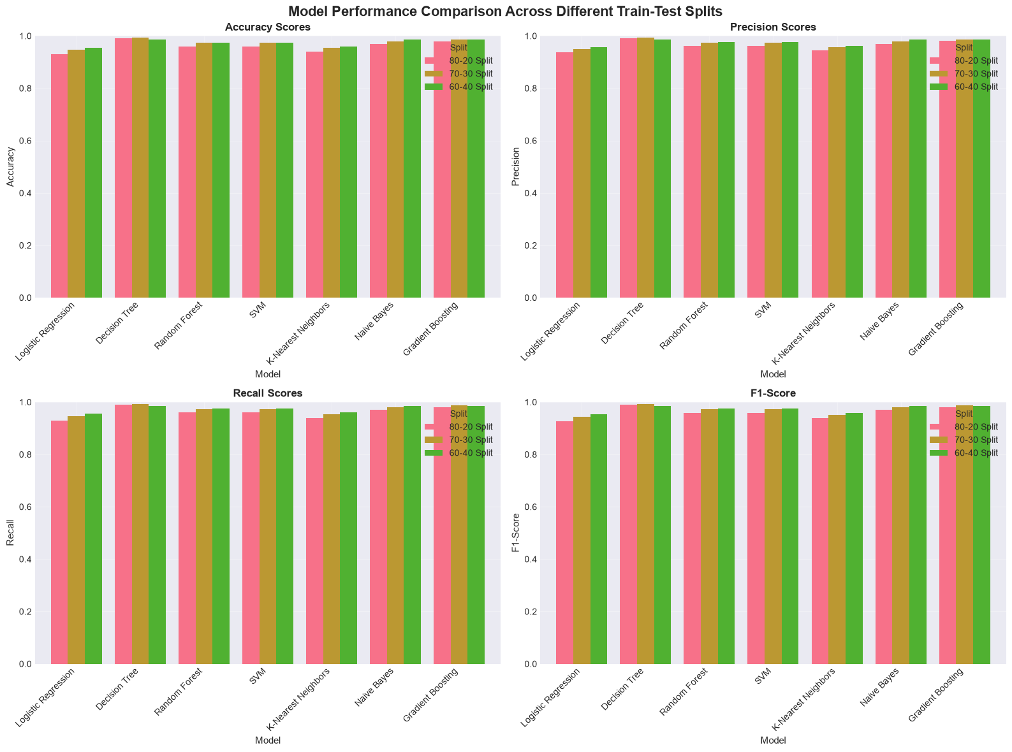
Figure 1. Accuracy, Precision, Recall, and F1-Score for every model, grouped by split (80-20, 70-30, 60-40).

Trend Lines — Performance Across Splits

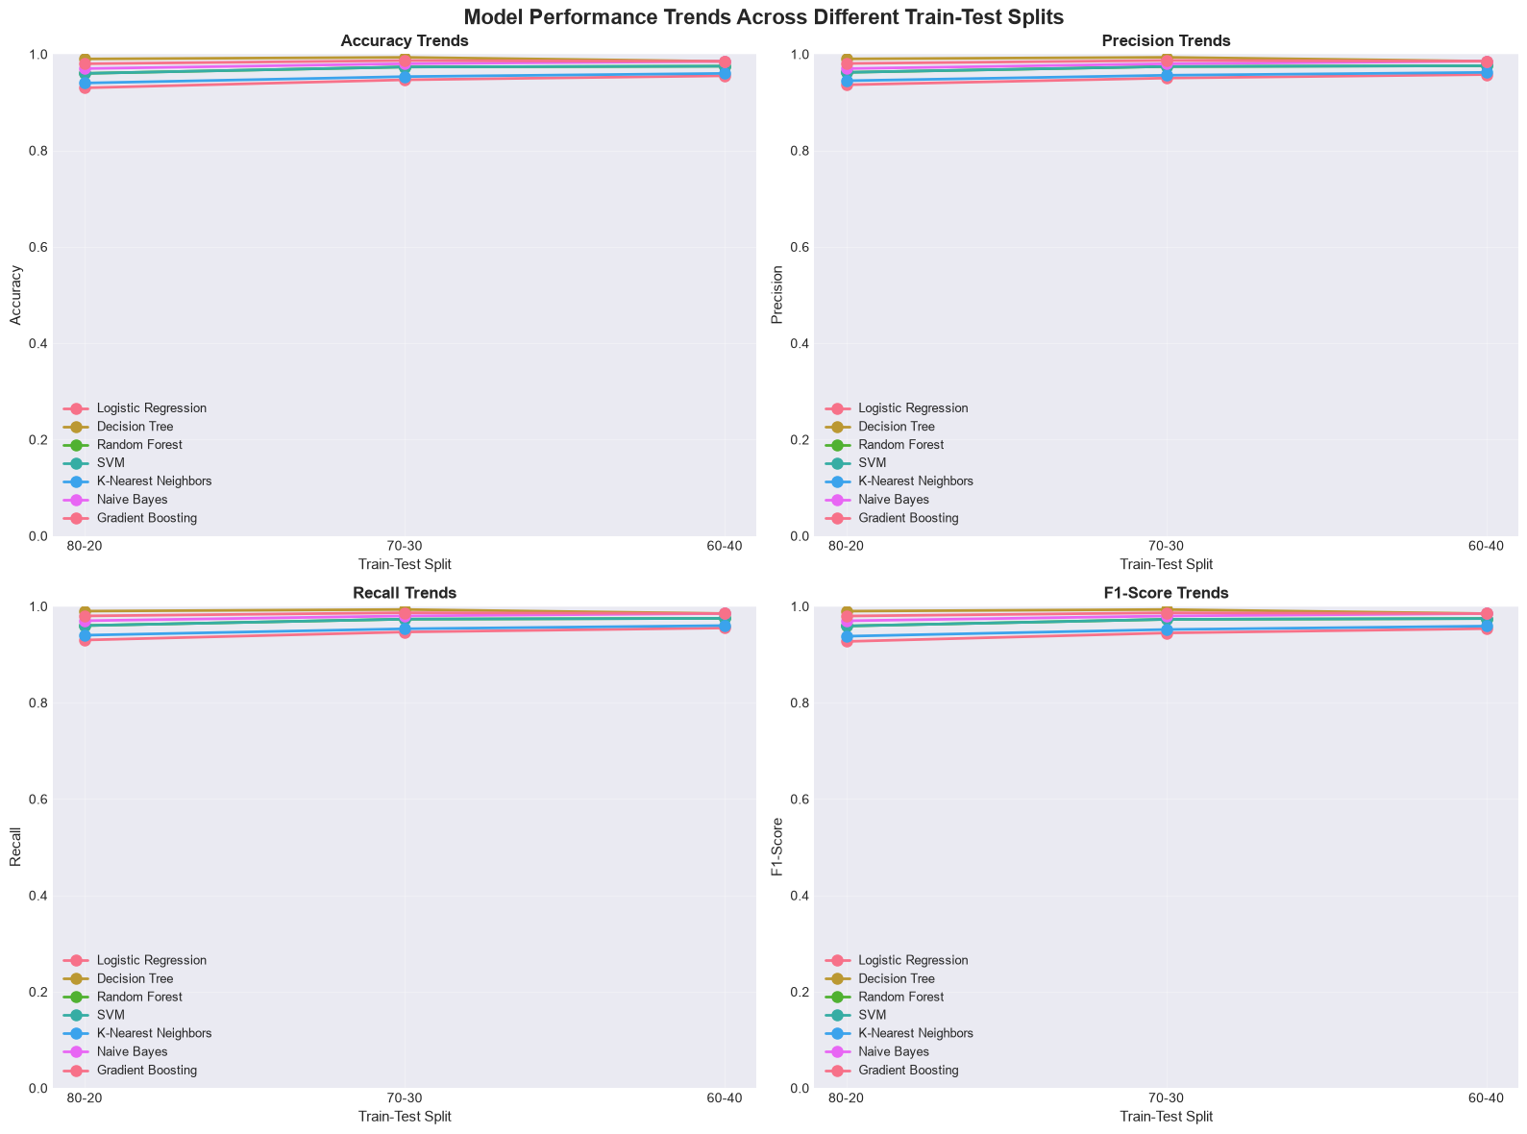
Figure 2. How each model's metric scores trend as the split ratio shifts from 80-20 to 60-40.

Average Performance Heatmap (Bar Form)

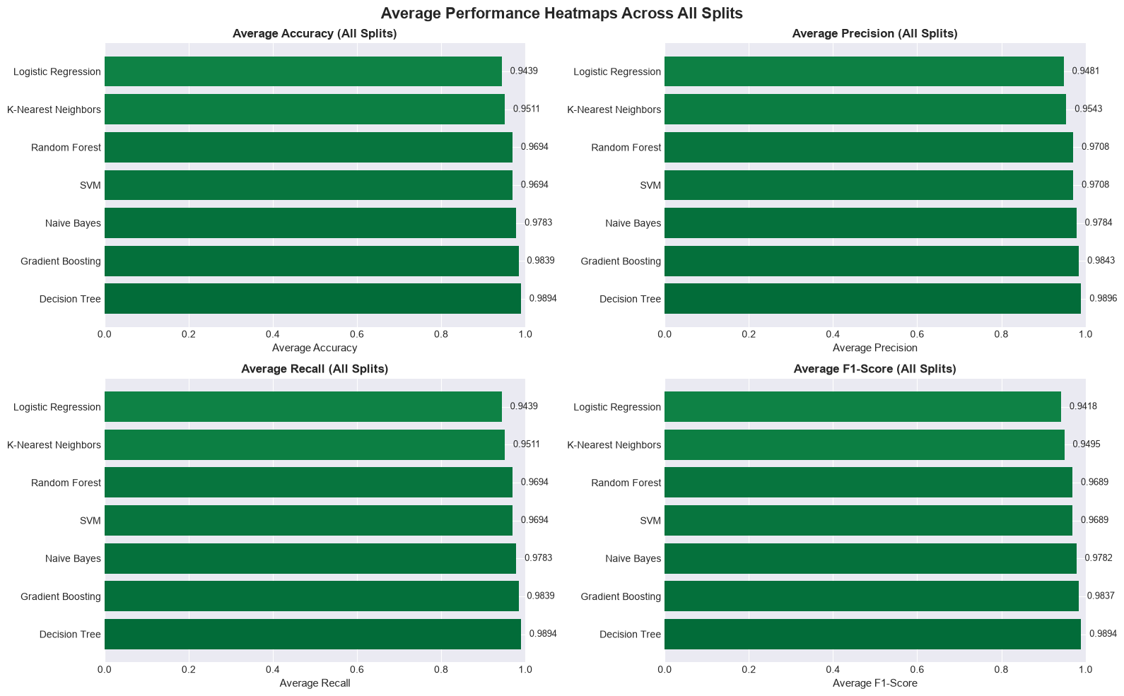
Figure 3. Average Accuracy, Precision, Recall, and F1-Score per model, averaged across all three splits, ranked low to high.

6. Key Insights & Recommendations

Key Observations
- Decision Tree was the top performer in every single split (80-20, 70-30, and 60-40), and also leads on average accuracy, precision, recall, and F1-score.
- Gradient Boosting and Naive Bayes followed closely behind, both posting average accuracy above 0.97 with low variability across splits.
- Random Forest and SVM produced identical scores across all three splits and all four metrics, suggesting both decision boundaries generalize similarly well on this feature set.
- Logistic Regression and K-Nearest Neighbors were the weakest performers overall, though both still exceeded 0.93 accuracy in every split.
- Gradient Boosting and Decision Tree had the lowest standard deviation in accuracy across splits (0.0035 and 0.0042 respectively), making them the most stable choices as training data volume changes.
- Performance for every model improved or stayed essentially flat between the 80-20 and 60-40 splits, indicating the dataset's class patterns are learnable even with less training data.

Recommendations
- Primary Recommendation: Deploy Decision Tree as the production model — it achieved the highest average accuracy (0.9894) and the best score on every metric in every split.
- For Robustness: Consider Gradient Boosting as a close runner-up; ensemble methods like this tend to generalize better on unseen, real-world sensor data than a single decision tree.
- Validation: Run k-fold cross-validation on the top 2-3 candidates (Decision Tree, Gradient Boosting, Naive Bayes) to confirm these results aren't an artifact of the specific random_state used for splitting.
- Split Choice: The 80-20 split offers the best balance of training data volume and a reliable held-out test set for final model selection.
- Monitoring: Given the class imbalance (73.6% Normal vs. 26.4% Stressed), continue tracking weighted Precision and Recall in production, not just Accuracy, to ensure the minority ‘Stressed’ class is being detected reliably.

