**Exercise 1: Implementing the Singleton Pattern**

public class Main {

public static void main(String[] args) {

Logger logger1 = Logger.getInstance();

logger1.log("First log message.");

Logger logger2 = Logger.getInstance();

logger2.log("Second log message.");

if (logger1 == logger2) {

System.out.println("Only one instance exists. Singleton pattern works");

} else {

System.out.println("Singleton pattern failed. Multiple instances exist.");

}

}

}

class Logger {

private static Logger instance;

private Logger() {

System.out.println("Logger instance created");

}

public static Logger getInstance() {

if (instance == null) {

instance = new Logger();

}

return instance;

}

public void log(String message) {

System.out.println("Log: " + message);

}

}

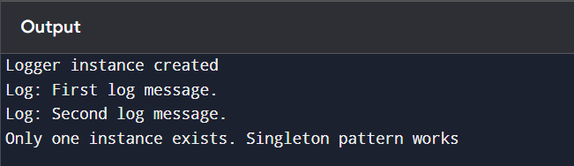

**Exercise 2: Implementing the Factory Method Pattern**

public class Main {

public static void main(String[] args) {

DocumentFactory wordFactory = new WordDocumentFactory();

Document wordDoc = wordFactory.createDocument();

wordDoc.open();

DocumentFactory pdfFactory = new PdfDocumentFactory();

Document pdfDoc = pdfFactory.createDocument();

pdfDoc.open();

DocumentFactory excelFactory = new ExcelDocumentFactory();

Document excelDoc = excelFactory.createDocument();

excelDoc.open();

}

}

interface Document {

void open();

}

class WordDocument implements Document {

public void open() {

System.out.println("Opening Word Document");

}

}

class PdfDocument implements Document {

public void open() {

System.out.println("Opening PDF Document");

}

}

class ExcelDocument implements Document {

public void open() {

System.out.println("Opening Excel Document");

}

}

abstract class DocumentFactory {

public abstract Document createDocument();

}

class WordDocumentFactory extends DocumentFactory {

public Document createDocument() {

return new WordDocument();

}

}

class PdfDocumentFactory extends DocumentFactory {

public Document createDocument() {

return new PdfDocument();

}

}

class ExcelDocumentFactory extends DocumentFactory {

public Document createDocument() {

return new ExcelDocument();

}

}

