**Exercise 1: Control Structures**

**Scenario 1:** The bank wants to apply a discount to loan interest rates for customers above 60 years old.

* + **Question:** Write a PL/SQL block that loops through all customers, checks their age, and if they are above 60, apply a 1% discount to their current loan interest rates.

CREATE TABLE Customers (

  CustomerID NUMBER,

  Age NUMBER,

  LoanInterestRate NUMBER(5,2),

  Balance NUMBER(10,2),

  IsVIP VARCHAR2(5)

);

INSERT INTO Customers VALUES (1, 65, 10.5, 15000, 'FALSE');

INSERT INTO Customers VALUES (2, 45, 12.0, 8000, 'FALSE');

INSERT INTO Customers VALUES (3, 70, 11.0, 12000, 'FALSE');

INSERT INTO Customers VALUES (4, 30, 13.0, 4000, 'FALSE');

COMMIT;

SELECT * FROM Customers;

BEGIN

  FOR rec IN (SELECT CustomerID, Age FROM Customers) LOOP

    IF rec.Age > 60 THEN

      UPDATE Customers

      SET LoanInterestRate = LoanInterestRate - 1

      WHERE CustomerID = rec.CustomerID;

    END IF;

  END LOOP;

  COMMIT;

END;

SELECT CustomerID, Age, LoanInterestRate FROM Customers;

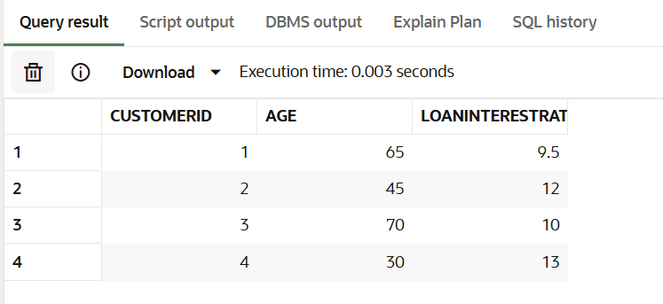

**Scenario 2:** A customer can be promoted to VIP status based on their balance.

* + **Question:** Write a PL/SQL block that iterates through all customers and sets a flag IsVIP to TRUE for those with a balance over $10,000.

BEGIN

  FOR rec IN (SELECT CustomerID, Balance FROM Customers) LOOP

    IF rec.Balance > 10000 THEN

      UPDATE Customers

      SET IsVIP = 'TRUE'

      WHERE CustomerID = rec.CustomerID;

    END IF;

  END LOOP;

  COMMIT;

END;

SELECT CustomerID, Balance, IsVIP FROM Customers;

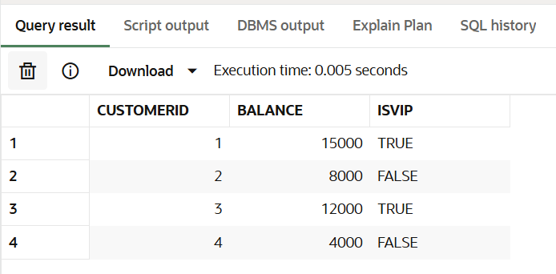

**Scenario 3:** The bank wants to send reminders to customers whose loans are due within the next 30 days.

* + **Question:** Write a PL/SQL block that fetches all loans due in the next 30 days and prints a reminder message for each customer.

CREATE TABLE Loans (

  LoanID NUMBER,

  CustomerID NUMBER,

  DueDate DATE

);

INSERT INTO Loans VALUES (1001, 1, SYSDATE + 10);

INSERT INTO Loans VALUES (1002, 2, SYSDATE + 40);

COMMIT;

BEGIN

  FOR rec IN (

    SELECT LoanID, CustomerID, DueDate

    FROM Loans

    WHERE DueDate <= SYSDATE + 30

  ) LOOP

    DBMS_OUTPUT.PUT_LINE(

      'Reminder: Loan ID ' || rec.LoanID ||

      ' for Customer ID ' || rec.CustomerID ||

      ' is due on ' || TO_CHAR(rec.DueDate, 'DD-MON-YYYY')

    );

  END LOOP;

END;

