SQL ADVANCED DATA ANALYTICS

Table of Contents
1. Project Overview
2. Change-Over-Time Analysis
3. Cumulative Analysis
4. Performance Analysis (Year-over-Year)
5. Part-to-Whole Analysis
6. Data Segmentation Analysis
7. Reporting — Customer Report
8. Reporting — Product Report
9. Summary of SQL Techniques

1. Project Overview
This document presents an Advanced SQL Data Analytics project built on the sales dataset. The goal of the project is to move beyond basic queries and demonstrate analytical SQL techniques that are commonly used in real-world business intelligence work — trend analysis, cumulative tracking, performance benchmarking, part-to-whole contribution, customer/product segmentation, and consolidated reporting views.
The analysis is built on top of three curated 'Gold Layer' tables, modeled as a simple star schema:
Table | Description
gold.fact_sales | Grain: one row per order line. Contains order_number, product_key, customer_key, order_date, shipping_date, due_date, sales_amount, quantity, price.
gold.dim_customers | Customer master data: customer_key, customer_id, customer_number, first_name, last_name, country, marital_status, gender, birthdate, create_date.
gold.dim_products | Product master data: product_key, product_id, product_number, product_name, category_id, category, subcategory, maintenance, cost, product_line, start_date.

fact_sales is the central fact table and joins to both dimension tables through their surrogate keys (product_key and customer_key). All analyses below are built as layered SQL: a base/staging CTE that joins and filters the raw grain, followed by aggregation, window functions, or CASE-based segmentation logic to produce the final analytical output.

Note:
Each section below explains the business purpose of the technique, the SQL functions used, the query itself, and a screenshot of the query result set as executed against the dataset.

2. Change-Over-Time Analysis
Change-over-time analysis examines how a measure evolves across a time dimension. It is the foundation of trend analysis and is used to track growth, decline, and seasonality.
For example: Total Sales by Year or Average Cost by Month.
SQL Functions Used
- Date functions: YEAR(), MONTH(), DATEPART(), DATETRUNC(), FORMAT()
- Aggregate functions: SUM(), COUNT(), AVG()

2.1 Quick Date Functions — YEAR() / MONTH()
Sales are grouped by calendar year and month using simple date part extraction. This is the most explicit approach and produces separate year and month columns.

SELECT
YEAR(order_date) AS order_year,
MONTH(order_date) AS order_month,
SUM(sales_amount) AS total_sales,
COUNT(DISTINCT customer_key) AS total_customers,
SUM(quantity) AS total_quantity
FROM gold.fact_sales
WHERE order_date IS NOT NULL
GROUP BY YEAR(order_date), MONTH(order_date)
ORDER BY YEAR(order_date), MONTH(order_date);

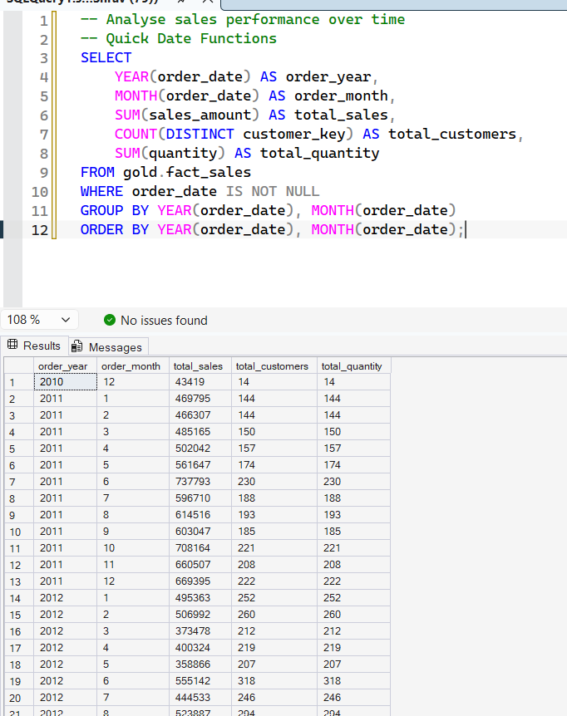
Figure 2.1 — Monthly sales trend using YEAR()/MONTH()

2.2 DATETRUNC()
DATETRUNC(month, order_date) truncates the date to the first day of its month, producing a single, sortable date column instead of two separate year/month integers,useful for charting a continuous time axis.

SELECT
DATETRUNC(month, order_date) AS order_date,
SUM(sales_amount) AS total_sales,
COUNT(DISTINCT customer_key) AS total_customers,
SUM(quantity) AS total_quantity
FROM gold.fact_sales
WHERE order_date IS NOT NULL
GROUP BY DATETRUNC(month, order_date)
ORDER BY DATETRUNC(month, order_date);

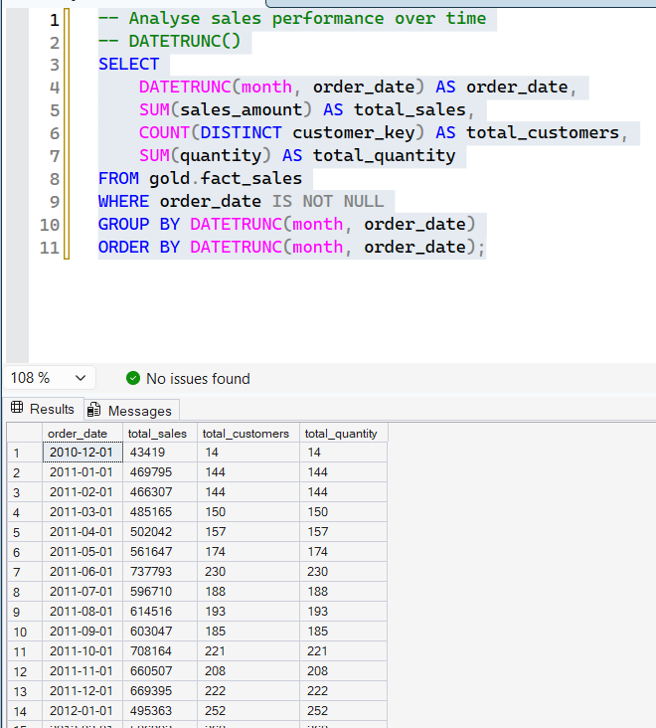
Figure 2.2 — Monthly sales trend using DATETRUNC()

2.3 FORMAT()
FORMAT(order_date, 'yyyy-MMM') produces a human-readable label such as '2011-Jan'. Note that because the result is a string, sorting alphabetically no longer sorts chronologically — visible in the result set below.

SELECT
FORMAT(order_date, 'yyyy-MMM') AS order_date,
SUM(sales_amount) AS total_sales,
COUNT(DISTINCT customer_key) AS total_customers,
SUM(quantity) AS total_quantity
FROM gold.fact_sales
WHERE order_date IS NOT NULL
GROUP BY FORMAT(order_date, 'yyyy-MMM')
ORDER BY FORMAT(order_date, 'yyyy-MMM');

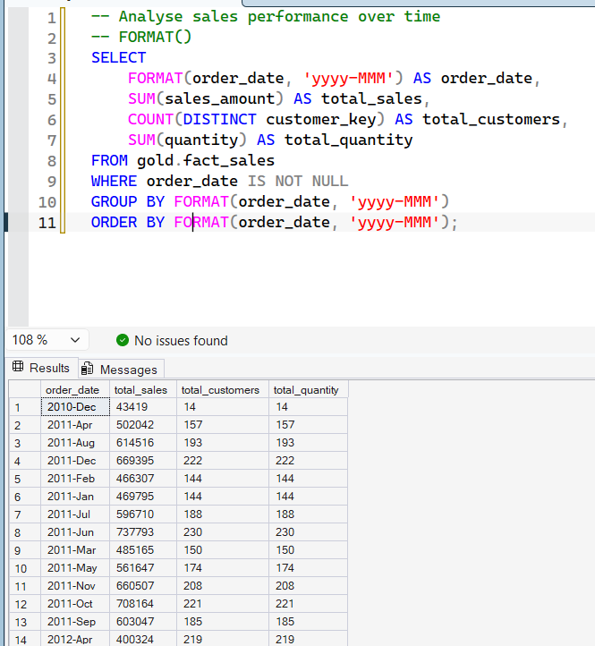
Figure 2.3 — Monthly sales trend using FORMAT() (note the string-sort ordering)

3. Cumulative Analysis
Cumulative analysis aggregates a measure progressively over time to calculate running totals and moving averages. It answers the question 'is the business growing or declining over time?' by accumulating values period over period rather than viewing each period in isolation.
SQL Functions Used
- Window functions: SUM() OVER(), AVG() OVER()

The query below first aggregates sales and average price by year in an inner subquery, then applies window functions over the yearly results to compute a running total of sales and a moving average of price.

SELECT
order_date,
total_sales,
SUM(total_sales) OVER (ORDER BY order_date) AS running_total_sales,
AVG(avg_price) OVER (ORDER BY order_date) AS moving_average_price
FROM
(
SELECT
DATETRUNC(year, order_date) AS order_date,
SUM(sales_amount) AS total_sales,
AVG(price) AS avg_price
FROM gold.fact_sales
WHERE order_date IS NOT NULL
GROUP BY DATETRUNC(year, order_date)
) t

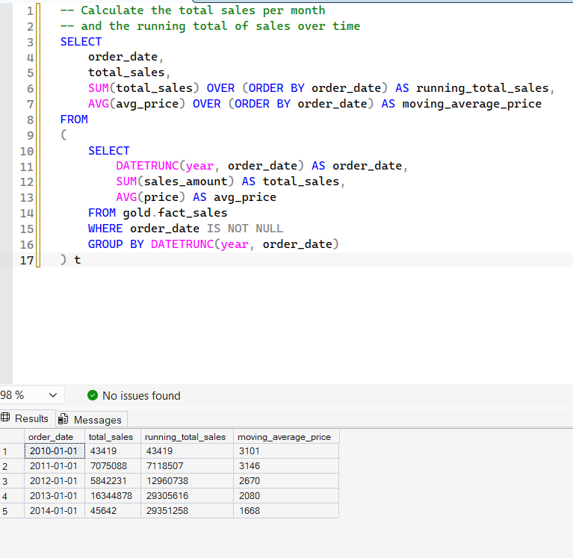
Figure 3.1 — Running total sales and moving average price by year

4. Performance Analysis (Year-over-Year)
Performance analysis compares a current value against a target or reference value to measure success. Typical comparisons include current sales vs. the average sales for that entity, current year sales vs. previous year sales, or current sales vs. the lowest historical sales.
SQL Functions Used
- LAG(): retrieves a value from a previous row within a partition
- AVG() OVER(): computes an average within a partition, without collapsing rows
- CASE: converts numeric differences into readable trend labels

The query analyzes yearly product sales two ways at once: against each product's own average sales across all years (avg_change), and against that same product's sales in the prior year (py_change, Year-over-Year).

WITH yearly_product_sales AS (
SELECT
YEAR(f.order_date) AS order_year,
p.product_name,
SUM(f.sales_amount) AS current_sales
FROM gold.fact_sales f
LEFT JOIN gold.dim_products p
ON f.product_key = p.product_key
WHERE f.order_date IS NOT NULL
GROUP BY YEAR(f.order_date), p.product_name
)
SELECT
order_year,
product_name,
current_sales,
AVG(current_sales) OVER (PARTITION BY product_name) AS avg_sales,
current_sales - AVG(current_sales) OVER (PARTITION BY product_name) AS diff_avg,
CASE
WHEN current_sales - AVG(current_sales) OVER (PARTITION BY product_name) > 0 THEN 'Above Avg'
WHEN current_sales - AVG(current_sales) OVER (PARTITION BY product_name) < 0 THEN 'Below Avg'
ELSE 'Avg'
END AS avg_change,
-- Year-over-Year Analysis
LAG(current_sales) OVER (PARTITION BY product_name ORDER BY order_year) AS py_sales,
current_sales - LAG(current_sales) OVER (PARTITION BY product_name ORDER BY order_year) AS diff_py,
CASE
WHEN current_sales - LAG(current_sales) OVER (PARTITION BY product_name ORDER BY order_year) > 0 THEN 'Increase'
WHEN current_sales - LAG(current_sales) OVER (PARTITION BY product_name ORDER BY order_year) < 0 THEN 'Decrease'
ELSE 'No Change'
END AS py_change
FROM yearly_product_sales
ORDER BY product_name, order_year;

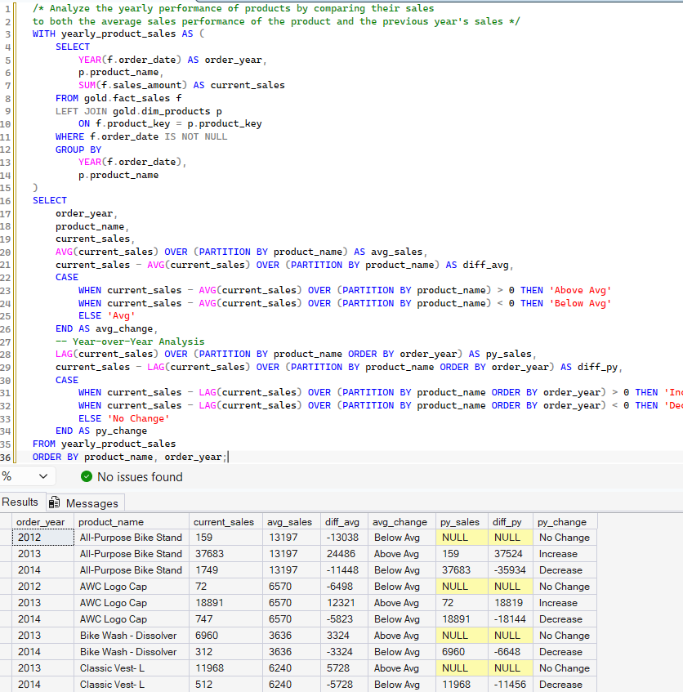
Figure 4.1 — Product sales vs. average and vs. prior year

5. Part-to-Whole Analysis
Part-to-whole (proportional) analysis shows how an individual segment performs relative to the overall total, revealing which category has the greatest impact on the business.
For example: (Sales / Total Sales) × 100 by Category.
SQL Functions Used
- Aggregates: SUM(), AVG() for computing part-level and overall totals
- Window function: SUM() OVER() with no PARTITION BY to compute a grand total alongside grouped rows

WITH category_sales AS (
SELECT
p.category,
SUM(f.sales_amount) AS total_sales
FROM gold.fact_sales f
LEFT JOIN gold.dim_products p
ON p.product_key = f.product_key
GROUP BY p.category
)
SELECT
category,
total_sales,
SUM(total_sales) OVER () AS overall_sales,
ROUND((CAST(total_sales AS FLOAT) / SUM(total_sales) OVER ()) * 100, 2) AS percentage_of_total
FROM category_sales
ORDER BY total_sales DESC;

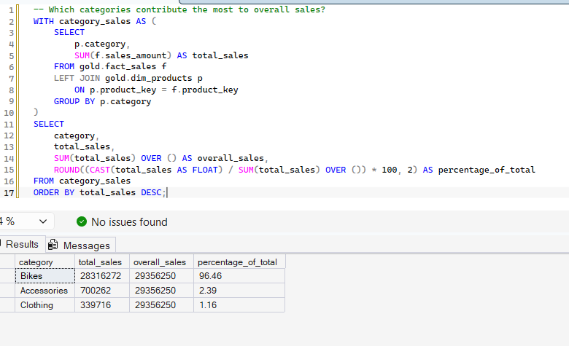

Figure 5.1 — Category contribution to total sales

6. Data Segmentation Analysis
Segmentation groups data into meaningful buckets to reveal patterns and correlations between two measures, For example: Total Products by Cost Range, or Total Customers by Spending behavior.
SQL Functions Used
- CASE: defines custom segmentation logic
- GROUP BY: aggregates rows within each segment

6.1 Product Segmentation by Cost Range
Products are bucketed into four cost bands, and the number of products in each band is counted.
WITH product_segments AS (
SELECT
product_key,
product_name,
cost,
CASE
WHEN cost < 100 THEN 'Below 100'
WHEN cost BETWEEN 100 AND 500 THEN '100-500'
WHEN cost BETWEEN 500 AND 1000 THEN '500-1000'
ELSE 'Above 1000'
END AS cost_range
FROM gold.dim_products
)
SELECT
cost_range,
COUNT(product_key) AS total_products
FROM product_segments
GROUP BY cost_range
ORDER BY total_products DESC;
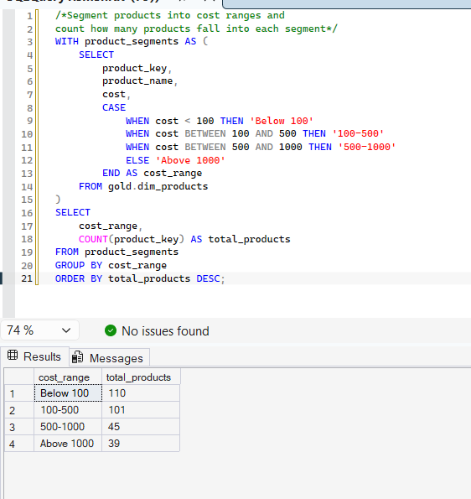

Figure 6.1 — Product count by cost range

6.2 Customer Segmentation by Spending Behavior
Customers are classified into three behavioral segments based on their purchase history:
- VIP — at least 12 months of purchase history and total spending greater than €5,000
- Regular — at least 12 months of purchase history but spending €5,000 or less
- New — less than 12 months of purchase history
WITH customer_spending AS (
SELECT
c.customer_key,
SUM(f.sales_amount) AS total_spending,
MIN(order_date) AS first_order,
MAX(order_date) AS last_order,
DATEDIFF(month, MIN(order_date), MAX(order_date)) AS lifespan
FROM gold.fact_sales f
LEFT JOIN gold.dim_customers c
ON f.customer_key = c.customer_key
GROUP BY c.customer_key
)
SELECT
customer_segment,
COUNT(customer_key) AS total_customers
FROM (
SELECT
customer_key,
CASE
WHEN lifespan >= 12 AND total_spending > 5000 THEN 'VIP'
WHEN lifespan >= 12 AND total_spending <= 5000 THEN 'Regular'
ELSE 'New'
END AS customer_segment
FROM customer_spending
) AS segmented_customers
GROUP BY customer_segment
ORDER BY total_customers DESC;

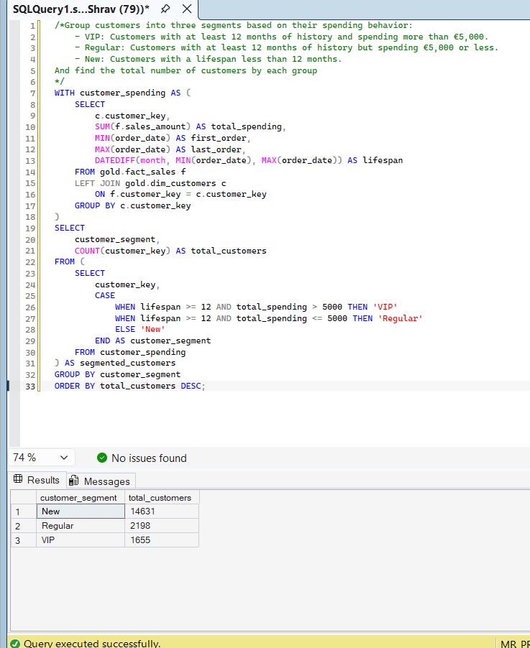
Figure 6.2 — Customer count by segment (New / Regular / VIP)

7. Reporting — Customer Report
The customer report consolidates all of the techniques above into a single, reusable view: gold.report_customers. It combines base-level joins, aggregation, age/segment classification and derived KPIs so downstream tools (dashboards, Excel, Power BI) can query one clean object instead of re-deriving these metrics each time.
What the view does
- Gathers core fields: customer name, age, and transaction details from fact_sales joined to dim_customers
- Buckets customers into age groups (Under 20, 20-29, 30-39, 40-49, 50 and above) and into VIP / Regular / New spending segments
- Aggregates customer-level metrics: total orders, total sales, total quantity purchased, total distinct products, and lifespan in months
- Calculates KPIs: recency (months since last order), average order value (AOV), and average monthly spend

CREATE VIEW gold.report_customers AS

WITH base_query AS (
SELECT
f.order_number, f.product_key, f.order_date, f.sales_amount, f.quantity,
c.customer_key, c.customer_number,
CONCAT(c.first_name, ' ', c.last_name) AS customer_name,
DATEDIFF(year, c.birthdate, GETDATE()) AS age
FROM gold.fact_sales f
LEFT JOIN gold.dim_customers c ON c.customer_key = f.customer_key
WHERE order_date IS NOT NULL
),
customer_aggregation AS (
SELECT
customer_key, customer_number, customer_name, age,
COUNT(DISTINCT order_number) AS total_orders,
SUM(sales_amount) AS total_sales,
SUM(quantity) AS total_quantity,
COUNT(DISTINCT product_key) AS total_products,
MAX(order_date) AS last_order_date,
DATEDIFF(month, MIN(order_date), MAX(order_date)) AS lifespan
FROM base_query
GROUP BY customer_key, customer_number, customer_name, age
)
SELECT
customer_key, customer_number, customer_name, age,
CASE
WHEN age < 20 THEN 'Under 20'
WHEN age BETWEEN 20 AND 29 THEN '20-29'
WHEN age BETWEEN 30 AND 39 THEN '30-39'
WHEN age BETWEEN 40 AND 49 THEN '40-49'
ELSE '50 and above'
END AS age_group,
CASE
WHEN lifespan >= 12 AND total_sales > 5000 THEN 'VIP'
WHEN lifespan >= 12 AND total_sales <= 5000 THEN 'Regular'
ELSE 'New'
END AS customer_segment,
last_order_date,
DATEDIFF(month, last_order_date, GETDATE()) AS recency,
total_orders, total_sales, total_quantity, total_products, lifespan,
-- Average Order Value (AOV)
CASE WHEN total_sales = 0 THEN 0 ELSE total_sales / total_orders END AS avg_order_value,
-- Average Monthly Spend
CASE WHEN lifespan = 0 THEN total_sales ELSE total_sales / lifespan END AS avg_monthly_spend
FROM customer_aggregation;

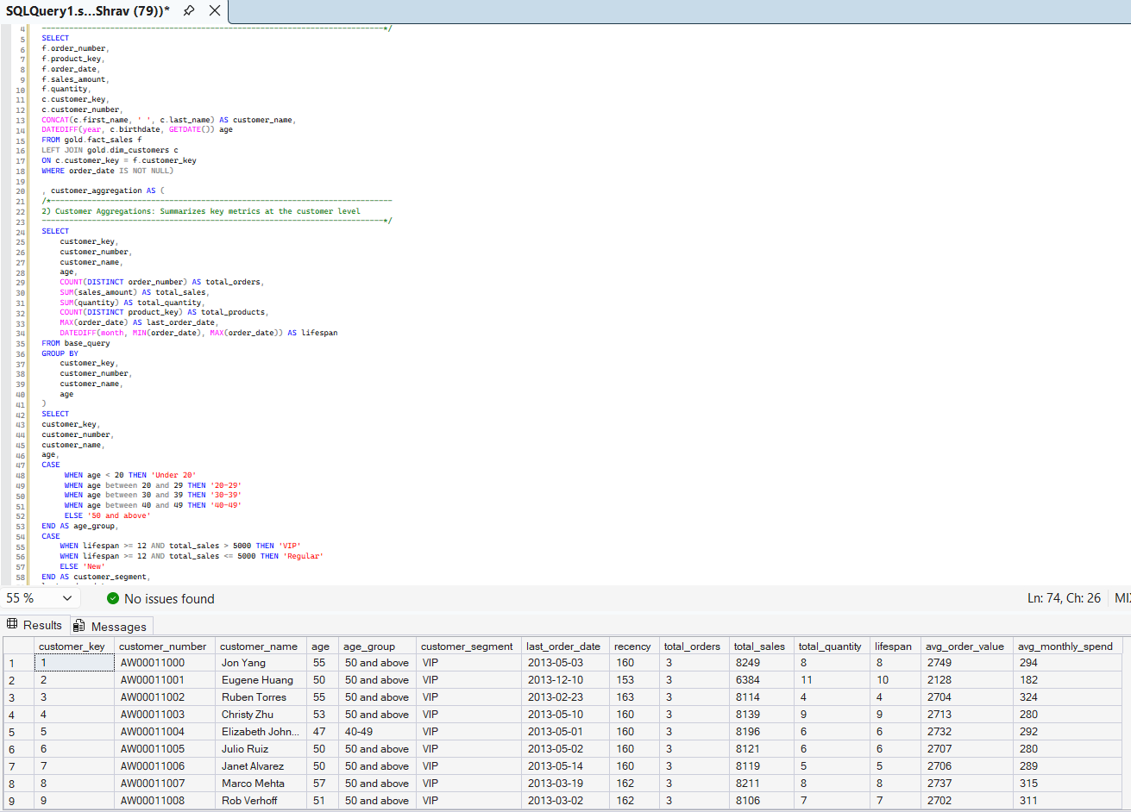
Figure 7.1 — gold.report_customers output

8. Reporting — Product Report
Symmetrically, gold.report_products consolidates product-level metrics and behaviors into a single reusable view, applying revenue-based performance segmentation.
What the view does
- Gathers core fields: product name, category, subcategory, and cost
- Segments products by total revenue into High-Performer (> 50,000), Mid-Range (10,000–50,000), or Low-Performer (< 10,000)
- Aggregates product-level metrics: total orders, total sales, total quantity sold, unique customers, and lifespan in months
- Calculates KPIs: recency (months since last sale), average selling price, average order revenue (AOR), and average monthly revenue

CREATE VIEW gold.report_products AS

WITH base_query AS (
SELECT
f.order_number, f.order_date, f.customer_key, f.sales_amount, f.quantity,
p.product_key, p.product_name, p.category, p.subcategory, p.cost
FROM gold.fact_sales f
LEFT JOIN gold.dim_products p ON f.product_key = p.product_key
WHERE order_date IS NOT NULL
),
product_aggregations AS (
SELECT
product_key, product_name, category, subcategory, cost,
DATEDIFF(MONTH, MIN(order_date), MAX(order_date)) AS lifespan,
MAX(order_date) AS last_sale_date,
COUNT(DISTINCT order_number) AS total_orders,
COUNT(DISTINCT customer_key) AS total_customers,
SUM(sales_amount) AS total_sales,
SUM(quantity) AS total_quantity,
ROUND(AVG(CAST(sales_amount AS FLOAT) / NULLIF(quantity, 0)), 1) AS avg_selling_price
FROM base_query
GROUP BY product_key, product_name, category, subcategory, cost
)
SELECT
product_key, product_name, category, subcategory, cost,
last_sale_date,
DATEDIFF(MONTH, last_sale_date, GETDATE()) AS recency_in_months,
CASE
WHEN total_sales > 50000 THEN 'High-Performer'
WHEN total_sales >= 10000 THEN 'Mid-Range'
ELSE 'Low-Performer'
END AS product_segment,
lifespan, total_orders, total_sales, total_quantity, total_customers, avg_selling_price,
-- Average Order Revenue (AOR)
CASE WHEN total_orders = 0 THEN 0 ELSE total_sales / total_orders END AS avg_order_revenue,
-- Average Monthly Revenue
CASE WHEN lifespan = 0 THEN total_sales ELSE total_sales / lifespan END AS avg_monthly_revenue
FROM product_aggregations;

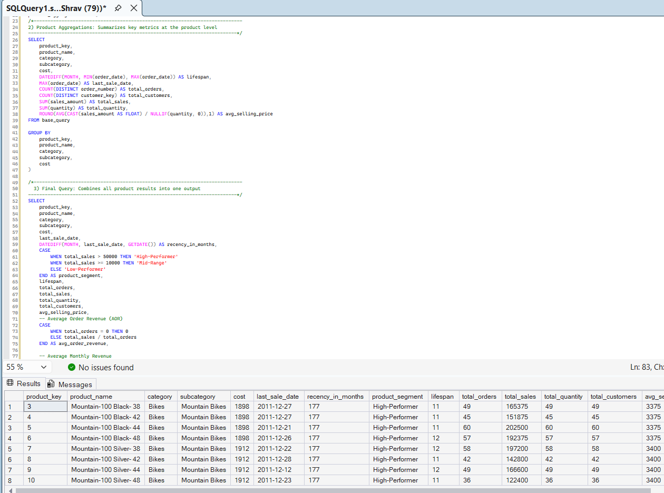
Figure 8.1 — gold.report_products output

9. Summary of SQL Techniques
The table below maps each business question to the analytical technique and core SQL functions used to answer it.

Technique | Business Question Answered | Key SQL Constructs
Change-Over-Time | Total Sales by Year / Avg Cost by Month | YEAR(), MONTH(), DATETRUNC(), FORMAT(), SUM(), AVG()
Cumulative | Running total sales; moving average price | SUM() OVER(), AVG() OVER()
Performance (YoY) | Current vs. average / vs. previous year sales | LAG(), AVG() OVER(), CASE
Part-to-Whole | % contribution of each category to total sales | SUM() OVER(), CAST(), ROUND()
Segmentation | Products by cost range; customers by spend segment | CASE WHEN, GROUP BY
Reporting | Consolidated customer & product views | CTEs, JOIN, CASE, DATEDIFF(), views

