SALES & MARKETING
Data Modelling Project

From a Fragmented Raw Dataset to a Governed Star Schema for Enterprise Reporting & Analytics in Power BI

Document Guide
This document is organised into the sections below. Each section groups related content so the reader can navigate directly to the topic of interest.
1 Executive Summary
Project objective · Summary of the approach and outcomes
2 Challenges in the Raw Data
Structural problems · Data quality issues · Granularity & normalisation issues · Relationship challenges · Business impact · Raw dataset inventory (23 tables)
3 Modelling Methodology
Four-phase approach: Prepare & Explore, Build Dimensions, Build Facts, Polish
4 Phase 1 – Prepare & Explore
Table-by-table review and analysis · Staging folder setup in Power Query
5 Phase 2 – Building the Dimensions
dim_customer construction · dim_product construction
6 Phase 3 – Building Facts & Dimensions Together
dim_order_flags (junk dimension) · fact_sales · dim_geo · fact_inventory · dim_campaign · fact_campaign_spend · fact_promotion_coverage (factless fact) · fact_order_process (accumulating snapshot) · fact_sales_target
7 Phase 4 – Polishing the Data Model
Naming standards · Date dimension · DAX measures & validation
8 Securing the Data Model
Row-level security (RLS) · Roles and access rules
9 Final Star Schema & Conclusion
Consolidated relationship map · Business outcomes

1. Executive Summary

1.1 Project Objective
Transform a messy, fragmented dataset into a clean, scalable Star Schema data model that supports reliable reporting and analytics in Power BI.

1.2 Summary
The raw dataset contained multiple structural issues — duplicate tables, inconsistent naming conventions, missing keys, and fragmented customer and product information. Collectively, these issues made reporting unreliable and slow.
The data model was redesigned into a Star Schema with well-defined fact and dimension tables, delivering the following outcomes:
1. Accurate joins and aggregations
2. Improved query performance
3. Scalability for future data (new years, campaigns, and products)
4. Business-ready reporting in Power BI

2. Challenges in the Raw Data
The raw dataset arrived with no clearly defined facts or dimensions, multiple many-to-many relationships, unlinked tables, filter directions applied inconsistently, and no star schema — making it unfit for reliable reporting.

2.1 Structural Problems
1. Several tables — regions, campaign_skus, security, dim_order, subcategories, cities, and inventory — contain generic column names such as Column1 and Column2. This indicates incomplete or improperly loaded data, which obscures relationships and reduces schema clarity.
2. Redundant fact tables exist (ORDERS_2025 and ORDERS_2026) with nearly identical structures. These needed to be consolidated into a single Orders fact table, with a dedicated Year column to distinguish records.
3. Customer-related data is fragmented across multiple tables (CUST_MASTER, customer_contacts, Address, user_details) without a consistent primary key, increasing the risk of duplicate or disconnected customer records.

2.2 Data Quality Issues
- Inconsistent naming conventions: some tables use uppercase (ORDERS_2026), others lowercase (products, shipments).
- Redundant fields: CustomerName appears in multiple tables (ORDERS, INVOICES, payments) instead of using CustomerID.
- Missing keys: several tables (e.g., invoice_lines, order_line_items) use ProductName instead of ProductCode or ProductID, making text-based joins error-prone.

2.3 Granularity & Normalisation Issues
- Fact tables (order_line_items, invoice_lines, payments) mix transactional data with descriptive attributes such as ProductName.
- Campaign-related tables (CAMPAIGN_LOG, campaign_skus) don't clearly connect to orders or customers.
- sales_targets is a standalone table with no link to regions, products, or a time dimension — making performance-against-target analysis difficult.

2.4 Relationship Challenges
- Multiple paths connect orders → invoices → payments → shipments, but with inconsistent keys (OrderID, InvoiceID, ShipmentID).
- Missing dimension tables, including: a Date dimension (to standardise OrderDate, InvoiceDate, ShipDate), a Product dimension (currently scattered between products, subcategories and inventory), and a Customer dimension (fragmented across CUST_MASTER, customer_contacts, Address and user_details).

2.5 Impact of These Issues
- Ambiguous joins: risk of incorrect aggregations in Power BI.
- Poor performance: text joins and duplicate fields slow queries.
- Hard to scale: adding new years or orders requires new tables instead of extending existing ones.

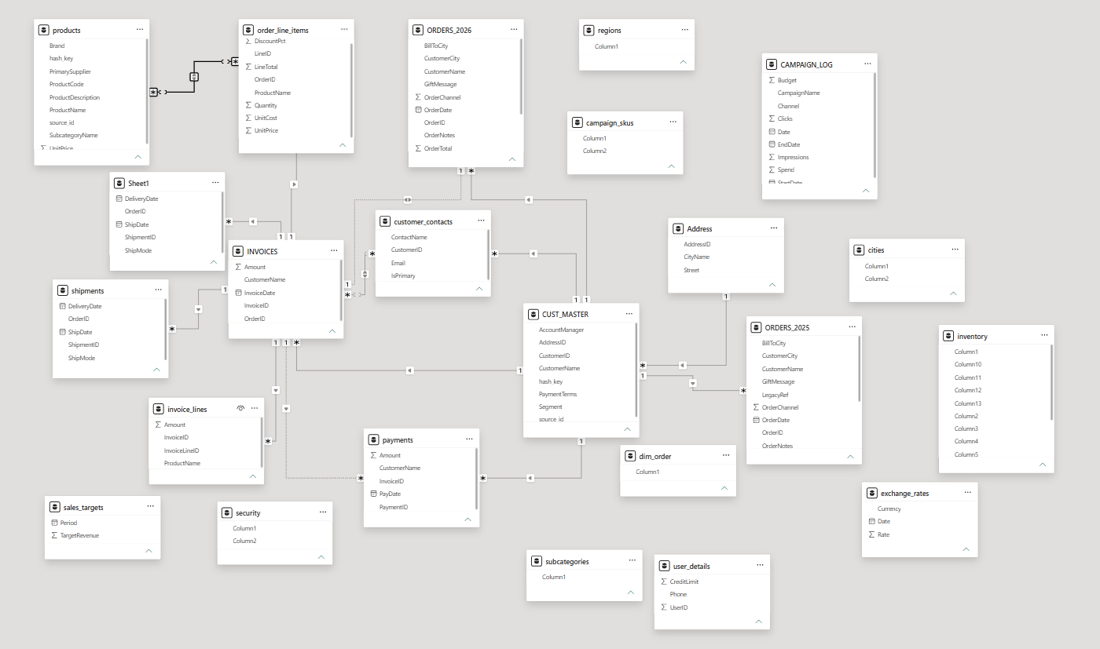
Figure 1 — Data Modelling View of the Raw Dataset in Power BI (no facts/dimensions defined, many-to-many relationships, unlinked tables)

2.6 Raw Dataset Inventory
The table below lists all 23 raw tables identified during discovery, together with their columns as originally loaded.
S.No | Table Name | Column Names
1 | Address | AddressID, Street, CityName
2 | CAMPAIGN_LOG | CampaignName, Channel, StartDate, EndDate, Budget, Date, Impressions, Clicks, Spend
3 | campaign_skus | Column1, Column2
4 | cities | Column1, Column2
5 | CUST_MASTER | CustomerID, CustomerName, Segment, AddressID, AccountManager, PaymentTerms, hash_key, source_id
6 | INVOICES | InvoiceID, OrderID, CustomerName, InvoiceDate, Amount
7 | ORDERS_2025 | OrderID, LegacyRef, CustomerName, CustomerCity, RegionName, ShipToCity, BillToCity, OrderDate, OrderChannel, Status, Priority, OrderTotal, OrderNotes, GiftMessage, SourceFile
8 | ORDERS_2026 | OrderID, LegacyRef, CustomerName, CustomerCity, RegionName, ShipToCity, BillToCity, OrderDate, OrderChannel, Status, Priority, OrderTotal, OrderNotes, GiftMessage
9 | Sheet1 | ShipmentID, OrderID, ShipMode, ShipDate, DeliveryDate
10 | customer_contacts | CustomerID, ContactName, Email, IsPrimary
11 | dim_order | Column1
12 | exchange_rates | Currency, Rate, Date
13 | inventory | Column1 – Column13
14 | invoice_lines | InvoiceLineID, InvoiceID, ProductName, Amount
15 | order_line_items | LineID, OrderID, ProductName, Quantity, UnitPrice, UnitCost, DiscountPct, LineTotal
16 | payments | PaymentID, InvoiceID, CustomerName, PayDate, Amount
17 | products | ProductCode, ProductName, Brand, SubcategoryName, UnitPrice, PrimarySupplier, ProductDescription, hash_key, source_id
18 | regions | Column1
19 | sales_targets | Period, TargetRevenue
20 | security | Column1, Column2
21 | shipments | ShipmentID, OrderID, ShipMode, ShipDate, DeliveryDate
22 | subcategories | Column1
23 | user_details | UserID, CreditLimit, Phone

3. Modelling Methodology
To resolve the issues identified above, the raw data was cleaned and converted into a Star Schema model, ready for report building. The work followed a structured four-phase approach.

3.1 Phase 1 — Prepare & Explore
Open the messy model, prepare the workspace, understand the business and the data, and spot dimensions and facts.

3.2 Phase 2 — Build Dimensions
Group the tables belonging to one entity, reshape them into a single clean dimension, standardise the result, and repeat for every dimension.

3.3 Phase 3 — Building Facts & Dimensions Together
Pick an event, read its grain, build the fact table from the transactional details, connect every relevant dimension, and test the numbers so nothing breaks.

3.4 Phase 4 — Polish
Re-check naming and modelling standards, add the date dimension, build the DAX measures, apply row-level security, and perform final validation.
Sections 4 through 7 of this document walk through each of these four phases in the order they were executed.

4. Phase 1 — Prepare & Explore

4.1 Step 1 — Table-by-Table Review
After importing the raw dataset into Power BI, each table and its columns were systematically examined in Table View to understand the details they contained. The analysis and key observations for every table are summarised below.
S.No | Table Name | Analysis Comments | Additional Comments
1 | Address | Address details of customer
2 | CAMPAIGN_LOG | Daily marketing campaigning information | Good for a fact — event information available
3 | campaign_skus | Campaign and product names | Messy data; column names are not correct
4 | cities | City and region information | Geography information; column names are not correct
5 | CUST_MASTER | Customer details | Customer names are company names
6 | INVOICES | Invoice information | Can act as a fact for invoices
7 | ORDERS_2025 | Orders information for 2025 | Good for a fact — event information available
8 | ORDERS_2026 | Orders information for 2026 | Good for a fact — event information available
9 | Sheet1 | Delivery information
10 | customer_contacts | Customer contact information | Multiple SPOCs for the same company
11 | dim_order | Order ID information | Only one column, with an incorrect column name
12 | exchange_rates | Currency rate business info
13 | inventory | Product name and monthly stock | Column names are not correct
14 | invoice_lines | Invoice information
15 | order_line_items | Order information | Invoice for each order
16 | payments | Payment information | Good for a fact — transaction info available
17 | products | Product information | Can be a dimension
18 | regions | Only column — region info | Only one column; column name is not correct
19 | sales_targets | Monthly target revenue info
20 | security | Email and region of users | Column names are not correct
21 | shipments | Identical table to Sheet1 | Duplicate table found with the same data
22 | subcategories | Category and subcategory of products | Column name incorrect; category & sub-category merged
23 | user_details | Customer information | UserID matches CustomerID in CUST_MASTER

4.2 Step 2 — Organising the Workspace
In Power Query, the tables were organised to prepare for the next step: all raw datasets were stored in a dedicated folder, and a Staging folder was created to hold every raw dataset.

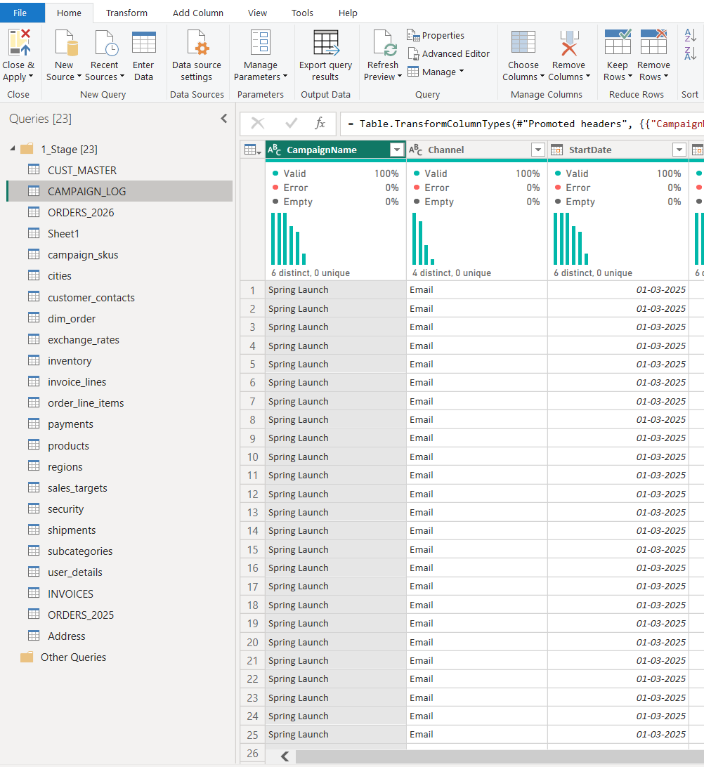
Figure 2 — Raw tables organised into the Staging folder in Power Query
With the raw dataset analysis complete and all tables moved into the Staging folder, the next phase involved building the dimension and fact tables.

5. Phase 2 — Building the Dimensions
Dimension tables were created from the raw data and stored in a dedicated Dimensions folder within Power Query. The process involved: (1) collecting all tables related to a single entity and grouping them together; (2) combining these tables into one dimension using split, merge, append, fix and drop operations; and (3) cleaning and standardising the dimension with consistent naming conventions (snake_case), meaningful table names, and appropriate prefixes or suffixes.
The tables identified for consolidation produced two core dimensions:
- dim_product — contains product-related information, built from the products and subcategories tables.
- dim_customer — contains customer details, constructed from customer_contacts, CUST_MASTER, user_details, regions, Address and cities tables.

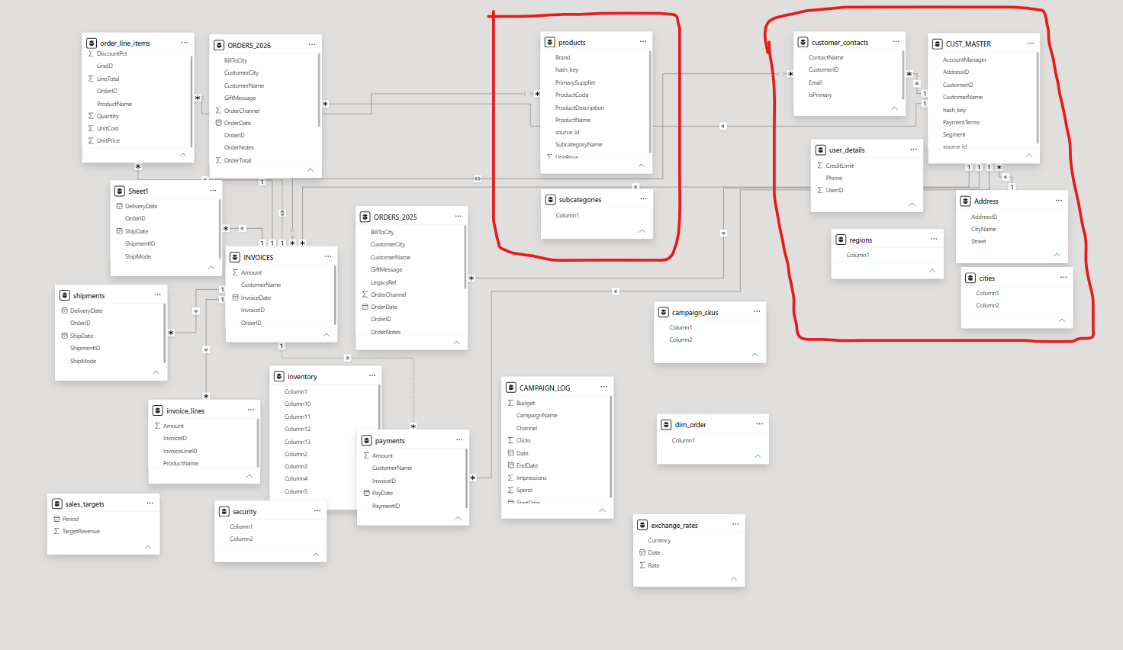
Figure 3 — Tables grouped for consolidation into dim_customer and dim_product

5.1 Building dim_customer

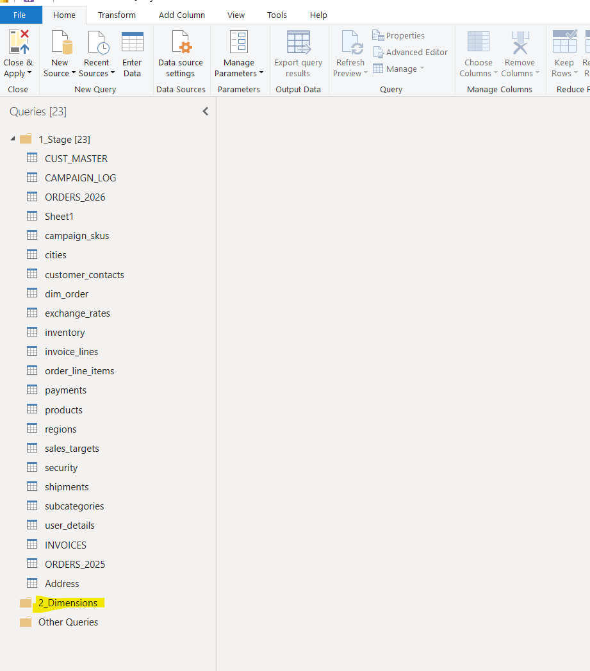
Figure 4 — Dimensions folder created in Power Query

Step 1 — Create the Dimensions Folder
A Dimensions folder was created in Power Query to hold all curated dimension tables.

Step 2 — Identify the Base Table
Among the grouped tables for the customer dimension, CUST_MASTER was identified as the largest table, providing the most comprehensive and detailed customer context.

Step 3 — Reference and Rename
A reference of the CUST_MASTER table was created, moved into the Dimensions folder, and renamed dim_customer.

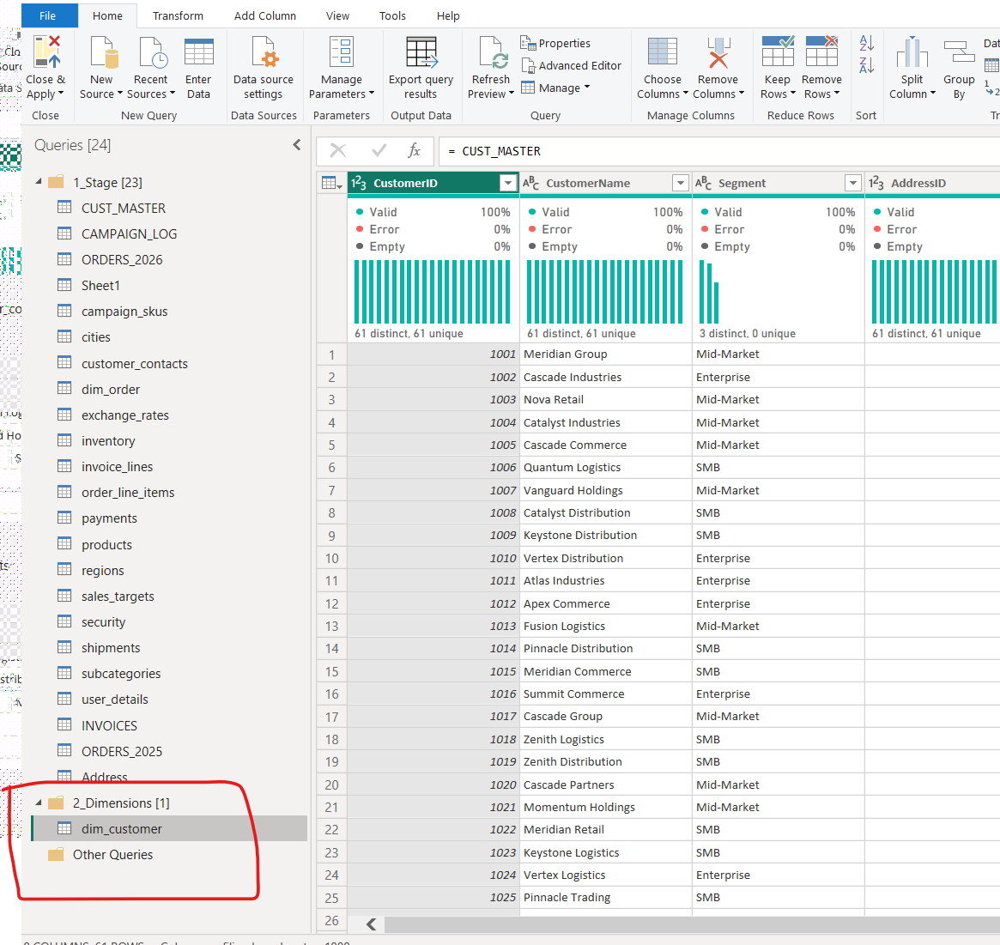
Figure 5 — Reference of CUST_MASTER renamed to dim_customer

Steps 4–10 — Clean, Merge and Standardise
1. The dim_customer table initially contained 61 rows. After reviewing the data, dummy records were identified and removed using filters, leaving 60 valid rows.
2. When merging additional tables into dim_customer, the row count was not allowed to exceed 60, to preserve unique customer records.
3. The customer_contacts table was merged into dim_customer on CustomerID using a left outer join, bringing in ContactID, ContactName, Email and IsPrimary.
4. Post-merge, the row count increased because customer_contacts holds multiple contacts per customer. This was resolved by filtering on IsPrimary = True to retain only the primary contact, restoring the row count to 60.
5. The user_details table was merged on CustomerID using a left outer join; the column user_id was renamed to customer_id for consistency. The row count remained at 60.
6. The Address table was merged on AddressID using a left outer join, with the row count validated at 60.
7. For the cities table, column names were corrected by promoting the first row to headers, then merged on CityName using a left outer join. The row count remained at 60.
8. The regions table contains only a single column (RegionName), which was already available, so no merge was required.
9. dim_customer was cleaned by removing unnecessary columns and applying standardised snake_case naming conventions.
10. The original source tables were hidden from the model by disabling the Enable Load option on each.
11. The finalised dim_customer table was reviewed in Power BI's Modelling View.

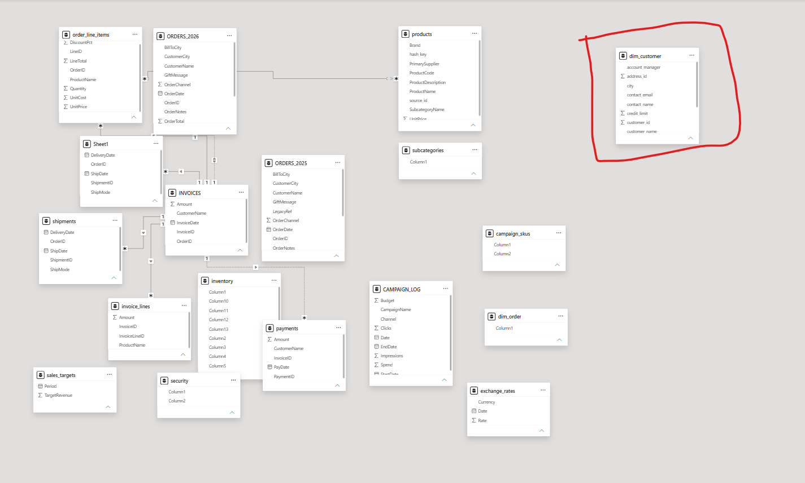
Figure 6 — Finalised dim_customer table in Power BI Modelling View

5.2 Building dim_product

Step 1 — Identify the Base Table
Among the tables consolidated for the Product dimension, the products table emerged as the primary source, being the most extensive and providing the most complete product attributes.

Step 2 — Reference and Rename
A reference of the products table was created under the Dimensions folder and renamed dim_product, serving as the standardised Product dimension in the star schema.

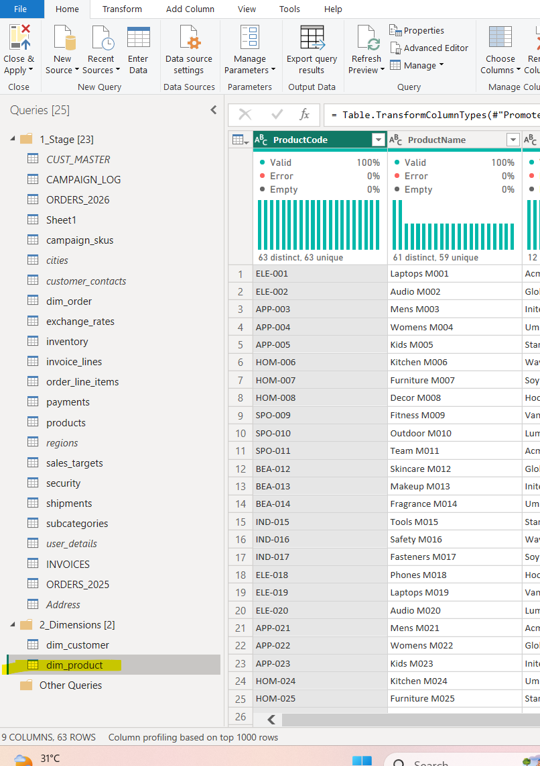
Figure 7 — Reference of products renamed to dim_product
1. dim_product initially contained 63 rows. Dummy or test records were filtered out, resulting in a final count of 62 valid product rows.
2. When enriching dim_product with data from other tables, the row count was not allowed to exceed 62, to maintain uniqueness.
3. The subcategories table was cleaned by correcting the column name, splitting the concatenated Category|Subcategory values into two separate columns, and standardising subcategory capitalisation to match dim_product.
4. The cleaned subcategories table was merged into dim_product using a left outer join on the Subcategory column; the row count remained consistent at 62.
5. Since dim_product had no unique identifier, a surrogate key was added via a custom index column, serving as the primary key for connecting to fact tables.
6. A final cleanup removed unnecessary columns, applied consistent snake_case naming, and hid the original raw tables by disabling Enable Load, leaving only the cleaned dimension visible in the model.

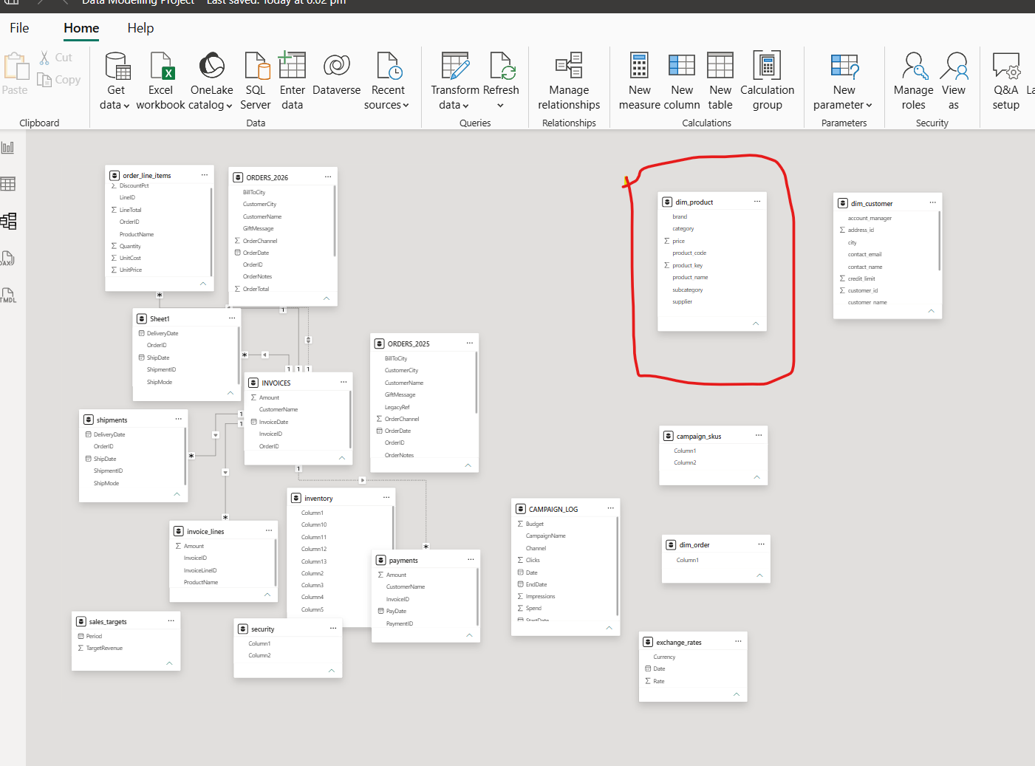
Figure 8 — Finalised dim_product table

6. Phase 3 — Building Facts & Dimensions Together
Because the data model contains many interconnected tables that are not standalone entities like CUST_MASTER or products, dimensions for the remaining areas had to be extracted from event-based tables. The most effective approach was to design fact and dimension tables in parallel, drawing on the data available across these sources.

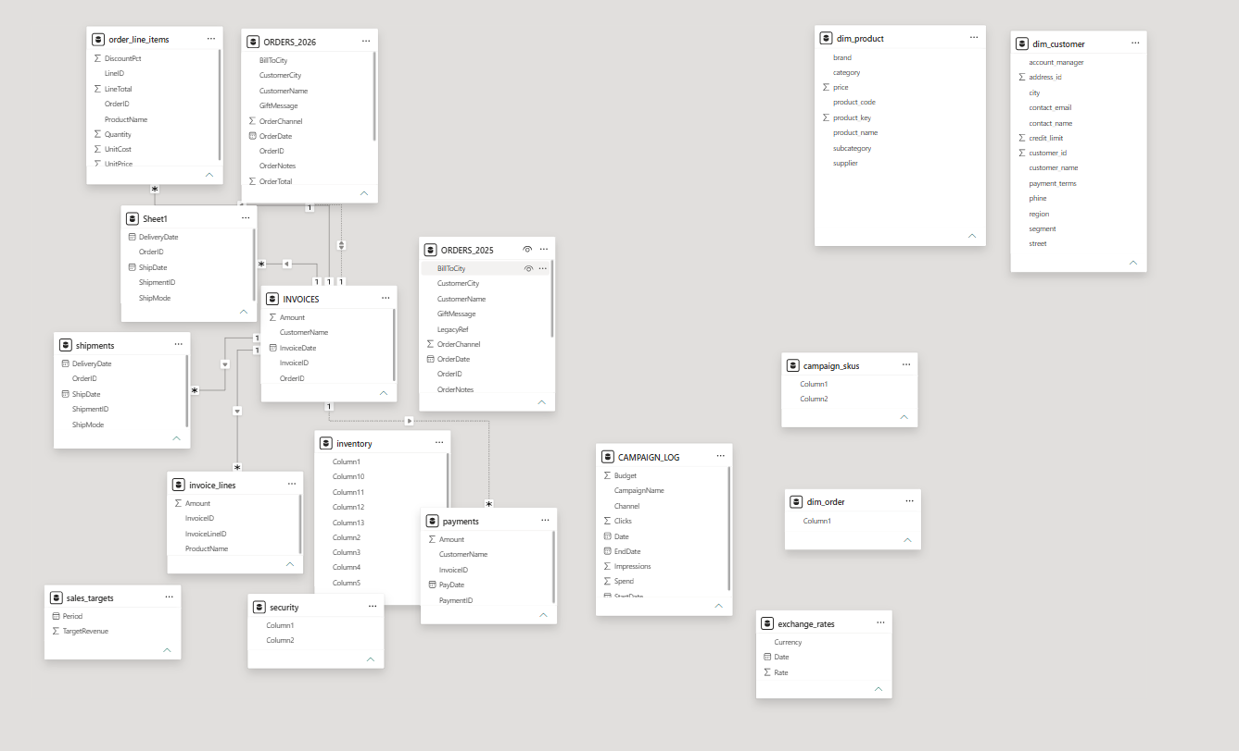
Figure 9 — Data model view before creating the remaining facts and dimensions

6.1 Consolidating the Orders Tables
The orders and sales tables were grouped as the primary sources for building this part of the model.

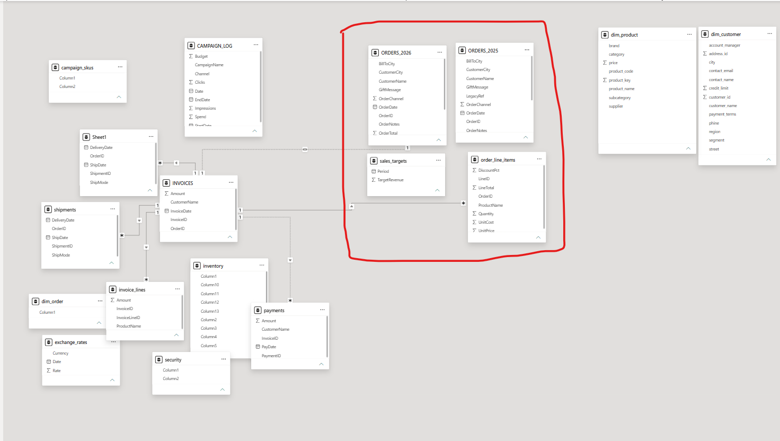
Figure 10 — Data model view after grouping orders information
In ORDERS_2025 and ORDERS_2026, each row represents a single order record. By contrast, order_line_items is more granular — each row represents an individual line item within an order — so a single order can span multiple line-item rows.
Since ORDERS_2025 and ORDERS_2026 share an identical structure, they were appended together into a single consolidated Orders table:
1. After appending, non-identical columns such as LegacyRef and SourceFile (present only in ORDERS_2025) were removed.
2. The GiftMessage column was dropped, as it contained only null values and added no analytical value.
3. The OrderNotes column was excluded, as it held lengthy free-text fields not required for reporting.
4. The cleaned and consolidated table was renamed orders.
The new orders table carries rich contextual information for each order, making it a strong candidate for a dimension table, while order_line_items holds the numerical and transactional detail — making it the core fact table of the star schema.

6.2 dim_order_flags (Junk Dimension)
Reviewing the orders table, columns such as OrderChannel, Status and Priority are useful descriptive attributes, but they are independent of one another and too weak to form standalone dimensions on their own. The best-practice solution here is a junk dimension.

Step 1 — Create the Junk Dimension
A reference of the orders table was created, moved into the Dimensions folder, and renamed dim_order_flags. Unnecessary columns were removed, duplicate records eliminated, and an index column added as the surrogate key, named flag_key.

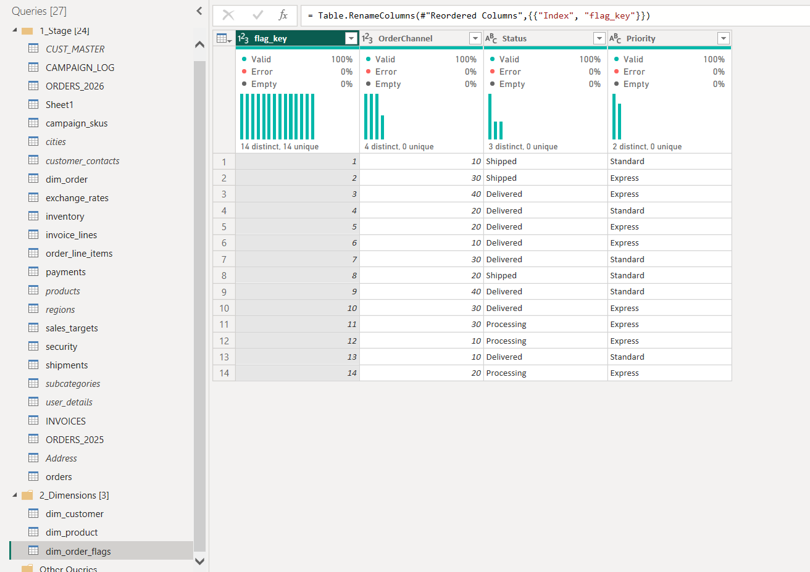
Figure 11 — dim_order_flags created as a junk dimension

Step 2 — Map Channel Codes
1. The OrderChannel values are IDs with no direct meaning in the current dataset, requiring an intermediate mapping table to translate them into meaningful values.
2. A left outer join was performed between dim_order_flags and the channels table on OrderChannel, to fetch the corresponding channel_name.
3. dim_order_flags was cleaned up after the merge by removing redundant columns and applying a consistent snake_case naming convention.

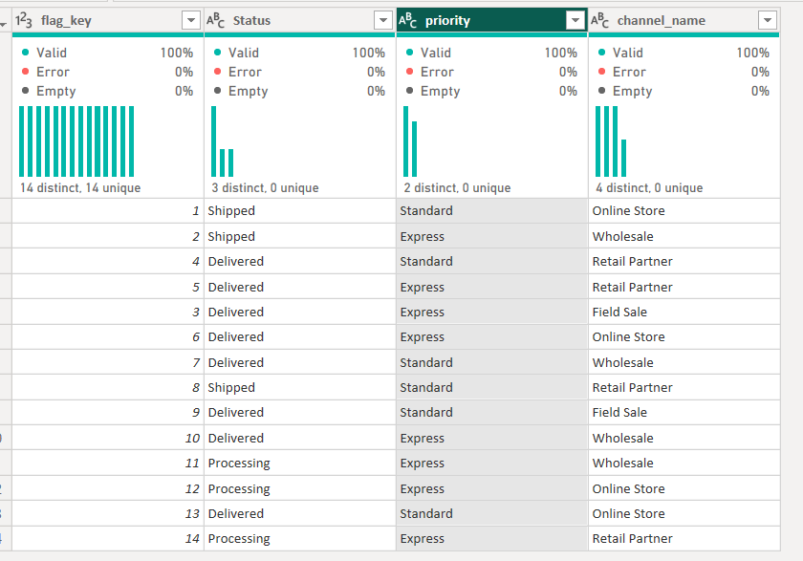
Figure 12 — dim_order_flags after mapping channel names and cleanup

6.3 fact_sales

Step 1 — Create the Fact Reference
A reference of the order_line_items table was created, moved into the Facts query folder, and renamed fact_sales.

Step 2 — Enhance with Supporting Dimensions
fact_sales was enhanced by combining it with supporting dimensions such as customers, order dates and junk dimensions, since these attributes are not directly available in order_line_items.

Step 3–4 — Validate Row Integrity
Before merging, the line_items column from fact_sales was added to a table visual in Report View and the total count noted. After each merge, the same visual was rechecked — the line-item count needed to remain identical; any change would indicate a join or relationship issue requiring correction.

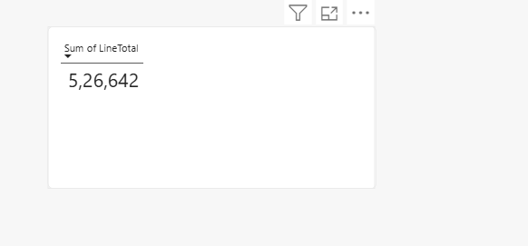
Figure 13 — Line-item count validation visual, used to verify row integrity after every merge

Step 5 — Bring in Order Attributes
Required dimensions were merged into fact_sales on the order_id column, using a left outer join with the orders table. The line-item count was reconfirmed unchanged after the merge.

Step 6 — Fetch Dimension Keys
fact_sales was merged with each dimension solely to retrieve keys and IDs, rechecking the numbers after every merge:
1. dim_customer was merged using customer_name to fetch customer_id — no change in the numbers.
2. dim_product was merged using product_name to fetch product_key — a change in the numbers was observed, indicating a data issue that required investigation.

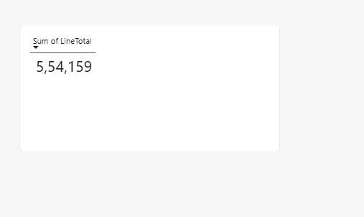
Figure 14 — Discrepancy detected after merging dim_product
To investigate, fact_sales was examined by grouping on line_id and order_id, which should be unique combinations. Two duplicate order/line combinations were found and required review.

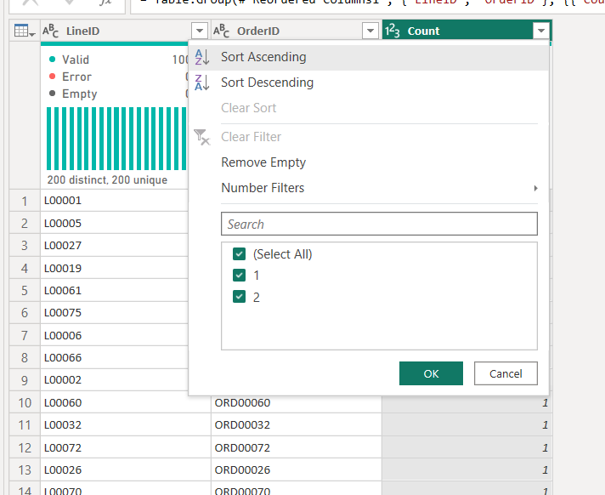
Figure 15 — Duplicate line_id / order_id combinations identified

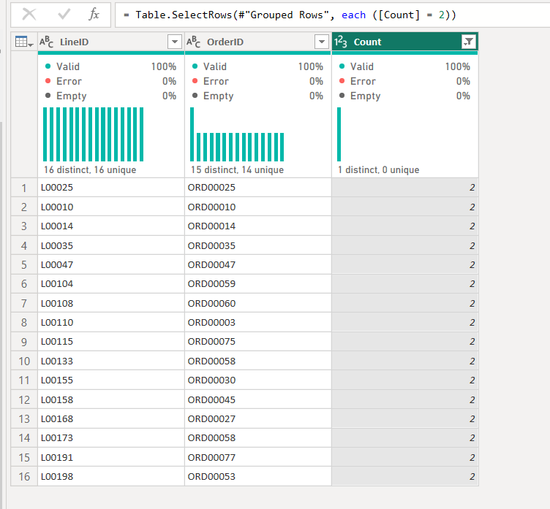
Figure 16 — Detailed review of the duplicate records
Order L00025 was checked to identify the root cause.

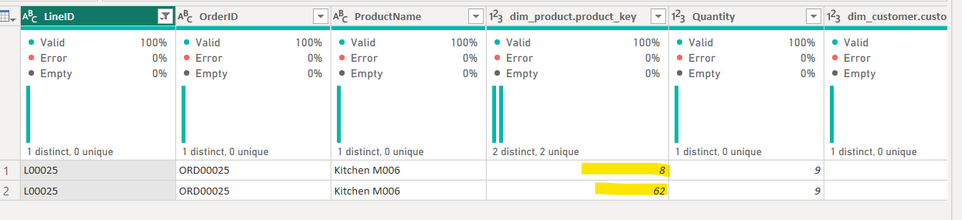
Figure 17 — Order L00025 investigation
The product_key differed for the same product. Checking dim_product revealed that one product had more detail records than another — a data quality issue originating from the source system.

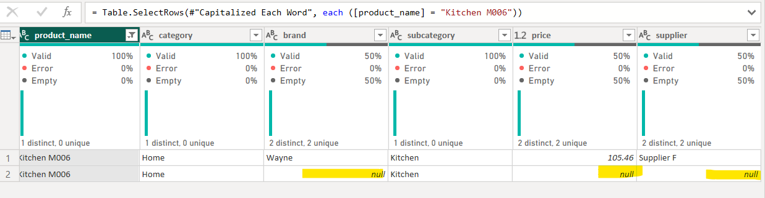
Figure 18 — Duplicate product records in dim_product causing the key mismatch
The affected rows containing null values were removed. The number of such cases was first checked by grouping on product name.

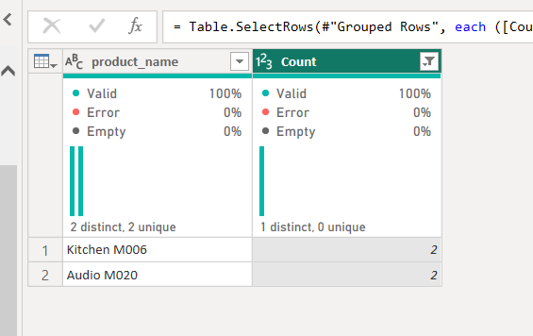
Figure 19 — Grouping by product name to isolate affected rows
Rather than leaving this for final dimension cleanup, the issue was addressed at the filtered-rows step in dim_product, removing the problematic items and re-running the group-by check to confirm consistency.

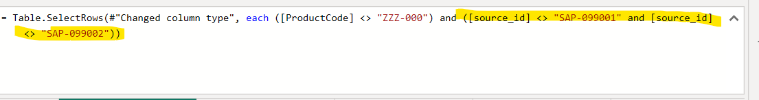
Figure 20 — Filtered-rows step in dim_product updated

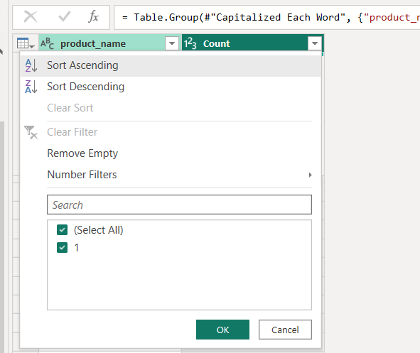
Figure 21 — Group-by validation after cleanup
With only non-duplicate items remaining, the numbers matched correctly (validated using the same line-item count visual shown in Figure 13).

Step 7 — Fetch Flag Key
dim_order_flags was merged using channel_code, status and priority to fetch flag_key — with no change in the numbers.

Step 8 — Final Clean-Up
- Removed unwanted columns.
- Applied a standard snake_case naming convention to all columns.
Note: fact_sales contains ShipToCity and BillToCity columns. Rather than leaving these as text, dimensions were built for them so that the fact table holds IDs, with the option to add further context such as region or country later. The raw cities table was used to build this dimension.

6.4 dim_geo

Step 1 — Create the Reference
A reference of the cities table was created, moved into the Dimensions folder, and renamed dim_geo.

Step 2 — Deduplicate and Key
Duplicate records were removed from dim_geo, and an index column was added as the surrogate key, named geo_key.

Step 3 — Connect Twice
Because there are two separate city references — one for shipment (orders.ShipToCity) and one for billing (orders.BillToCity) — dim_geo was connected to fact_sales twice, once for each column.

Step 4 — Finalise
fact_sales was cleaned by removing unnecessary columns and applying consistent snake_case naming. With the fact table finalised, the raw source tables were deactivated to keep the model streamlined.

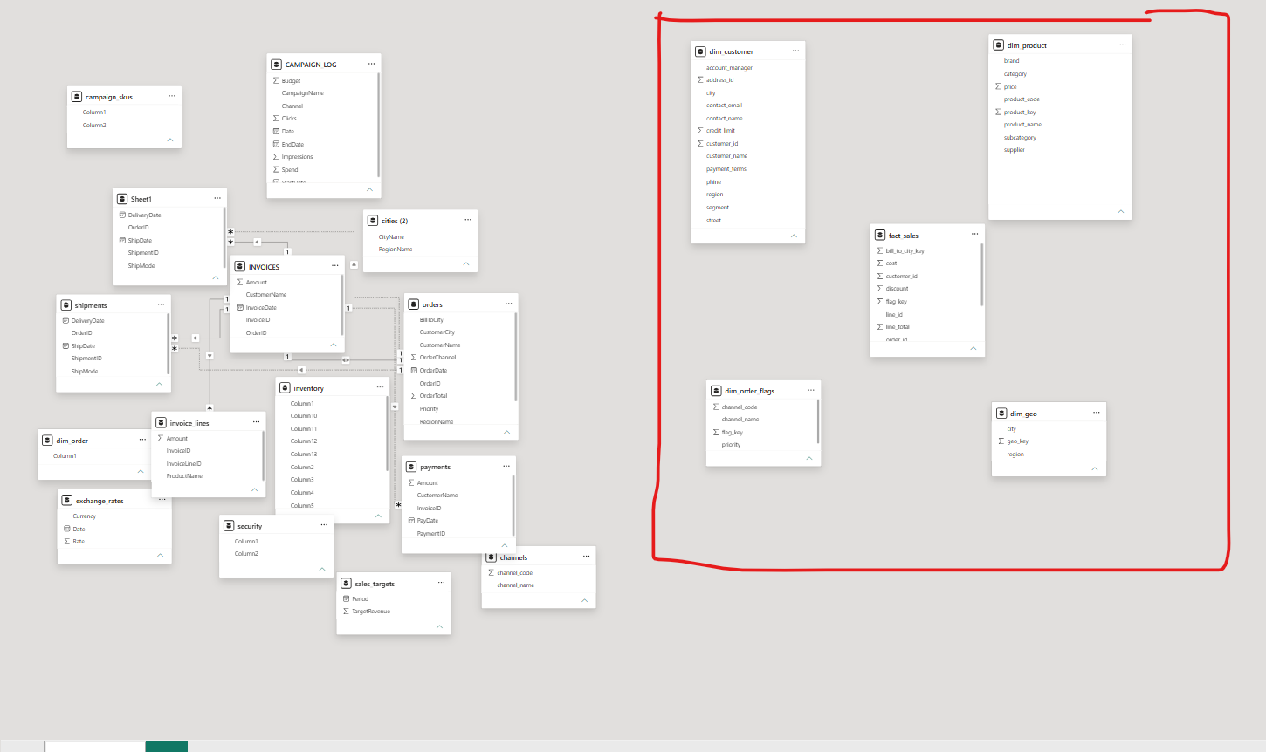
Figure 22 — dim_geo finalised and connected to fact_sales

6.5 Star Schema Relationships (Sales Area)
With the dimensions and fact tables highlighted, the following relationships form the star schema for this part of the model:
- A one-to-many relationship from fact_sales to dim_customer using customer_id.
- A one-to-many relationship from fact_sales to dim_product using product_key.
- A one-to-many relationship from fact_sales to dim_order_flags using flag_key.
- A one-to-many relationship from fact_sales to dim_geo using geo_key, for ship_to_city_key.
- A one-to-many relationship from fact_sales to dim_geo using geo_key, for bill_to_city_key (set as inactive).
Two relationships were created with dim_geo: one for shipping (active) and one for billing (inactive).

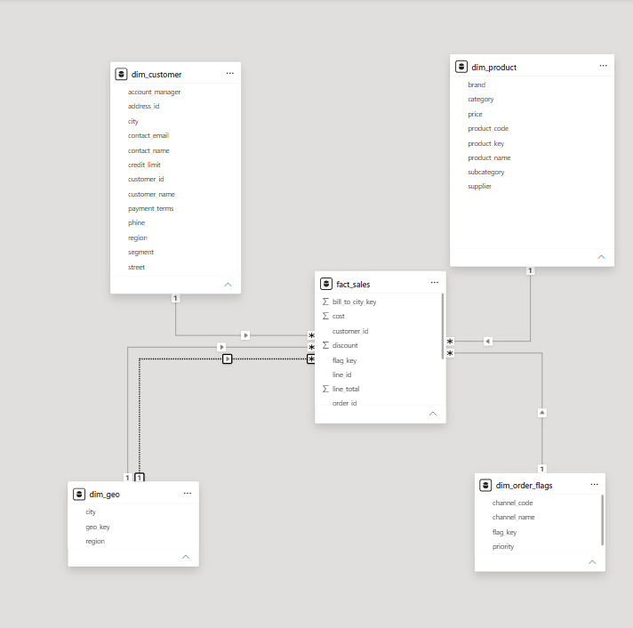
Figure 23 — Sales area star schema relationships

6.6 fact_inventory
Applying the same approach to remaining tables, the inventory table stores product names alongside monthly item quantities across the year. Since it holds both numerical measures and date information, it qualifies as a fact table.

Step 1 — Create and Correct Headers
1. A reference of the inventory table was created, moved into the Facts folder, and renamed fact_inventory.
2. Misaligned column headers were corrected using the First Row as Headers option.

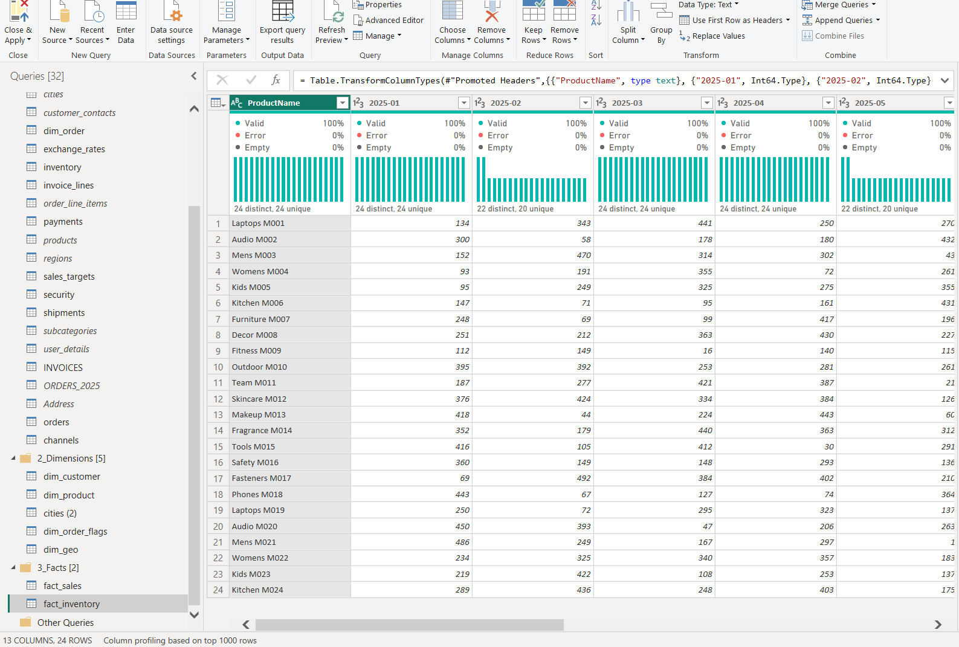
Figure 24 — fact_inventory header correction
The original structure stored dates as columns, which is unsuitable for reporting. The table was unpivoted so date values became rows, and the data type was converted from text to date.
A product key was introduced by merging fact_inventory with dim_product to retrieve product_key; the product name column was then removed and the remaining column renamed for consistency.

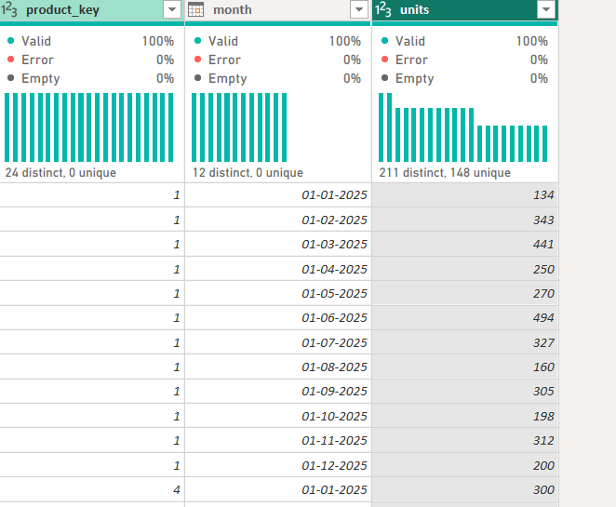
Figure 25 — fact_inventory after unpivoting dates and merging product_key
With fact_inventory finalised, the raw source tables were deactivated, and a one-to-many relationship was established between fact_inventory and dim_product using product_key.

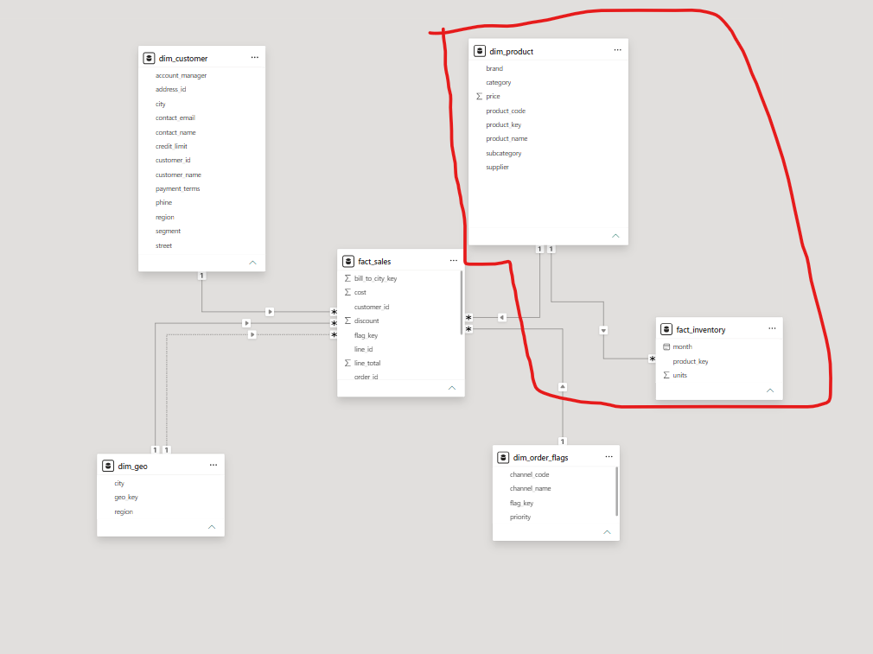
Figure 26 — fact_inventory linked to dim_product

6.7 dim_campaign, fact_campaign_spend & fact_promotion_coverage
The CAMPAIGN_LOG and campaign_skus tables were grouped to extract the remaining facts and dimensions.

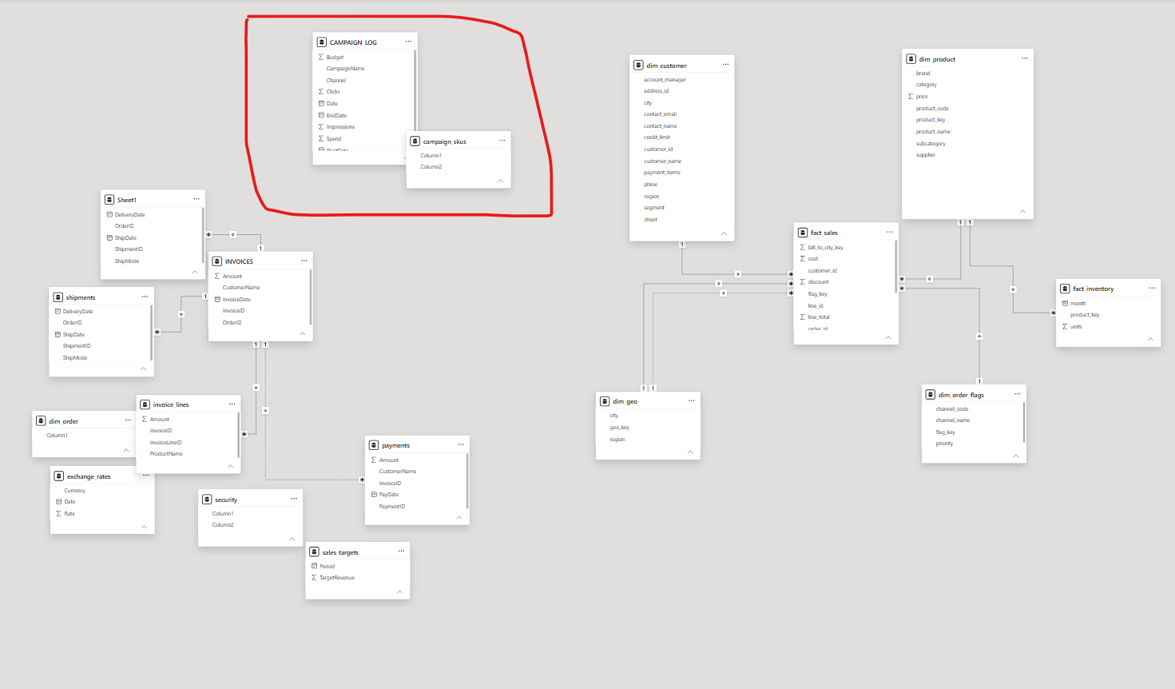
Figure 27 — CAMPAIGN_LOG and campaign_skus grouped for processing
CAMPAIGN_LOG contains campaign information and resembles a fact table, but it also includes contextual attributes — indicating it should be split into a separate fact and dimension. campaign_skus stores campaign names with associated product lists, making it suitable to model as a dimension.

dim_campaign
A reference of CAMPAIGN_LOG was created and moved into the Dimensions folder, renamed dim_campaign.

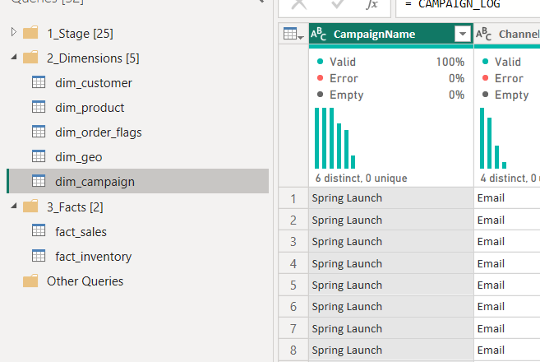
Figure 28 — Reference of CAMPAIGN_LOG renamed to dim_campaign
1. The Date, Impressions, Clicks and Spend columns were removed from dim_campaign, as these are transactional measures belonging in a fact table.
2. Duplicate records were eliminated from the remaining columns.
3. An index column was added as a unique identifier, and all fields renamed using snake_case.

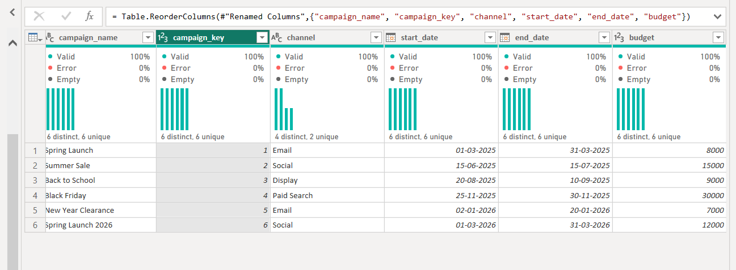
Figure 29 — dim_campaign finalised

fact_campaign_spend
1. A reference of CAMPAIGN_LOG was created, moved into the Facts folder, and renamed fact_campaign_spend.
2. dim_campaign was merged into fact_campaign_spend on campaign_name using a left outer join, bringing in the key column.
3. Descriptive columns (CampaignName, Channel, StartDate, EndDate, Budget) were removed, since these attributes are already available in the dimension, and the remaining columns renamed to snake_case.

fact_promotion_coverage (Factless Fact Table)
A reference of campaign_skus was created, moved into the Facts folder, and renamed fact_promotion_coverage. This table links two distinct entities — products and campaigns — and, since dim_product and dim_campaign already exist, there was no need for a separate mapping dimension. Instead, fact_promotion_coverage acts as a bridge fact table connecting campaigns to products.

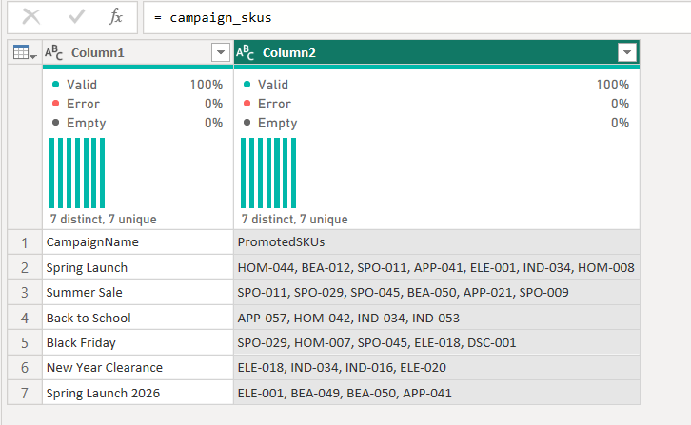
Figure 30 — campaign_skus referenced as fact_promotion_coverage
1. The first row was promoted to column headers, since the existing column names were incorrect.
2. The PromotedSKUs column, containing a list of product codes, was split so each code appears on its own row. A spacing issue was then resolved by trimming the values.

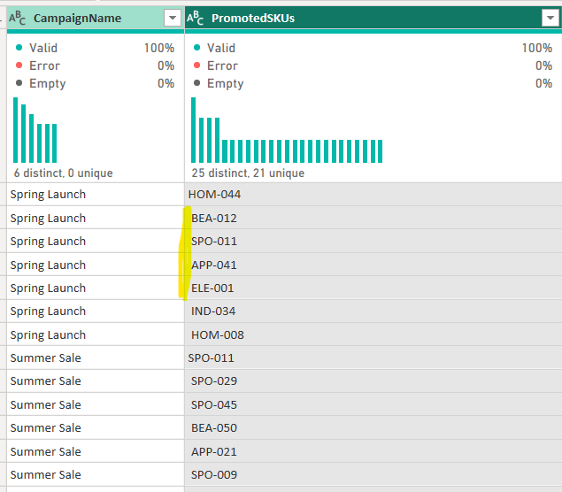
Figure 31a — Before trimming the split SKU values

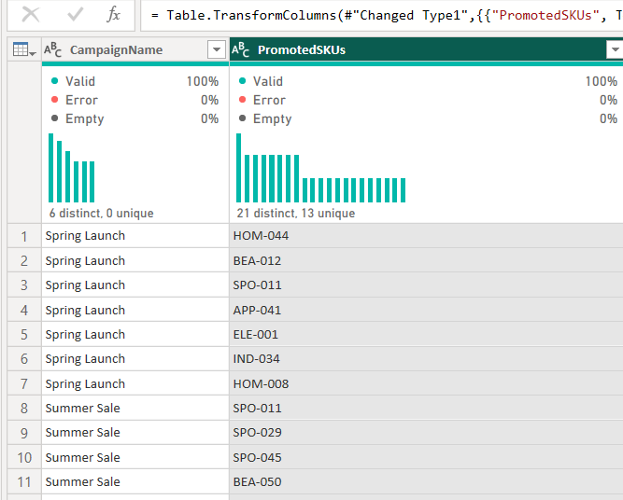
Figure 31b — After trimming the split SKU values
3. fact_promotion_coverage was merged with dim_campaign on campaign_name to retrieve campaign_key.
4. fact_promotion_coverage was merged with dim_product on product_code to retrieve product_key.
5. Remaining non-essential columns were removed, fields renamed to snake_case, and raw tables deactivated. Because it holds only relationships without direct measures, this structure is a Factless Fact Table.

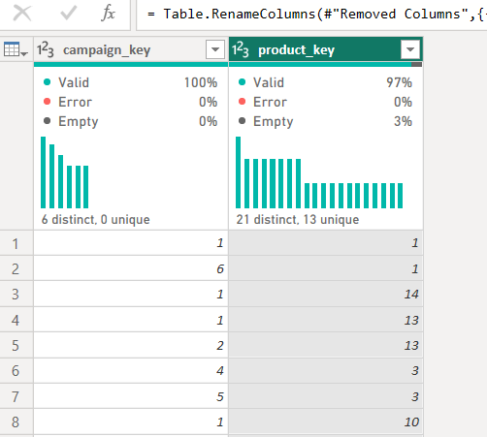
Figure 32 — fact_promotion_coverage finalised as a factless fact table
fact_promotion_coverage was linked to both dim_product and dim_campaign via one-to-many relationships, and fact_campaign_spend was linked to dim_campaign via a one-to-many relationship.

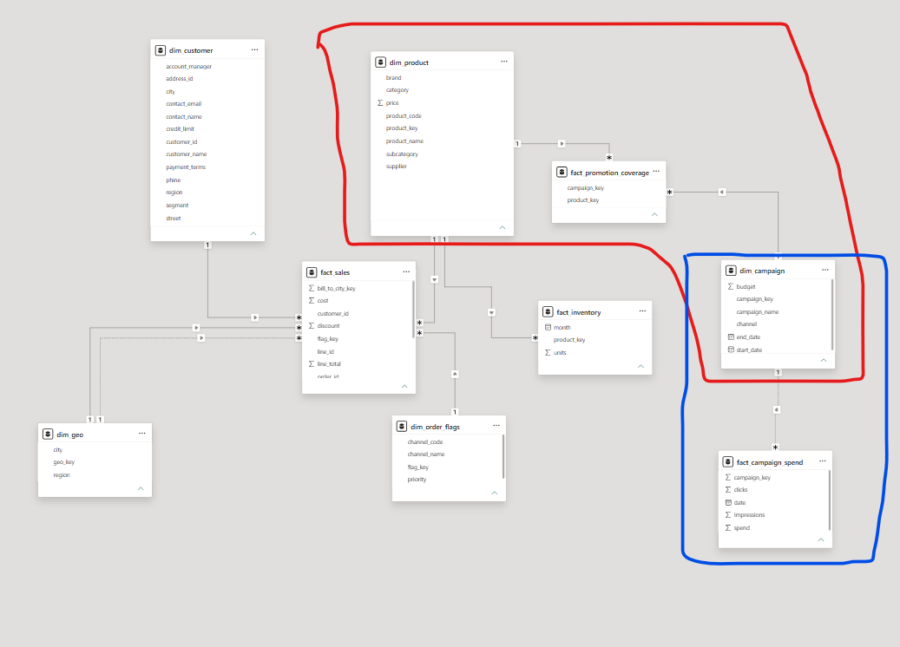
Figure 33 — Campaign area relationships in the model

6.8 fact_order_process (Accumulating Snapshot Fact Table)
The remaining transactional tables were reviewed:
- Invoices — InvoiceID, OrderID, CustomerName, InvoiceDate and Amount; transactional information.
- Payments — PaymentID, InvoiceID, CustomerName, PayDate and Amount; transactional information.
- Shipments — ShipmentID, OrderID, ShipMode, ShipDate and DeliveryDate; transactional information.
These tables are interconnected: following the order lifecycle — Order → Ship → Deliver → Invoice → Pay — each stage is a transaction, but all trace back to the order that triggers the entire process. Since dates are available for each milestone, they were consolidated into a single fact table capturing all these events: an Accumulating Snapshot Fact Table, where each row represents one order and holds the key milestone dates across the process.

Step 1 — Create the Reference
A reference of the orders table was created, moved into the Facts folder, and renamed fact_order_process, keeping only the columns required to capture milestone dates for each order and customer.

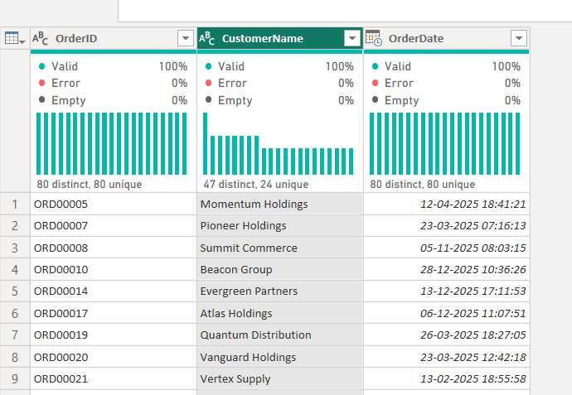
Figure 34 — fact_order_process created from the orders reference

Step 2 — Fetch the Customer Key
The CustomerName field was replaced with a key by merging fact_order_process with dim_customer on customer_name using a left outer join to fetch customer_id, then removing CustomerName.

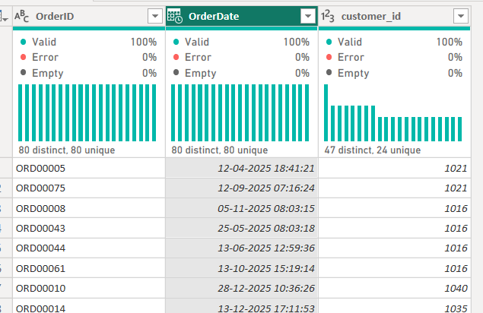
Figure 35 — Customer key merged into fact_order_process

Step 3 — Bring in Shipment Milestones
Shipment details were merged into fact_order_process from the shipments table on order_id, extracting ShipDate and DeliveryDate to capture shipment milestones.

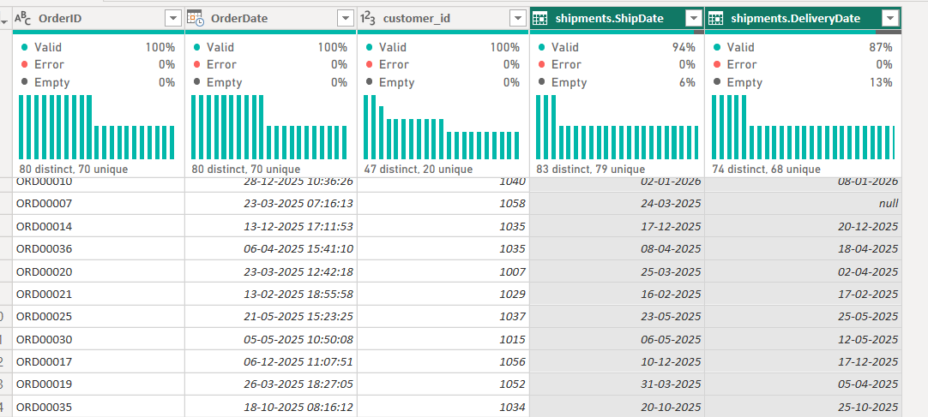
Figure 36 — Shipment milestone dates merged in

Step 4 — Bring in Invoice Milestones
Invoice information was integrated by merging with the INVOICES table on order_id, bringing in InvoiceId and InvoiceDate to capture the invoicing milestone.

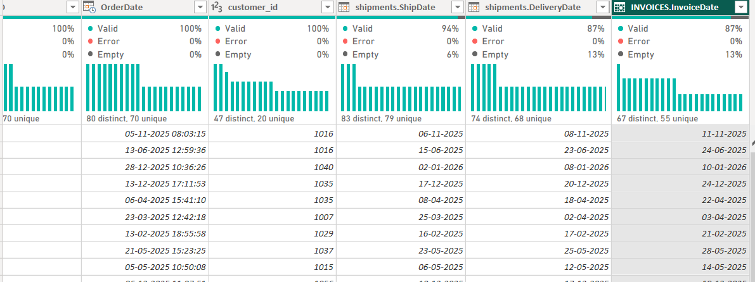
Figure 37 — Invoice milestone data merged in

Step 5 — Bring in Payment Milestones
Payment information was incorporated by merging with the payments table on InvoiceId, bringing in PayDate to capture the payment milestone.

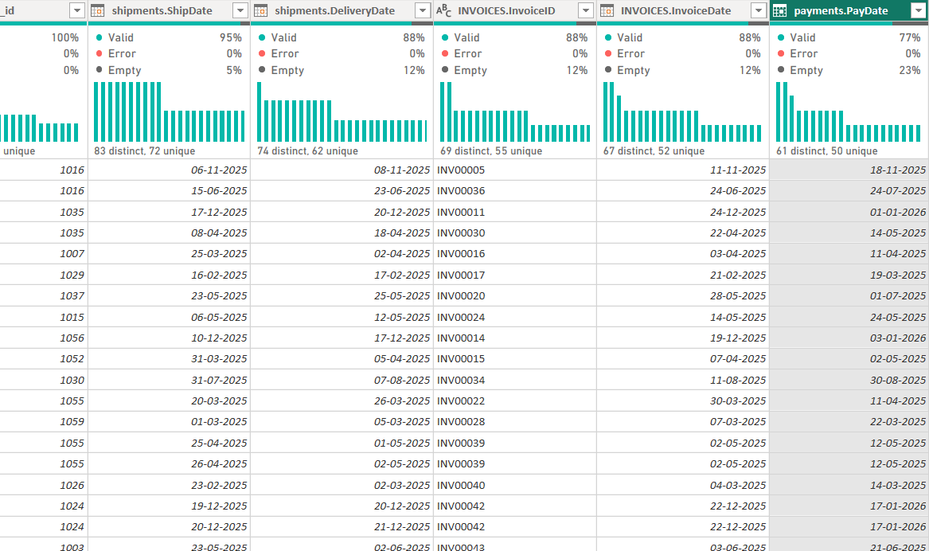
Figure 38 — Payment milestone data merged in

Step 6 — Finalise
Remaining non-essential columns were removed, all fields renamed to snake_case, and the raw tables deactivated. This finalised structure — consolidating multiple milestone dates per order — is an Accumulated Fact Table.

Step 7 — Link to dim_customer
fact_order_process was linked to dim_customer via a one-to-many relationship, ensuring each order record is associated with the correct customer.

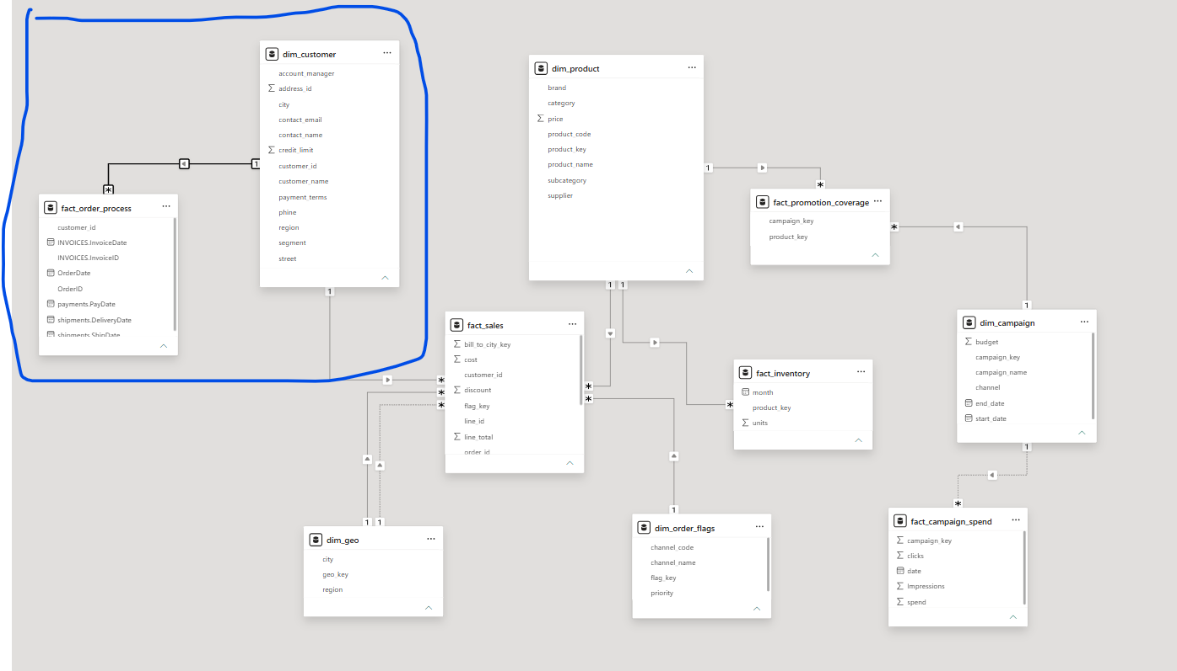
Figure 39 — fact_order_process linked to dim_customer

6.9 Remaining Tables
The same review process was applied to the last unresolved tables:
- Sheet1 — a duplicate of the shipments table; deleted from the model.
- exchange_rates — not relevant to the current model; standalone with no valid connection, so deactivated.
- sales_targets — contains Period and TargetRevenue, transactional in nature, and converted into a fact table.
- security — contains UserEmail and Region; used later to secure the model (see Section 8).
- dim_order — a list of order IDs with no meaningful attributes; a garbage table, deleted from the model.

6.10 fact_sales_target
A reference of the sales_targets table was created, moved into the Facts folder, and renamed fact_sales_target. Column names were standardised to convention, and the raw table deactivated once the transformation was complete.

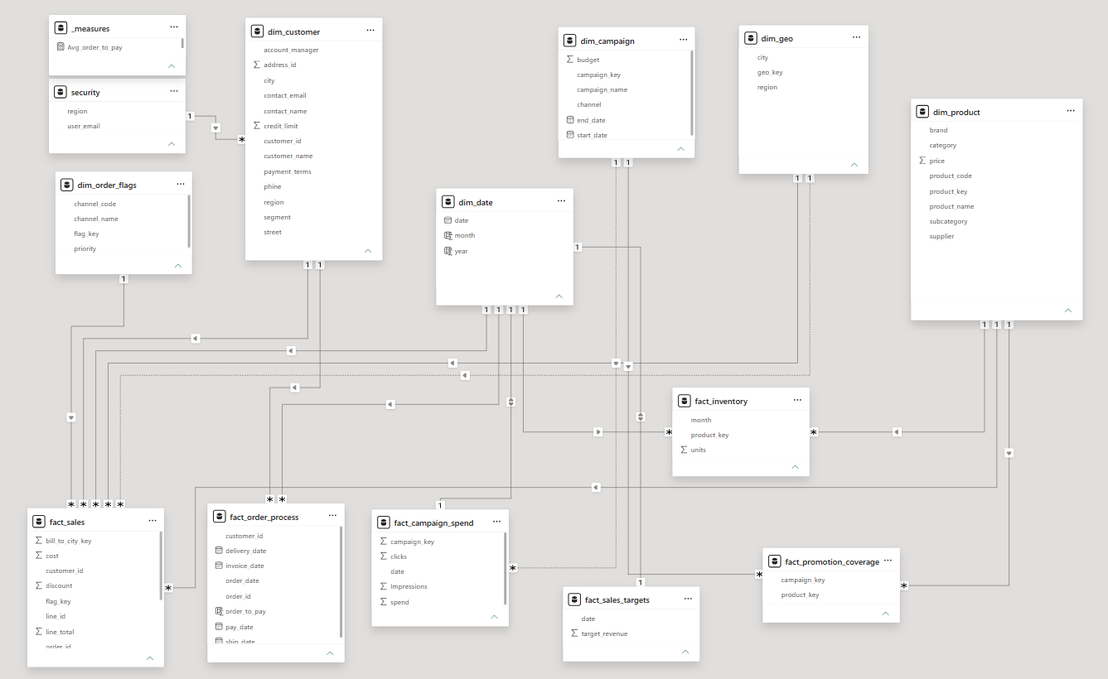
Figure 40 — fact_sales_target finalised in the data model

7. Phase 4 — Polishing the Data Model

7.1 Naming & Modelling Standards
All tables and fields were checked against a consistent set of standards:
- Language: English
- Naming convention: snake_case
- Table prefixes: fact_ or dim_
- Keys: use the _key or _id suffix
- Column names: must be readable and user-friendly
Every table was verified against these conventions and updated accordingly, and date formats were checked across all tables and standardised to a consistent format.

7.2 Date Dimension
A calendar table was created using the CALENDARAUTO() function, with Month and Year columns added for easier time-based analysis. Relationships were then established between the new date dimension and the relevant fact tables via their respective date fields.

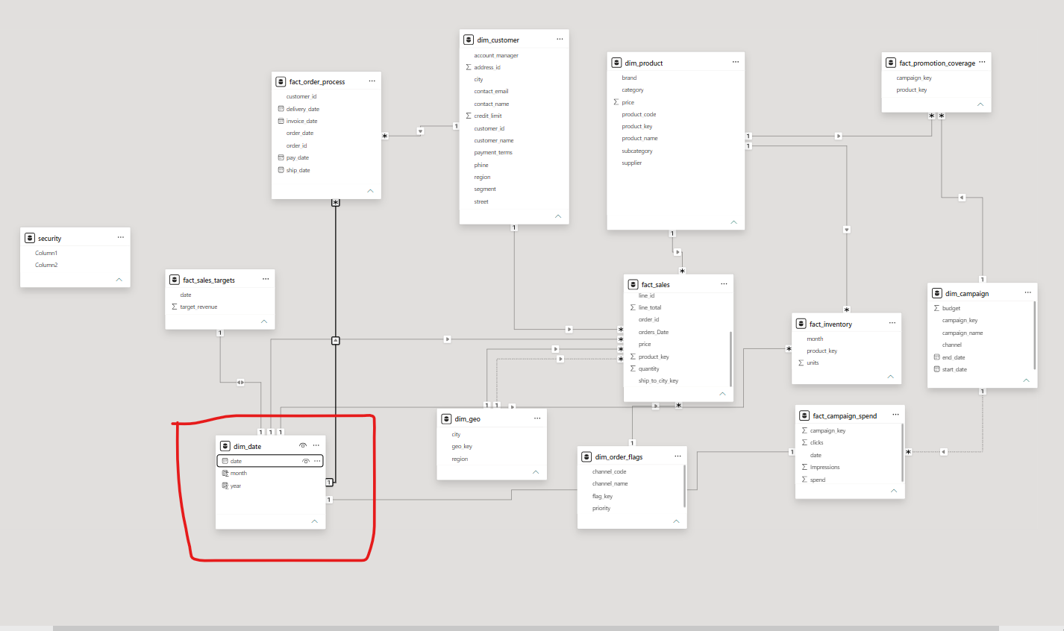
Figure 41 — Date dimension connected to the fact tables

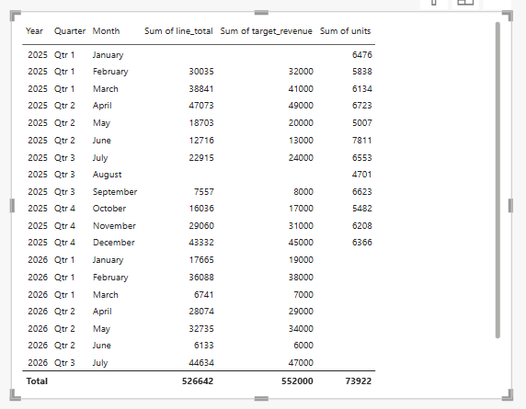
Figure 42 — Testing the data after creating the date dimension

7.3 Measures & Validation
A set of DAX measures was defined on top of the data model to support analysis and reporting, providing meaningful calculations and insights derived from the fact and dimension tables.

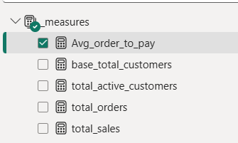
Figure 43 — Measures created in the data model

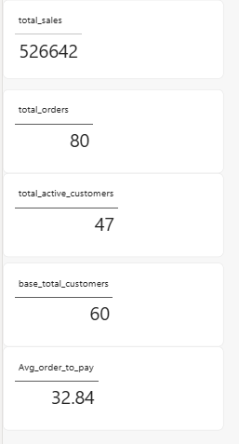
Figure 44 — Metrics validation

8. Securing the Data Model

8.1 Preparing the Security Table
1. In Power Query, the headers of the security table were promoted to column names, as the original column names were incorrect.
2. Columns were renamed according to the established standards (English, snake_case, readable names).
3. The table was moved into the Support query folder for proper organisation.

8.2 Row-Level Security (RLS)
Row-Level Security was applied to the data model so that access to records is restricted based on defined user roles and permissions, allowing each user to view only the data relevant to them. RLS is implemented on the dim_customer table, which propagates filters to both fact_sales and fact_order_process — ensuring data visibility is restricted based on customer context across the connected fact tables.

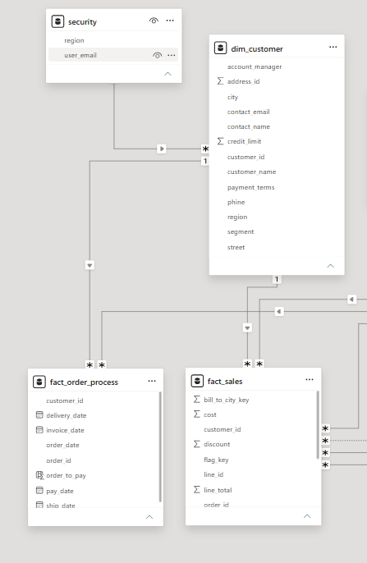
Figure 45 — Row-level security applied on dim_customer

8.3 Roles
Roles were defined and configured within Power BI to manage access permissions and enforce row-level security, determining what data different users can view based on the applied security rules.

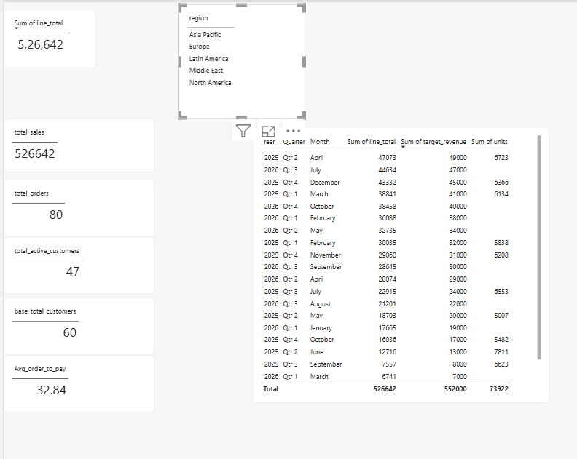
Figure 46 — Model view before applying the role

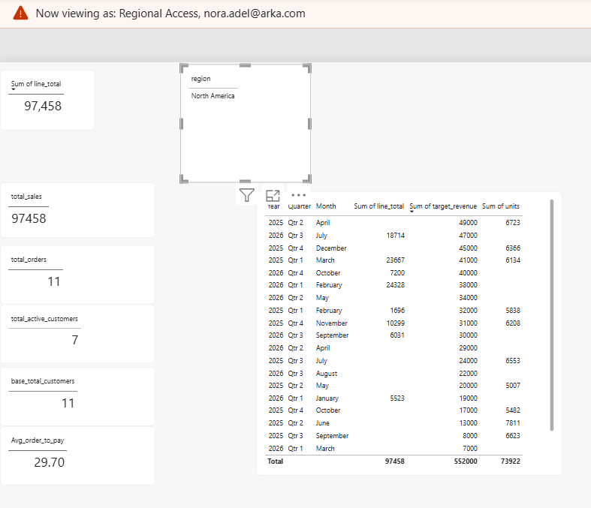
Figure 47 — Model view after applying the role

9. Final Star Schema & Conclusion
The completed model consolidates every raw table identified at the start of this project into a governed set of fact and dimension tables, connected in a true star schema.

Figure 48 — Final star schema data model (as first shown in Figure 40)

9.1 Business Outcomes
- Reporting is now built on accurate joins and aggregations, removing the ambiguous relationships present in the raw dataset.
- Query performance has improved by replacing text-based joins with surrogate keys across all fact-to-dimension relationships.
- The model scales cleanly to new years, campaigns and products without requiring new tables to be introduced.
- Row-level security ensures each user sees only the data relevant to their role, supporting safe, business-ready reporting in Power BI.
This structured, four-phase approach — Prepare & Explore, Build Dimensions, Build Facts, and Polish — converted a fragmented, error-prone dataset into a reliable analytical foundation that leadership can trust for ongoing sales and marketing reporting.

