**Project - Creation of dashboard for Sales Analysis**

1. Table box and sales dashboard (sum(Sales) bar chart)

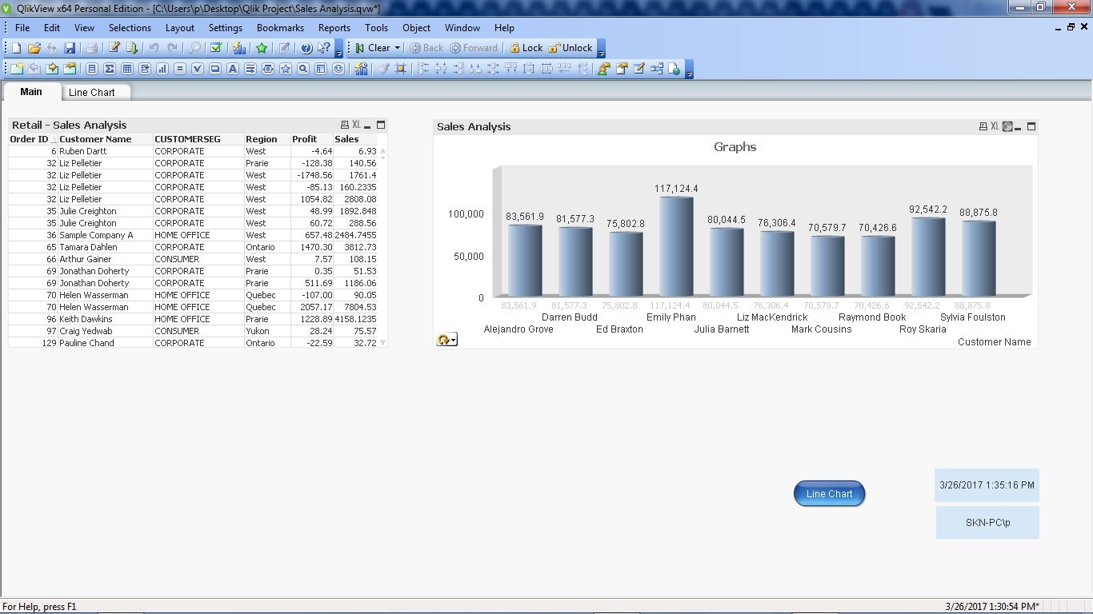

1. Sales dashboard (avg(Profit) bar chart)

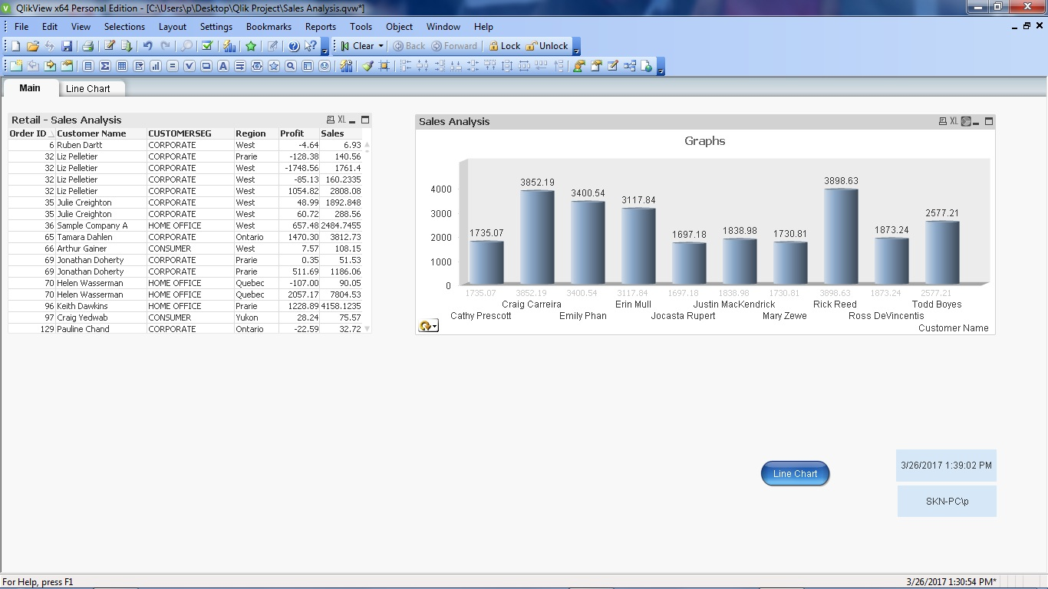

1. Sales dashboard [Cyclic group – sum(Sales ) and avg(profit)]

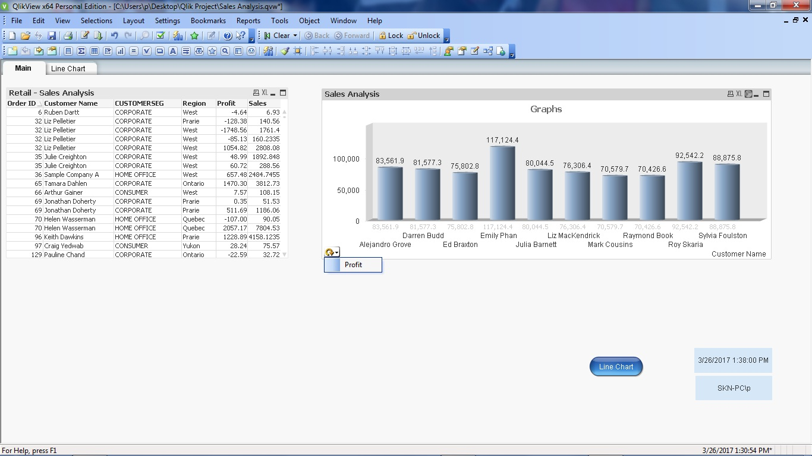

1. Dashboard (Pie chart for sum(Sales))

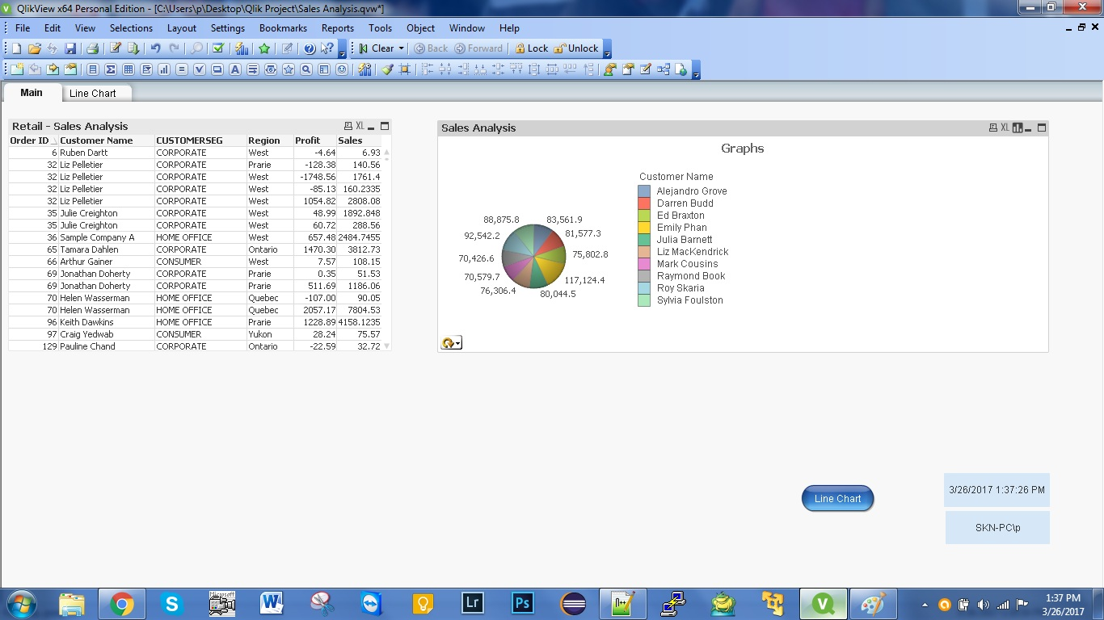

1. Dashboard (Pie chart for avg (Profit))

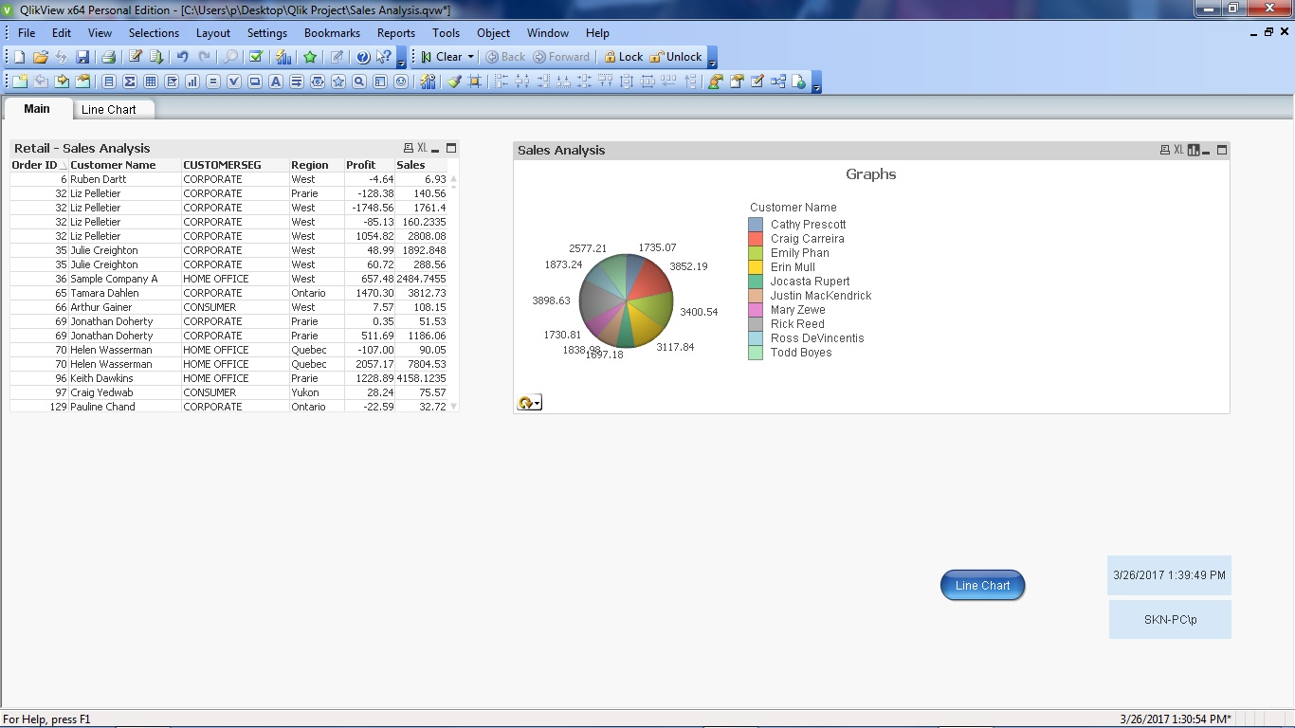

1. Creation of button with action – ‘Next sheet’ which contains Combo chart

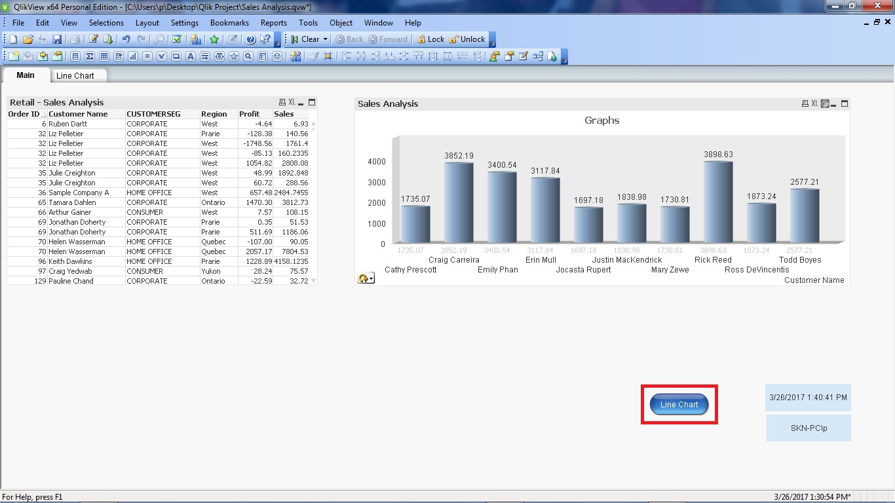

1. Combo chart – Bar chart [sum(Sales)] and Line chart [avg(Profit)]

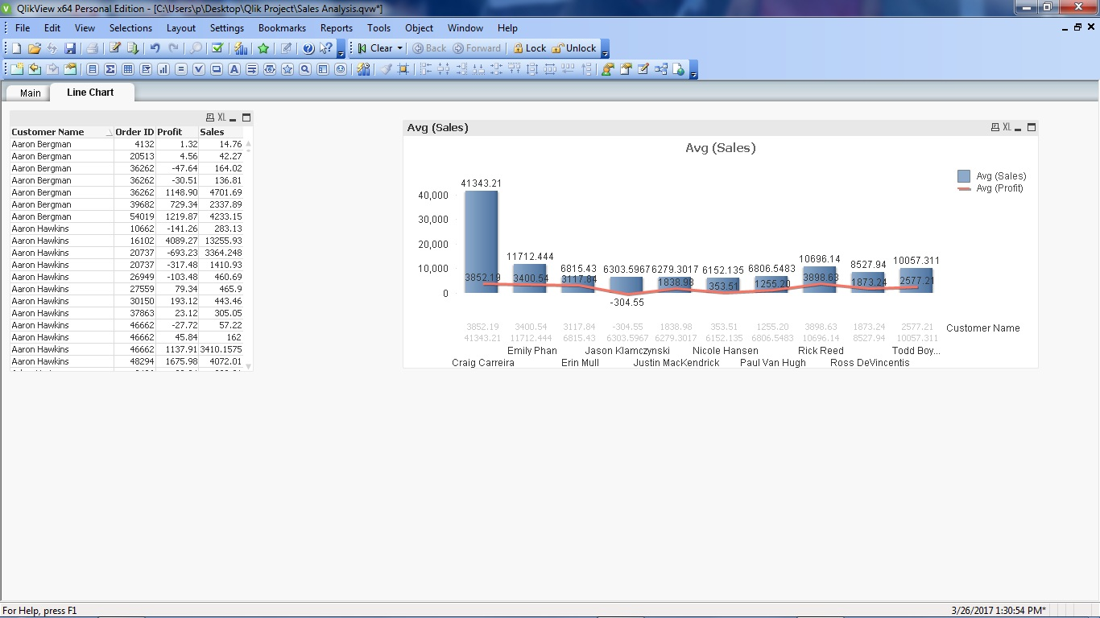

1. Set analysis – Profit = 7.57

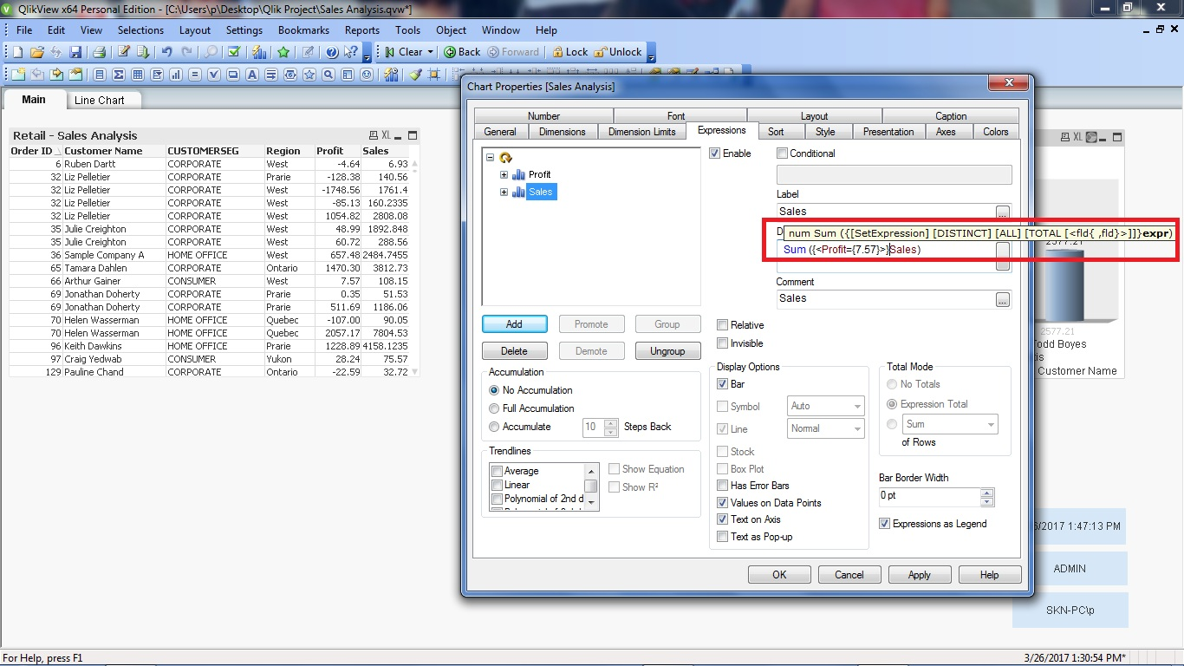

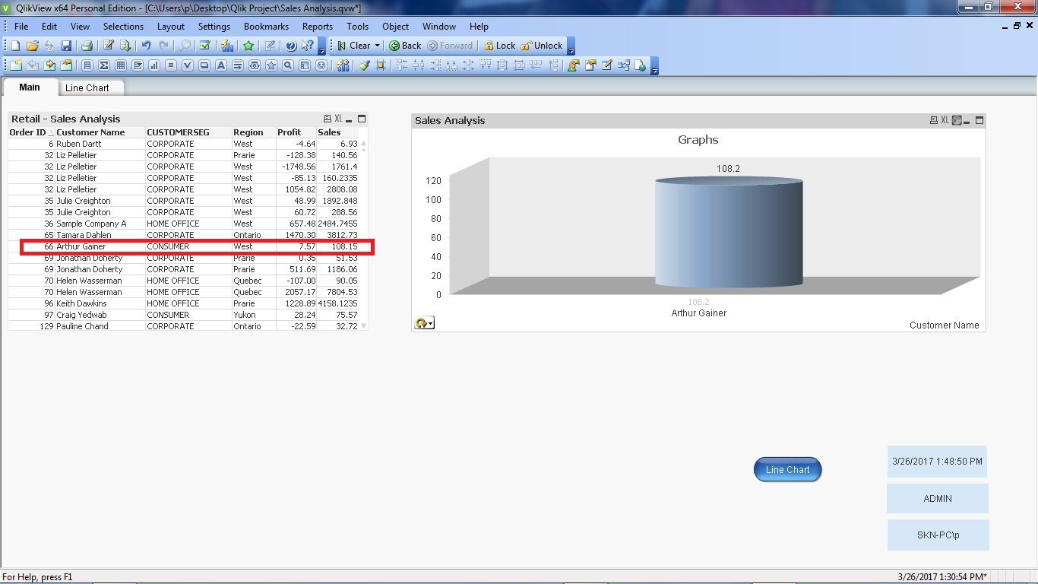

1. Date, time, user, system details

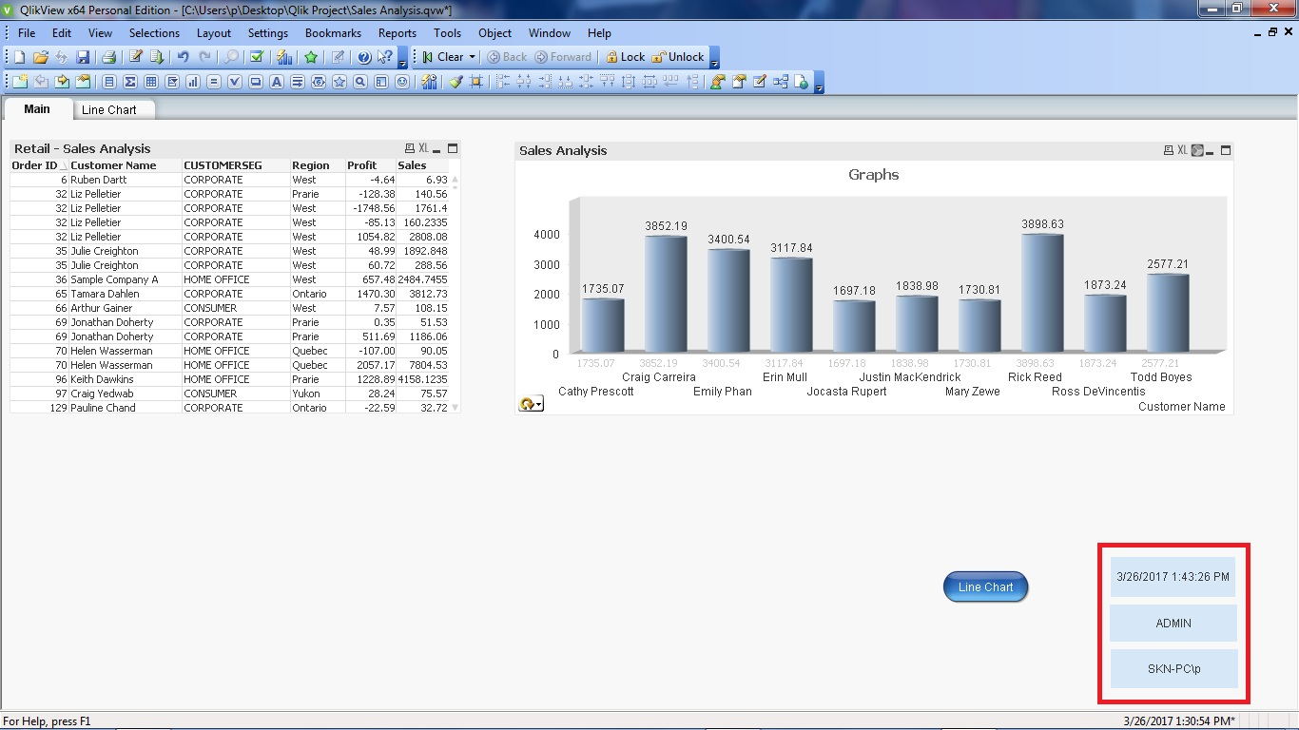

1. Created different users and provided privileges based on different user.

