**Research Methodology**

This research explores user sentiments towards the Oura ring by conducting a primary analysis of reviews from two platforms: Trustpilot and YouTube comments on relevant videos. The methodology encompasses data collection, sentiment analysis, and visualization techniques to draw insights into the perceptions and opinions of users regarding the Oura ring.

**Trustpilot Review Analysis-**

a. Data Collection

Web scraping techniques were employed to collect user reviews from Trustpilot. A total of 42 pages were scraped, yielding a diverse dataset over time. Ratings and corresponding reviews were extracted and stored in arrays for further analysis.

b. Rating Distribution Analysis

The distribution of user ratings was visualized using a bar chart, providing a clear overview of the satisfaction levels among Oura ring users. This analysis helps identify prevalent sentiments expressed in the Trustpilot reviews.

c. Sentiment Analysis

TextBlob library was utilized to conduct sentiment analysis on the Trustpilot reviews. Polarity scores for each review were calculated, and an overall sentiment score was derived. A histogram was generated to illustrate the distribution of sentiment polarities, offering insights into the overall sentiment of the reviews.

d. Word Frequency Analysis

Word frequency analysis was performed to identify the most common words used in the Trustpilot reviews. Positive and negative words were distinguished using the Afinn library, and bar charts were created to display the top 10 most common positive and negative words, providing a deeper understanding of user sentiments.

**YouTube Comment Analysis-**

a. Data Collection

Comments from three YouTube videos related to the Oura ring were collected using the YouTube Data API. These videos were selected based on their popularity and relevance to the Oura ring. The comments were retrieved, processed, and stored for further analysis.

b. Sentiment Analysis

Similar to Trustpilot reviews, sentiment analysis was conducted on YouTube comments using TextBlob library. Polarity scores were calculated for each comment, and an overall sentiment score was determined. A histogram was created to visualize the distribution of sentiment polarities in the YouTube comments.

c. Word Frequency Analysis

Word frequency analysis was performed on the YouTube comments to identify the most common positive and negative words. The Afinn library was employed to assign sentiment scores to words, allowing for the extraction of top positive and negative words. Bar charts were generated to illustrate the most common positive and negative words in YouTube comments

**Data Collection**

The data for this primary research project was collected from two main sources to provide a comprehensive understanding of user sentiments towards the Oura ring:

The data for this primary research project was collected from two main sources to provide a comprehensive understanding of user sentiments towards the Oura ring:

a. Trustpilot Reviews

Trustpilot, a reputable customer review platform, was selected as a primary source for written reviews. Trustpilot hosts a diverse range of user-generated reviews, offering valuable insights into the experiences and opinions of individuals who have used the Oura ring.

Website: *https://ca.trustpilot.com/review/ouraring.com*

b. YouTube Video Comments

YouTube, a popular video-sharing platform, was chosen to supplement the textual reviews with visual and dynamic content. Comments from relevant YouTube videos discussing the Oura ring were collected to capture a broader spectrum of user reactions. A very unconventional way to gauge the response of users on the product. The comments were retrieved from below 3 YouTube videos.

Chase the summit- link: *https://www.youtube.com/watch?v=o_vTIEoRRtI&t=1s&ab_channel=ChasetheSummit*

Unbox Therapy- link: *https://www.youtube.com/watch?v=8hp1TEUqvW4&ab_channel=UnboxTherapy*

Jonny&Yusef- link: [*https://www.youtube.com/watch?app=desktop&v=G1E1GfQAE5o&ab_channel=Jonny%26Yusef-Propanefitness*](https://www.youtube.com/watch?app=desktop&v=G1E1GfQAE5o&ab_channel=Jonny%26Yusef-Propanefitness)

**Analysis**

1. **YouTube Reviews-**

**1.**

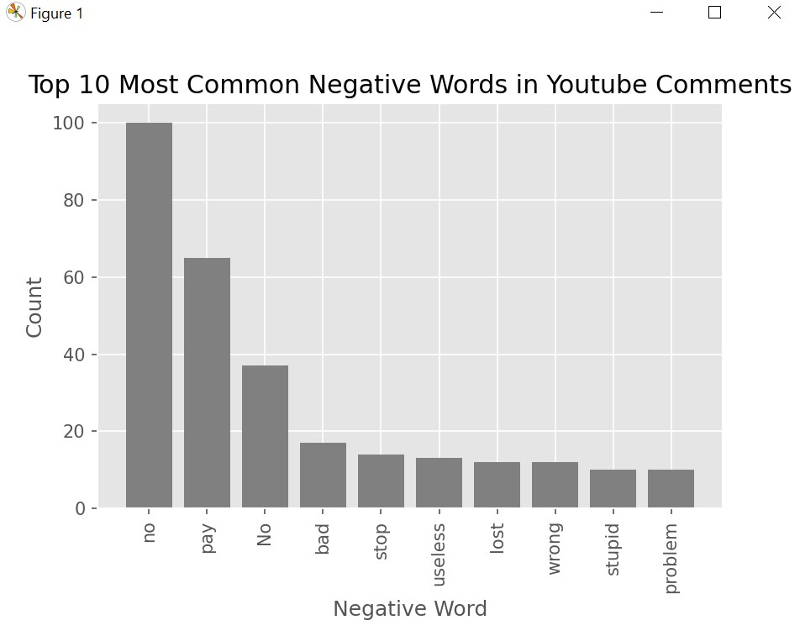

YouTube comments on the Oura ring reflect diverse negative sentiments. The frequent use of "No" indicates dissatisfaction, possibly linked to unmet expectations. "Pay" suggests prevalent financial concerns, while "Bad" straightforwardly summarizes negative experiences. The recurrence of "Stop" implies users advocating for change, and "Useless" conveys perceived ineffectiveness. "Lost" and "Wrong" signal problems, and "Stupid" indicates dissatisfaction with certain aspects.

The mention of "Problem" highlights challenges, contributing to negative feedback. In summary, the variety of negative expressions encompasses functional and financial concerns, emphasizing the need to address these issues for enhanced user satisfaction with the Oura ring.

**2.**

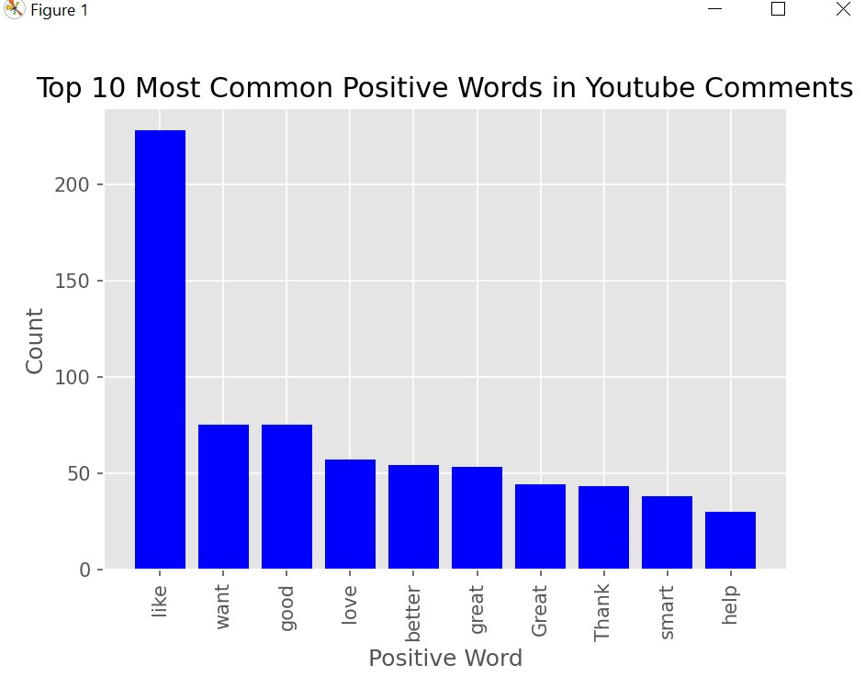

YouTube comments on the Oura ring consistently express optimism, with widespread appreciation indicated by terms like "Like" and a positive inclination seen through the recurrence of "Want." The frequent use of "Good" and "Great" signifies an overall positive evaluation, emphasizing user commendations.

The emotional depth conveyed by "Love" reflects profound enthusiasm. The inclusion of "Better" suggests perceived improvements, while expressions of gratitude and positive interactions with "Thank," "Smart," and "Help" underline user satisfaction. In summary, the prevalent use of positive words showcases a generally favourable sentiment, highlighting strong user approval and connection with the Oura ring.

**3.**

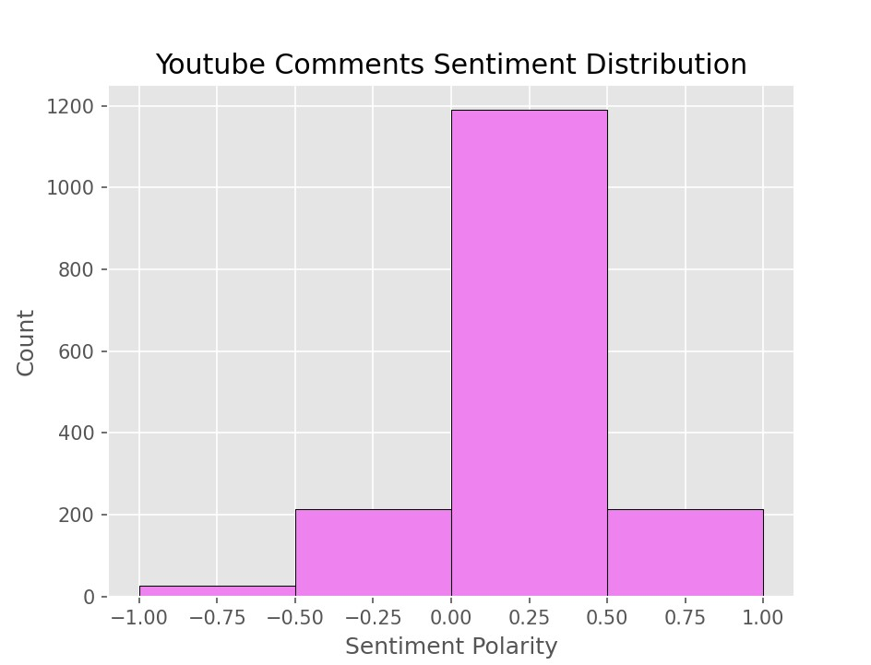

The sentiment distribution chart for YouTube comments on the Oura ring provides insights into the diverse range of opinions among users. A minority of comments (~20 comments) strongly express negative sentiments, suggesting a segment of users who are notably dissatisfied or critical of the product. Moving into the range of mildly negative to neutral sentiment (~210 comments), a larger group appears to have concerns or criticisms, but their sentiments may not be as vehemently negative. The most significant portion of the distribution lies in the neutral sentiment range (~1200 comments), indicating that a substantial number of users share feedback without expressing strong positive or negative emotions. This category could include users providing objective assessments, factual information, or general observations. In the mildly positive to positive sentiment range (~200 comments), there is an indication that some users have favourable opinions or positive experiences with the Oura ring. While positive sentiments exist, they don't dominate the overall sentiment landscape.

In summary, the sentiment distribution highlights the nuanced nature of user opinions on the Oura ring. It's crucial to recognize and understand the diversity of sentiments expressed, ranging from strong negativity to positivity, with a significant portion falling in the neutral category. This nuanced perspective is valuable for product improvement and addressing specific concerns raised by users across different sentiment categories.

1. **Trustpilot Reviews**

**1.**

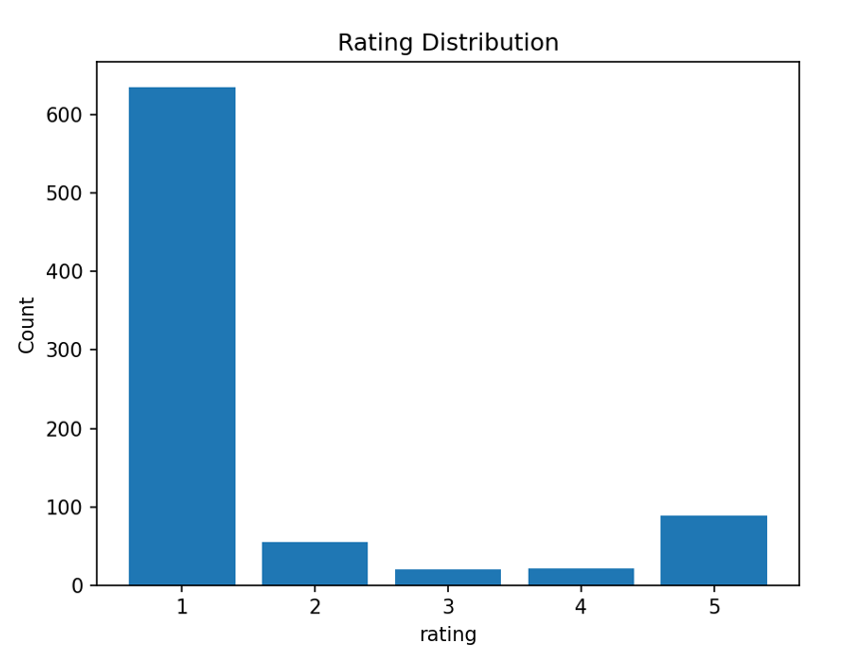

The Trustpilot ratings for the Oura ring delineate a comprehensive spectrum of user sentiments. With over 600 reviews falling into the 1-star category, a prevailing theme of dissatisfaction or negative experiences is evident, indicating substantial areas of concern that warrant detailed attention. The close to 50 reviews in the 2-star category suggest a minority expressing a level of dissatisfaction less severe than the 1-star group but still notable. In contrast, the 3 and 4-star categories, each with close to 20 reviews, represent smaller groups of users with mixed to moderately positive experiences. These users may have specific areas of satisfaction but also room for improvement. The 5-star category, with close to 90 reviews, indicates a relatively modest proportion of highly satisfied users.

In summary, the diverse distribution of Trustpilot ratings emphasizes the need for targeted efforts to address specific concerns, enhance user satisfaction, and promote a more balanced representation of experiences with the Oura ring.

**2.**

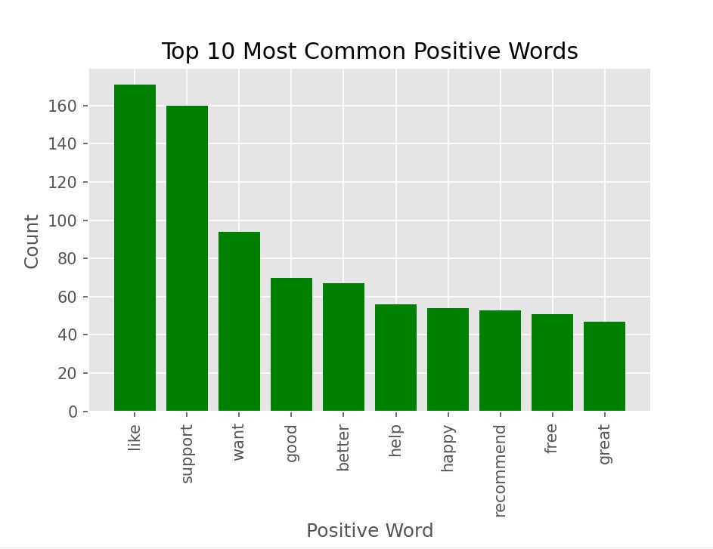

The analysis of the top 10 positive words in Trustpilot reviews for the Oura Ring provides insights into the overwhelmingly positive sentiment among users. "Like" stands out as the most frequently used term, surpassing 160 mentions, indicating a widespread approval and satisfaction. The prominence of "support" and "want," with approximately 160 and 90 mentions respectively, underscores users' positive inclinations and desires associated with the Oura Ring. Additionally, words such as "good," "better," and "great" contribute to the positive narrative, suggesting favourable evaluations and an overall sense of improvement. Expressions like "help," "happy," and "recommend" further emphasize positive interactions, contentment, and user endorsements.

The abundance of these positive words collectively paints a compelling picture of users' positive experiences and favourable perceptions of the Oura Ring, contributing to a robust and affirmative portrayal in Trustpilot reviews.

**3.**

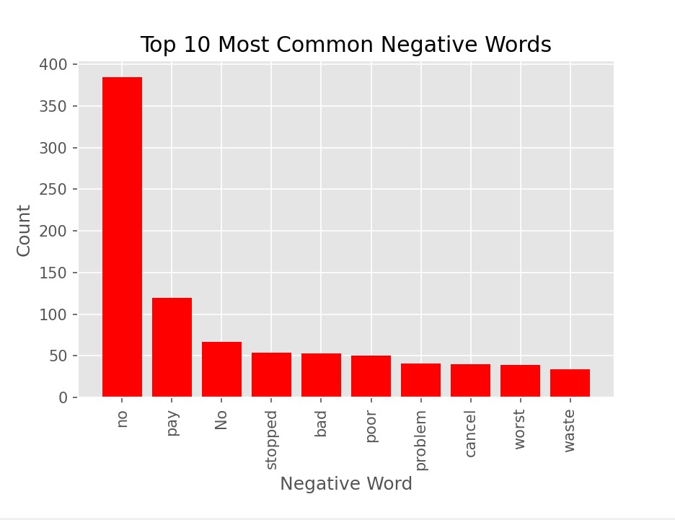

The analysis of the top 10 negative words in Trustpilot reviews for the Oura Ring sheds light on prevalent concerns and criticisms expressed by users. The most frequently occurring term, "No" (approx. 450 occurrences), signifies a substantial level of disagreement or dissatisfaction, indicating a noteworthy portion of users expressing opposition or discontent with the product. The term "Pay" (approx. 120 occurrences) suggests widespread financial concerns, encompassing issues related to costs, payment processes, or perceived value. Other negative words like "Stopped," "Bad," "Poor," "Problem," "Cancel," "Worst," and "Waste" (each with around 40 occurrences) collectively point to diverse challenges and disappointments users face, ranging from functionality issues to negative experiences.

This comprehensive analysis highlights the multifaceted nature of user grievances, emphasizing the importance of addressing these concerns to enhance overall satisfaction and product reception.

**4.**

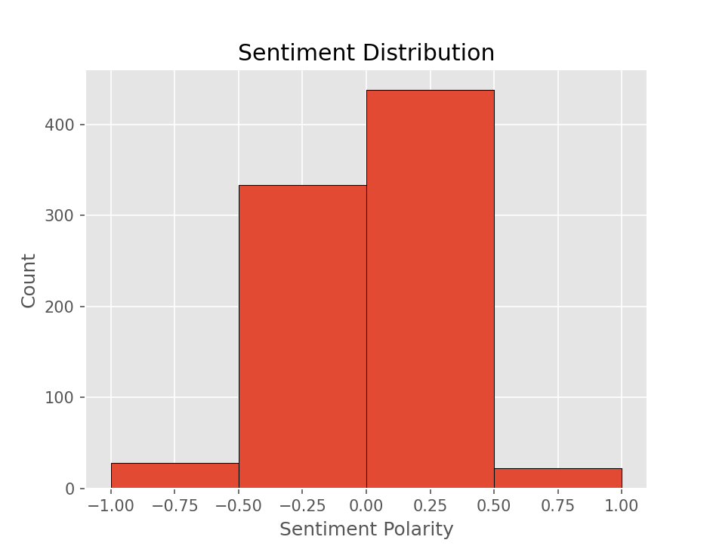

The sentiment polarity plot for Trustpilot reviews on the Oura Ring reveals a distribution of sentiments among users. The majority of reviews fall within the range of -0.5 to 0, with close to 330 counts, suggesting a prevalent neutral to slightly negative sentiment. Additionally, there is a substantial number of reviews in the range of 0 to 0.5, approximately 430 counts, indicating a prevailing neutral to slightly positive sentiment. Reviews with extreme sentiments, both below -0.5 and above 0.5, are relatively less frequent, each with close to 20 counts.

This distribution suggests that the overall sentiment among Trustpilot reviewers for the Oura Ring tends to be centred around neutrality, with a notable presence of both positive and negative sentiments, albeit less extreme.

**Outcome**

In conclusion, the comprehensive analysis of user sentiments towards the Oura ring from Trustpilot reviews and YouTube comments provides valuable insights into the multifaceted landscape of user experiences and opinions. The Trustpilot reviews, with over 600 falling into the 1-star category, highlight prevalent dissatisfaction and negative experiences that necessitate focused attention. The distribution of ratings across various categories underscores the need for targeted efforts to address specific concerns and enhance overall user satisfaction.

The sentiment analysis of YouTube comments reveals a nuanced spectrum of opinions, ranging from strong negativity to positivity, with a significant portion falling in the neutral category. This diversity emphasizes the importance of recognizing and understanding various sentiments expressed by users, allowing for targeted improvements and addressing specific concerns raised across different sentiment categories.

Analyzing the top 10 positive and negative words further illuminates the key themes in user feedback. Positive terms like "Like," "Support," and "Great" showcase widespread approval, while negative terms like "No" and "Pay" highlight prevalent concerns and dissatisfactions. Addressing these multifaceted issues is crucial for enhancing the overall reception and satisfaction of users with the Oura ring.

In summary, a holistic approach that incorporates insights from Trustpilot reviews and YouTube comments is essential for developing strategies to improve the product, address specific concerns, and foster a more balanced representation of user experiences. This research lays the foundation for understanding user sentiments, guiding future enhancements, and fostering a positive relationship between users and the Oura ring.

**Appendix**

1. **TrustPilot reviews:**
2. **Importing necessary libraries in python script**

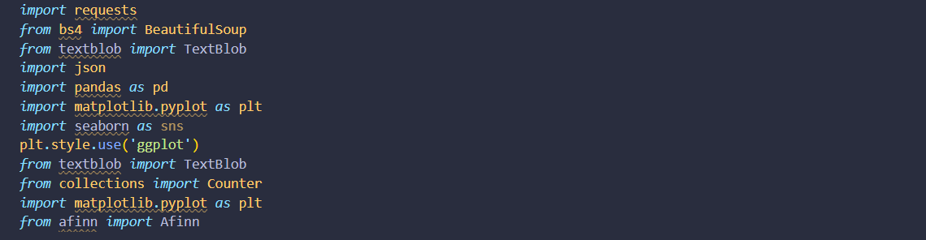

1. **Scraping webpages with beautifulsoup libraries and storing reviews and ratings in arrays**

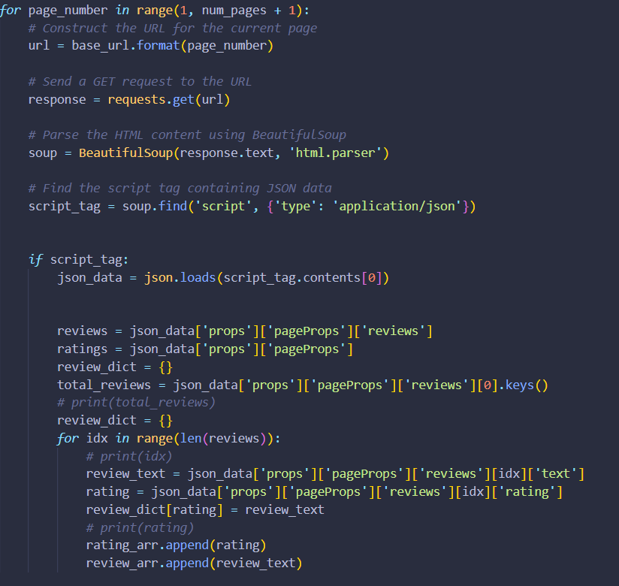

1. **Plotting the Trustpilot ratings**

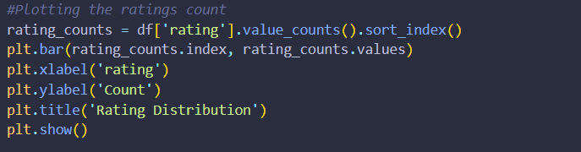

1. **Checking the sentiments of each review with the Textblob library and plotting it.**

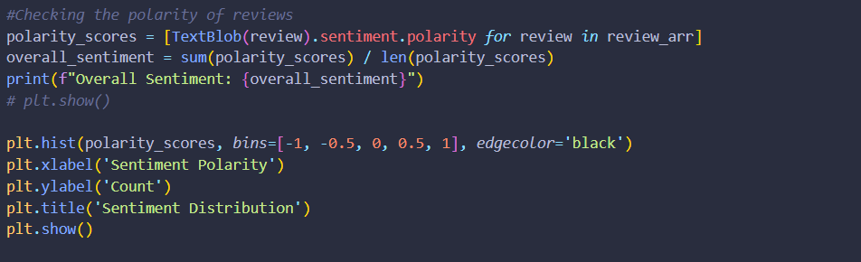

1. **With the afinn library we group the words into positive and negative words**

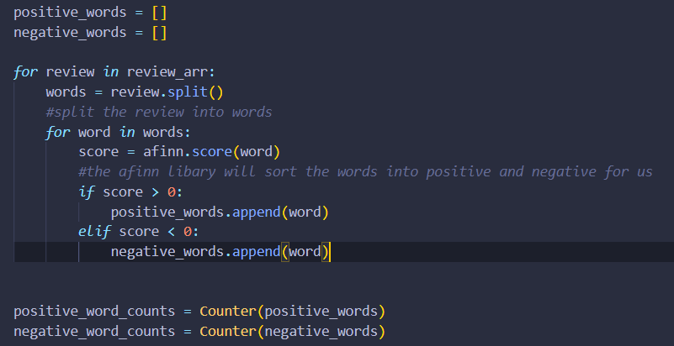

1. **Plotting the positive and negative words**

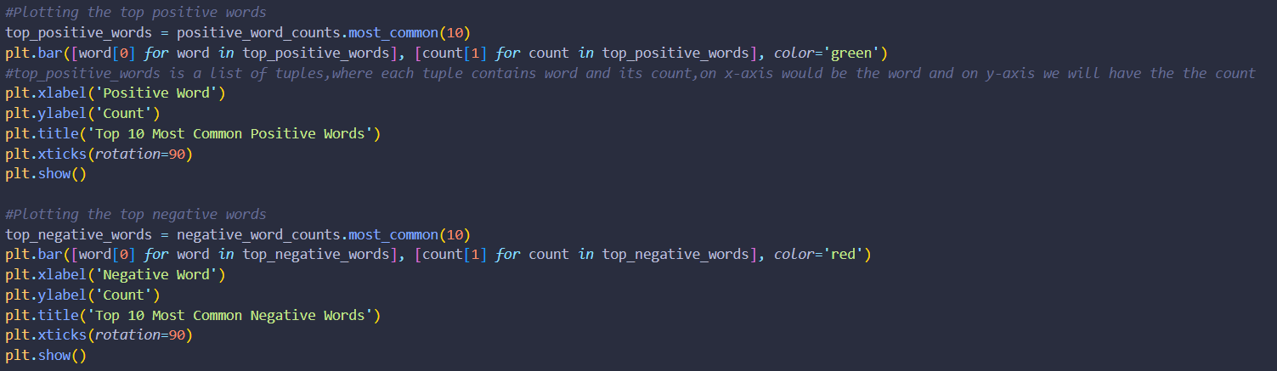

1. **YouTube reviews**
2. **Importing the libraries required and obtaining the authentication to use YouTube Data Api**

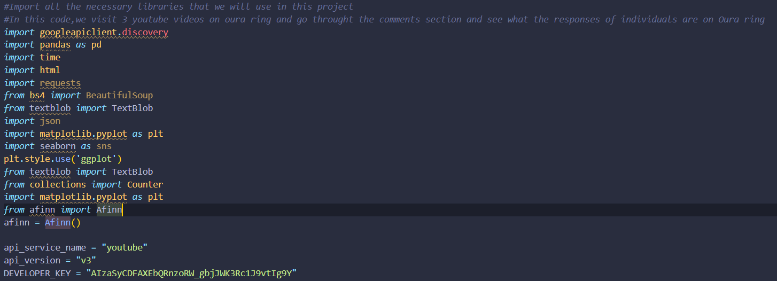

1. **Request Data from YouTube data Api and extract all comments on a specific review of Oura ring.**

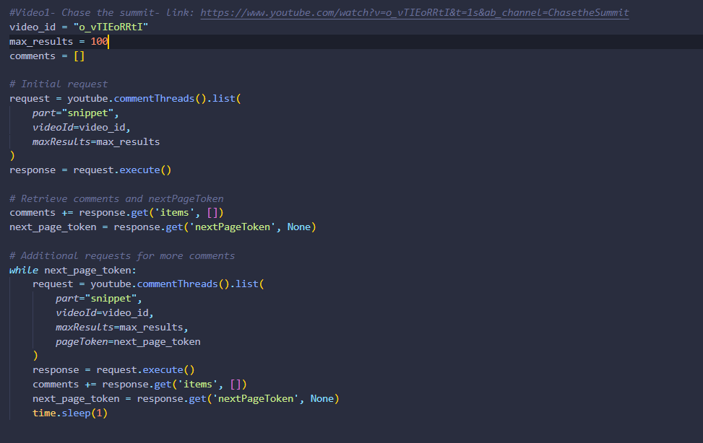

1. **Next step is to process the comments and appending them to an array and converting arrays into a dataframe to be used for plots and analysis**

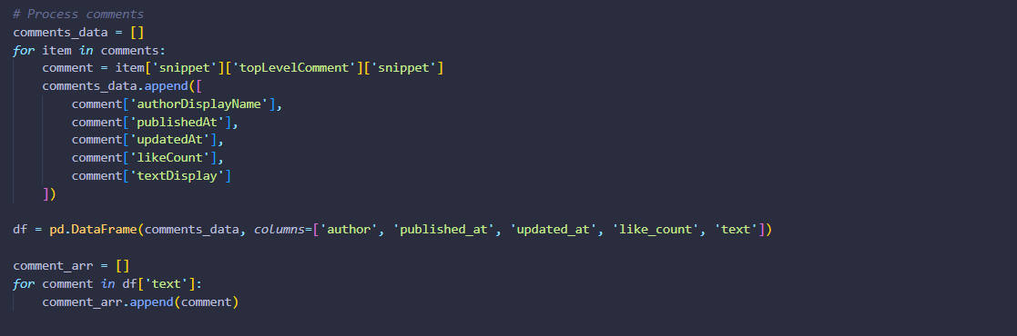

1. **The remaining part of code is similar to the Truspilot reviews part**