Website link - [http://my360design.com.au/hendrikx/#](http://my360design.com.au/hendrikx/)

**Top of page – white banner**

Will need banner logo to be added (supplied soon)

Links for social media to be added

Facebook – <https://www.facebook.com/hendrikxelectrics/>

Instagram –<https://www.instagram.com/hendrikxelectrics/>

Phone number with Link to directly call 0408 476 101

* **Updated**

**Menu bar**

Home - remove this

About Us

Our Services

What’s New

Contact

* **Updated**

**Header Boxes**

**Banner –**3 images on a carousel (supplied soon)

**Why Choose Us?** – remove ‘to’

1. Spanner icon change to 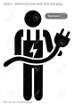
2. Experienced electrician (remove ’30 years plus.’)
3. $ icon is good
4. Affordable, high-quality service & materials (remove ‘but’ and add ‘,’)
5. Time icon change to 
6. Always on time (remove ‘-‘)

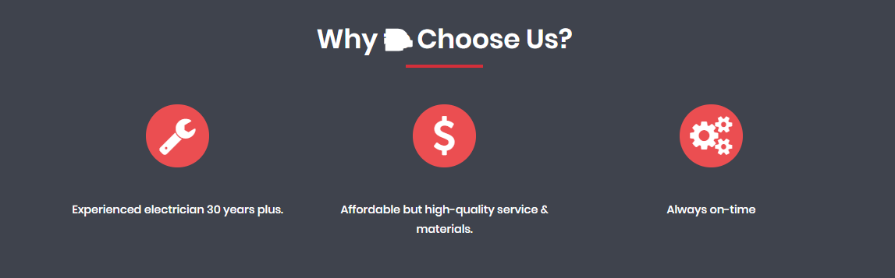

* **Updated**

**About Us**

**Image** – this is good but will let you know if it needs to be updated when we have finished with the branding

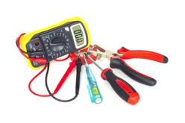

**Remove – read more about us**

* **Updated**

**Update with following paragraph**

Reliable local licensed electrician providing quality electrical installation and repairs. We service domestic, rural, industrial and commercial jobs with no call out fee.

Hendrikx Electrics is the longest established electrician in the Ormeau area. He’s a true local that has grown up and gone to school in the area, so he knows the surrounding suburbs in great detail.

Fully licensed; insured and qualified to resolve any job efficiently. He provides high quality workmanship, good knowledge and great advice for anything electrical.

His service is highly professional, keeps everything clean, and always on time or will let you know if running late.

Hendrikx Electrics will always listen to your needs and expectations and will provide information and accurate pricing/timeline for the work that is required.

Call us on

CTA Phone number with Link to directly call 0408 476 101

* **Updated**

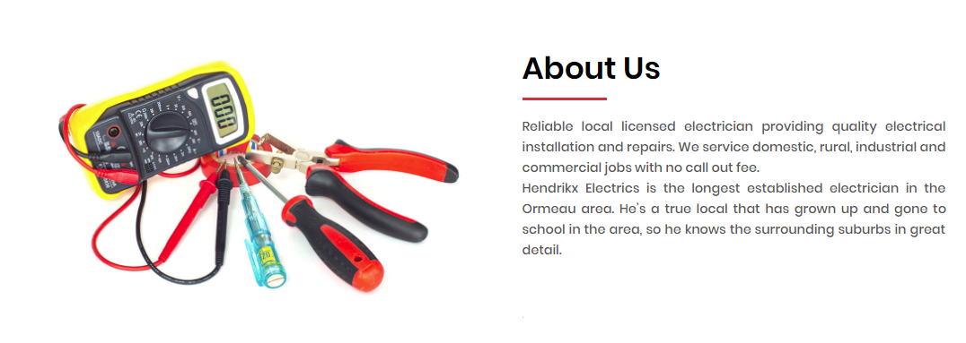

**Our services**

Our products needs to be updated to ‘Our Services’

Short bio – have each sentence on a new line

Eg

Reliable local licensed electrician providing quality electrical installation and repairs.

We service domestic, rural, industrial and commercial jobs with no call out fee.

Contact us for all your electrical needs.

* **Updated**

**Power/Lights/TV points (Lights needs a capital ‘L’)**

Image - good

Paragraph – good

CTA - Read More link – change to ‘Contact us now’ with link to directly call 0408 476 101

**Ceiling fans**

Image - good

Paragraph – good

CTA - Read More link – change to ‘Contact us now’ with link to directly call 0408 476 101

**House renovations**

Image - good

Paragraph – good

CTA - Read More link – change to ‘Contact us now’ with link to directly call 0408 476 101

* **Updated**

**Quality Offers/Do you need electrician boxes need to be combined as 1 box** – all 3 headers need to be removed

Hendrikx Electrics will always listen to your needs and expectations and will provide information and accurate pricing/timeline for the work that is required.

Contact Kris for all your electrical needs, enquiries or work required on 0408 476 101.

Phone number with link to directly call

Icon 1 – replace with  (update colours to red and white version that matches other icons)

Icon 2 – update with (update colours to red and white version that matches other icons)

Icon 3 – good

Icon 4 – good

* **Updated**

**What’s New**

Please have a Facebook feed as this page - <https://www.facebook.com/hendrikxelectrics/>

*See this link as an example*

<https://maralytics.com/news/>

**I have not got FB credentials for Hendikx page yet. I will update once I get it.**

**Contact Us**

Format looks good

Left box needs to be updated as follows:

* remove home address, but leave Kingsholme, QLD, Australia
* phone is correct
* email update to [krihen@skymesh.com.au](mailto:krihen@skymesh.com.au)
* ABN is correct
* Licence number 51880 needs to be added
* Open is correct
* Time needs to be changed to Hours
* Actual times need to be updated to 8.00am to 5.00pm
* Remove social media links

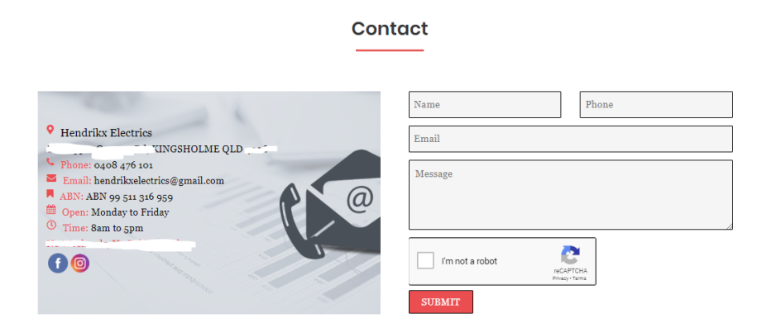

* **Updated**

**Footer**

Terms of Service – needs to be added

Privacy Policy – needs to be added

Social media links – need to be added

Contact us - needs to be added

Master Electricians logo – need to be added (see file for requirements) – NO link

Text - Electrical Contractor Licence No:51880

* **Footer part have already updated.**
* **You have not provided “Terms of Service” and “Privacy Policy” text document. So we have not given any link to it.**
* **Because of design alignment I have just given “**Licence No**” text.**

*********** Icons *****************

All icon images that I have updated, are copied from Google Images. I have not checked if they are royalty free, or free to use.

I have added these images so you have a guideline of what I would like to have