Website link - [http://my360design.com.au/hendrikx/#](http://my360design.com.au/hendrikx/)

**Top of page – white banner**

Will need banner logo to be added – see attached in other email today

Links for social media to be added at the top in white banner

Facebook – <https://www.facebook.com/hendrikxelectrics/>

Instagram –<https://www.instagram.com/hendrikxelectrics/>

* Updated

**Header Boxes**

**Banner –**3 images on a carousel – see attached in other email today

* Updated

**About Us**

Text is correct but spacing has not been adjusted

Please add additional spacer line between each paragraph

Example

Reliable local licensed electrician providing quality electrical installation and repairs. We service domestic, rural, industrial and commercial jobs with no call out fee.

Hendrikx Electrics is the longest established electrician in the Ormeau area. He’s a true local that has grown up and gone to school in the area, so he knows the surrounding suburbs in great detail.

Button text - Call Us

CTA Phone number with Link to directly call 0408 476 101

* Updated
* We have already given link to call. I have attached image for your reference. Please have a look.

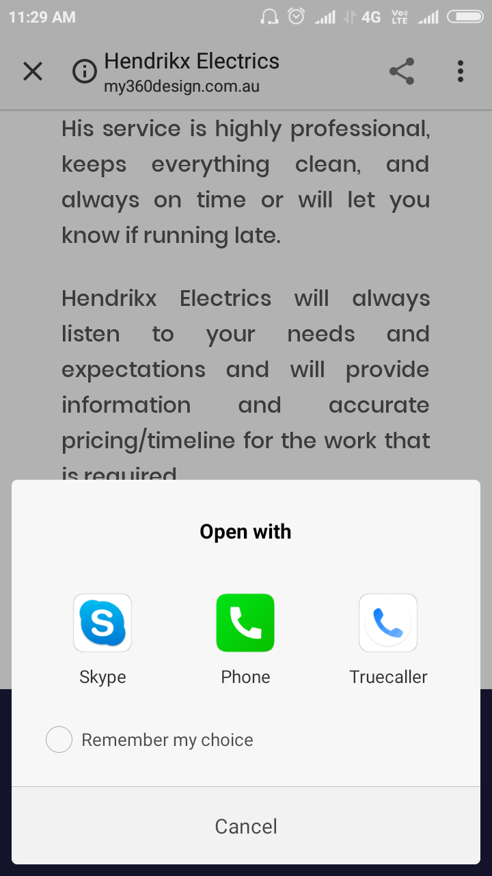

**Our services – Quality Offers**

Text is correct but spacing needs to be adjusted

### Hendrikx Electrics will always listen to your needs and expectations

### and will provide information and accurate pricing/timeline

### for the work that is required.

### Contact Kris for all your electrical needs, enquiries or work required

### on [0408 476 101](tel:0408%20476%20101) (phone needs link for calling)

* Updated
* We have given link to call. I have attached image for your reference. Please have a look.

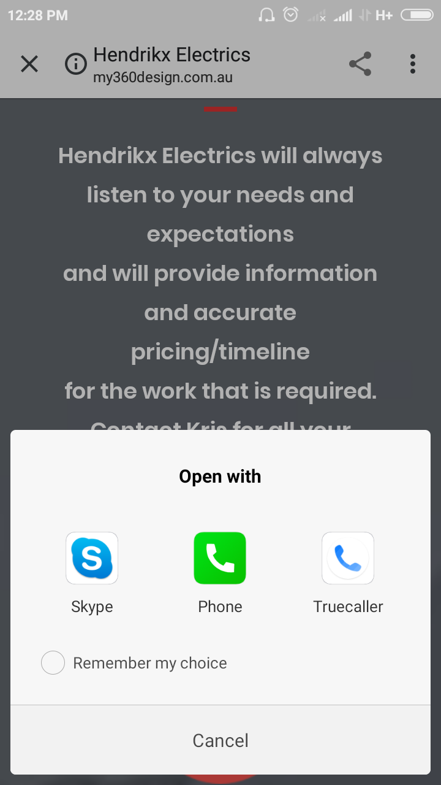

**Do you need to an electrician?**

Please update to – Do you need an electrician?

Call us now on – update to have a link to directly call on the number

Button text - Call Us

CTA Phone number with Link to directly call 0408 476 101

Remove ‘Email Now’ button

* Updated
* We have already given link to call. I have attached image for your reference. Please have a look.

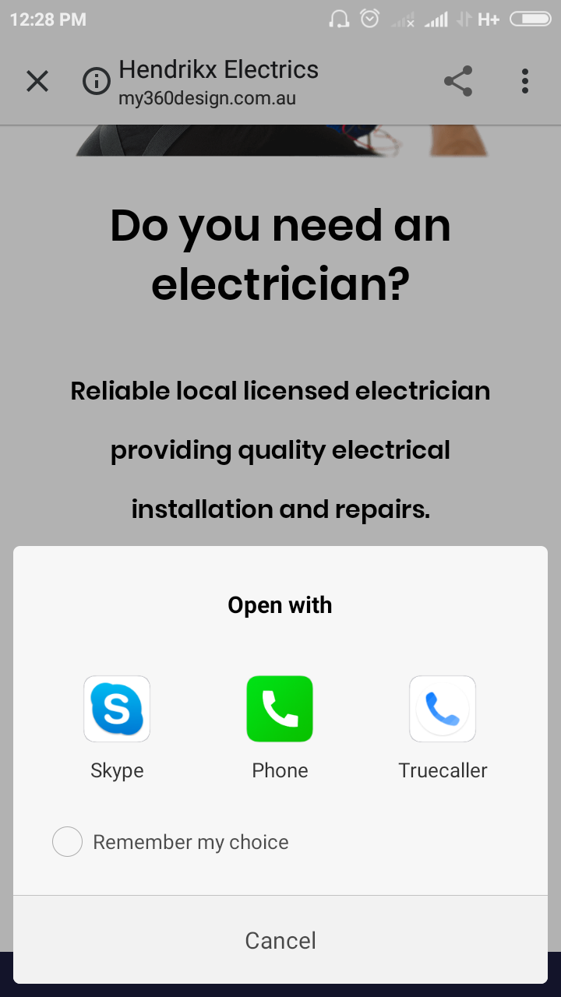

**Footer**

Remove enquiry form as this should not be in the footer as was not there on the last update

* Removed

Add Useful links – Terms of Service and Privacy Policy underneath contact information

Remove Contact us header

Timings – remove

Add Master Electrician details

* Updated

Format – please updated so icons and first word are all lined up, eg 5 spaces between icon and word

Terms of Trade – needs to be added (see attachment for text document)

Master Electricians logo – need to be added (see attached file for requirements) – NO link

Left box needs to be updated as follows:

* Remove Kingsholme, QLD, Australia
* Remove Timings
* Remove ‘no weekends, no public holidays’

See this example:

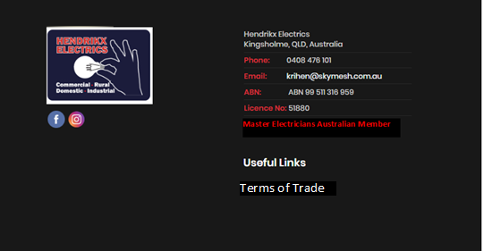

* Updated

**What’s New**

Please have a Facebook feed as this page - <https://www.facebook.com/hendrikxelectrics/>

*See this link as an example*

<https://maralytics.com/news/>

**FB newsfeed – I have added Gopi as admin to Hendrikx Electrics Facebook page so you can update this requirement**

* Updated

**Contact**

Format – please updated so icons and first word are all lined up, eg 5 spaces between icon and word

Left box needs to be updated as follows:

* remove Kingsholme, QLD, Australia
* Time needs to be changed to Hours (missing ‘s’)
* Remove ‘no weekends, no public holidays’
* Updated

Submit button link – krihen@skymesh.com.au

* The contact form details will submit to the above email id

**Contact**

Format – please updated so icons and first word are all lined up, eg 5 spaces between icon and word

* Updated

Left box needs to be updated as follows:

* remove Kingsholme, QLD, Australia
* Time needs to be changed to Hours (missing ‘s’)
* Remove ‘no weekends, no public holidays’
* Updated

**Documents**

Documents attached for updating website

Logo

Banner x 3

Flavicon files

Terms of Trade

* Updated