Website link - [http://my360design.com.au/hendrikx/#](http://my360design.com.au/hendrikx/)

**Top of page – white banner**

Banner logo – Call Now button not activated to link to calling (like you have done below)

* Updated

Links for social media to be added at the top in white banner

Facebook – <https://www.facebook.com/hendrikxelectrics/>

Instagram –<https://www.instagram.com/hendrikxelectrics/>

Please add phone number 0408 476 101

* Updated

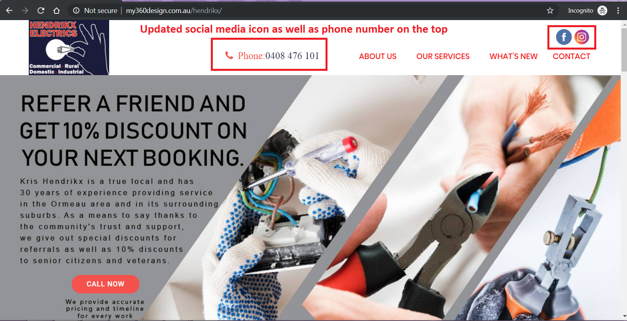

**About Us**

Button text - Call Us – this has not been updated

* Updated

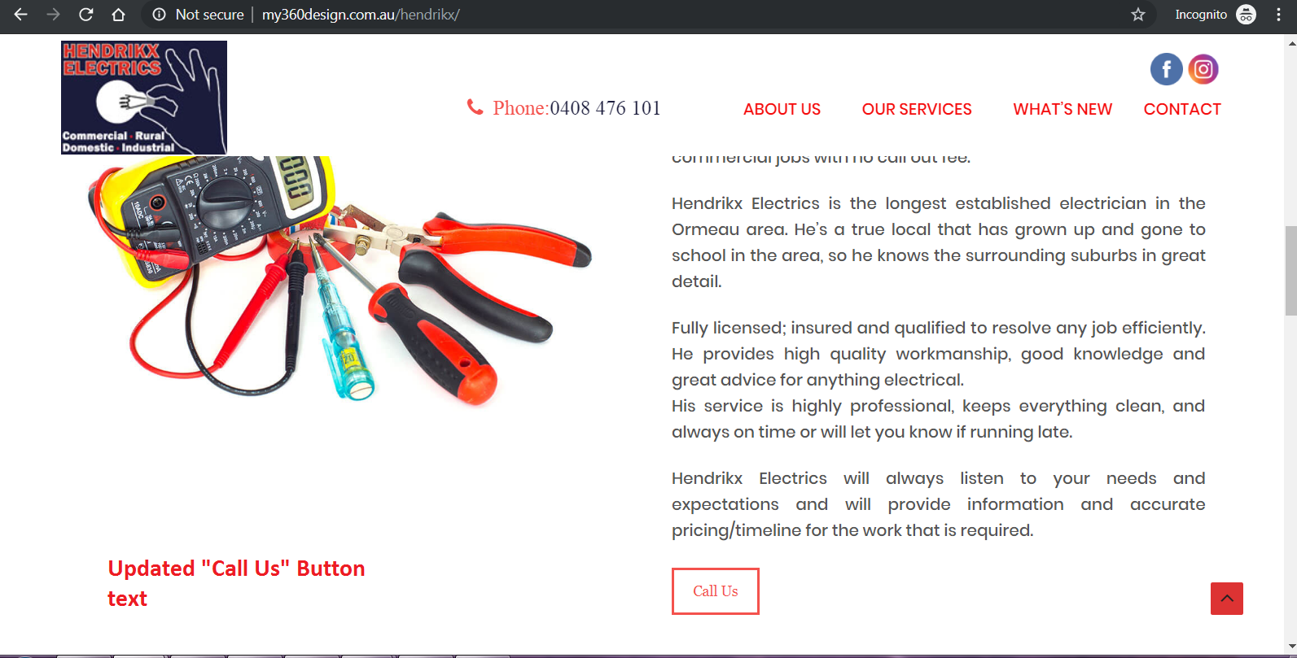

**Contact**

Format – please updated so icons and first word are all lined up, eg 5 spaces between icon and word

* **Updated**

