Website link - [http://my360design.com.au/hendrikx/#](http://my360design.com.au/hendrikx/)

All previous updates have been completed and approved.

**Hi, the client has had the following grammar issues**

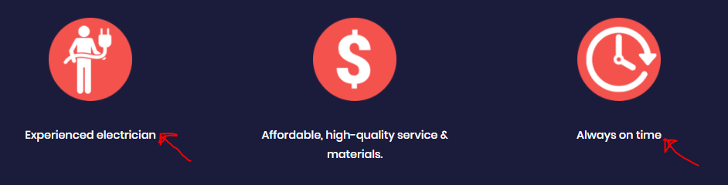

Both sections are missing the full stop at the end of the sentence

*Experienced electrician.*

*Always on time.*

* **Updated**

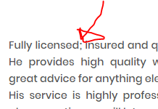

About Us

3rd paragraph, needs semi colon removed and comma added

*Fully licensed, insured and qualified*

* **Updated**

Power/Lights/TV points

or the TV point is in the wrong spot.This is a f

Needs spaces after full stop

*the TV point is in the wrong spot. This is a fast*

* **Updated**

Ceiling fans

ns is our #2 best-seller.We do

Needs spaces after full stop

*is our #2 best-seller. We do*

* **Updated**



Last section is missing the full stop at the end of the sentence

*Jacobs Well & Beenleigh.*

* **Updated**

Our Services page

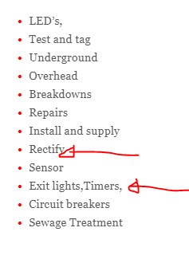

Remove - Rectify

Separate for 2 lines - Exit lights

Separate for 2 lines – Timers

Update – Sewage treatment systems

* **Updated**

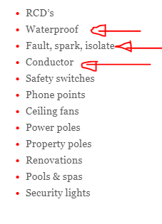

Remove - waterproof, fault, spark, isolate, conductor

* **Updated**

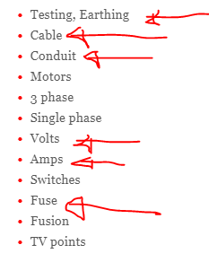

Separate line – Testing

Separate line - Earthing

Cable needs to be changed to Cabling

Remove - conduit, volts, amps

Update - Fuse to Fuses

* **Updated**