Details

|  |  |
| --- | --- |
| **Item** | **Details** |
| **Project Type** | New website, landing page and payment gateway |
| **Purpose of website** | Company profile, showcase services, blog and other tips, lead generation and bookings, calendar |
| **Domain needed** | No – gctw.com.au |
| **Hosting needed** | Yes |
|  |  |

Landing Page for Business

|  |
| --- |
| **Mockup** |
| Do you need to have your business online but don’t know how to create a strategy for all areas?   * 82% of searchers use their phone to help them make a decision * Close to half the world’s population ([3.03 billion people](https://blog.statusbrew.com/social-media-statistics-2018-for-business)) are on some type of social media     When you do our workshops, we guarantee that you will have:   1. Training and implementation workshop 2. A clear documented strategy 3. Be easily found online   Upcoming workshops and dates  (sync with calendar) |

Competitor example:

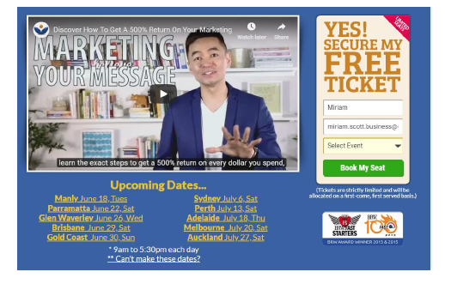

Payment Gateway

|  |  |
| --- | --- |
| **Item** | **Details** |
| Paypal Account | Go to your Paypal account to create payment button |
| Credit Card |  |

Link to CRM – items required

What kind of information do you want to add about your customer’s

|  |  |
| --- | --- |
| **Item** | **Details** |
| Title |  |
| First Name |  |
| Last Name |  |
| Mobile Phone |  |
| Email |  |
| Business Name |  |
| Website |  |
| Social Media | Facebook, Instagram, LinkedIn, YouTube, Pinterest, Twitter |
| Activity | Workshop  Support Package  Specialist Services |
|  |  |

Website

|  |  |
| --- | --- |
| **Item** | **Details** |
| Domain name | [www.gctw.com.au](http://www.gctw.com.au) |
| Hosting | Needed |
| Business email | [info@gctw.com.au](mailto:info@gctw.com.au) (needed) |
| Pages required | See file attached |
| Page titles | Home Page – long bio  Services – will be provided later as will be workshop descriptions (can you let me know if I can upload this onto the site?)  Contact Us – email enquiry  What’s New – Facebook newsfeed and Blogs  Social media links  Calendar  Terms of Service  Privacy Policy |
| Competitor Website URL’s | <https://www.authentic.com.au/>  <http://www.southerngoldcoast.com.au/digital-marketing>  <https://optimiseandgrowonline.com.au/marketing-workshops/>  <http://www.marketingangels.com.au/marketing-workshops/> |
| Examples of websites that you like | Wordpress themes  Airi  Simplicity of following (but I don’t like animations)  <https://trello.com/en-AU>  <https://www.vendhq.com/au/> |
| Online business objective | Marketing/branding awareness  Lead generation |
| Date to complete by | ASAP |
|  |  |
| **Design** | **Details** |
| Any style guide/theme |  |
| Logo design |  |
| Banner design |  |
| Images for website |  |
|  |  |
| **Content** | **Details** |
| Page content | Miriam and website developer |
| Blogs | To be added later |
| 5 Common key search phrases | Marketing workshops  Digital marketing workshops  Marketing training  Marketing workshops near me  Digital marketing training  How do you write a marketing plan  How do you create a marketing plan  How do you develop a marketing strategy  How do I do digital marketing  Digital marketing workshops  Digital marketing training  Digital marketing training course  Digital marketing workshop |
|  |  |
|  |  |
| **Technology** | **Details** |
| Integrations | CRM, accounting software, payment gateways, , calendar |
| Social media URL links | Facebook/Instagram/Twitter/LinkedIn/PInterest |
| Facebook | <https://www.facebook.com/gctrainingworkshops>/ |
| Instagram | <https://www.instagram.com/gctrainingworkshops/> |
| Twitter | <https://twitter.com/gctrainingwork> |
| Linked In | <https://www.linkedin.com/company/gold-coast-training-workshops/> |
| PInterest | <https://www.pinterest.com.au/gctrainingworkshops/> |
|  |  |
| Platform | Wordpress |
| Chatbot | Yes |
| SSL Certificate | ?? |
|  |  |
| **Lead Generation** | **Details** |
| Main CTA | Book A Workshop |
| Mailing list | Yes |
|  |  |
| **Future Management** | **Details** |
| Website | Miriam and developer will do |
| Social media | Miriam will do |
|  |  |
|  |  |
|  |  |