Bank Loan Analysis

**PROBLEM STATEMENT AND SOLUTIONS**

### BRD 1: SUMMARY – (Python 3.9.20)

#### Key Performance Indicators (KPIs) Requirements:

1. **Total Loan Applications:** We need to calculate the total number of loan applications received during a specified period. Additionally, it is essential to monitor the Month-to-Date (MTD) Loan Applications.

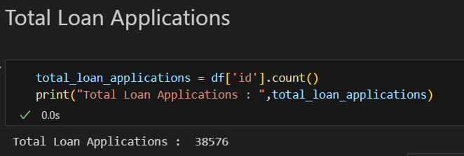

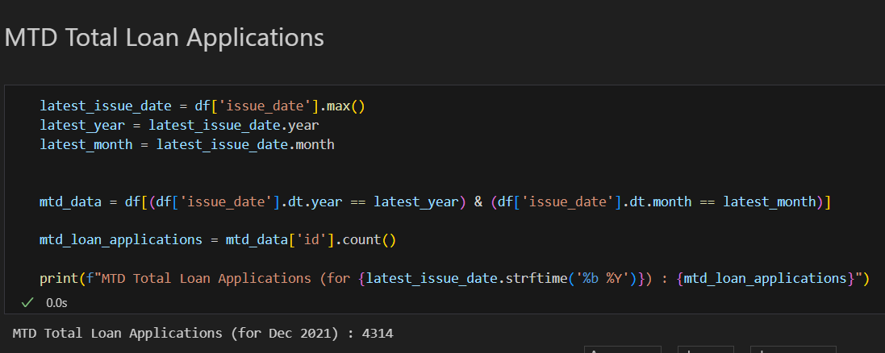

1. **Total Funded Amount:** Understanding the total amount of funds disbursed as loans is crucial. We also want to keep an eye on the MTD Total Funded Amount metric.

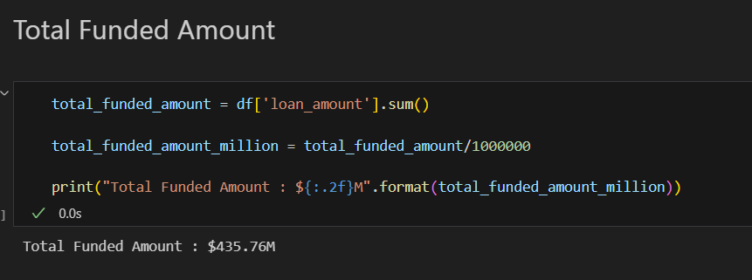

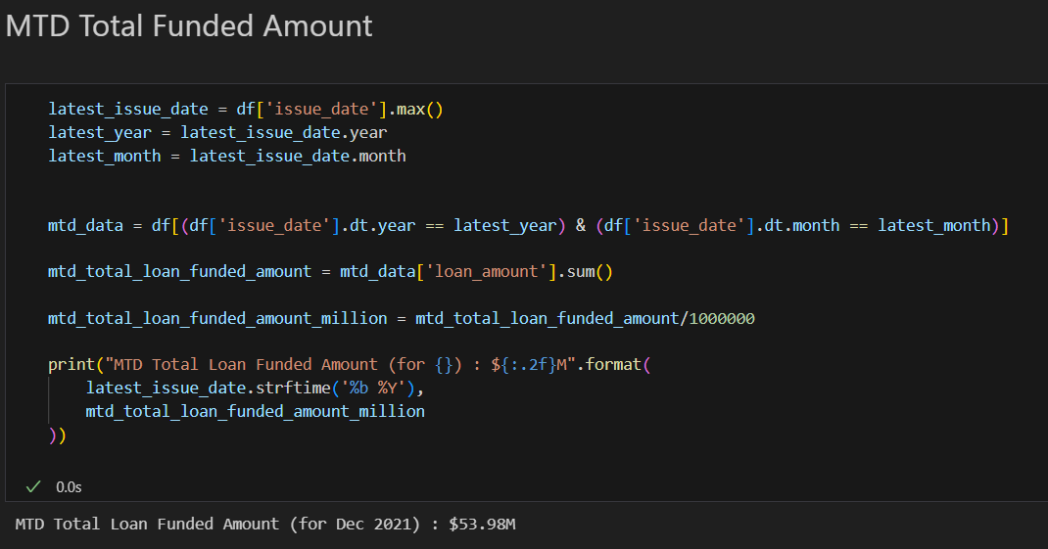

1. **Total Amount Received:** Tracking the total amount received from borrowers is essential for assessing the bank's cash flow and loan repayment. We should analyse the Month-to-Date (MTD) Total Amount Receive.

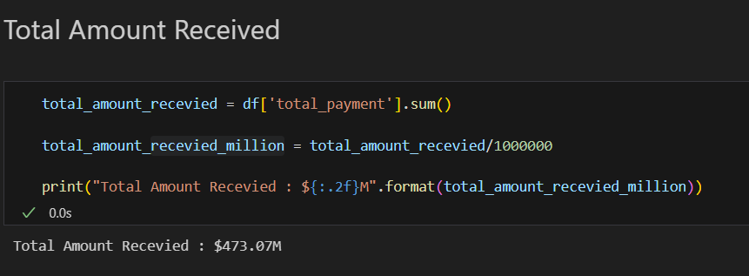

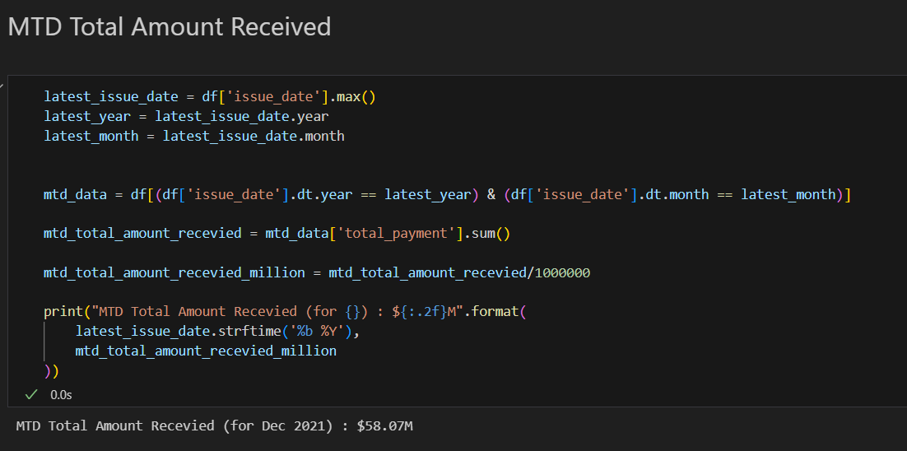

1. **Average Interest Rate:** Calculating the average interest rate across all loans which will provide insights into our lending portfolio's overall cost.

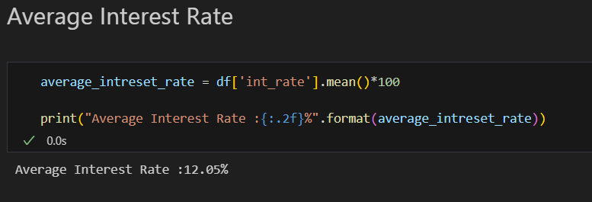

1. **Average Debt-to-Income Ratio (DTI):** Evaluating the average DTI for our borrowers helps us gauge their financial health. We need to compute the average DTI for all loans.

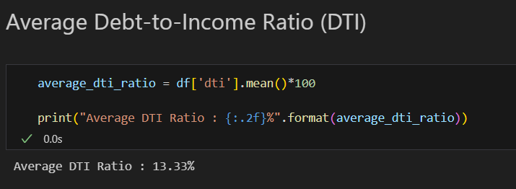

#### Good Loan v Bad Loan KPI’s

##### Good Loan

1. **Good Loan Application Percentage**
2. **Good Loan Applications**
3. **Good Loan Funded Amount**
4. **Good Loan Total Received Amount**

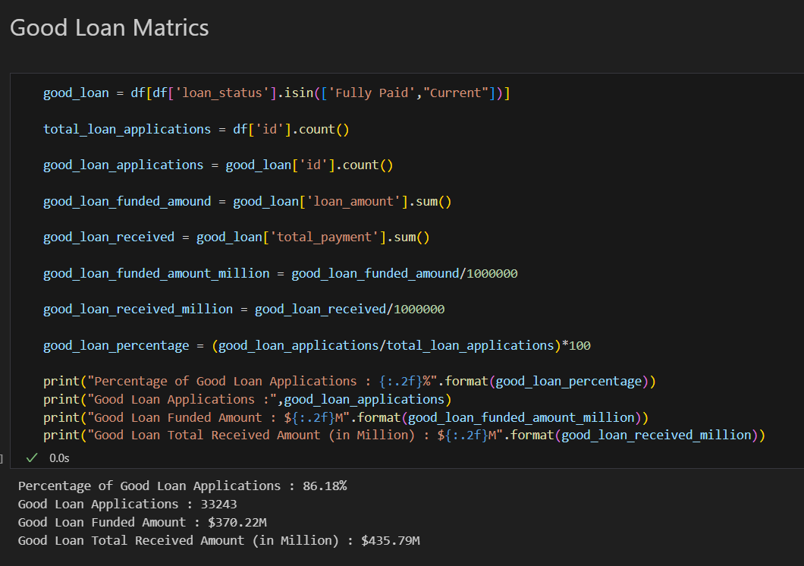

##### Bad Loan

1. **Bad Loan Application Percentage**
2. **Bad Loan Applications**
3. **Bad Loan Funded Amount**
4. **Bad Loan Total Received Amount**

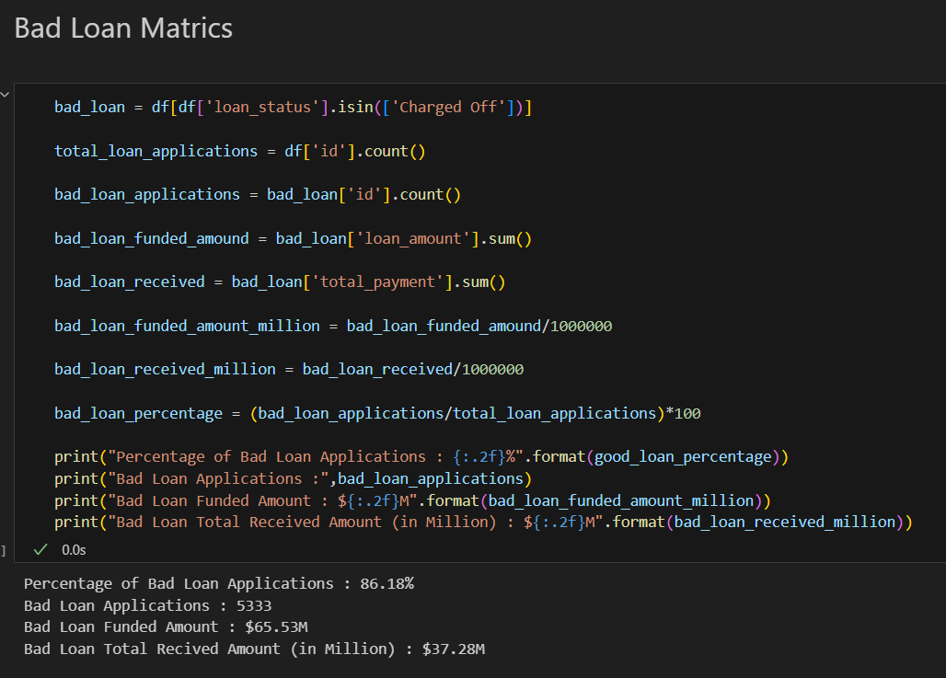

### BRD 2: OVERVIEW

#### CHARTS

1. **Monthly Trends by Issue Date (Line/ Area Chart):** To identify seasonality and long-term trends in lending activities

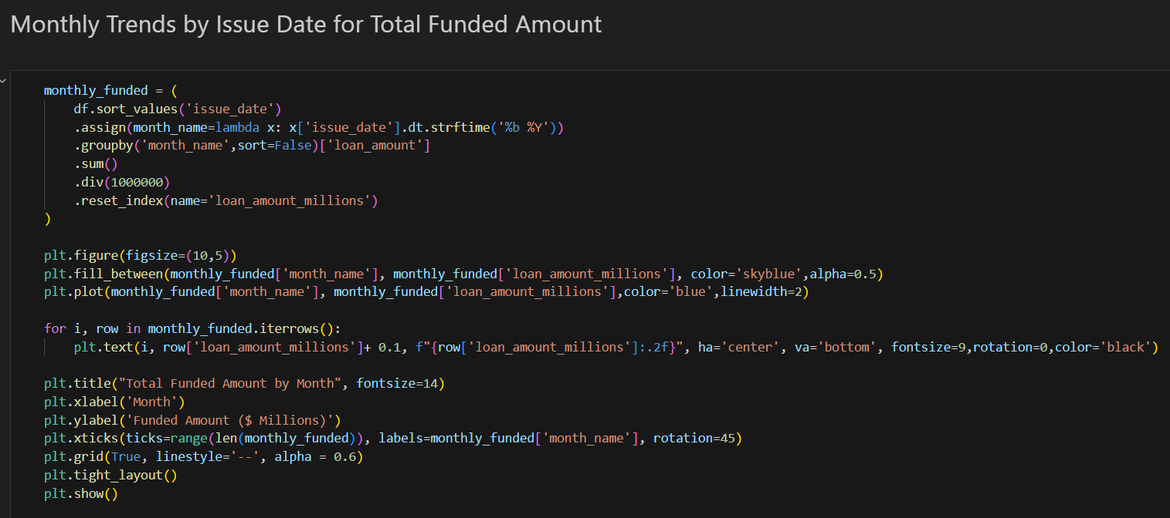

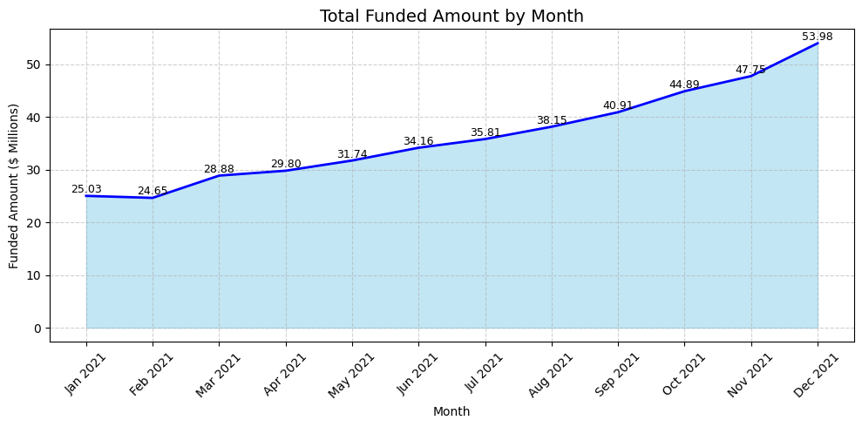

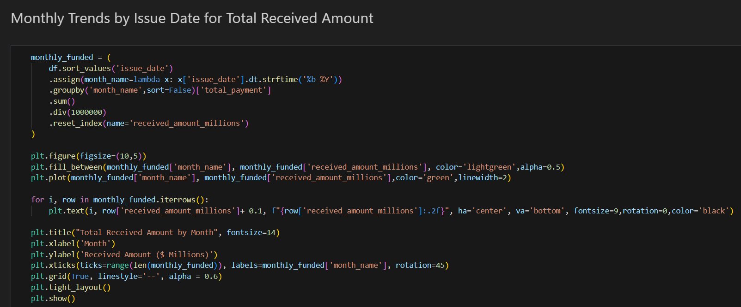

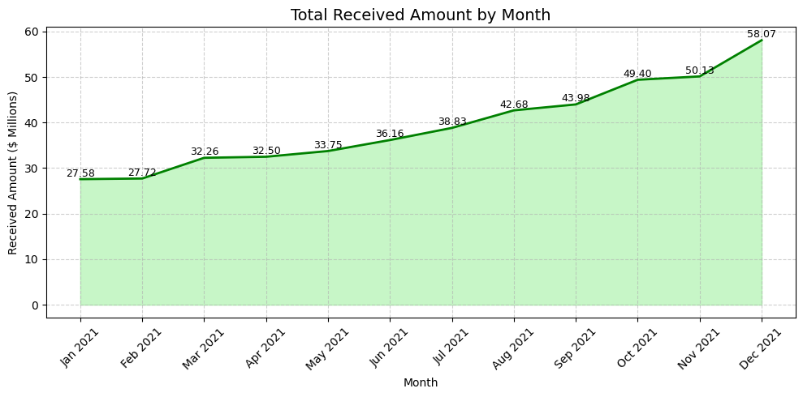

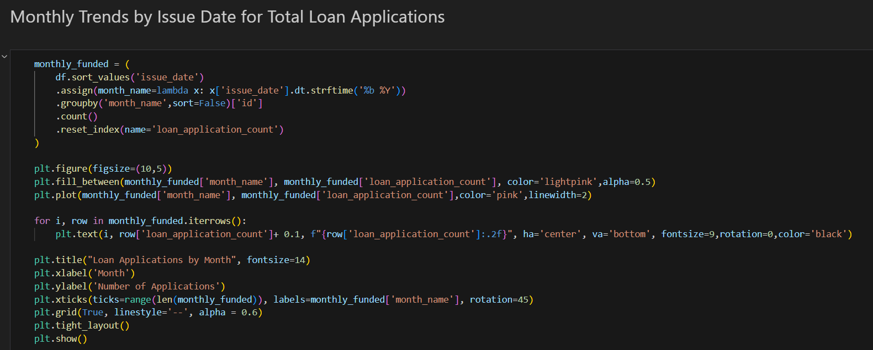

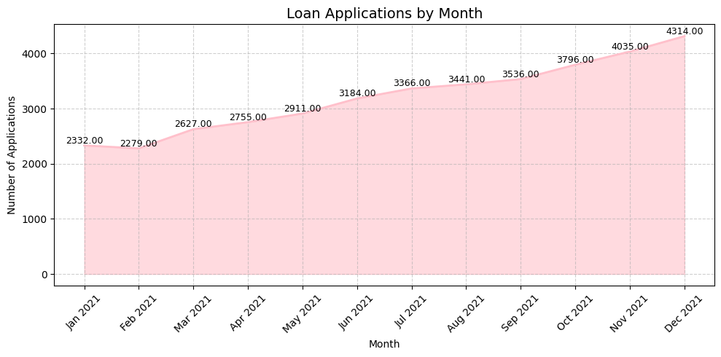

1. **Regional Analysis by State (Bar Chart):** To identify regions with significant lending activity and assess regional disparities

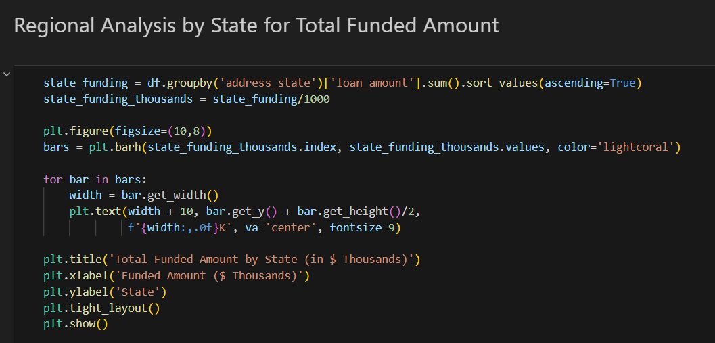

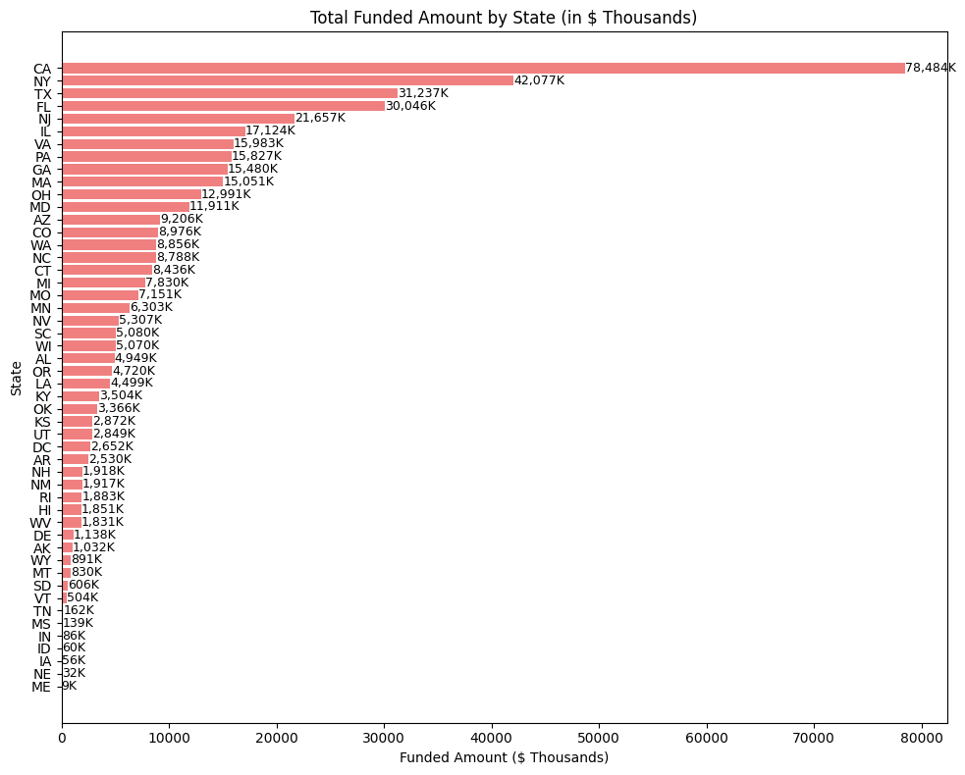

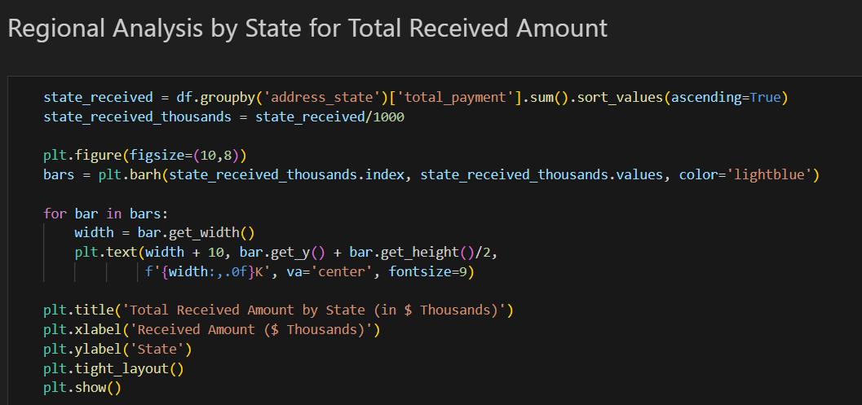

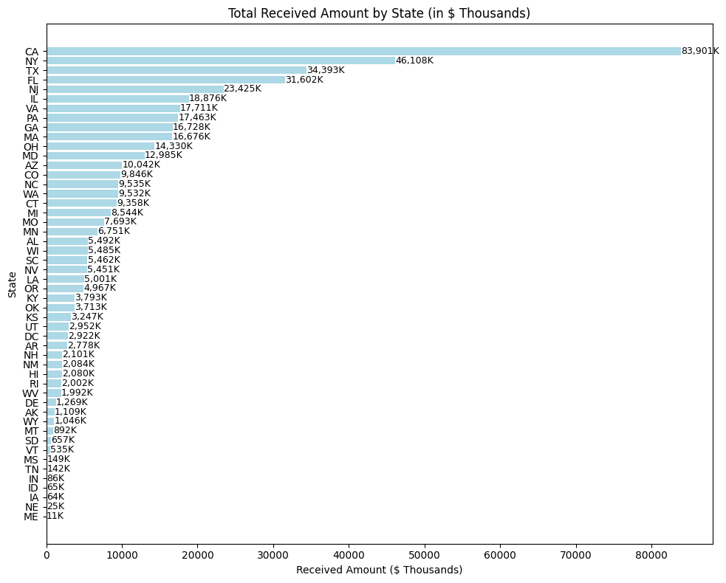

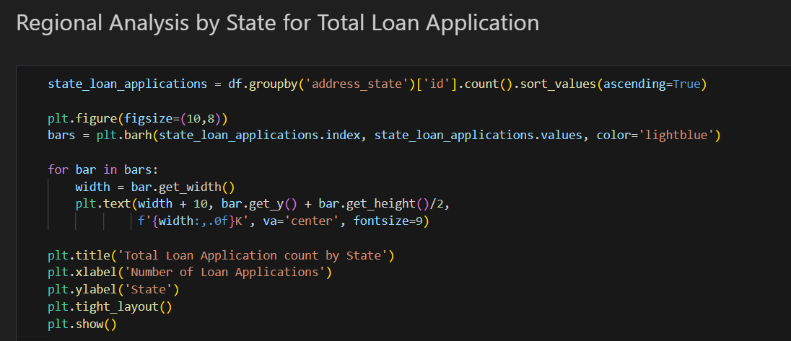

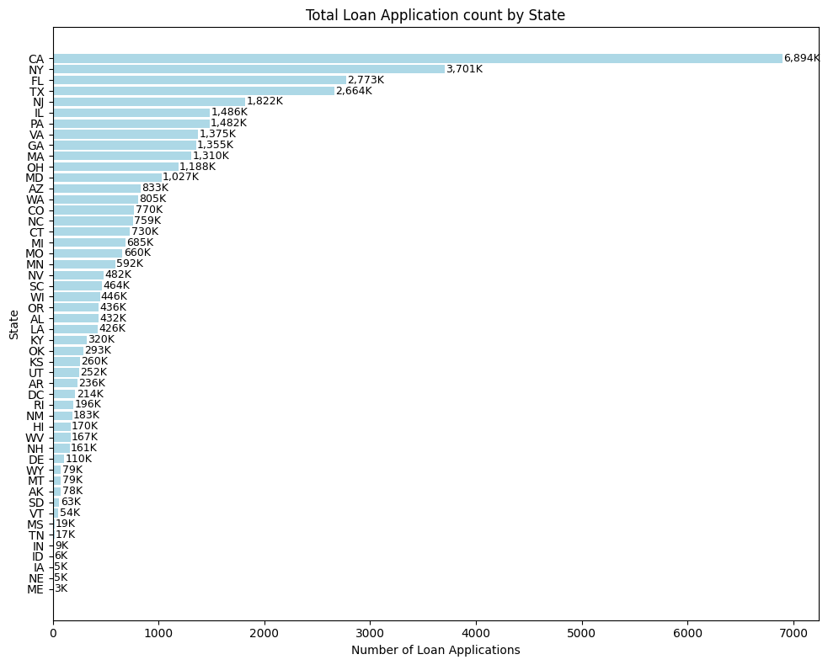

1. **Loan Term Analysis (Donut Chart):** To allow the client to understand the distribution of loans across various term lengths.

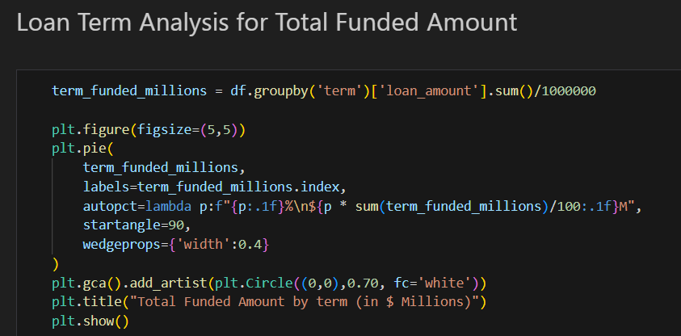

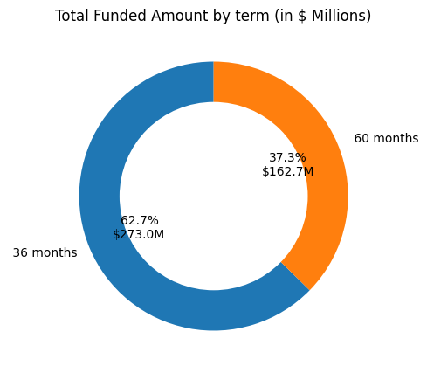

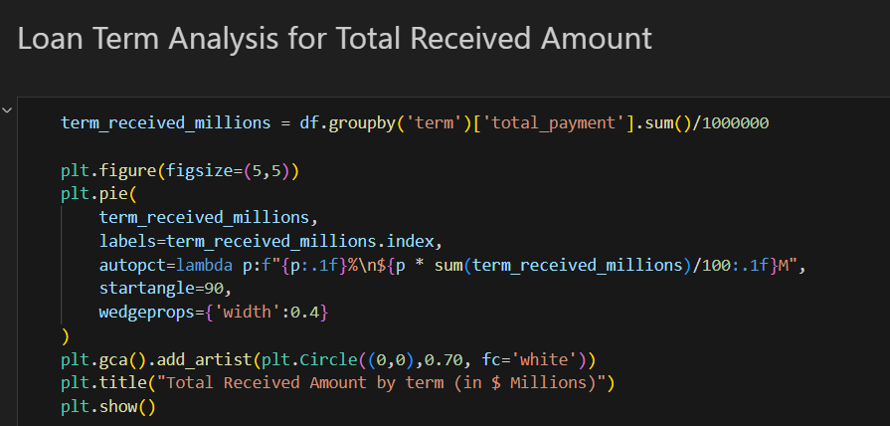

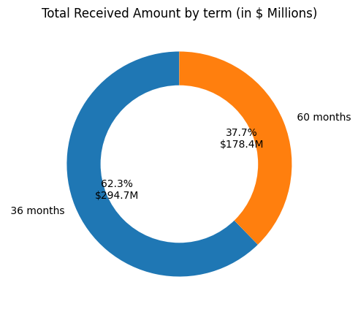

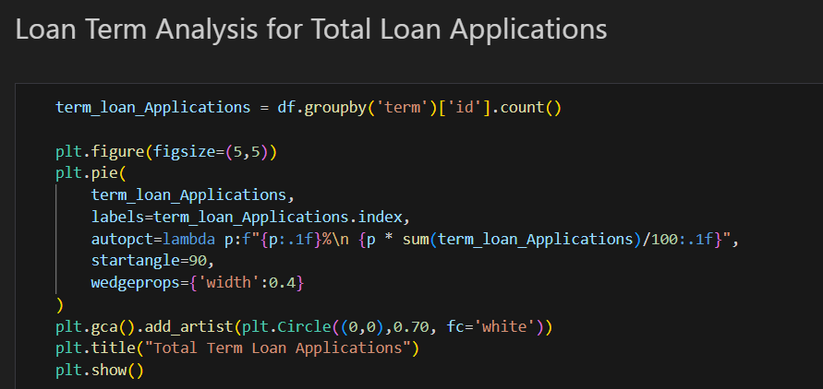

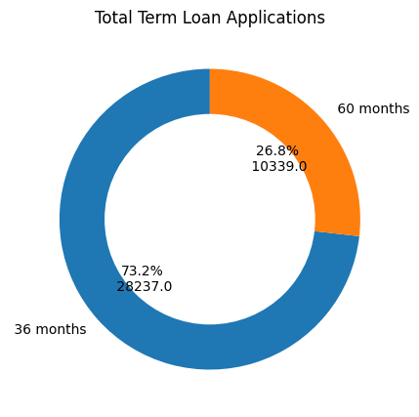

1. **Employee Length Analysis (Bar Chart):** How lending metrics are distributed among borrowers with different employment lengths, helping us assess the impact of employment history on loan applications.

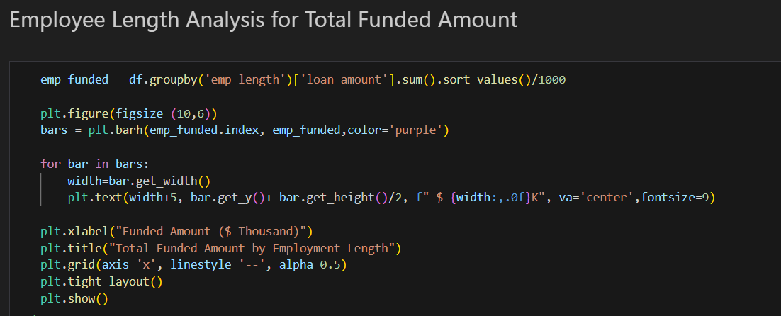

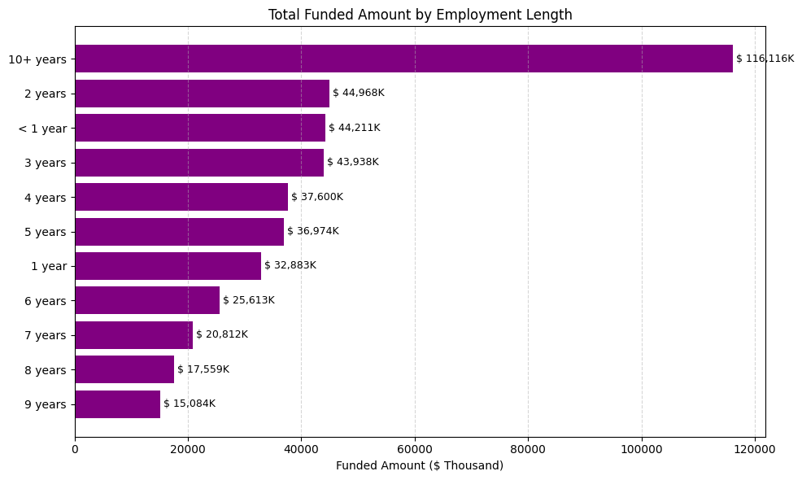

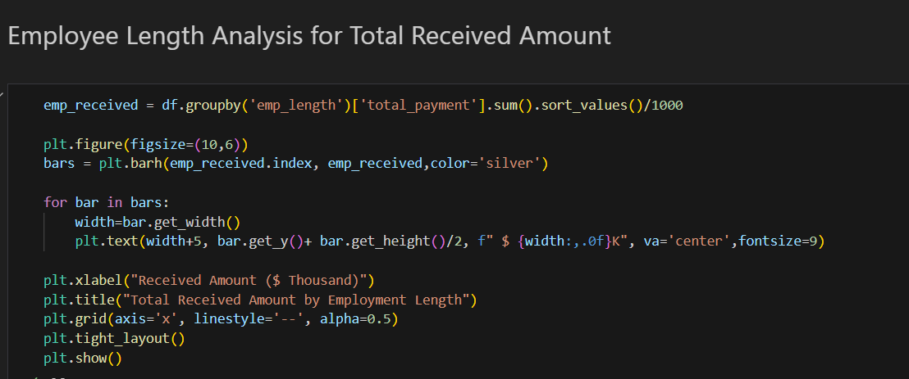

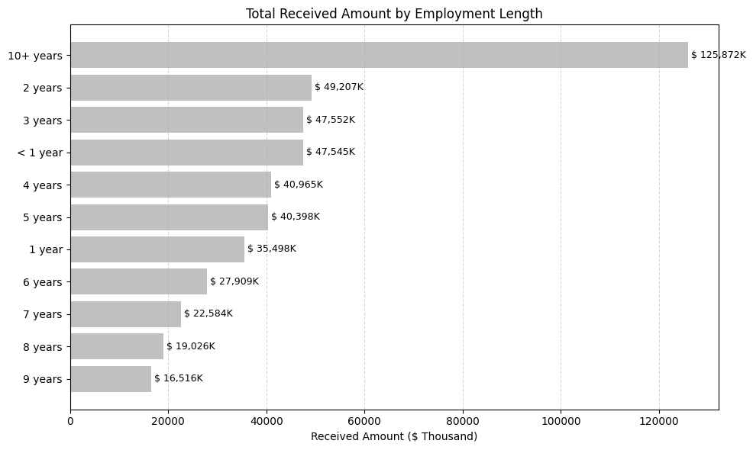

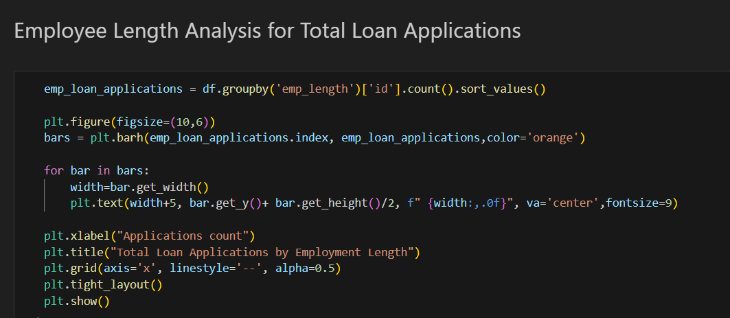

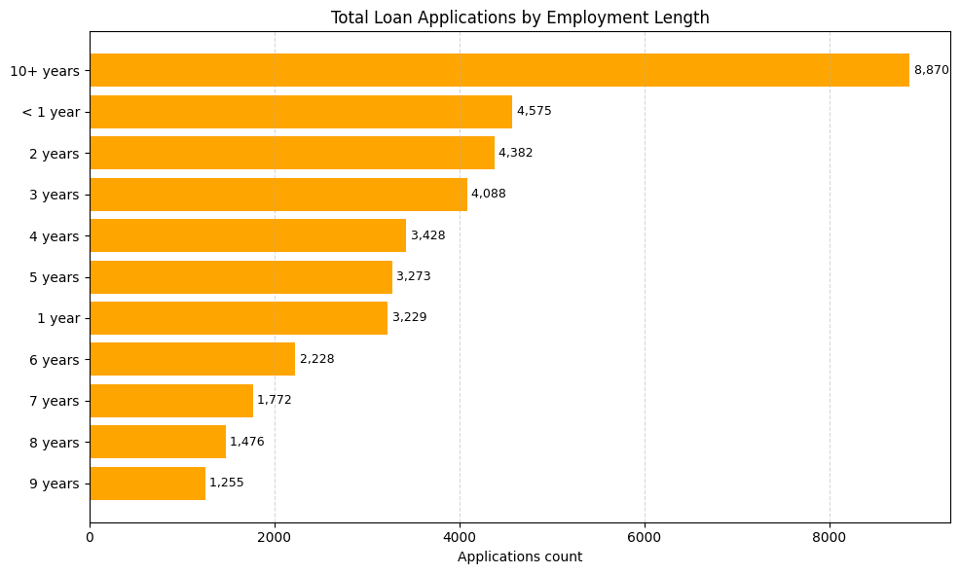

1. **Loan Purpose Breakdown (Bar Chart): W**ill provide a visual breakdown of loan metrics based on the stated purposes of loans, aiding in the understanding of the primary reasons borrowers seek financing.

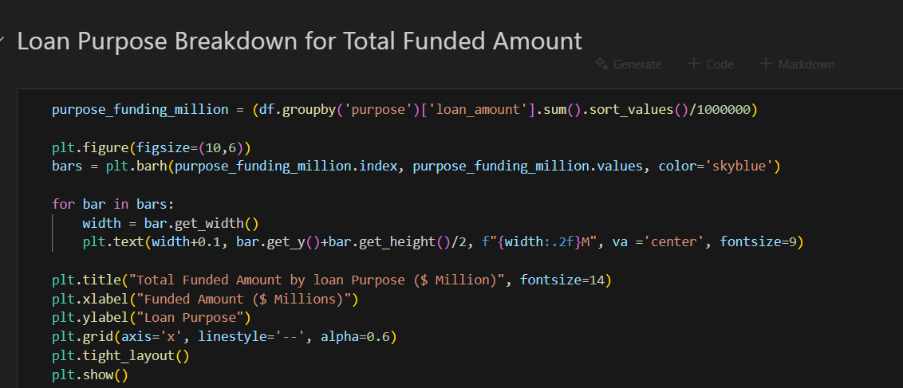

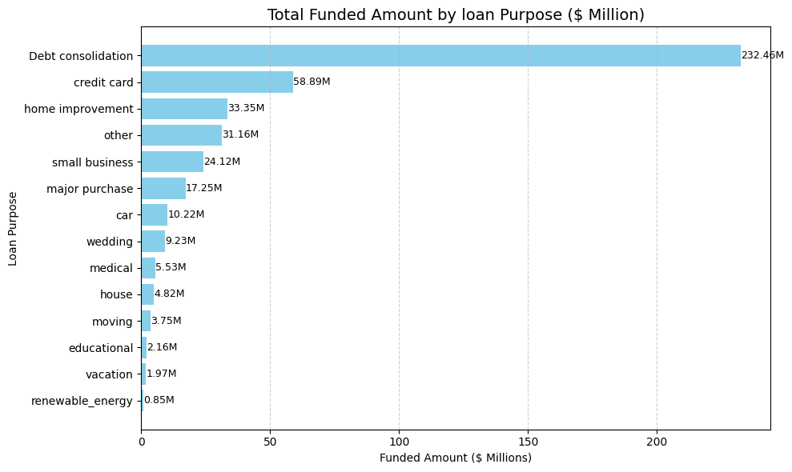

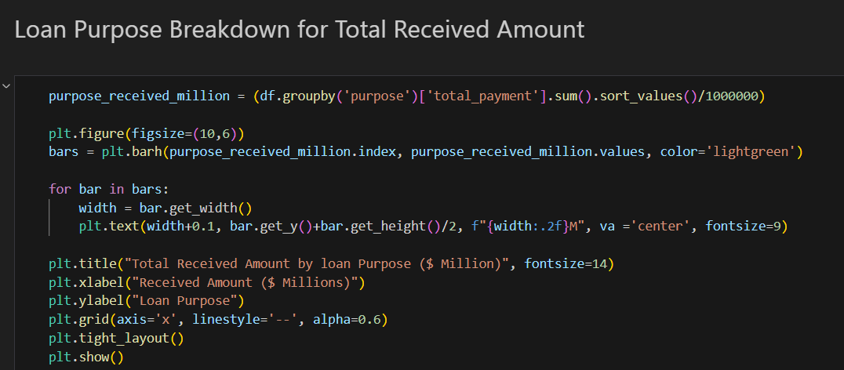

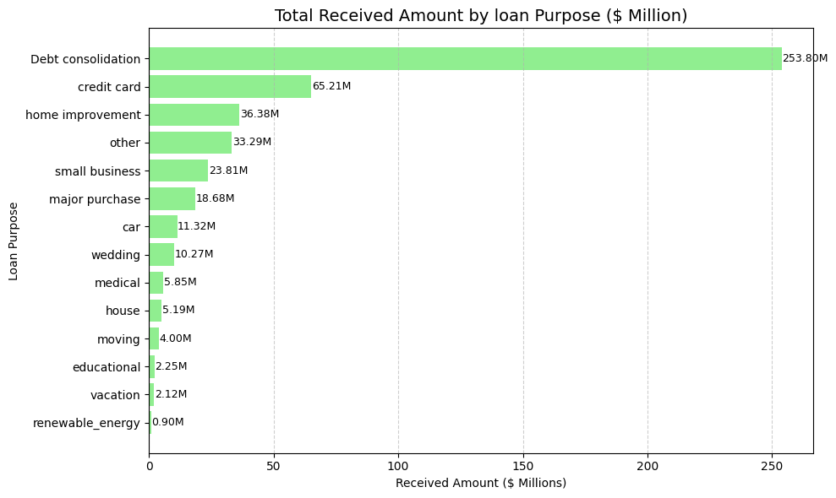

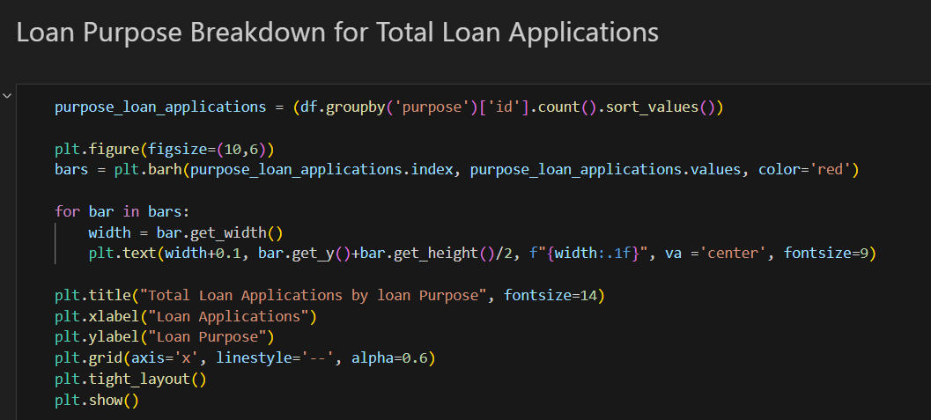

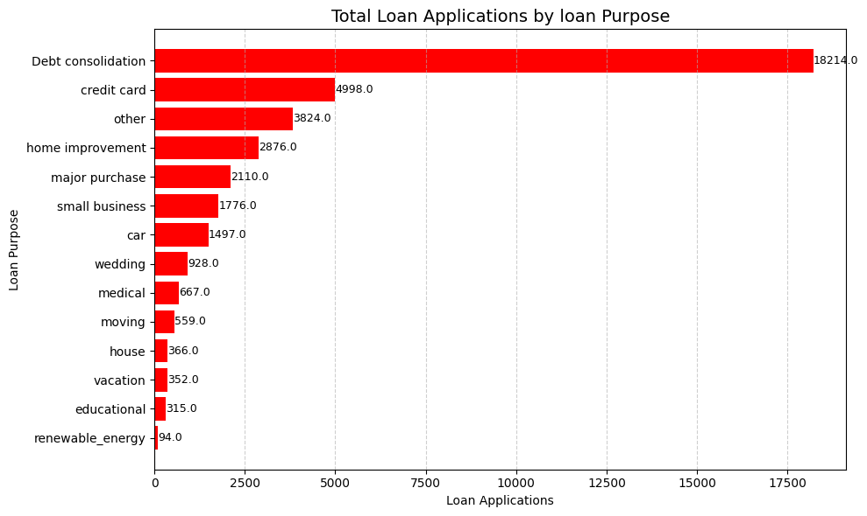

1. **Home Ownership Analysis (Tree/ Heat Map):** For a hierarchical view of how home ownership impacts loan applications and disbursements.

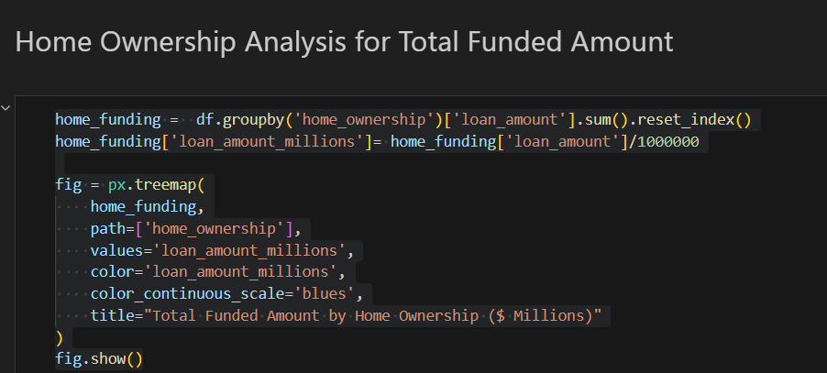  
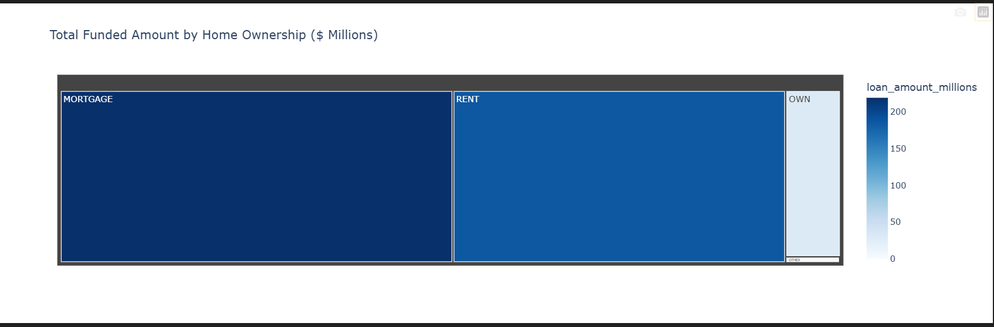

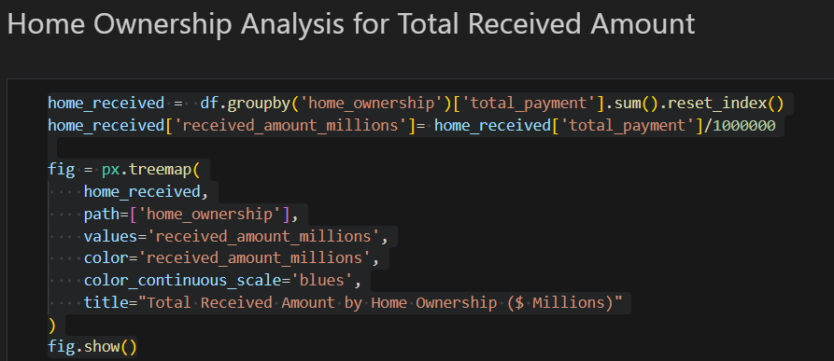

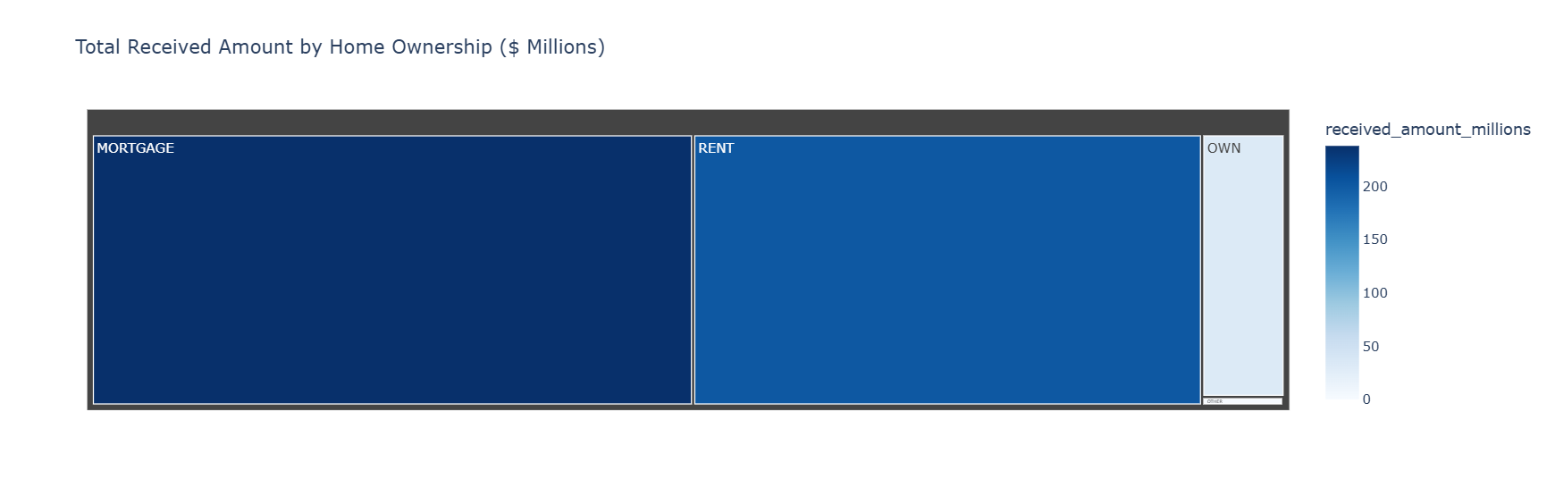

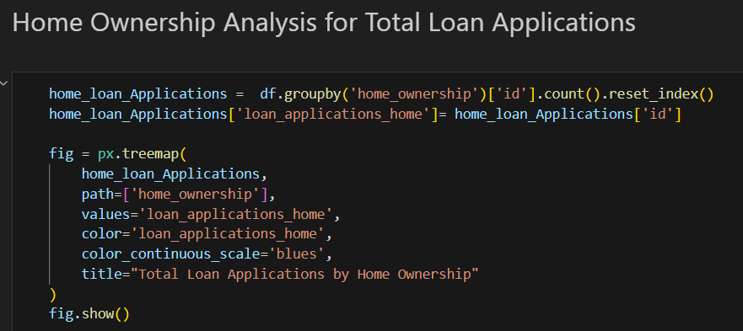

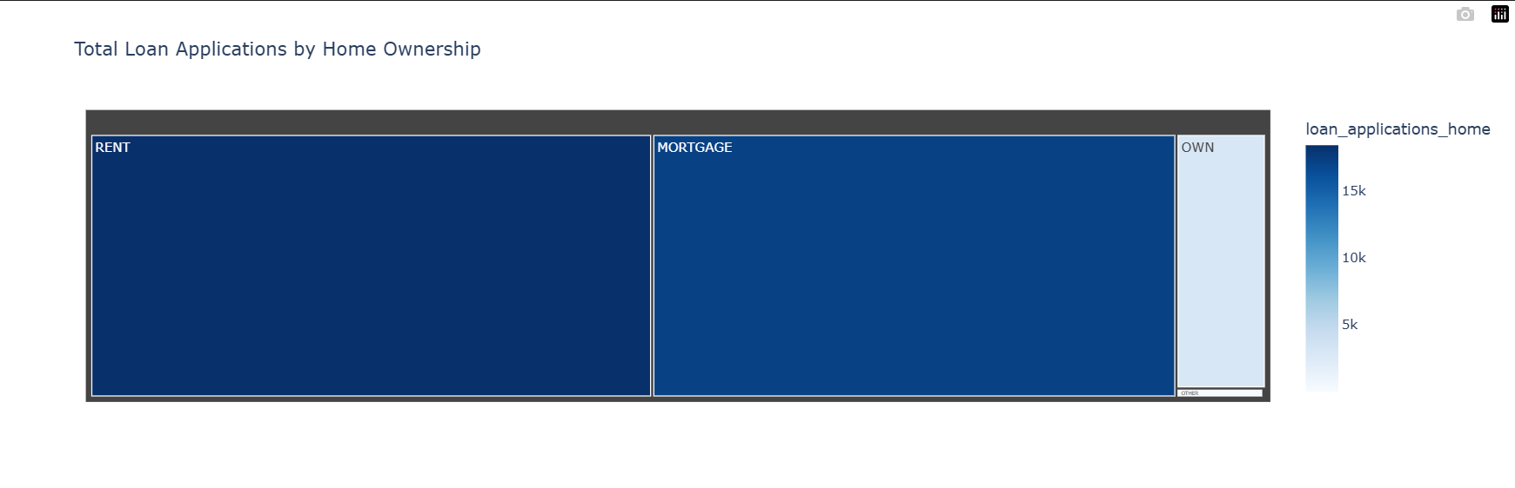Metrics to be shown: 'Total Loan Applications,' 'Total Funded Amount,' and 'Total Amount Received”