CANTEEN PRE-ORDER SYSTEM
USING HTML,CSS AND JAVASCRIPT

INTERNSHIP REPORT
Submitted in partial fulfillment of the requirements for the award of the degree of
BACHELOR OF SCIENCE IN COMPUTER TECHNOLOGY
at the Bharathiar University

by
HARISH K
(Reg. No: 24UGCTE00043)
Under the Guidance of
Dr.D.Geethamani M.Sc., M.Phil., Ph.D.
Assistant Professor
DEPARTMENT OF COMPUTER TECHNOLOGY

DR. N.G.P. ARTS AND SCIENCE COLLEGE
(An Autonomous Institution, Affiliated to Bharathiar University, Coimbatore)
Approved by Government of Tamil Nadu & Accredited by NAAC with A++ Grade (3rd Cycle)
Dr. N.G.P.-Kalapatti Road, Coimbatore-641 048, Tamil Nadu, India.
SEPTEMBER- 2026

DECLARATION

I, HARISH K (Reg. No: 24UGCTE00043) hereby declare that the internship report entitled "CANTEEN PRE-ORDER SYSTEM USING HTML,CSS AND JAVASCRIPT” submitted in partial fulfillment of the requirement for the award of the degree of Bachelor of Science in Computer Technology at the Bharathiar University is a record of original work done during the period of internship under the supervision and guidance of Dr.D.Geethamani M.Sc., M.Phil., Ph.D.., Assistant Professor, Department of Computer Technology, Dr. N.G.P. Arts and Science College, Coimbatore - 48, and it has not formed on the basis of award of any Degree / Diploma / Associateship / Fellowship or other similar title to any candidate of any university.

Place: Coimbatore HARISH K
Date: 26.05.2026 (Reg: 24UGCTE00043)

CERTIFICATE

This is to certify that the internship report entitled " CANTEEN PRE-ORDER SYSTEM USING HTML,CSS AND JAVASCRIPT " submitted in partial fulfillment of the requirement for the award of the degree of Bachelor of Science in Computer Technology at the Bharathiar University is a record of original work done by HARISH K (Reg. No: 24UGCTE00043) during the period (2025-2026) of his study in Department of Computer Technology, Dr. N.G.P. Arts and Science College, Coimbatore - 48 under my supervision and guidance, and the internship report has not formed the basis for the award of any Degree / Diploma / Associateship / Fellowship or other similar title to any candidate of any university.

(Dr. D. Geethamani) (Dr. M. Rathi)
Guide HoD
Place: Coimbatore
Date:
Viva-voce Examination held on: _______________

Internal Examiner External Examiner

INTERNSHIP CERTIFICATE


ACKNOWLEDGEMENT
This internship report was the most significant accomplishment in my life and it would not have been possible without the blessing of God almighty and those who supported and believed in my caliber.
I record my deep sense of gratitude to Dr. NALLA G PALANISWAMI M.D, AB (USA), Chairman, Dr. N.G.P. Research and Educational Trust, Coimbatore for providing me an opportunity to carry out internship successfully.
I record my deep sense of gratitude to Mrs. Mathura V. Palaniswami, Secretary, Dr. N.G.P. Arts and Science College, Coimbatore for providing me an opportunity to carry out internship successfully.
I record my sincere thanks to Dr. S. SARAVANAN M.Com., M.Phil., MBA., Ph.D., Principal, Dr. N.G.P. Arts and Science College, Coimbatore, for every help he rendered before and during the period of project.
I would like to extend my sincere gratitude to Dr. M. Rathi MCA., M.Phil., SET., Ph.D., Professor and Head, Department of Computer Technology, Dr. N.G.P. Arts and Science College, Coimbatore for her constant motivation during my internship.
I record my deep sense of gratitude to the management and team at LITZ Tech for providing me an opportunity to carry out internship in their organization and helping me gain practical exposure towards the industry.
I would like to extend my sincere thanks to my guide Dr.D.Geethamani M.Sc., M.Phil., Ph.D., Assistant Professor, Department of Computer Technology, Dr. N.G.P. Arts and Science College, Coimbatore for her exemplary guidance, encouragement, and sustained interest throughout the period of this work.
I take this opportunity to acknowledge my sincere thanks to all the staff members of the Department of Computer Technology for their constant inspiration, assistance, and resourceful guidance.
I express my sincere thanks to my family and friends for their encouragement, love, advice, and sacrifice without which I would not have been able to pursue the course of this study.

HARISH K
(Reg: 24UGCTE00043)

ABSTRACT

The College Canteen Pre-Order System is a web-based application developed to make the process of ordering food in a college canteen faster, easier, and more convenient. In a traditional canteen, students and staff often have to wait in long queues during break time to place their orders and make payments. This system provides a simple online platform through which users can log in, select food items, place an order, make a payment, and receive a pickup token without waiting for a long time at the canteen counter.
The system provides three different login options: Student Login, Staff Login, and New User Login. Students can access the system using their roll number and date of birth, while staff members can log in using their staff ID and password. New users can directly access the system by entering their name and mobile number without requiring a separate registration process. This makes the application flexible and convenient for different categories of users.
After successful login, users can view the available food menu along with the prices of each item. They can add food items to the cart, increase or decrease the quantity, and view the total amount before proceeding to payment. The payment section provides different payment methods such as UPI, debit card, and credit card. Once payment is completed, the system displays a Payment Successful message and generates a unique pickup token for the order. This token can be used by the user to collect the ordered food from the canteen.
The system also maintains an Order History, allowing users to view their previous orders, including the user details, food items, quantities, total amount, and payment method. A bill can also be downloaded in PDF format for each completed order. The application is designed using HTML, CSS, and JavaScript, which provide the structure, visual design, and interactive functionality of the system. The interface is designed to be simple and user-friendly so that users can easily navigate through the different sections.

TABLE OF CONTENTS

CHAPTER NO | TITLE | PAGE NO
I | Introduction | 1
II | Company Profile | 2
III | System Requirements | 3
IV | Internship Activities | 4
V | Application Modules | 6
VI | Application Usage & Technical Foundations | 12
VII | Conclusion | 20
VIII | Future Scope | 21
IX | References | 22

CHAPTER I: INTRODUCTION

The rapid growth of digital technology has changed the way people access and use various services. In a college environment, the canteen is an important facility used by students and staff every day. During break times, a large number of students gather at the canteen, which can result in long queues, waiting time, and difficulty in managing food orders.
The College Canteen Pre-Order System is a web-based application designed to make the food ordering process faster, easier, and more convenient. The system allows users to log in and select food items from an online menu before placing their order. Users can add or remove food items from the cart, view the total amount, select a payment method, and receive a pickup token after successful payment.
The system provides different login options for students, staff, and new users. Students can log in using their roll number and date of birth, staff can access the system using their staff credentials, and new users can continue by entering their name and mobile number. This makes the system flexible and convenient for different types of users.
The application also maintains order history and provides an option to download the bill in PDF format. By reducing the need to stand in long queues and organizing orders digitally, the system can improve the overall canteen experience for both users and canteen staff.
The project is developed using HTML, CSS, and JavaScript. HTML is used to create the structure of the web pages, CSS is used for designing and formatting the interface, and JavaScript is used to implement login, menu, cart, payment, order, token, and bill-generation functions. The system provides a simple and user-friendly interface suitable for a college canteen environment.

CHAPTER II: COMPANY PROFILE

LITZ Tech is an ISO 9001:2015 certified technology solutions and training provider based in Tamil Nadu, specializing in software development, cybersecurity solutions, machine learning integrations, and enterprise IT platforms. For several years, the organization has focused on providing scalable digital solutions while bridging academia and industry through hands-on technical training programs.
The company provides key services including:
• Custom Software & Web Application Development
• Cybersecurity Assessments & Enterprise Infrastructure Setup
• Artificial Intelligence & Machine Learning Integration
• Industrial Internship & Hands-On Technical Skill Training
Address:
LITZ Tech
2X2W+C8F, Access Rd, Peelamedu
Chitra Nagar, Civil Aerodrome Post
Coimbatore, Tamil Nadu 641045.

CHAPTER III: SYSTEM REQUIREMENTS

Hardware Requirements

• Processor: Intel Core i3 / AMD Ryzen 3 or higher
• RAM: Minimum 4 GB (8 GB recommended)
• Storage: 20 GB free space (SSD recommended)
• Network Interface: Standard Network Adapter supporting promiscuous mode
• Display: 1280 × 720 resolution or higher

Software Requirements

• Operating System: Windows, Linux, or macOS
• Code Editor: Visual Studio Code or any HTML editor
• Technologies: HTML5, CSS3, JavaScript
• Browser: Google Chrome, Microsoft Edge, Mozilla Firefox, or another modern browser
• No database or server is required for the current demonstration version

CHAPTER IV: INTERNSHIP ACTIVITIES

Date | Day | Work Done
14-May-26 | Thursday | Orientation on Company, Project Requirements & Visual Studio Code Environment Setup
15-May-26 | Friday | Introduction to Web Development, HTML Fundamentals & Website Structure
16-May-26 | Saturday | HTML Page Development, Navigation Bar & Basic Website Sections
18-May-26 | Monday | CSS Fundamentals, Styling, Layout Design & Responsive Web Design
19-May-26 | Tuesday | Development of Homepage, Hero Section & Call-ToAction Buttons
20-May-26 | Wednesday | Development of About / Our Story Section & Foundation Information
21-May-26 | Thursday | Development of Programs Section and Presentation of Foundation Initiatives
22-May-26 | Friday | Development of Gallery, Stories & Impact Statistics Sections
23-May-26 | Saturday | JavaScript Integration for Interactive Features and User Experience
25-May-26 | Monday | Development of Donate Now Section, Bank Details & Contact Information
26-May-26 | Tuesday | Responsive Design Testing and Optimization for Desktop and Mobile Devices
27-May-26 | Wednesday | Bug Fixing, UI Refinements, Content Updates & Navigation Improvements
28-May-26 | Thursday | Website Testing, Cross-Browser Verification & Final Feature Validation
29-May-26 | Friday | Final Code Review, Website Optimization & Documentation
30-May-26 | Saturday | Final Project Submission & Internship Completion

CHAPTER V: APPLICATION MODULES

The College Canteen Pre-Order System is divided into different modules to make the food ordering process simple, organized, and user-friendly. Each module performs a specific function in the application.
1. User Login Module
The User Login Module provides secure access to the canteen system. It contains three login options: Student Login, Staff Login, and New User Login. Students can log in using their roll number and date of birth. Staff can log in using their staff ID and password. New users can access the system by entering their name and mobile number.
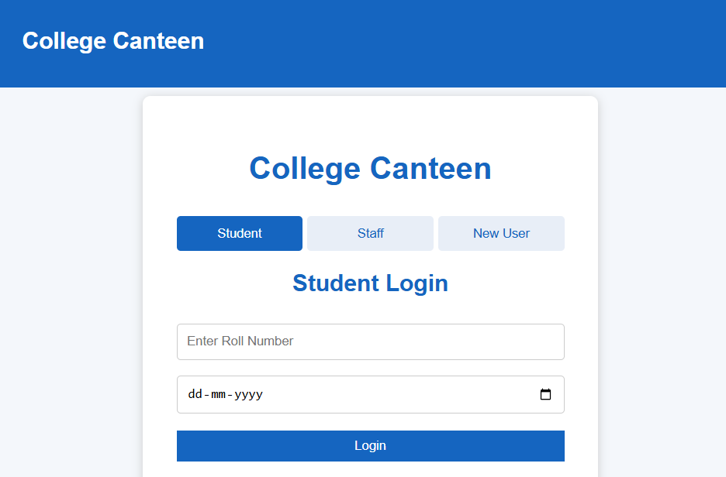
2. Home Module
The Home Module is the main page displayed after successful login. It welcomes the user and provides basic information about the canteen pre-order system. A button is provided to access the food menu and start placing an order. 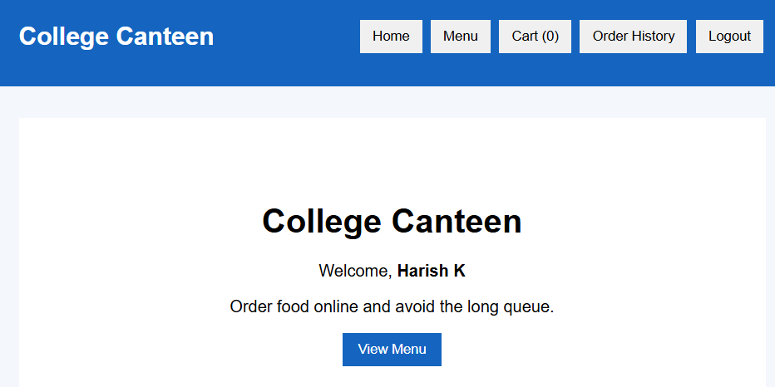
3. Food Menu Module
The Food Menu Module displays the available food items along with their prices. Users can select items such as Egg Puff, Veg Puff, Tea, Coffee, Biscuits, Chips, Rolls, Soft Drinks, Chocolate, and Vada. The user can add items to the cart and increase or decrease the quantity.
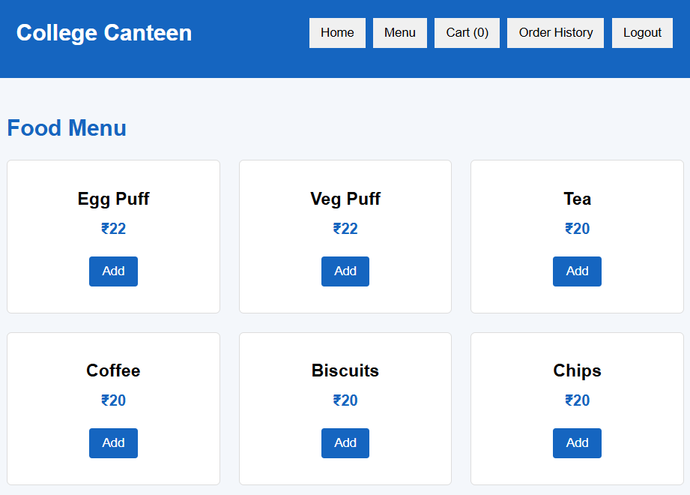
4. Shopping Cart Module
The Shopping Cart Module displays all the food items selected by the user. It shows the quantity and price of each item and automatically calculates the total amount. Users can increase or decrease quantities before proceeding to payment.
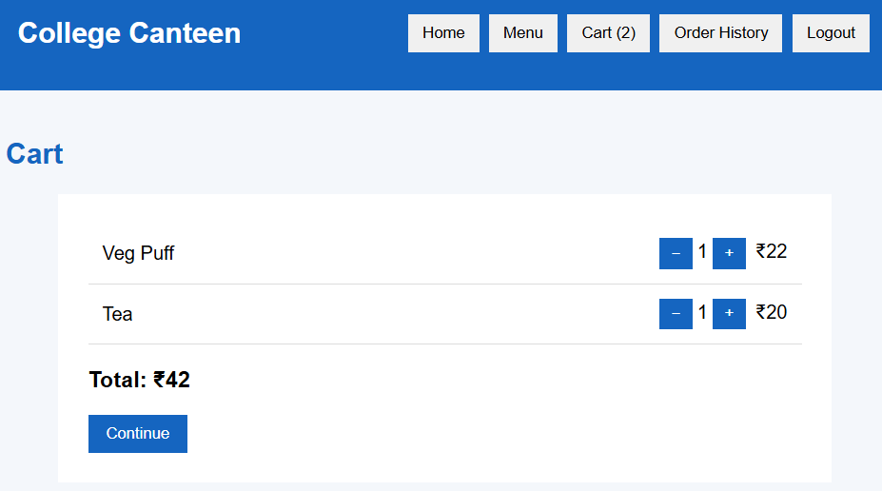
5. Payment Module
The Payment Module displays the user's details and total order amount. Users can select a payment method such as UPI, Debit Card, or Credit Card and complete the payment process. After successful payment, the system generates an order token.
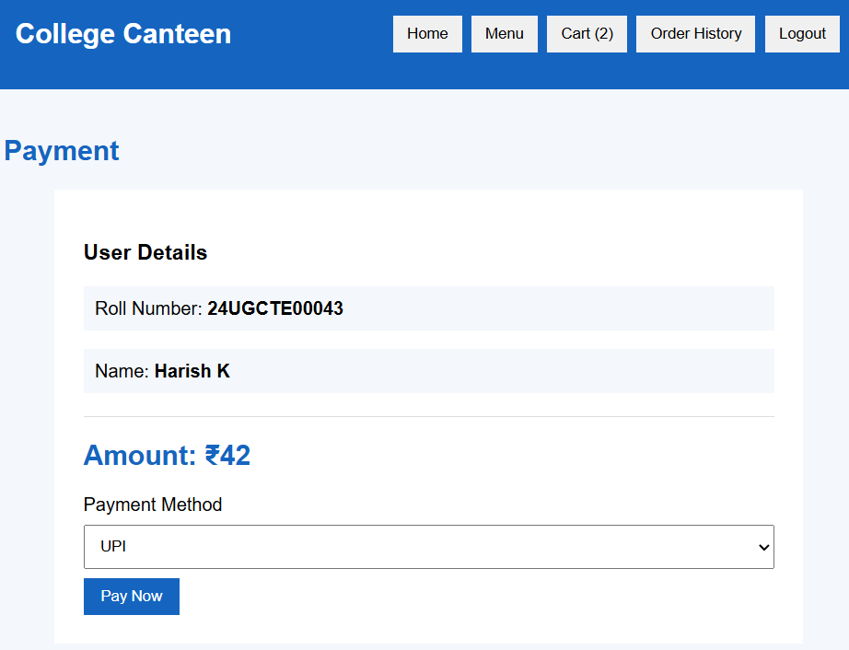
6. Order Confirmation Module
The Order Confirmation Module displays a Payment Successful message after an order has been placed. It shows the user's name and a unique pickup token. The token can be used to identify and collect the order from the canteen.
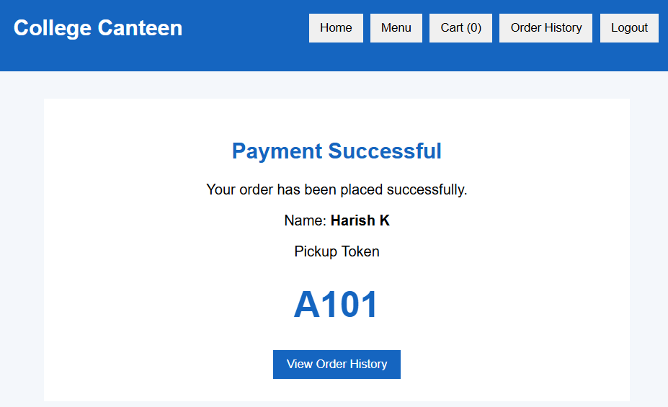

7. Order History Module
The Order History Module stores the orders placed during the current session. It displays the order token, user details, selected food items, total amount, payment method, and payment confirmation. 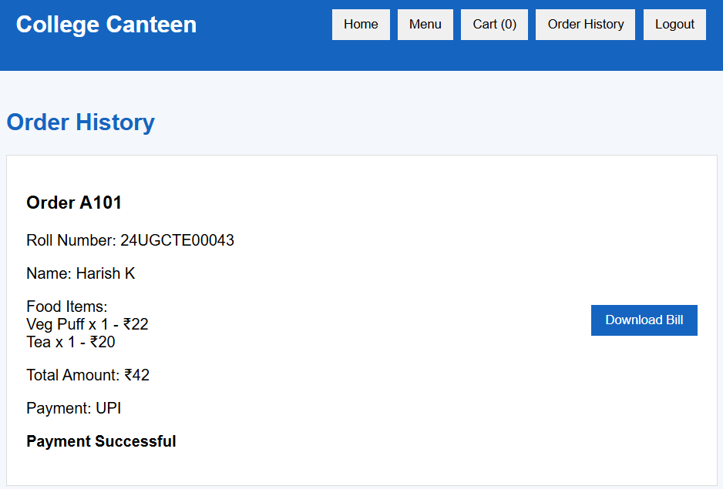
8. Bill Download Module
The Bill Download Module allows users to download their completed order bill as a PDF file. The bill contains the order token, user details, food items, quantities, total amount, payment method, and payment confirmation.
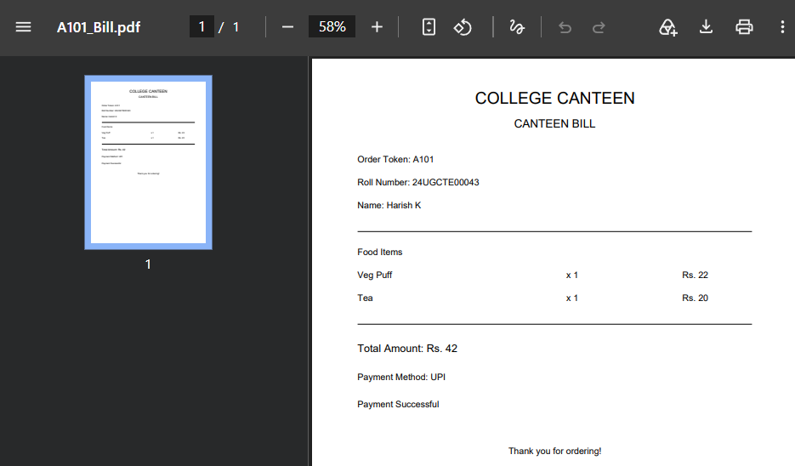
9. Logout Module
The Logout Module allows users to safely exit the system. When the user logs out, the current cart and login session are cleared and the application returns to the login screen.

Logout on next to Order History
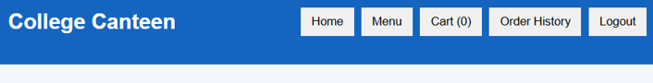

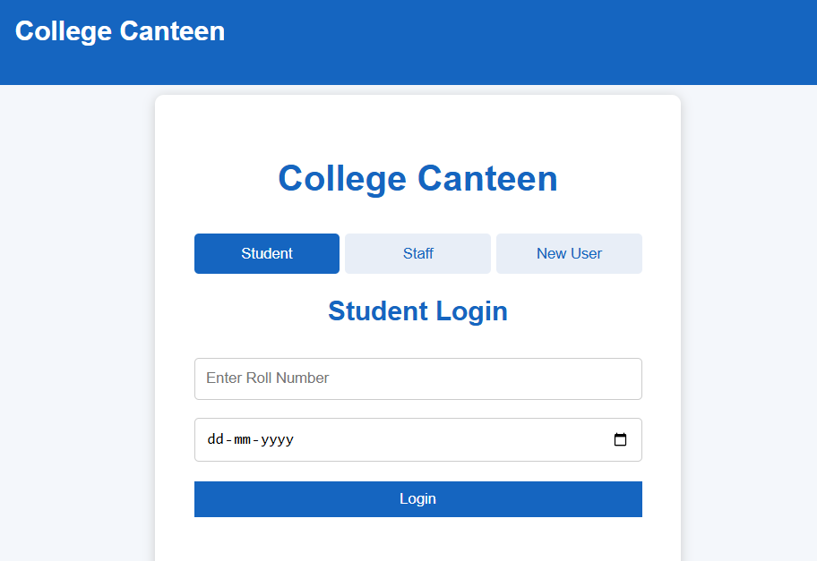

CHAPTER VI: APPLICATION USAGE & TECHNICAL FOUNDATIONS

College Canteen Pre-Order System is developed using HTML, CSS, and JavaScript to create a simple, interactive, and user-friendly web-based food ordering application. Visual Studio Code is used as the primary development environment. The application allows students, staff, and new users to log in, view the food menu, add items to the cart, make payment, receive a pickup token, view order history, and download the bill.

1. HTML
HTML is used to structure the login sections, navigation bar, home page, food menu, shopping cart, payment section, order confirmation, order history, and action buttons.

Basic HTML Structure
<!DOCTYPE html>
<html lang="en">
<head>
<meta charset="UTF-8">
<meta name="viewport"
content="width=device-width, initial-scale=1.0">
<title>College Canteen Pre-Order System</title>
<link rel="stylesheet" href="style.css">
</head>
<body>
<header>
<h1>College Canteen</h1>
</header>
<script src="script.js"></script>
</body>
</html>

The basic HTML structure contains the page title, CSS file connection, main webpage content, and JavaScript file connection.

Login Structure
HTML is used to create Student, Staff, and New User login forms.

<div class="loginTabs">
<button onclick="showLogin('student', this)">
Student
</button>
<button onclick="showLogin('staff', this)">
Staff
</button>
<button onclick="showLogin('newuser', this)">
New User
</button>
</div>
<div id="studentLogin">
<input type="text"
id="rollNo"
placeholder="Enter Roll Number">
<input type="date" id="dob">
<button onclick="login()">Login</button>
</div>

2. CSS
CSS is used to design the application and control the appearance of the login page, navigation bar, food cards, buttons, cart, payment section, order history, and other interface elements.

CSS Styling

.loginTab {
flex: 1;
background: #e8eef7;
color: #1565c0;
border: none;
padding: 10px;
border-radius: 4px;
}
.loginTab.active {
background: #1565c0;
color: white;
}

The above CSS code styles the login tabs and highlights the currently selected login option.

Food Card Styling
CSS is also used to arrange food items in an organized grid layout.

.foodGrid {
display: grid;
grid-template-columns:
repeat(auto-fit, minmax(200px, 1fr));
gap: 20px;
}
.foodCard {
padding: 15px;
border-radius: 8px;
}

This helps display multiple food items in a proper and responsive layout.

3. JavaScript
JavaScript is used to provide functionality and interaction in the application. It handles login validation, food selection, cart management, payment processing, token generation, order history, bill generation, and logout.

Student Login
JavaScript validates the Roll Number and Date of Birth entered by the student.

function login() {
let rollNo =
document.getElementById("rollNo").value.trim();
let dob =
document.getElementById("dob").value;

if (rollNo === "" || dob === "") {
document.getElementById("loginMessage").innerText = "Please enter Roll Number and Date of Birth";
return;
}
enterSystem();
}

Staff Login
JavaScript checks the Staff ID and Password entered by the staff member.

function staffLogin() {
let staffId =
document.getElementById("staffId").value.trim();
let password =
document.getElementById("staffPassword").value;
if (staffId === "staff" &&
password === "1234") {
enterSystem();
} else {
document.getElementById("loginMessage").innerText =
"Invalid Staff ID or Password";
}
}

New User Login
New users can enter their name and mobile number without registration.

function newUserLogin() {
let name =
document.getElementById("newUserName").value.trim();
let mobile =
document.getElementById("newUserMobile").value.trim();
if (name === "") {
return;
}
if (!/^[0-9]{10}$/.test(mobile)) {
return;
}
currentStudent = {
name: name,
mobile: mobile
};
enterSystem();
}

Add to Cart

JavaScript is used to add selected food items to the cart.

function addToCart(index) {
let item = menu[index];
cart.push({
name: item.name,
price: item.price,
quantity: 1
});
updateCart();
}

Total Amount Calculation
JavaScript calculates the total price based on the selected food items and their quantities.

let total = 0;
cart.forEach(function(item) {
total += item.price * item.quantity;
});

Payment and Pickup Token
After payment, JavaScript creates the order and generates a pickup token.

let newOrder = {
token: "A" + token,
name: currentStudent.name,
method: method,
total: total,
items: JSON.parse(JSON.stringify(cart))
};
orders.push(newOrder);
token++;

PDF Bill
The application uses the jsPDF library to generate the bill as a PDF file.

const { jsPDF } = window.jspdf;
let doc = new jsPDF();
doc.text("College Canteen", 20, 20);
doc.text("Payment Successful", 20, 30);
doc.text("Total: Rs. " + total, 20, 40);
doc.save("canteen-bill.pdf");

The generated PDF contains the order and payment information and can be downloaded by the user.

Logout
JavaScript clears the cart and returns the user to the login page.

function logout() {
cart = [];
currentStudent = null;
document.getElementById("mainNav").style.display =
"none";
document.getElementById("login").style.display =
"flex";
}

Visual Studio Code
Visual Studio Code is used as the primary development environment for creating and editing the HTML, CSS, and JavaScript files. It provides syntax highlighting, code completion, error detection, file management, and extensions. Live Server can be used to run and preview the canteen application through a local browser while developing and testing the system.

Responsive Web Design
CSS is used to make the canteen application suitable for different screen sizes. Flexible layouts, grid structures, spacing, and responsive CSS rules allow the login forms, food menu, shopping cart, payment section, and order history to adjust according to the available screen size. This helps the application work comfortably on desktop, tablet, and mobile screens.

Client-Side Processing
The main application operations are performed on the client side using JavaScript. Login validation, food selection, cart updates, quantity changes, total calculation, payment confirmation, pickup token generation, order history, and logout are handled within the browser. This allows the system to provide immediate responses to user actions without requiring a separate backend server.

External Library Integration
The project integrates the jsPDF library through a CDN link for PDF bill generation. This allows the application to create downloadable bills without installing an additional PDF-generation application on the user's computer.

CHAPTER VII: CONCLUSION

The College Canteen Pre-Order System provides a simple and efficient solution for managing food ordering within a college campus. The system allows students, staff, and new users to access the canteen through separate login options and place food orders conveniently through a web-based interface.
The application provides important features such as food menu display, cart management, quantity selection, total amount calculation, payment selection, payment confirmation, pickup token generation, order history, and bill downloading. These features help reduce waiting time, avoid confusion during busy hours, and make the food ordering process more organized.
The project was developed using HTML, CSS, and JavaScript. HTML provides the structure of the application, CSS improves its appearance and responsive design, while JavaScript handles login validation, cart operations, calculations, payment processing, order management, and bill generation. The project demonstrates how basic web technologies can be combined to create a useful real-world application.
Overall, the College Canteen Pre-Order System improves convenience for users and provides a better way to manage canteen orders. With further development, the system can be connected to a database, integrated with real payment gateways, provide notifications, support online administration, and be extended into a mobile application. Thus, the project provides a strong foundation for a modern and efficient digital canteen management system.

CHAPTER VIII: FUTURE SCOPE

The Canteen Pre-Order System provides a convenient way for students and staff to order food online. The system can be further improved with the following features:
1. Database Integration
The system can use MySQL or Firebase to permanently store users, food items, orders, and payment details.
2. Admin Management
An admin panel can be added to manage food items, prices, availability, users, and orders.
3. Online Payment
Real UPI, card, and other secure payment gateways can be integrated.
4. Live Order Tracking
Users can check whether their order is received, preparing, ready for pickup, or completed.
5. Notifications
SMS, email, or push notifications can inform users about order confirmation and food readiness.
6. Mobile Application
The system can be developed as an Android or iOS application for easier mobile ordering.
7. QR Code Pickup
QR codes can be generated for quick order verification and food collection.
Overall, these improvements can make the Canteen Pre-Order System more efficient, secure, and convenient for both users and canteen staff.

CHAPTER IX: REFERENCES
BOOK REFERENCES:
- Duckett, J. (2011). HTML and CSS: Design and Build Websites. John Wiley & Sons.
- Duckett, J. (2014). JavaScript and JQuery: Interactive Front-End Web Development. John Wiley & Sons.
- Nixon, R. (2018). Learning PHP, MySQL & JavaScript: With jQuery, CSS & HTML5 (5th ed.). O'Reilly Media.
- Flanagan, D. (2020). JavaScript: The Definitive Guide (7th ed.). O'Reilly Media.
- Freeman, E., Robson, E., Sierra, K., & Bates, B. (2004). Head First HTML with CSS & XHTML. O'Reilly Media.
- McFarland, D. S. (2014). CSS3: The Missing Manual (3rd ed.). O'Reilly Media.
- Robbins, J. N. (2018). Learning Web Design: A Beginner's Guide to HTML, CSS, JavaScript, and Web Graphics (5th ed.). O'Reilly Media.
- Keith, J. (2010). HTML5 for Web Designers. A Book Apart.
- Meyer, E. A. (2018). CSS: The Definitive Guide (4th ed.). O'Reilly Media.
- Simpson, K. (2015). You Don't Know JS: Up & Going. O'Reilly Media.
WEB REFERENCES:
- MDN Web Docs – HTML, CSS and JavaScript: MDN Web Docs
- W3Schools – HTML, CSS & JavaScript: W3Schools
- Bootstrap Documentation: Bootstrap Documentation
- JavaScript Documentation: JavaScript.info
- Visual Studio Code Documentation: Visual Studio Code Documentation

