JENKINS CI/CD
Github:- https://github.com/ShravanSM/Devops

Flask Backend + Express Frontend on Amazon EC2
Flask repository: https://github.com/ShravanSM/jenkins-flask-backend
Express repository: https://github.com/ShravanSM/jenkins-express-frontend

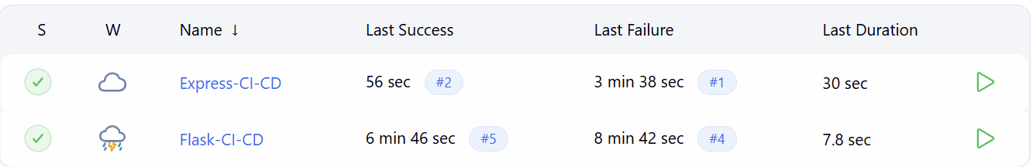
Figure 1 — Jenkins dashboard: both jobs have successful recorded builds.

Project overview
The project uses two GitHub repositories and two Jenkins pipeline jobs. Flask provides the backend API on port 5000. Express serves the dashboard on port 3000 and reads the backend status.
GitHub Flask repo → Jenkins Flask-CI-CD
GitHub Express repo → Jenkins Express-CI-CD
EC2 during practical: Flask :5000 | Express :3000
Intermediate theory: CI (Continuous Integration) checks out the code and runs verification steps. CD (Continuous Delivery/Deployment) extends the pipeline to deliver verified code to a target server. In this practical, the CI jobs succeeded, while automated SSH deployment and webhooks remain incomplete.

GitHub repositories
Separate repositories keep the backend and frontend code independent.
Flask: https://github.com/ShravanSM/jenkins-flask-backend
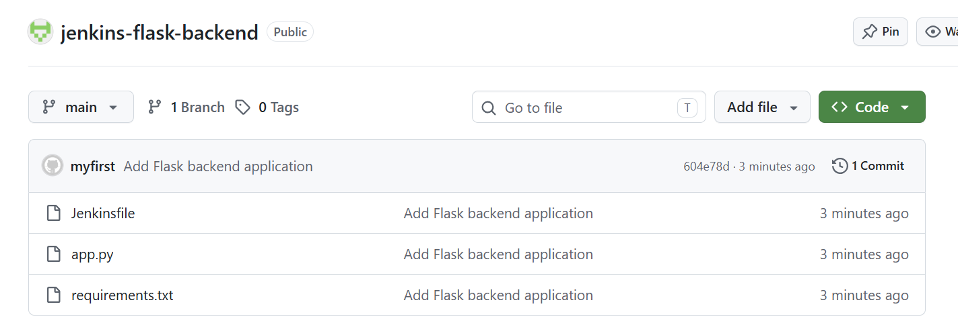
Figure 2 — Flask backend repository and its Jenkinsfile.
Express: https://github.com/ShravanSM/jenkins-express-frontend
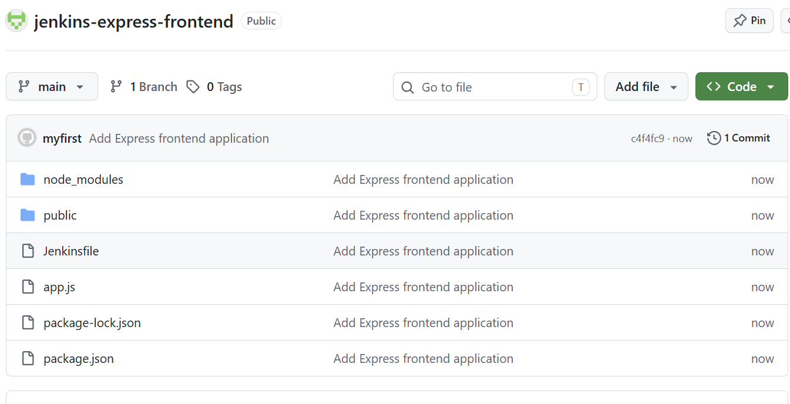
Figure 3 — Express frontend repository and its Jenkinsfile.

Applications deployed on EC2
An Ubuntu EC2 instance was used during the practical. Flask and Express were installed on the same instance and managed with PM2 so the processes could run in the background.

Main setup commands
sudo apt update
sudo apt install -y python3 python3-pip python3-venv git
sudo apt install -y nodejs npm
sudo npm install -g pm2

Flask backend
git clone https://github.com/ShravanSM/jenkins-flask-backend.git ~/apps/flask-app
cd ~/apps/flask-app
python3 -m venv venv
source venv/bin/activate
pip install -r requirements.txt
pm2 start venv/bin/python --name flask-backend -- app.py
curl http://127.0.0.1:5000/api/status
The status endpoint returned the DevOps Status Dashboard response with backend Flask and status UP.

Express frontend
git clone https://github.com/ShravanSM/jenkins-express-frontend.git ~/apps/express-app
cd ~/apps/express-app
npm install
pm2 start app.js --name express-frontend
pm2 status
curl http://127.0.0.1:3000/api/backend-status
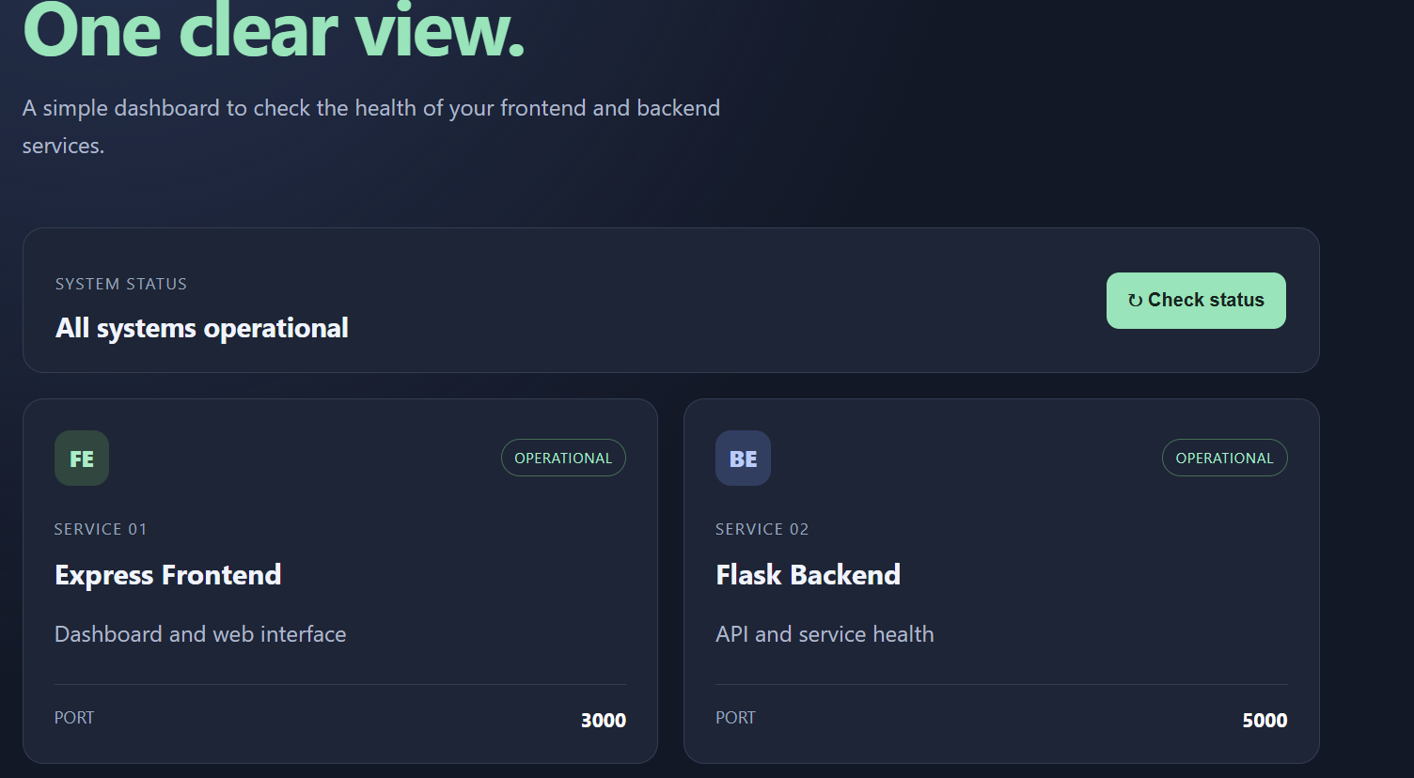
Figure 4 — Dashboard displayed while both application services were running.
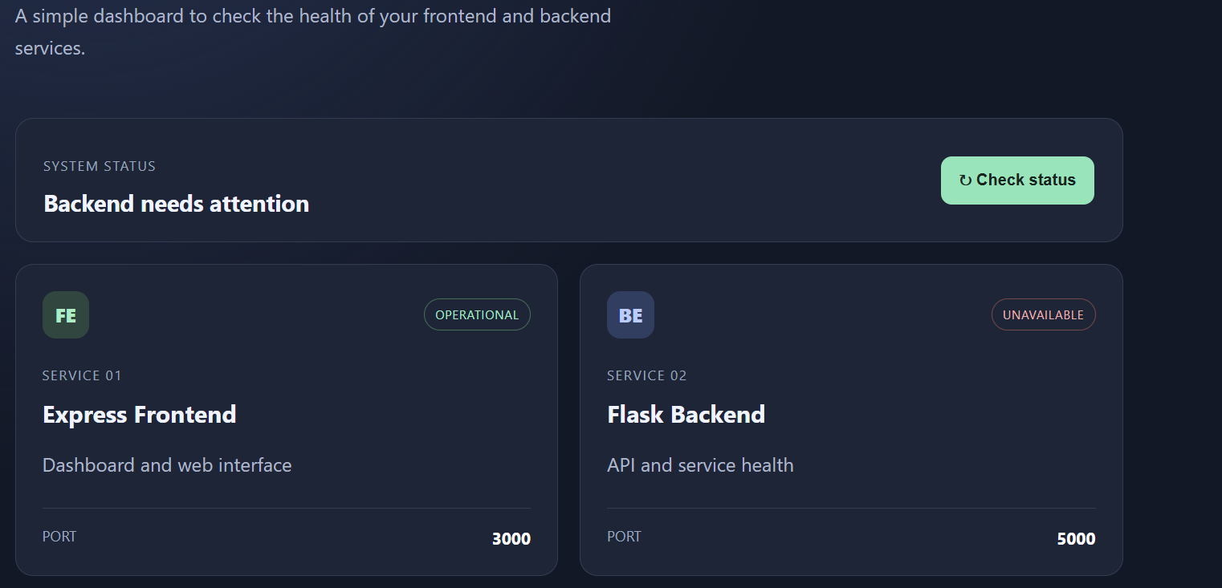
Figure 5 — Dashboard view showing the Flask and Express service cards.

Jenkins pipeline configuration
Both Jenkins jobs use Pipeline script from SCM. Jenkins reads the Jenkinsfile from the matching GitHub repository.

Pipeline stages
- Checkout — fetch the repository code.
- Install dependencies — install Python requirements or npm packages.
- Verify application — check Python syntax or JavaScript syntax.
- Deploy to EC2 — intended to pull the latest code on EC2 and restart the corresponding PM2 process.
The first three stages ran successfully in the Flask pipeline. The Express pipeline also has a successful recorded build.
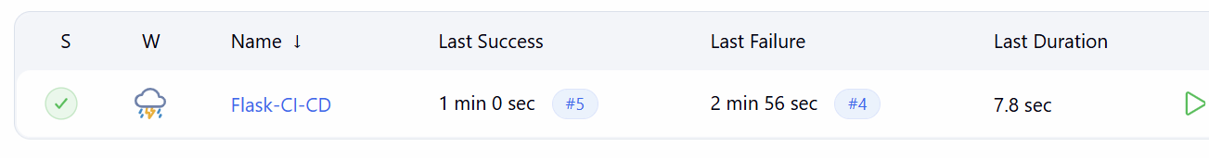
Figure 6 — Jenkins jobs showing the successful build status.
Figure 7 — Jenkins dashboard with successful pipeline indicators.

